Precommitment in stochastic versus deterministic social dilemmas

Authors: David J. Hardistyª, Amir Sepehri^{b}, Howard Kunreuther^{c}, David H. Krantz^{d}, and Poonam Arora^{e}
ªUniversity of British Columbia, Sauder School of Business, Canada, david.hardisty@sauder.ubc.ca
^{b}Essec Business School, France, Sepehri@essec.edu
^{c}University of Pennsylvania, Wharton School of Business, United States, kunreuth@wharton.upenn.edu
^{d}Columbia University, Department of Psychology, United States, dhk@psych.columbia.edu
^{e}Quinnipiac University, School of Business, United States, Poonam.Arora@quinnipiac.edu

Author note: Please direct correspondence to David J. Hardisty, david.hardisty@sauder.ubc.ca. The full stimuli, data (long and short formats), and analysis scripts can be accessed on OSF at https://osf.io/jfmte/?view_only=825938bb4c7547b195da865986ab919f

Funding: This research was supported NSF grants SES-0345840 and SES-0820496 and by the Canadian Social Sciences and Humanities Research Council.
Abstract
Many real-world social dilemmas require interdependent people to repeatedly protect against a large loss that has a low probability of occurring. Examples include protecting against disease outbreak (e.g., COVID-19), terrorism (shared border security), or extreme weather events (from climate change). Decisions on whether to invest in protection may be made period by period (e.g., month by month), or investment may be precommitted in advance for a number of periods. How does precommitment influence cooperation in these situations? A series of four studies (plus one supplemental study) investigate this question, using incentive-compatible, repeated social dilemmas with large-magnitude, low-probability losses. These studies found that in stochastic social dilemmas, binding precommitment increases cooperation, but non-binding precommitment has little effect, and in deterministic social dilemmas, binding precommitment decreases cooperation. These patterns were driven by changes in responsiveness to probabilities and interactions with counterparts, with implications for how to structure real-world dilemmas to increase cooperative investment in protection.

Keywords: social dilemma; risk; time; interdependent security; choice bracketing

Precommitment in stochastic versus deterministic social dilemmas

In independent security situations, risk-connected actors must decide whether to invest in preventive measures against the chance of catastrophic loss, affecting both their individual risk and the spillover risk to others. For example, people facing a contagious disease outbreak (such as measles or COVID-19) must decide whether reduce their risk by engaging in preventative measures such as vaccination (Trueblood et al., 2022). The security of each person depends not only on their own choices, but also on the choices of their neighbors. If one person does not take preventative measures (e.g., skipping a measles vaccination), it increases the risk for others (e.g., they could get infected and spread the disease). In contrast, if most people engage in risk prevention, it provides spillover protective benefits (e.g., heard immunity), even to those individuals who freeride and do not take preventative measures. A second example is border security; the United States and Canada share a huge undefended border and both must protect against illegal smuggling, foreign agents, and terrorism. Each country relies on the security investments of the other. A third example of interdependent security has been seen in financial firms, where catastrophic losses in one division may bring down the whole company (Kunreuther & Heal, 2005).
Interdependent security situations such as these are a special type of social dilemma. In social dilemmas, individuals are incentivized to put their self-interest over the collective benefit and therefore act non-cooperatively in the short-term (Axelrod, 1980). To counteract this, a huge literature on social dilemmas has documented factors which promote cooperation and, hence, lead to mutual benefit (for a review, see Van Lange et al., 2013). For example, cooperation rates are higher when interactions are repeated (Axelrod & Hamilton, 1981), when actions are observable and punishment is possible (Fehr & Gachter 2000), when communication is possible (Dawes, McTavish, & Shaklee, 1977), and when there are shared norms, shared identity, or affiliation between the actors (Brewer & Kramer, 1986; Arora et al., 2012). While all social dilemmas involve some uncertainty about the actions that others will take, once all actions are known, the outcome is typically fully deterministic. (For example, if both players cooperate, they know the payoff will be $X each, and if they both do not cooperate, they know the payoff will be $Y each.) Therefore, in the current manuscript we call these deterministic social dilemmas, because given a set of actions, the outcomes are completely certain and determined.
While previous academic research has mostly studied deterministic social dilemmas (though see our literature review below), many real-world situations of interest involve stochastic outcomes, where even if the decisions of all actors are known, there is still some risk involved. For example, farmers investing in security for their crops do not know exactly what will happen given how much they spend. A group of farmers might spend nothing on disease prevention, despite a 10% probability of total crop failure, and yet get lucky and never face diseased crops for many years. The current research examines the effect of this “outcome risk” on cooperation decisions involving large potential losses, and tests an intervention to encourage participants to engage in mutually-beneficial protection. Table 1 shows the payoff matrix used in the present research to study stochastic prisoner’s dilemmas (SPDs), with low probability, high magnitude losses.

Table 1: Payoff matrix in a stochastic prisoner's dilemma (SPD). The scenario employs an environmental cover story of two farmers deciding whether to protect against groundwater contamination. (Note that a purely financial SPD scenario with the same payoff structure was also tested and reported in Appendix Study A.)
 |  | Your Counterpart
 |  | INVEST | NOT INVEST
You | INVEST | - You definitely lose 1,400 Rp, and have a 0% chance of groundwater contamination.  - Your counterpart definitely loses 1,400 Rp, and has a 0% chance of groundwater contamination. | - You definitely lose 1,400 Rp and have a 1% chance of groundwater contamination occuring and losing an additional 40,000 Rp.  - Your counterpart has a 3% chance of losing 40,000 Rp due to groundwater contamination and a 97% chance of losing 0 Rp
You | NOT INVEST | - You have a 3% chance of losing 40,000 Rp due to groundwater contamination and a 97% chance of losing 0 Rp.  - Your counterpart definitely loses 1,400 Rp and has a 1% chance of groundwater contamination occuring and losing an additional 40,000 Rp. | - You have a 4% chance of groundwater contamination occurring and losing 40,000 Rp and a 96% chance of losing 0 Rp.  - Your counterpart has a 4% chance of groundwater contamination occurring and losing 40,000 Rp and a 96% chance of losing 0 Rp.

To better understand the SPD shown in Table 1 and isolate the effects of risk from other factors (such as loss framing), we contrast it with an equivalent, deterministic payoff structure. Table 2 shows the deterministic prisoners dilemma (DPD) used in the current research, with losses equivalent to the expected value of the payoffs of the SPD dilemma shown in Table 1.
Table 2: Payoff matrix in a deterministic prisoner's dilemma (DPD). The scenario employs a financial cover story of two investors making decisions.
 |  | Your Counterpart
 |  | INVEST | NOT INVEST
You | INVEST | - You lose 1,400 Rp.  - Your counterpart loses 1,400 Rp. | - You lose 1,800 Rp.  - Your counterpart loses 1,200 Rp.
You | NOT INVEST | - You lose 1,200 Rp.  - Your counterpart loses 1,800 Rp. | - You lose 1,600 Rp.  - Your counterpart loses 1,600 Rp.

Previous Research on Outcome Risk in Social Dilemmas
We build on the literature on interdependent security dilemmas, which explore the effects of outcome risk on cooperation (Heal & Kunreuther, 2005), particularly in cases of low probability, catastrophic loss. Real-life examples dilemmas include disease prevention, computer security, fire protection, protection against bankruptcy, and theft protection. In each of these cases, cooperation is manifested through investing in protection measures, which have some protective spillover and reduce the chance that counterparts will experience a loss. Overall, outcome risk about losses lowers cooperation between individuals quite substantially. For example, while cooperation rates in a loss-framed, repeated, deterministic prisoner's dilemma (DPD) may hover around 60-75%, outcome risk lowers that cooperation rate to around 25-40% (Gong et al., 2009; Kunreuther et al., 2009).
Consistent with that finding, Xiao and Kunreuther (2016) argue that noncooperative behavior is less likely to be punished when there is risk in the game outcomes. One theory on why this happens is that the motivations for cooperation in a prisoners dilemma game -- such as altruism, reciprocity, or commitment -- are diluted when outcomes are uncertain. For example, if someone cooperates in a typical, deterministic prisoners dilemma (DPD) game, they know it will help their counterpart, while if someone cooperates in a stochastic prisoners dilemma (SPD) game, they do not know if it will result in a tangible benefit for their counterpart or not, due to the outcome risk. Similarly, the ability to retaliate with a tit-for-tat strategy is reduced when outcomes involve risk: defection will not necessarily hurt one's counterpart. For example, people may think, “Most likely the loss will not occur, so it won’t matter to my counterpart if I invest in protection or not”, and so they choose the self-benefitting choice more often.

How to Increase Cooperation Under Outcome Risk
Because individuals are less likely to cooperate under outcome risk, and because so many real-world situations of interest resemble interdependent security situations (with risky, large-magnitude, negative prospects), behavioral research should explore ways to increase cooperation under outcome risk. In the present research, we investigate the idea that precommitting to multiple rounds of a social dilemma simultaneously might alter the perceived probabilities and payoffs, and change the interactions and perceptions of other players, therefore increasing cooperation levels in stochastic dilemmas.
One source of inspiration comes from Redelmeier and Tversky's (1992) work on single vs multiple prospects: although many individuals make sub-optimal choices on a single risky gamble, their choices improve when playing multiple gambles simultaneously. For example, when offered a chance to play a gamble with a 50% chance of winning $2,000 and a 50% chance of losing $500, only 43% of participants indicated they would play this attractive gamble. However, when offered the chance to play this same gamble 5 times simultaneously, the number of participants wanting to play increased to 63%. Thus, about 20% of participants would not play the gamble once, but would play it five times. Presumably, these people want to avoid the possibility of a net loss from the gamble(s), and they rightly perceive the chance of a net loss to be lower with 5 plays than with 1.
Relatedly, past research has investigated the effect of broadening the time-horizon on individuals’ decisions with rare events. Slovic, Fischhoff, & Lichtenstein (1978) show that when the risk of death or injury over a lifetime of driving (versus a single trip) is communicated to individuals, seatbelt use increases. In another example, communicating the cumulative chance of flood over 30 years as opposed to that of one year has been shown to be effective in selling flood insurance policies (Chaudhry et al., 2018). Moreover, this effect has been shown to be robust to time delay and robust to whether individuals actually suffer the large loss or not.
In addition to broadening the number of outcomes under consideration, increasing the time-horizon also broadens the number of choices under consideration. “Choice bracketing” refers to where repeated decisions are mentally represented as either a series of one-off, individual choices (ie, narrow bracketing) or as a single, combined set of choices (broad bracketing) (Read et al., 1999). When it comes to smoking, the positive utility of choosing to smoke one single cigarette may outweigh the tiny health risk it brings about and the person may choose to smoke a single cigarette. However, if 3,700 individual decisions of smoking a cigarette over a year (one pack per day) are bracketed together and the aggregate pleasure and health risk are considered, the same individual may choose to forgo smoking altogether (Read et al., 1999).
Similarly, in real-world social dilemmas, decision makers may make different choices when considering one, five, or twenty years of actions. For example, a homeowner in a wildfire-prone region such as California must decide each year whether to invest their time and money in fire protection through activities such as clearing vegetation and flammable materials around their home, or maintaining fire suppression systems. The chance of a wildfire spreading depends not only on what the individual homeowner does, but also on the security precautions of their neighbors. If most homeowners in an area engage in rigorous fire protection, a particular homeowner may be able to free-ride on the protection of the others and enjoy lower risk of wildfire spreading to their own home even without investing in protection themselves. In these situations, precommitment may be used as a form of choice-bracketing (Read et al., 1999). Precommitment naturally lends itself to broad-bracketing of decisions, and thus may improve long-term, holistic thinking and cooperation: the chance of a wildfire in any particular neighborhood and home in any given year is small, and a homeowner considering only the current year (narrow bracketing) will most often be rewarded for skipping the costly protective measures. However, when the same homeowner considers multiple years (broad bracketing), the aggregation of risks and costs may favor security.
Another, altogether different impact of precommitment in social dilemmas is that it reduces the opportunities for feedback and interaction between decision makers. In the case of “binding” precommitment (which is the main focus of this manuscript), choices are made in advance for some number of rounds, and cannot be changed. Thus, feedback -- about the actions of others and about the stochastic outcomes -- is only seen after the precommitted choices play out. Therefore, opportunities to respond to feedback are more limited. Previous research on feedback in social dilemmas (for a review, see van Dijk et al., 2008) has found that it can be an enhancer: seeing others cooperate leads to greater cooperation (Schroeder et al. 1983). However, the opposite can also be true, due to the desire to avoid being a sucker (Kerr, 1983): “defection breeds defection” (Fleishman, 1988; Messick et al. 1983). Indeed, in a public-good setting, people tend to adjust their own contributions to those of the lowest contributor (Kurzban et al., 2001). This literature might suggest the precommitment, by reducing opportunities for feedback, could keep cooperation rates higher in stochastic dilemmas. In summary, there are conflicting predictions for the overall the effect of precommitment on cooperation in social dilemmas.

The Present Research
The present research set out to test the effect of precommitment as a method to increase investment rates in social dilemmas with outcome risk. (Here and below, we use “invest” to refer to paying a small amount to reduce the likelihood of catastrophic loss. In the social dilemma scenarios, investing is the “cooperative” choice, and in the solo games we describe below, investing is the expected-value maximizing choice.) Unlike previous social dilemma research which has examined verbal commitments to cooperate (Chen, 1996; Chen & Komorita, 1994; Kerr & Kaufman-Gilliland, 1994), we focus on the case where individuals make binding choices in advance (or non-binding choices in advance, in Study 4).
The interdependence theory model suggested by Van Lange & Rusbult (2012) assumes that decision makers transform a “given payoff matrix” of objective outcomes to an “effective payoff matrix” of subjective outcomes. One of the factors influencing that transformation is temporal transformation. Rare events with a catastrophic loss pose a dilemma: Either to pay a certain cost (e.g., a financial cost or a time cost) and be safe, or to do nothing and to risk being exposed to the large loss. Individuals often make more rational and reasoned choices for the future than for the present (Soll et al., 2015). Therefore, we argue that precommitment can be an effective tool to nudge people to invest in safer choices in SPDs. We propose that precommitment does this through increasing the individuals’ decision-making time-horizon and in turn, the goals that they pursue and the weight of the large loss. In other words, when players make decisions one at a time, they often have the single goal of doing well in the next round. But when players precommit, they more often consider other goals as well, such as avoiding a negative cumulative result, achieving some overall payment threshold, or maximizing expected value, and these additional goals lead them to invest more often.
We also theorize that SPDs (as compared with DPDs) induce decision makers to focus more on probability and less on the social dilemma nature of the situation and the actions of their counterpart. This happens because human attention and cognition are limited; as compared to deterministic situations, SPD situations add outcome risk as a salient and impactful factor, capturing attention and processing and therefore reducing the focus on their counterpart. Furthermore, precommitment reduces the frequency and immediacy of feedback, further weakening focus on the actions of the counterpart and increasing focus on cumulative probabilities and outcomes.
We hypothesize that when participants are forced to precommit their actions for multiple rounds, it leads them to reflect on a longer time horizon, thereby changing their goals and goal weighting, leading them to increase their investment rates. When a player considers one round, they compare a sure loss (investment) with a risky loss, and opt for the risky option, consistent with Prospect Theory (Kahneman & Tversky, 2013). When precommitting for 20 rounds, however, the importance of the cumulative payout increases and the same player may now invest in protection. In other words, the focus of decision-maker will shift from one individual outcome to the cumulative distribution of outcomes, which in turn will lead to safer choices.
Yet, the player may also consider the actions of their counterpart; if the player invests in protection, their counterpart may free-ride. For this reason, a precommitment to protection may risk opening the player up to exploitation, and thus precommitment might, instead, decrease investment in SPD situations. In line with that argument, Faillo, Greico, and Zarri (2013) found that eliminating the feedback of counterpart actions diminishes cooperation. Similarly, Bolton, Greiner, & Ockenfels (2018) found that feedback withdrawal options may create situations where they would hinder rather than promote trust. Precommitment also reduces feedback of counterpart actions and thus, one needs to consider this hypothesis. The present research tested which of these possibilities would play out, and under which conditions.
Overview of studies:
The first study used an environmental social dilemmas scenario to investigate the effect of risk on cooperation rates in a loss-framed, stochastic prisoner's dilemma compared to the deterministic version of the game. In the stochastic game, the probabilities were low and potential losses were high, simulating real-world catastrophes, and similar to previous work on interdependent security (Gong et al., 2009; Kunreuther et al., 2009). This study also tested whether precommitment by participants buffers against the negative effects of risk. More formally, we tested whether:
H1a: The presence of risk reduces investment (ie, cooperation) rates in a stochastic, loss-framed prisoners dilemma with players playing round-by-round versus an equivalent, deterministic prisoners dilemma
H1b: Precommitment buffers against the adverse effect of risk in the stochastic prisoners dilemma, such that players who are required to precommit will invest more frequently than players who play round-by-round.
Appendix Study A tested the robustness of these hypotheses in another context, employing a financial SPD scenario rather than an environmental one, and found the same pattern of results, though slightly weaker.
Subsequently, to isolate the effects of risk perceptions and preferences from the effects of counterpart interaction (Faillo et al., 2013), we designed Study 2, where the participants take part in a “solo” game, having only themselves playing in the game against the odds of the loss happening, and otherwise employing the same payoffs and probabilities as previous studies. We tested the hypothesis that:
H2: Investment rates in the stochastic solo game will be higher when the participants are required to precommit their decisions.
While Study 2 eliminates the counterpart to isolate the effect of risk, Study 3 eliminates the risk to investigate the effect of precommitment in a deterministic prisoner's dilemma. Since this type of design transforms the repeated game into a one-shot game (with the opportunity to defect without any consequences), we tested whether:
H3: In the deterministic prisoners dilemma, participants in the precommitment condition will invest less often (as compared to participants in the non-precommitment/control condition).
Finally, Study 4 explored whether binding versus non-binding precommitment is effective for promoting cooperation in stochastic prisoners dilemmas. This is important from a practical perspective, as binding precommitment is not always possible, and also tests the importance of feedback and partner interaction. In a “binding” precommitment, participants make a series of choices in advance, and those choices cannot later be changed (for example, a legal contract). In contrast, in a “non-binding” precommitment, participants make a series of choices in advance, but they can later change those choices if they desire. On one hand, non-binding precommitment creates an incentive to treat one’s counterpart well each round and maintain reciprocal altruism, which could lead to greater cooperation. On the other hand, non-binding precommitment is a weaker form of pre-commitment and allows one to “back out” of previously cooperative intentions, which could lead to lower cooperation. Or, these forces could cancel out and lead to no difference between binding and non-binding precommitment. Therefore, we did not have a clear hypothesis for the non-binding precommitment condition in Study 4.
In summary, the present research makes the following major contributions: 1) proposing and testing binding precommitment as a novel intervention in the context of social dilemmas, 2) uncovering the mechanisms driving the effectiveness of precommitment, 3) demonstrating opposite effects of precommitment in stochastic versus deterministic prisoners dilemmas, and 4) testing binding versus non-binding precommitment in stochastic dilemmas.
Study designs and findings are summarized in Table 3. All studies used incentive compatible designs, and mainly between-subject designs. Studies 1-3 (and Appendix Study A) were run in 2009, using sample sizes of 30 participants per condition and 80 observations per participant, while Study 4 was run in early 2020 (pre-COVID) with over 50 participants per condition and 60 observations per participant. All study materials, data, and analysis code are available at https://osf.io/jfmte/?view_only=825938bb4c7547b195da865986ab919f.
Table 3: Summary of hypotheses, manipulations, and game types in Studies 1-4.
Study | Hypothesis  Tested | Type of Games | Game Features | Focal  Manipulation | Effect of Focal Manipulation on  Investment Rates
1 & A | H1a | SPDs compared to DPDs | Both risk and counterpart | Risk | Decrease
1 & A | H1b | SPDs compared to DPDs | Both risk and counterpart | Precommitment | Increase
2 | H2 | Stochastic “solo” games compared to deterministic “solo” games. | Risk only | Precommitment | Increase
3 | H3 | Precommitment DPDs compared to round-by-round DPDs. | Counterpart only | Precommitment | Decrease
4 | -- | SPDs | Both risk and counterpart | Binding vs Non-binding precommitment | Decrease
Study 1:
The first study compared a typical, repeated, deterministic prisoner's dilemma (DPD-rep) with a stochastic version of the same game (SPD-rep), and a version of the stochastic game in which participants would be forced to precommit their choices for 20 rounds at a time (SPD-pre). We hypothesized that cooperation rates would be lower in the stochastic game than the deterministic game (H1a, which would replicate previous research). We further hypothesized that precommitment would raise investment rates in the stochastic game, moving them closer to the deterministic condition (H1b, our novel contribution).

Study 1: Participants
90 participants (61% female, mean age = 22.00, SD=4.71) were recruited via paper flyers and word of mouth for a study on Interdependent Security Games. The study was open to the public for participation, but nearly all participants (97%) were students at a North-American university. Participants' compensation depended entirely on the outcome of the experiment, as described below. Participants were told that while average payments were around $10, it was theoretically possible (though unlikely) to finish with negative money, and if this happened they would have to stay after the study and complete additional surveys at the rate of 25 cents per minute to pay back their debt. (Across studies, this did indeed happen to a couple participants.)

Study 1: Design Overview
In a between-subjects design, participants played one of three versions of a social dilemma game: a deterministic prisoner's dilemma with repeated play (DPD-rep), a stochastic prisoner's dilemma with repeated play (SPD-rep), or a stochastic prisoner's dilemma with precommitted play (SPD-pre). Participants played a total of 80 rounds in the game, broken down into 4 blocks of 20. Participants were randomly assigned a counterpart for each block, and one block was randomly selected and paid out for real money at the end of the study. Participants were seated at separate computers in a large room, but otherwise had no way to know the identity (i.e., not even an ID number) of their counterpart.

Study 1: Methods
The study materials (the complete texts of which can be found in the appendices), were modeled after Kunreuther et al (2009) and Gong et al. (2009). Similar to previous studies, the game used an experimental currency, the Indonesian Rupiah (Rp); this is done because larger numeric values have been found to motivate participants in social dilemmas even if objective values remain unchanged (Furlong & Opfer, 2009). At the end of the study, Rp were converted to dollars at the rate of 9,673 Rp = $1 USD, which was the actual exchange rate at the time the study was designed.
Experimental sessions were run in groups of 4 to 6 participants (mean = 5.00). Each participant was seated at a computer and instructed not to communicate with any of the other participants. After agreeing to the consent form (which stated the average payout would be around $15), participants read five pages of instructions on the computer. They learned that they would play a scenario in which their payment would depend on their choices as well as those of a counterpart. They were told to imagine they were a farmer in Indonesia. Each "year" (i.e., game round), they would earn 8,500 Rp from their potato crop. However, they had to use a pesticide, which caused groundwater contamination, also affecting their counterpart. In the DPD conditions, the pesticide caused a certain, moderate loss each year, while in the SPD conditions, pesticide had a low (4% or lower) probability of causing a large loss.
Participants learned they had the option each year to invest in a safer, though more expensive pesticide, which would reduce the risk of groundwater contamination. However, contamination was only completely eliminated if both counterparts invested. Participants learned that they would play a 20-year session with one anonymous counterpart, after which they would again be randomly paired with a new counterpart and play another session. They would play 4 sessions in total, one of which would be randomly selected and have all rounds paid out for real money (converted to dollars). Participants in the DPD-rep and SPD-rep conditions were told they would play one round at a time, while those in the SPD-pre condition learned that they would precommit their choices for all 20 rounds in a session.
Participants were told that while average payments were around $15, it was theoretically possible (though unlikely) to finish with negative money, and if this happened they would have to stay after the study and complete additional surveys at the rate of 25 cents a minute to pay back their debt (one unfortunate participant actually had to do this).
After reading the instructions, participants saw a payoff matrix summarizing the contingencies (see Table 1 and Table 2, above). Note that the expected values of the SPD and DPD conditions are identical, and note that both matrices take the form of a prisoner's dilemma, whereby each individual can expect a higher payout through not investing (ie, defecting), while the overall expected value for the dyad is higher if both invest (ie, cooperate). The ratios of the expected values of each cell (in other words, the relative attractiveness of each option) matched those in previous work on IDS (Gong et al., 2009; Kunreuther et al., 2009). Participants then took a 4-item comprehension test. If participants got any items wrong on the test, they had to re-read the instructions and take the test again. Every page of the experiment had a note at the bottom that said "If you have questions at any time, please ask the experimenter." Some participants did indeed ask questions, and the experimenter assisted as necessary.
Participants next had to wait until all other participants at that session had completed the knowledge test, and were then randomly paired with a counterpart for the first block of 20 rounds. Subsequently, participants were again presented with the appropriate payoff matrix for reference, and were asked to 1) choose whether to invest or not, and 2) to predict whether their counterpart would invest (on a 4-point scale: "Definitely Not", "Probably Not", "Probably", or "Definitely).
Participants in the DPD-rep and SPD-rep conditions made a choice and prediction for the first round, and then got feedback for the first round. The feedback specified their choice, the choice of their counterpart, and the end result. In the SPD-rep condition, participants were also told which number was randomly generated to determine if the groundwater contamination occurred. Participants then made their choice and prediction for the second round, got feedback for the second round, and so-on, until they finished all 20 rounds, at which time they saw a summary of the results of all 20 rounds. Participants in the SPD-pre condition first made choices and predictions for all 20 rounds at once (all on the same page). They then saw round by round feedback for all 20 rounds played out one at a time, and then the summary of all 20 rounds. Thus, after 20 rounds, participants in the SPD-rep and SPD-pre conditions had seen exactly the same feedback.
Note that when participants in the SPD-pre condition made their precommitted choices (and predictions), they could make different choices for each round if they desired. For example, a participant could precommit to investing in the first 15 rounds and not in the last 5. Although this might not seem rational, many participants precommitted to a “mixed strategy” such as this, and in fact gave understandable reasons on why in their comments at the end of the study. For example, one pre-committing participant wrote “I chose to invest almost all 20 times except for one or 2 years to make an extra bonus”, while another saw it as a prediction game, writing “It was really hard to decide when to invest and when to not invest. In the end, I decided to make a random choice of investing the last 8 years for one round, not investing for another round, then every 5 years for another round, and lastly investing the first year, 10th year, and 20th year...”)
After the summary at the end of this first block of 20 rounds, participants in all conditions were again randomly paired with a counterpart (with replacement), and played another block. After completing all 4 blocks of 20 rounds each, participants were asked “What are your thoughts on playing the game? Please give a brief summary of why you chose to invest or not invest:”, as well as a number of demographic questions. In the stochastic conditions, there was also a question about probability, “With no investment in protection, what do you think is the likelihood that a loss would occur at least once in 20 rounds? _____ out of 100.” Finally, one block was randomly selected and each participant was paid accordingly.

Study 1: Results
Mean investment rates were computed for each participant for each block of 20 rounds, and are summarized in Figure 1. As seen there, investment rates were highest in the repeated deterministic condition (at .80) and lowest in the repeated stochastic condition (at .29), with the precommitted stochastic condition in the middle (at .48), and the difference between the DPD and SPD conditions grew larger across the four blocks of trials. To model participants’ dichotomous choices and account for correlated responses between paired participants, we ran a logistic regression mixed model with condition (SPD-rep, SPD-pre, or DPD-rep; using SPD-rep as the reference group), block number (continuous, mean-centered), the interaction of condition and block number as fixed effects, and participant id and partner id as random effects. We report only the focal results here, and complete syntax and output are available at https://osf.io/jfmte/?view_only=825938bb4c7547b195da865986ab919f
The logistic mixed model confirmed H1a, finding that players cooperated more in the DPD-rep condition than in the SPD-rep condition, B=3.96, SE=0.85, p<.001, OR=4.68, and confirmed H1b, finding that players cooperated more in the SPD-pre condition than in the SPD-rep condition, B=1.82, SE=0.85, p=.03, OR=2.14. Furthermore, significant effects of block number and block by condition interactions (all p<.04 or lower) reflected the fact that cooperation rates in the two SPD conditions trended down over the four blocks, while the DPD condition trended up over the four blocks.
Figure 1: Mean proportion investing against loss in each of the four blocks in Study 1 in the repeated deterministic prisoner's dilemma (DPD-rep), repeated stochastic prisoner's dilemma (SPD-rep), and precommitted stochastic prisoner's dilemma (SPD-pre) conditions. Each block represents 20 trials. Error bars show +/- one standard error.
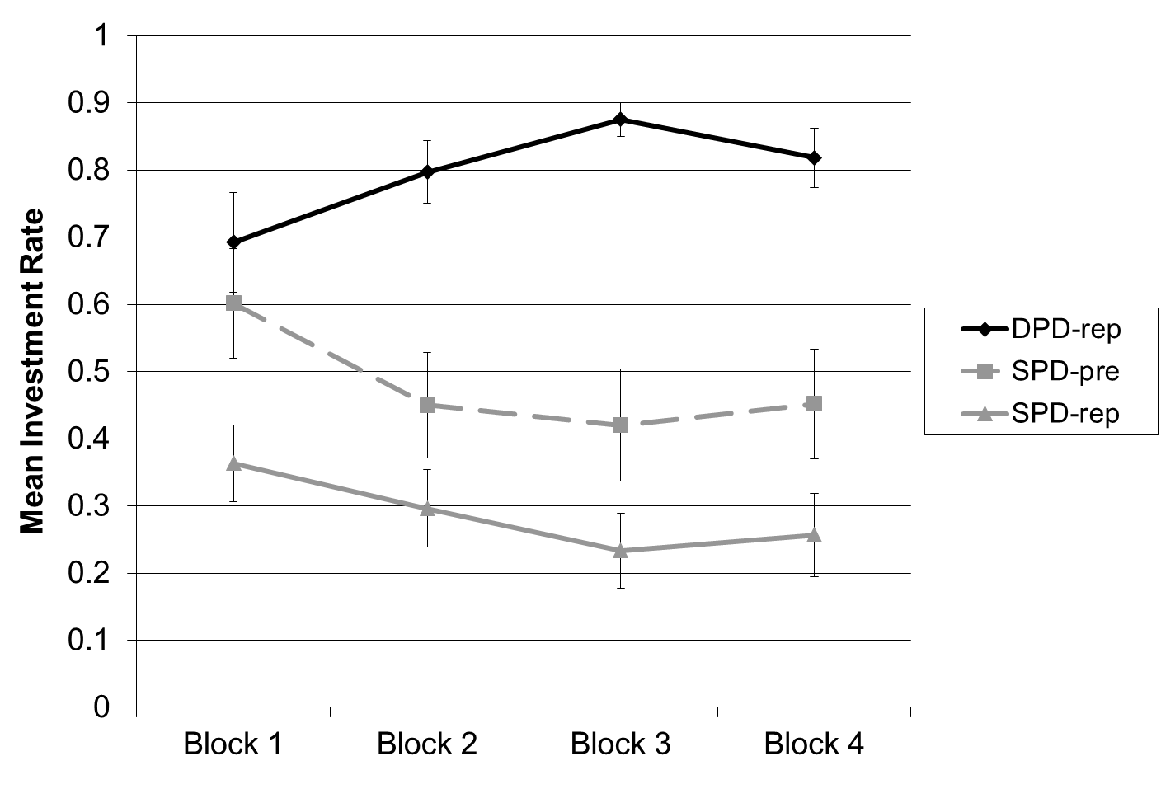
Participants were fairly engaged in writing their free responses regarding “a brief summary of why you chose to invest or not invest” at the end of the study, writing an average of 36.59 words in 2.01 sentences. These open-ended responses were coded by two independent coders, to classify whether they mentioned their counterpart or not, and whether they mentioned probability or not. The inter-rater reliability was quite high, at a correlation of r=.95 (Cohen’s Kappa = .95, SE = .03) for mentioning the counterpart and r=.91 (Cohen’s Kappa = .91, SE = .05) for mentioning probability. In the cases of disagreement between raters, we “rounded up” and coded the participant as indeed having mentioned that thing. Also, in two cases, the coders agreed that the participant’s free response was not codable, and so the coding was left blank.
As seen in Figure 2, participants were much more likely to mention their counterpart in the deterministic version of the game, but much more likely to mention probability in the stochastic versions of the game. 97% of participants mentioned their counterpart in the deterministic prisoner's dilemma (DPD-rep), compared with only 37% in the repeated, stochastic game (SPD-rep) and 28% in the precommitted stochastic game (SPD-pre). A contrast-coded logistic regression confirmed that while the proportion mentioning their counterpart in the DPD-rep was higher than in the stochastic games, B=4.09, SE=1.06, p<.001, there was not a significant difference between the two stochastic games, B=-0.42, SE=0.56, p=.46. In contrast, only 10% of those in DPD-rep mentioned probability, as compared with 70% in SPD-rep and 59% in SPD-pre. Logistic regression showed that while the proportion of DPD-rep participants mentioning probability was lower than the proportion in the other two conditions, B=-2.76, SE=0.67, p<.001, there wasn't a significant difference between the SPD-rep and SPD-pre conditions, B=-.50, SE=.55, p=.36.

Figure 2: Proportion of participants spontaneously mentioning their counterpart or probability in Study 1, in response to the post-game open-ended question after playing the repeated deterministic prisoner's dilemma (DPD-rep), repeated stochastic prisoner's dilemma (SPD-rep), or precommitted stochastic prisoner's dilemma (SPD-pre) game. Error bars represent +/- one standard error.
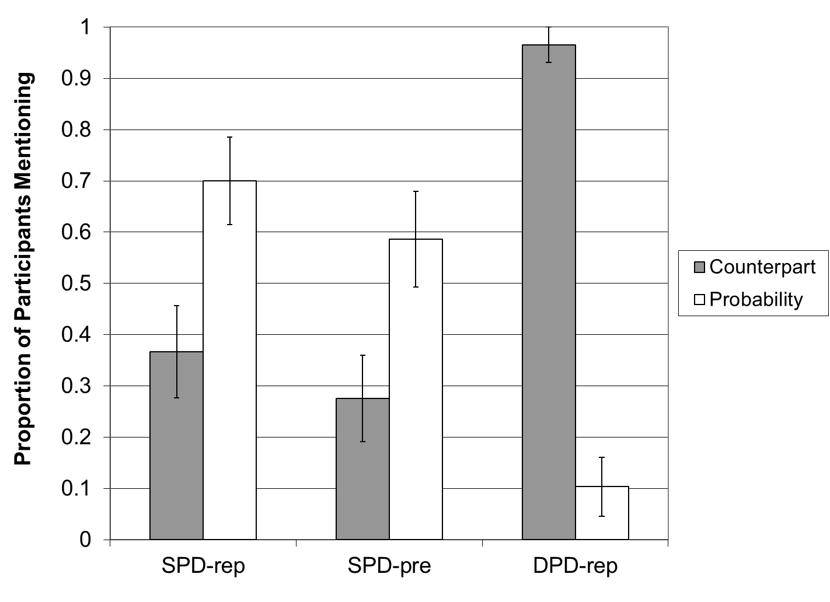
Another measure of participants’ sensitivity to the actions of their counterpart can be seen in Figure 3. Recall that every round, after participants made their own choice, they were asked to predict what their counterpart would do. As seen in Figure 3 (using each individual round as the unit of observation), there is overall a high correspondence between what participants expected their counterpart to do, and what they themselves chose. However, this correspondence varied by condition. In the DPD-rep game, there was a strong linear relationship between what people expected their counterpart to do and their investment rate. If a participant thought their counterpart would definitely invest, then they themselves were very likely to invest, and vice versa. However, participants in the stochastic games were less responsive to what they thought their counterpart would do. This pattern was confirmed through logistic regression by interactions between condition (as a categorical variable) and “partner prediction” (analyzed as a linear 1-4 variable) predicting investment. Taking the DPD-rep condition as the reference group, there were interactions with SPD-rep and partner prediction, B=-0.6, SE=0.13, p<.001, as well as SPD-pre and partner prediction, B=-1.5, SE=0.12, p<.001, confirming that the interaction seen in Figure 3 is significant. Moreover, in the DPD-rep condition, players’ predictions of their counterpart's action were highly predictive of their own action, B=2.3, SE=0.10, p<.001, r²=.61. In contrast, in the SPD-rep condition, the relationship was much weaker, though still significant, B=.831, SE=.058, p<.001, r²=.13. The SPD-pre condition fell in the middle, B=1.79, SE=.083, p<.001, r²=.31.

Figure 3: Proportion investing against loss in Study 1, depending on their prediction of their counterpart's investment choice, in the repeated deterministic prisoner's dilemma (DPD-rep), repeated stochastic prisoner's dilemma (SPD-rep), and precommitted stochastic prisoner's dilemma (SPD-pre) conditions. Error bars represent +/- one standard error.
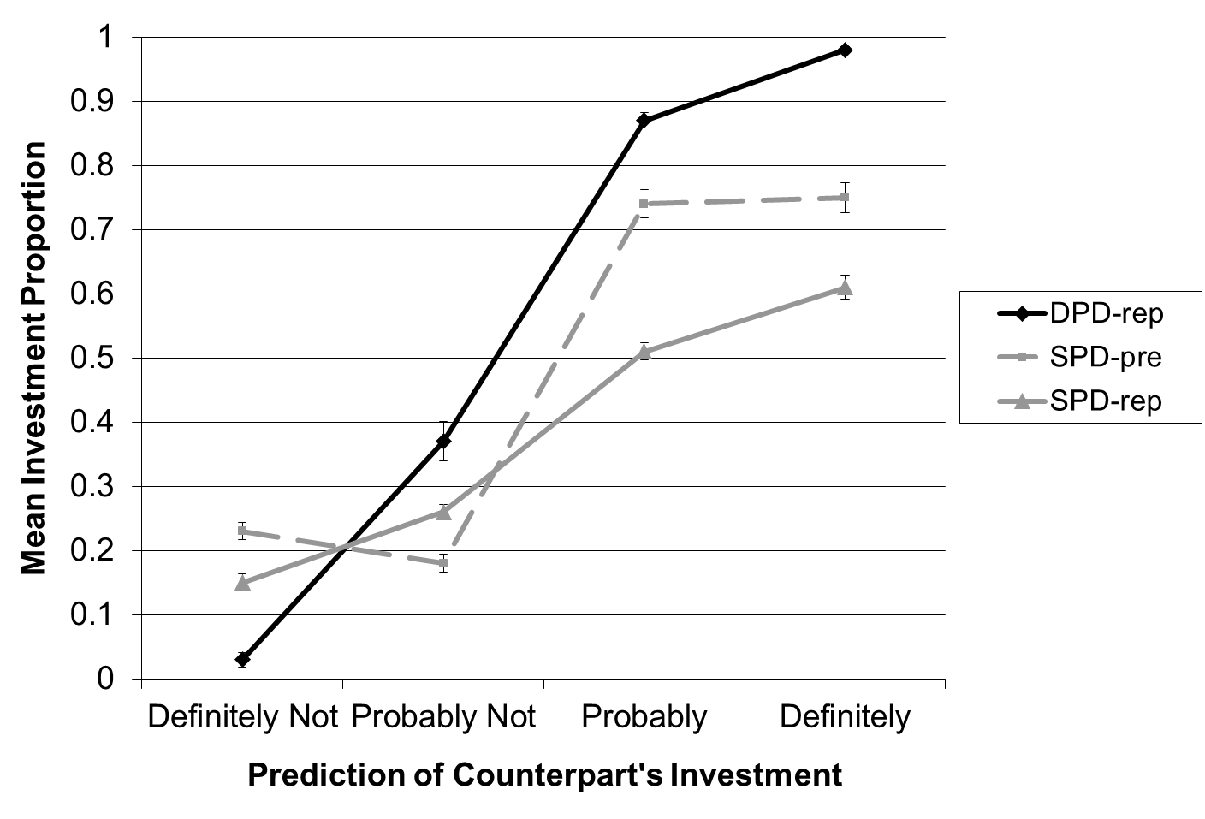
Similar evidence comes from looking at the simple correlations of each participant’s choice with that of their counterpart in the preceding round (this analysis excludes the first round, as there is no preceding round). In the DPD-rep condition, participants' choices correlated r=.64 with their counterpart's choice in the preceding round, while in the SPD-rep condition it was only r=.21 and in the SPD-pre condition it was r=-.16.
Further evidence for the diminished sensitivity to the social dilemma in the stochastic conditions can be seen in Figure 4, which shows the investment rates in each round, collapsing across blocks. The deterministic game shows the classic end-game effect, with investment rates dropping sharply in the final rounds of the block. In contrast, the stochastic games do not show any end-game effects.

Figure 4: Proportion investing against loss in each round in the repeated deterministic prisoner's dilemma (DPD-rep), repeated stochastic prisoner's dilemma (SPD-rep), and precommitted stochastic prisoner's dilemma (SPD-pre) conditions. Error bars represent +/- one standard error.
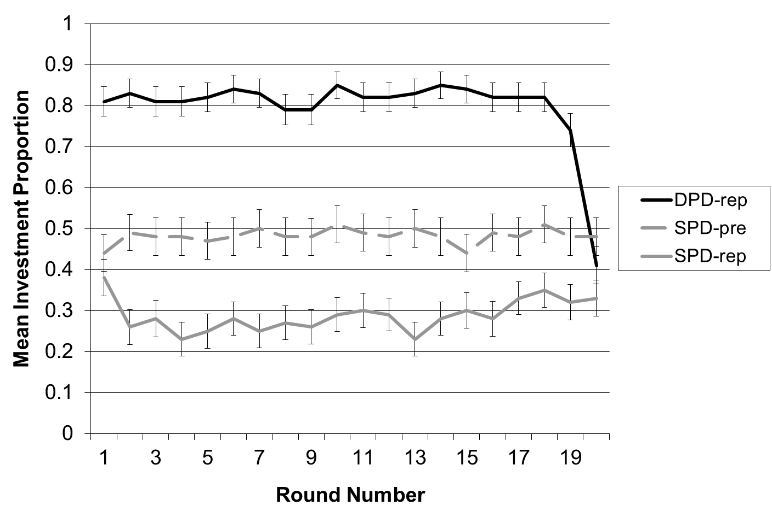
Study 1: Discussion
Cooperation rates in a repeated social dilemma are much lower when outcomes are stochastic (versus deterministic), supporting H1a. However, forcing participants to precommit their choices in the stochastic dilemma significantly reduces this gap, supporting H1b.
Several lines of evidence suggest that players in stochastic prisoner's dilemmas are not very responsive to their counterpart: players are less likely to mention their counterpart in stochastic games, their choices are less well correlated with their predictions of their counterparts' choices, their choices are less well correlated with their counterparts' previous choices, and they do not show the classic end-game drop-off normally seen in social dilemmas.
It seems, then, that players in a stochastic social dilemma are subjectively playing an outcome risk game more than a social dilemma. Indeed, the majority of their open-ended comments in the SPD conditions mentioned probability, but not their counterpart. As we know from prospect theory, people tend to be risk-seeking in the domain of losses (Kahneman & Tversky, 2013). This may explain why investment rates are low in SPDs with low probability, large magnitude losses (i.e., interdependent security games): investment entails a sure loss, while non-investment is a gamble that may enable the participants to avoid loss.
Building on previous literature on risk and the framing of multiple prospects, precommitment appears to be a successful, though modest, intervention for raising investment rates in loss-framed, stochastic social dilemmas. Presumably, those participants who play one round at a time see a 4% chance of loss as very low, and decide not to invest in protection. In contrast, those participants who must precommit their choices over a much longer time horizon may be nudged into pursuing multiple goals instead of one. In other words, they would be more likely to plan on “doing well overall” in additional to “doing well on the next round”. We explore this possibility in the following studies.
Unlike most previous literature, the games we tested had an environmental cover story. We used this to make the scenario more interesting and understandable to participants, giving it context. However, it is possible that this framing interacted with our manipulations and influenced our results. Therefore, we ran a follow-up study in which we re-tested our key manipulation -- precommitment in a stochastic prisoner’s dilemma -- using a financial frame. The results in the financial frame mirror the findings of the environmental frame, ruling out the possibility of results being specific to the cover story employed (full details on the participants, methods, and results of this study can be found in Web Appendix A).
Forcing participants to precommit their choices also limits their ability to interact with each other, raising possible confounds. For example, perhaps some participants are motivated to outperform their counterpart, and so avoid the sure loss associated with investment, but precommitment precludes dynamic comparison and so reduces this tendency, leading to higher investment rates. Furthermore, as mentioned in the introduction, blocking the immediate feedback of the counterpart’s actions may reduce the cooperation rates (Faillo et al., 2013). To rule out these possible confounds and to test the hypothesis that precommitment influences responses to outcome risk per se, we ran Study 2 in which participants played a stochastic solo game rather than engage in a social dilemma, but otherwise employing the same experimental procedure and payoff structure as Study 1. As before, choices were repeated or precommitted, and we hypothesized that investment rates would be higher in the precommitment condition, even without a counterpart.
Study 2: Participants and Design Overview
60 participants were recruited from the same pool as Study 1 and had similar demographics. Participants played a solo stochastic game in which they had the option each round to invest in protection against the large loss (see the payoff structure in Table 4). Because there was no counterpart and no dilemma, investment had a higher expected value and should have always been chosen by rational, risk-neutral individuals.
Table 4: Solo payoff matrix used in Study 2 for the solo conditions (Solo-rep and Solo-pre).
You | INVEST | - You definitely lose 1,400 Rp, and have a 0% chance of the large loss occurring.
You | NOT INVEST | - You have a 4% chance of losing 40,000 Rp and a 96% chance of losing 0 Rp.

Participants were randomly assigned to either a repeated choice (Solo-rep) or precommitted choice (Solo-pre) condition. (We did not run a solo version of the DPD game for the obvious reason that this would have entailed asking participants to simply choose between losing more or less money. It is safe to assume that participants would overwhelmingly prefer losing less money, which would lead to investment rates in a DPD solo game close to 100%, regardless of whether participants precommitted or not.)

Study 2: Methods
The procedure was the same as previous studies except that participants did not interact with a counterpart. Thus, the instructions, payoff matrix, quiz, choices, and feedback were rewritten so as to only require one player. As before, all participants knew in advance that they would play 4 blocks of 20 rounds.
The revised payoff matrix (see Table 4) essentially asked participants to choose between the upper-left (Invest/Invest) cell or the lower right (Not-Invest/Not-Invest) cells from the SPD games in the previous studies.
As in previous studies, participants in the repeated (Solo-rep) condition made choices and got feedback one round at a time, while those in the precommitted (Solo-pre) condition made twenty choices at a time and then received identical feedback after each block of 20 rounds.

Study 2: Results
In this solo, stochastic losses game, precommitment substantially increased investment by participants, from 32% to 61%, as seen by comparing the Solo-Rep and Solo-Pre lines in Figure 5. Thus, twice as many participants invested in protection when precommitting. This was confirmed with a logistic mixed model, predicting investment choices with fixed effects of condition, block number, and their interaction, plus a random effect of participant ID. This revealed a significant effect of condition, B=1.78, SE=0.54, p=.001, OR=3.27, supporting H2. In addition, an effect of block number and a block by condition interaction (both p<.02 or lower) reflected the fact that investment rates trended down in the Solo-rep condition, but held relatively constant in the Solo-pre condition.
As an exploratory analysis, we compared the Study 2 (solo game) results with the Study 1 (stochastic social dilemma) results by combining the datasets, as seen in Figure 5. We employed a logistic mixed model predicting investment choices, using fixed effects of game type (comparing SPD vs solo), choice type (repeated vs precommitted), block number (continuous), and their interactions, plus a random effect of participant ID. (We did not include a random effect of partner ID, because participants in the solo condition did not have a partner.) This revealed a significant effect of choice type (repeated vs precommitted), B=1.42, SE=0.69, p=.04, OR=2.07. In addition, a 2-way interaction of block number with game type, B=0.51, SE=0.07, p<.001, OR=6.96, a 2-way interaction of block number and choice type, B=0.17, SE=0.07, p=.001, OR=2.64, and a 3-way interaction of block number, choice type, and game type, B=0.33, SE=0.10, p<.001, OR=3.38, reflect the time trends seen in Figure 5: in the first block, precommitment had the same impact in the SPD game and Solo game, but over time the Solo-pre condition remain relatively constant while the other three conditions all trended downward.
Figure 5: Mean investment proportions in the repeated solo (Solo-rep) and precommitted solo (Solo-pre) games in Study 2, as compared with the stochastic prisoner's dilemma (SPD-rep and SPD-pre) data from Study 1. Error bars represent +/- one standard error.
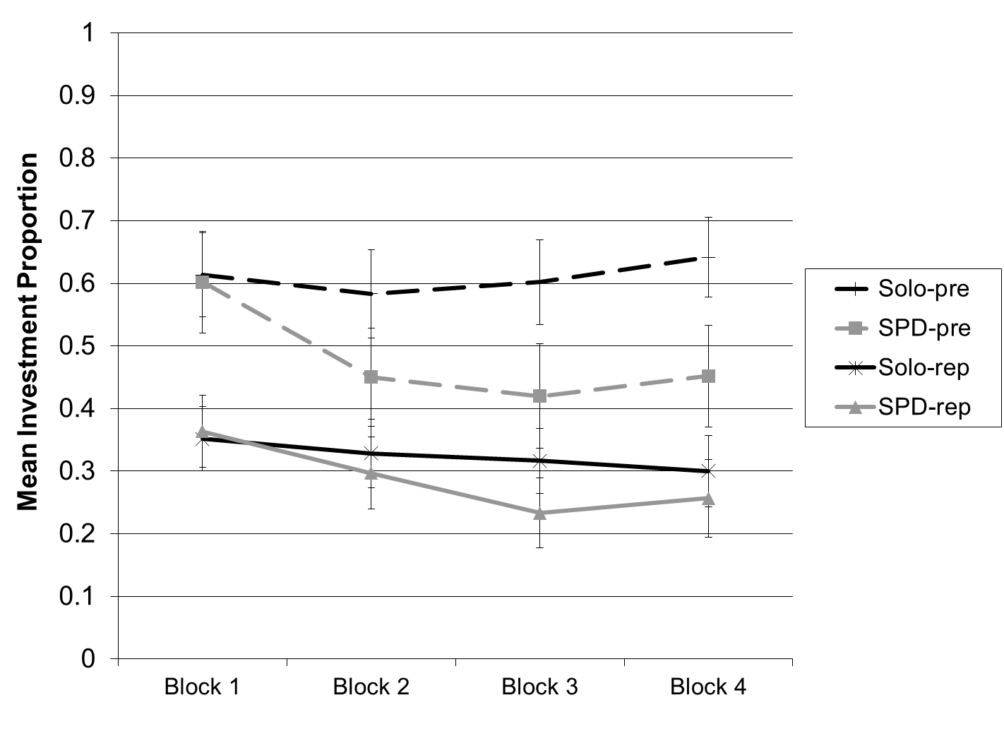
To further explore the “multiple goals” explanation for the effectiveness of precommitment, we had two independent coders code whether or not each participant mentioned low probability of loss (coding data from both the SPD conditions in Study 1 and the solo conditions in Study 2). Recall that we hypothesized that precommitment would nudge the participants to recruit a more holistic view with a focus on a good performance overall (i.e., across all rounds of the game) -- therefore, we expected that participants in precommitted conditions would be less likely to mention low probability of loss. The correlation between coders was moderate, at r=.83 (Cohen’s Kappa = .83, SE = .05). As before, when there was disagreement, we “rounded up” and considered that participant as having indeed mentioned that thing.
As shown in Figure 6, participants in the precommitted conditions were less likely to mention low probability of loss, as confirmed by a chi-square test of independence, x² (n=118)=7.66, p<.01. Rather, participants in the precommitted condition were more likely to mention the cumulative chance of loss, weighed against the aggregate costs of investment. As one participant wrote, “4% chance means a loss will happen approx 1 out of 20 years. Investment means a loss of 1,400*20 (28k) while a expected loss of 40,000 results from no investment.”
Figure 6: Mean proportion of participants mentioning "low" probability of loss in each condition, collapsing and comparing data from Studies 1 and 2. Error bars represent +/- one standard error.
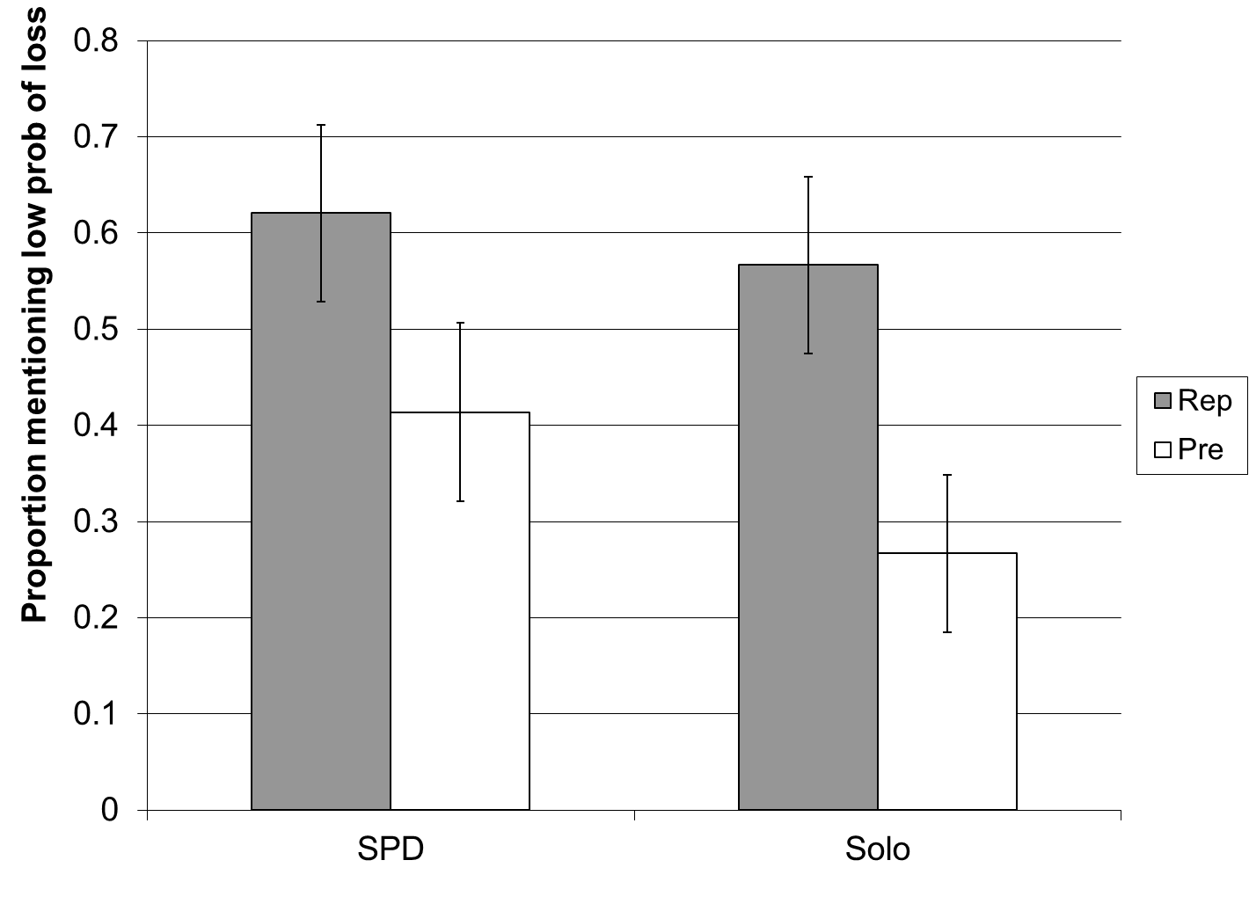
Study 2: Discussion
In this solo stochastic loss game, forcing participants to precommit their choices increased their investment rates, even when there was no counterpart to interact with or consider. Therefore, it is likely that the precommitment intervention seen in Study 1 also acted on participants’ weighting of the risky large loss. It is worth restating that both the repeated and precommitted participants in this solo game knew they would play 4 blocks of 20 rounds each -- the only difference was whether participants were forced to precommit their choices or not. Rationally, there should be no difference between the two solo conditions.
Further supporting the hypothesis that precommitment influences participants’ focus on single vs. multiple goals, we observed that those in the precommitment were considering multiple rounds and therefore, much less likely to mention a low probability of loss (which would only be the case if one considers “one” round). We believe that participants playing the repeated game typically considered each decision as a single choice between a certain loss (from investment) or a risk with the possibility of zero loss, and therefore showed risk-seeking behavior to avoid the loss, consistent with Prospect Theory. In contrast, we believe the precommitting participants often considered multiple rounds together as a “broad bracket” (Read, Loewenstein, & Rabin, 1999), leading them to consider the cumulative risk of large loss, cumulative investment costs, cumulative income earnings, and their net cumulative payout, thus 1) focusing them more on expected value, which leads to investment in this context, and 2) putting their mindset into the domain of gains, triggering risk averse preferences. This is consistent with earlier work on the framing of prospects (Redelmeier & Tversky, 1992): the same person might make different decisions when making the same choice one by one (twenty times in a row) or twenty times all at once.
Next, we ran Study 3 to explore the effects of precommitment in a deterministic social dilemma condition. Because binding precommitment precludes the chance for participants to dynamically interact with their counterpart, we hypothesized that it would reduce cooperation rates by transforming the repeated game into a one-shot game. With no tit-for-tat incentives, participants would cooperate less often (similar to the end game rounds of a repeated game).

Study 3: Participants and Design Overview
30 participants were recruited from the same pool as Study 1 and had similar demographics. Only one condition was run: a deterministic prisoner's dilemma game with precommitted choices (DPD-pre). The results of this condition would then be compared with the existing DPD-rep results from Study 1. (This seemed like a more efficient use of time and resources than running yet another standard prisoner’s dilemma.)

Study 3: Methods
The procedure was identical to the DPD-rep condition in Study 1, except that participants precommitted their choices. Thus, there was only one condition and we compared the results with the DPD-rep results from Study 1.

Study 3: Results
As seen in Figure 7, investment rates in the precommitted, deterministic prisoner’s dilemma (DPD-pre) started out high (at 63%) but dropped rapidly over the four trial blocks (to 29%). Thus, while investment rates in the first block were equivalent to the DPD-rep data from Study 1, they diverged over time. A logistic mixed model, predicting cooperation choices using fixed effects of condition (repeated vs precommitted), block number (mean centered), and their interaction, plus random effects of participant ID and partner ID. This confirmed a main effect of precommitment, B=2.76, SE=0.60, p<.001, OR=4.60, supporting H3. In addition, a significant effect of block number, B=0.31, SE=0.06, p<.001, OR=5.21, reflected the fact that cooperation rates trended down over time overall. This was qualified by a block by condition interaction, B=1.10, SE=0.08, p<.001, OR=13.20, reflecting the trend that the repeated and precommitted conditions started out very close in block 1 and then diverged over time as the precommitted condition trended sharply downward.
Figure 7: Mean investment proportion in the precommitted deterministic prisoner's dilemma (DPD-pre) condition in Study 3, as compared with the repeated deterministic prisoner's dilemma (DPD-rep) data from Study 1.
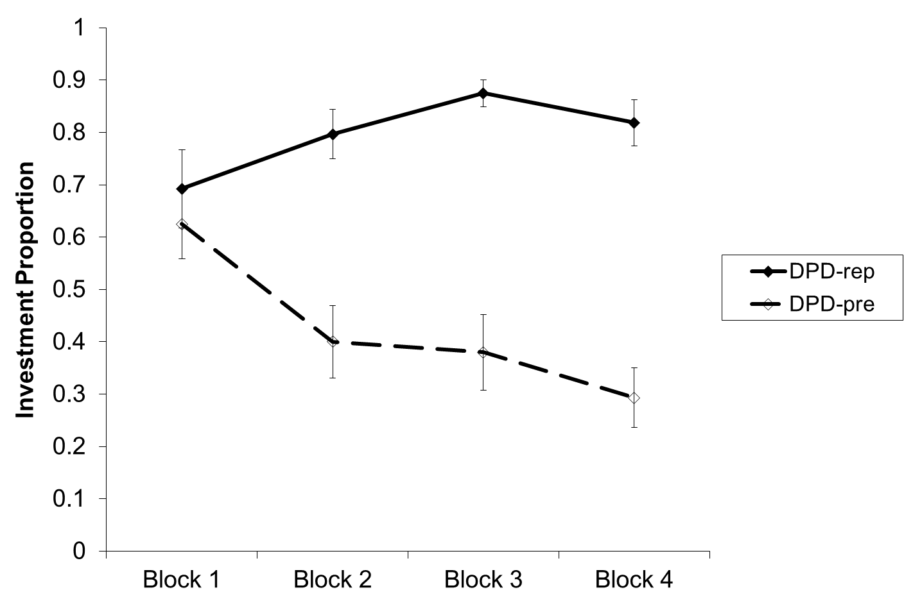
Study 3: Discussion
Strikingly, precommitment initially has almost no effect on investment/cooperation in a deterministic prisoner’s dilemma, but with repeated plays it rapidly decreases investment. Why does this happen? One possibility is learning effects. While all participants are tested on the rules of the game, and they initially “play nice” 60%-70% of the time, they do not know how their counterparts will behave. Subsequently, those in the repeated condition learn that their choices influence their counterpart (with “tit for tat” variations being a common strategies), leading to increasing cooperation over time. In contrast, those in the precommitted condition soon experience another player “taking advantage of them” without repercussions, leading to decreasing cooperation across blocks.
These results may help explain why precommitment is more effective in stochastic solo games (Study 2) than in stochastic social dilemmas (Studies 1 and A): on the one hand, precommitment under extends individuals’ time-horizon and nudges them to set more holistic goals, thereby increasing investment in protection against stochastic risks. However, when precommitting in a social dilemma, this is tempered by the knowledge that one's counterpart may defect without repercussions. Specifically, in a stochastic prisoner’s dilemma, the temptation to defect becomes a variable that is determined by an element of chance and with the specific outcome at each round of interaction rather than a fixed payoff. This randomness changes the strategic landscape of the dilemma. Players now need to make choices based on their beliefs about future interactions and probability distribution of payoffs. This uncertainty also changes how players think about their risk of exploiting others in the dilemma. On balance, participants are more sensitive to probabilities than to their counterparts. Therefore, precommitment in SPDs has a positive, though modest, effect.
Another major contribution of Study 3 is illuminating the sharply diverging impacts of precommitment in SPD vs DPD settings. As can be seen in Figure 8 (which combines and compares data from Study 1 and Study 3), in the deterministic setting investment rates are lower when players must precommit. Conversely, as we observed in Study 1, precommitment increases investment in stochastic social dilemmas. Combining the data across studies and running a logistic mixed model with fixed effects for game type, choice type, and their interaction, plus random effects of participant ID and partner ID, we found that the focal 2x2 interaction between the game type (DPD vs. SPD) and choice type (Precommitted vs. Repeated) observed in Figure 8 is significant B=4.65, SE=1.09, p<.001, OR=4.27. This interaction illustrates the opposing forces: in stochastic settings, investment rates may benefit from precommitment through broadening participants decision horizons and increasing the importance placed on avoiding cumulative long-term risks; but in deterministic settings, investment rates suffer from precommitment, in that each party will eventually learn that they will be defected on without any repercussions. Another factor may be that a defection in the DPD is a clearly selfish choice, while a defection in the SPD may either reflect selfishness or a risk-seeking preference, thereby diluting both the positive influence of “tit for tat” strategies in the repeated conditions, and the negative influence of restricted interactions in the precommitted conditions.

Figure 8: Mean investment proportion in the Deterministic Prisoner's Dilemma (DPD) vs. Stochastic Prisoner's Dilemma (SPD) and Repeated vs. Precommitted choices, comparing data across Study 1 and Study 3. When the outcomes are stochastic, precommitment results in higher investment rates, but when the outcomes are deterministic, the opposite is true. Error bars indicate +/- one standard error.

Finally, in Study 4 we explored the effects of non-binding precommitment, both for the practical value (many real-life commitments are non-binding), and also as a way to combine increased time horizons while also allowing interactions between participants. As laid out in the introduction, the conflicting forces at play meant that we did not have a strong hypothesis prior to conducting the study; we ran it using an exploratory approach.

Study 4
The primary goal of Study 4 was to compare the effects of binding versus non-binding precommitment in the SPD setting. A second goal was to examine the replicability of the binding precommitment effect previously observed in Study 1, while using a different population, 11 years later, and with a larger sample size.
Study 4: Design overview
In a between-subjects design, participants played one of three versions of the SPD game. Participants were randomly assigned to either an SPD with repeated choices, an SPD with binding precommitted choices, or an SPD with non-binding precommitted choices. As we elaborate later in the methods section, the difference between binding and non-binding precommitment conditions was that in the latter, participants could change their choices each round, even after precommitting them. Participants played 3 blocks of 20 rounds each. (In this study, we used 3 blocks rather than 4 for brevity, to be sure the study would finish within a 30-minute timeslot.) As in previous studies: participants were tested for knowledge before they could proceed, counterparts for each block were anonymous, participants were randomly assigned a counterpart for each block (with replacement), and using an incentive-compatible design, one block was randomly selected and paid out for real money at the end of the study.
Study 4: Methods
160 participants (70% female, M_{age} = 22.8, SD = 5.31) were recruited for a study on Interdependent Security Games. Participants were students and employees at a different North American University. As in previous studies, participants learned that they would earn 8,500 Rp per round, and face the chance of suffering a large loss each round according to the payoff matrix is shown in Table 5. (The numbers and probabilities are the same as previous studies but the wording is slightly different.)
Table 5. Payoff matrix shown to participants in Study 4.
 |  | Your Counterpart
 |  | INVEST | NOT INVEST
You | INVEST | - You definitely lose 1,400 Rp, and have a 0% chance of the large loss occurring.  - Your counterpart definitely loses 1,400 Rp, and has a 0% chance of the large loss occurring. | - You definitely lose 1,400 Rp and have a 1% chance of losing an additional 40,000 Rp.  - Your counterpart has a 3% chance of losing 40,000 Rp and a 97% chance of losing 0 Rp.
You | NOT INVEST | - You have a 3% chance of losing 40,000 Rp and a 97% chance of losing 0 Rp.  - Your counterpart definitely loses 1,400 Rp and has a 1% chance of losing an additional 40,000 Rp. | - You have a 4% chance of losing 40,000 Rp and a 96% chance of losing 0 Rp.  - Your counterpart has a 4% chance of losing 40,000 Rp and a 96% chance of losing 0 Rp.

Participants in the repeated-choice SPD condition and those in the binding precommitment SPD condition followed an identical procedures to those in the SPD-rep and SPD-pre conditions in Study 1. Participants in the non-binding precommitment condition first made choices for all 20 rounds in a block, using the same interface as was used in the binding precommitment decision. They then got feedback for the first round, which included the same feedback seen in the other conditions: their choice, the choice of their counterpart, the randomly generated number, and the end result. Participants then saw a screen showing their past choice (grayed out) and their choices for the upcoming 19 rounds filled in according to their prior selections, and they had the opportunity to advance to the next round or to change any of their future choices and then advance to the next round. This process continued until they finished all 20 rounds, at which time they saw a summary of the results of all 20 rounds, as in the other conditions. In other words, the content of the feedback information was the same across all conditions; only the timing of feedback delivery changed across conditions.
After the end-of-block summary of the 20 rounds, all participants were again randomly paired with a counterpart (with replacement) and played another block. After completing all 3 blocks, one block was randomly selected, and each participant was paid according to the choices and outcomes in that block.
Study 4: Results
As seen in Figure 9, binding precommitment increased investment rates (i.e., safer, more cooperative choices) in this SPD, replicating the results seen in Study 1. However, non-binding precommitment did not increase investment rates. We predicted investment rates using a logistic mixed model with fixed effects of condition (SPD-Rep, SPD-Pre-Bind, and SPD-Pre-Nonbind, with SPD-Rep as the reference condition), block number (mean centered), and their interactions, plus random effects for participant ID and partner ID. This confirmed that binding precommitment SPD condition significantly increased investment as compared to the repeated-choice SPD condition, B=1.42, SE=0.48, p=.002, OR=3.00, but the non-binding precommitment condition did not, B=0.38, SE=0.47, p=.41, OR=0.81. Furthermore, a significant effect of block number, B=0.21, SE=0.06, p<.001, OR=3.43, reflected the fact that investment rates trended down over time, and an interaction of the binding precommitment condition with block number, B=0.21, SE=0.09, p=.02, OR=2.39, indicated that this condition trended down more sharply, as seen in Figure 9.
Figure 9. Proportion of investments (i.e., safe, cooperatives choices) in the stochastic social dilemma in Study 4 as a function of whether choices were repeated (SPD-Rep), binding precommitted (SPD-Pre-Bind), or non-binding precommitted (SPD-Pre-Nonbind). Error bars show +/- one standard error.

To further probe the differences between binding and non-binding precondition, we plotted the round by round estimated probabilities in each condition (from the logistic mixed model), shown in Figure 10. As seen there, the probability of investment was identical between the binding and non-binding precommitment conditions in round 1, but diverged sharply in round 2. It is also notable that none of these SPD conditions showed an end-of-game effect in round 20, replicating the pattern seen in Study 1.
Figure 10. Estimated probability of investments (i.e., safe, cooperatives choices) in the stochastic social dilemmas in Study 4 in each of the 20 rounds (collapsing across blocks).
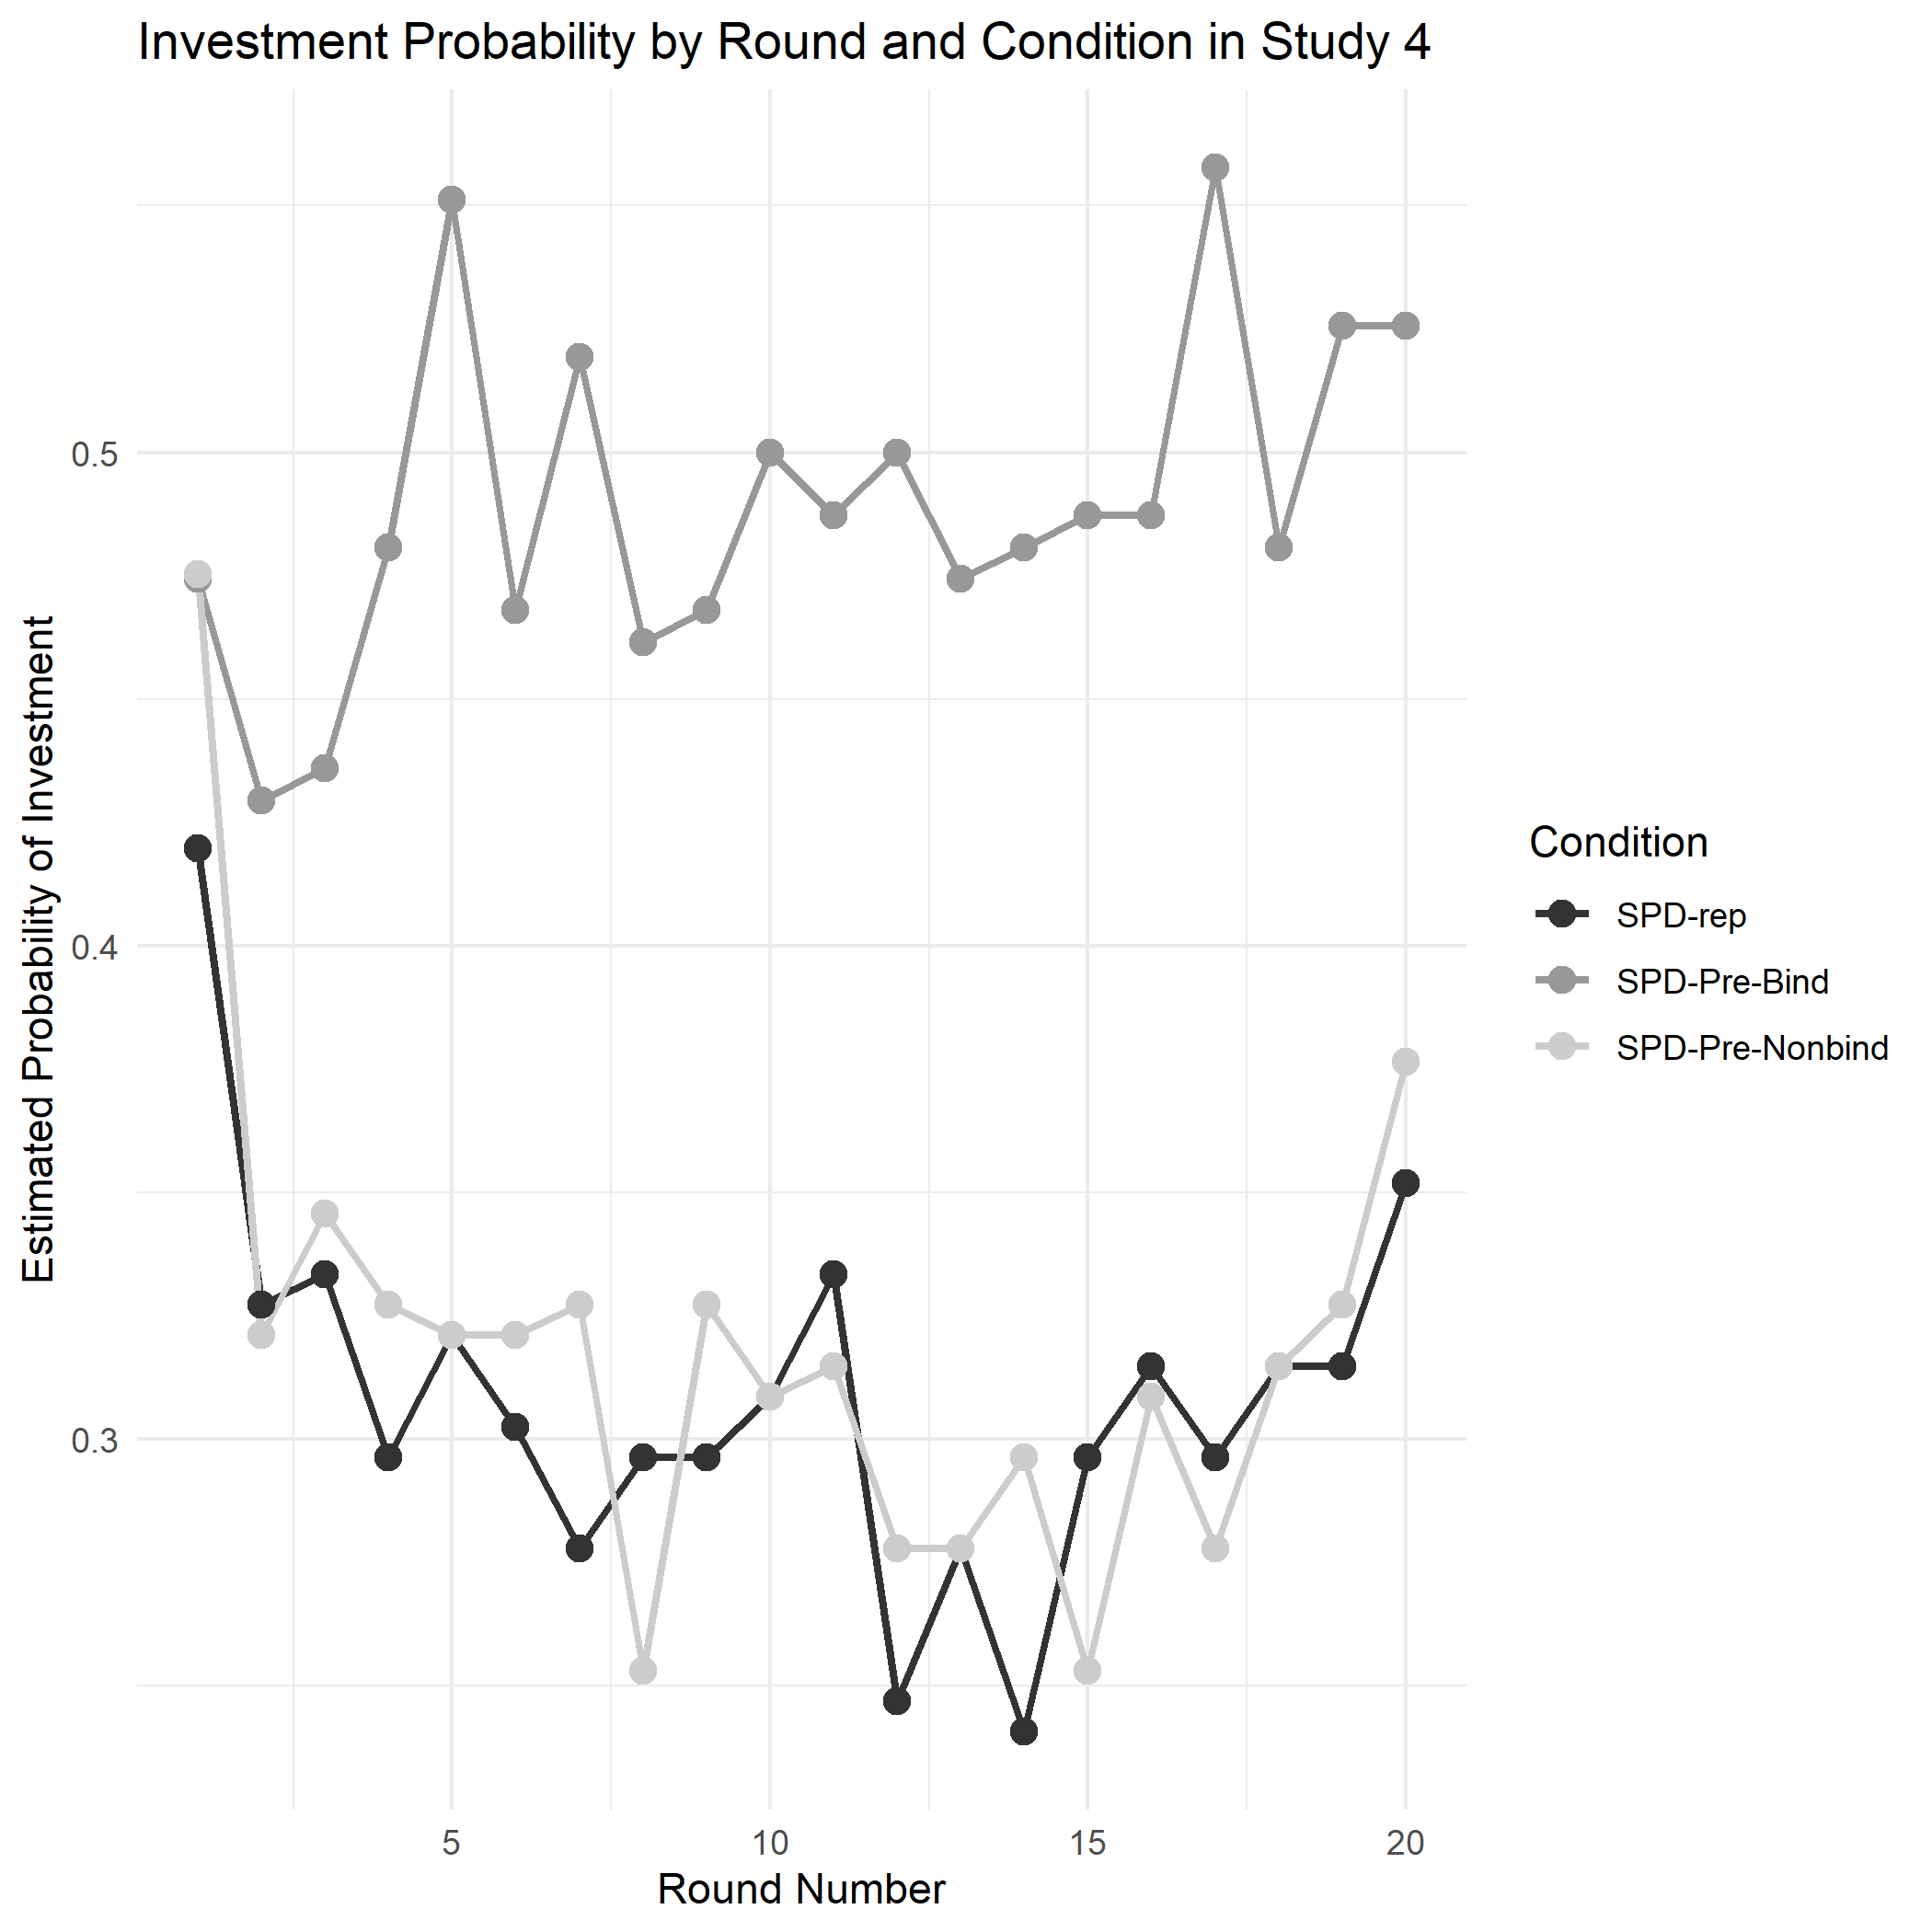
Study 4: Discussion
As in previous SPD studies, the overall investment proportion in safer, cooperative behavior was low, around 30-35%. Binding precommitment increased this investment proportion, but non-binding pre-commitment had basically no effect. The reason for the difference between binding and non-binding precommitment in this study is unclear, but certainly relates to the dynamics of playing with a counterpart. One possibility is that cooperation in safety is fragile in this situation, and if one person sees that the other is not paying for safety, then they are not likely to pay for safety either. This dynamic can only emerge in non-binding precommitment; in binding precommitment there is not opportunity to react to one’s counterpart, until the next block of choices, when one is randomly paired with a (potentially new) counterpart again. An empirical investigation of the process driving the difference vs non-binding precommitment in social dilemmas remains a topic for future research.

General Discussion
Adding risk to the outcomes in social dilemmas dramatically changes the behavior of those involved. In both the present research and previous studies of interdependent security (Gong et al., 2009; Kunreuther et al., 2009), individuals cooperated at much lower rates when facing low probability, high magnitude losses than they did in a typical (deterministic) prisoner's dilemma. A number of factors showed that participants in stochastic dilemmas (versus deterministic dilemmas) pay much more attention to probabilities than to their counterparts, perhaps because they view the game as one of chance, and participants are risk-seeking to avoid the sure loss associated with investing in security.
We tested binding precommitment as an intervention and found that it increased rates of investment in protection against low probability, high-magnitude risk in a social dilemma context. Why does this happen? Through triangulation across methods and studies, we learned that binding precommitment is effective in these stochastic dilemmas because it 1) shifts focus toward avoiding the large probabilistic loss across multiple rounds and 2) it reduces negative focus on – and negative interactions with – counterparts. For example, a home-owner might make different choices if buying a fire-protection policy monthly, annually, or a multi-year contract. The chance of a fire happening next month is likely to be viewed as small so the homeowner may not invest in protection voluntarily. Furthermore, seeing neighbors without visible fire protection measures may dissuade the homeowner, leading them to cancel their costly protection policy after a few months. However, when considering an annual or multi-year policy, the homeowners’ time-horizon is extended, a focus on multiple years of fire risk is activated, focus on neighbors’ actions is reduced, and the same person might invest in extended protection or choose a more expensive policy. If the fire protection policy were tied to a mortgage, the homeowner might be even more interested in since the commitment period would normally be 30 years.
We found that the effects of uncertainty and precommitment in social dilemmas were reliable across both environmental and financially framed scenarios. However, future studies with different scenarios (that don't necessarily involve financial payouts) might yet find domain differences. Lotz (2015) found that people cooperate more when primed with intuitive thinking (i.e., System 1) rather than reflective thinking (i.e., System 2) so a promising future direction would be to investigate whether precommitment has an impact on the type of thinking in which individuals engage when deciding whether to invest in protective measures.
A caveat to using precommitment as an intervention in social dilemmas is that it seems to only increase investment when the commitments are binding, such as would be the case for a contract or long-term service agreement. Another major caveat that precommitment eventually lowers investment rates in social dilemmas with deterministic outcomes. Therefore, the application of precommitment as a device to increase cooperation in real-world social dilemmas should be combined in realistic probabilities of losses over the relevant time horizon.
This research makes the following contributions: 1) proposing and testing precommitment as a novel intervention in the context of social dilemmas, and finding that binding precommitment increases cooperation rates stochastic prisoners dilemmas, 2) demonstrating opposite effects of precommitment in stochastic versus deterministic prisoners dilemmas, 3) exploring the psychological mechanisms (effects of probability considerations and partner considerations) driving precommitted versus non-precommitted decisions, and 4) finding that non-binding precommitment has little effect in stochastic dilemmas.

Constraints on Generality
The findings reported in this paper are based on samples of mostly students and staff members at two different universities in North America. Given the diversity of the sample pool we recruited in terms of gender, ethnicity, and political orientation as well as incentive compatibility of the experimental approach, we believe that our findings would generalize to similar populations. Two major constraints on generality are as follows: First, since most of our participants were university students, we do not have evidence for generalizability of our findings to lower or higher age ranges. Second, we cannot speak to generality of our findings to non-WEIRD populations (Henrich et al., 2010). In particular, people in interdependent cultures, with different levels of education, and/or with different levels of income, might take different approaches stochastic social dilemmas, influencing investment rates accordingly. However, as of yet, we have no reason to suspect that the effects of precommitment on investment rates would play out differently across different populations. This could be explored in future research.
Another shortcoming is that the present research only used variations on one basic payoff matrix, so the robustness of the results is unknown. How would the effect of precommitment change if investment didn't completely eliminate uncertainty? Or if the probabilities and associated large losses were less extreme, or gain framed? Or if there were two equilibria, making the game a case of coordination rather than dilemma? Future research should examine these questions.
More broadly, future research on social dilemmas should do more to incorporate and explore risk and uncertainty. Real-world social dilemmas of interest, such as pandemics and climate change, involve large risks and also uncertainties in outcomes, where precise risk levels are often unknown. By including these risks and uncertainties in our theoretical empirical models, we can hope to more effectively address the tragedy of the commons.

References
Arora, P., Peterson, N. D., Krantz, D. H., Hardisty, D. J., & Reddy, K. S. (2012). To cooperate or not to cooperate: Using new methodologies and frameworks to understand how affiliation influences cooperation in the present and future. Journal of Economic Psychology, 33(4), 842-853.
Axelrod, R. (1980). Effective choice in the prisoner’s dilemma. Journal of Conflict Resolution, 24(1), 3–25.
Axelrod, R., & Hamilton, W. D. (1981). The Evolution of Cooperation. Science, 211(4489), 1390–1396. DOI: 10.1126/science.7466396
Bolton, G., Greiner, B., & Ockenfels, A. (2018). Dispute resolution or escalation? The strategic gaming of feedback withdrawal options in online markets. Management Science, 64(9), 4009–4031.
Botelho, A., Dinar, A., Pinto, L. M. C., & Rapoport, A. (2014). Time and uncertainty in resource dilemmas: Equilibrium solutions and experimental results. Experimental Economics, 17(4), 649–672.
Brewer, M. B., & Kramer, R. M. (1986). Choice behavior in social dilemmas: Effects of social identity, group size, and decision framing. Journal of Personality and Social Psychology, 50(3), 543–549.
Budescu, D. V, Rapoport, A., & Suleiman, R. (1990). Resource dilemmas with environmental uncertainty and asymmetric players. European Journal of Social Psychology, 20(6), 475–487.
Chaudhry, S. J., Hand, M., & Kunreuther, H. (2018). Extending the time horizon: Elevating concern for rare events by communicating losses over a longer period of time. In Working paper# 2018-06. Risk Management and Decision Processes Center Philadelphia, PA.
Chen, X.-P. (1996). The group-based binding pledge as a solution to public goods problems. Organizational Behavior and Human Decision Processes, 66(2), 192–202.
Chen, X.-P., & Komorita, S. S. (1994). The effects of communication and commitment in a public goods social dilemma. Organizational Behavior and Human Decision Processes, 60(3), 367–386.
Dawes, R. M., McTavish, J., & Shaklee, H. (1977). Behavior, communication, and assumptions about other people's behavior in a commons dilemma situation. Journal of Personality and Social Psychology, 35(1), 1–11.
De Kwaadsteniet, E. W., van Dijk, E., Wit, A., & de Cremer, D. (2006). Social dilemmas as strong versus weak situations: Social value orientations and tacit coordination under resource size uncertainty. Journal of Experimental Social Psychology, 42(4), 509–516.
Faillo, M., Grieco, D., & Zarri, L. (2013). Legitimate punishment, feedback, and the enforcement of cooperation. Games and Economic Behavior, 77(1), 271–283.
Fehr, E., & Gächter, S. (2000). "Cooperation and punishment in public goods experiments." American Economic Review 90.4: 980-994.
Fleishman, J. A. (1988). The effects of decision framing and others’ behavior on cooperation in a social dilemma. Journal of Conflict Resolution, 32, 162–180.
Furlong, E. E., & Opfer, J. E. (2009). Cognitive constraints on how economic rewards affect cooperation. Psychological Science, 20(1), 11–16.
Gaudeul, A., Crosetto, P., & Riener, G. (2015). Of the stability of partnerships when individuals have outside options, or why allowing exit is inefficient. Jena Economic Research Papers, 1.
Gong, M., Baron, J., & Kunreuther, H. (2009). Group cooperation under uncertainty. Journal of Risk and Uncertainty, 39(3), 251.
Gustafsson, M., Biel, A., & Gärling, T. (1999). Overharvesting of resources of unknown size. Acta Psychologica, 103(1–2), 47–64.
Heal, G., & Kunreuther, H. (2005). IDS models of airline security. Journal of Conflict Resolution, 49(2), 201–217.
Henrich, J., Heine, S. J., & Norenzayan, A. (2010). The weirdest people in the world? Behavioral and Brain Sciences, 33(2–3), 61–83. https://doi.org/10.1017/S0140525X0999152X
Kahneman, D., & Tversky, A. (2013). Prospect theory: An analysis of decision under risk. In Handbook of the fundamentals of financial decision making: Part I (pp. 99–127). World Scientific.
Kerr, N. L. (1983). Motivation losses in small groups: A social dilemma analysis. Journal of Personality and Social Psychology, 45, 819–828.
Kerr, N. L., & Kaufman-Gilliland, C. M. (1994). Communication, commitment, and cooperation in social dilemma. Journal of Personality and Social Psychology, 66(3), 513.
Köke, S., Lange, A., & Nicklisch, A. (2015). Adversity is a school of wisdom: experimental evidence on cooperative protection against stochastic losses. WiSo-Forschungslabor Working Paper Series.
Kunreuther, H., & Heal, G. (2005). Interdependencies within an organization. In B. Hutter & M. Power (Eds.), Organizational Encounters with Risk (pp. 190–208). Cambridge University Press. https://doi.org/DOI: 10.1017/CBO9780511488580.008
Kunreuther, H., Silvasi, G., Bradlow, E., & Small, D. (2009). Bayesian analysis of deterministic and stochastic prisoner’s dilemma games. Judgment and Decision Making, 4(5), 363.
Kurzban, R., McCabe, K., Smith, V. L., Wilson, B. J. (2001). Incremental commitment and reciprocity in a real-time public goods game. Personality and Social Psychology Bulletin, 27, 1162–1673.
Lotz, S. (2015). Spontaneous giving under structural inequality: Intuition promotes cooperation in asymmetric social dilemmas. PLoS One, 10(7), e0131562.
MacKay, D. J. C., Cramton, P., Ockenfels, A., & Stoft, S. (2015). Price carbon—I will if you will. Nature, 526(7573), 315–316.
Messick, D. M., Allison, S. T., Samuelson, C. D. (1988). Framing and communication effects on group members’ responses to environmental and social uncertainty. In S. Maital (ed.), Applied Behavioural Economics (Vol. 2, pp. 677–700). Brighton, UK: Wheatsheaf.
Messick, D. M., & Brewer, M. B. (2005). Solving social dilemmas: a review. In M. H. Bazerman (Ed.), Negotiation, Decision Making and Conflict Management, Vol. 1–3 (pp. 98–131). Edward Elgar Publishing.
Read, D., Loewenstein, G., & Rabin, M. (1999). Choice Bracketing. Journal of Risk and Uncertainty, 19(1), 171–197. https://doi.org/10.1023/A:1007879411489
Redelmeier, D. A., & Tversky, A. (1992). On the framing of multiple prospects. Psychological Science, 3(3), 191–193.
Roch, S. G., & Samuelson, C. D. (1997). Effects of environmental uncertainty and social value orientation in resource dilemmas. Organizational Behavior and Human Decision Processes, 70(3), 221–235.
Rusbult, C. E. (2012). Interdependence theory. In P. A. M. Van Lange (Ed.), Handbook of Theories of Social Psychology, Vol. 2 (pp. 251–272). Sage Publications Ltd. https://doi.org/10.4135/9781446249222.n39
Schroeder, D. A., Jensen, T. D., Reed, A. J., Sullivan, D. K., Schwab, M. (1983). The actions of others as determinants of behavior in social dilemmas. Journal of Experimental Social Psychology, 19, 522–539.
Slovic, P., Fischhoff, B., & Lichtenstein, S. (1978). Accident probabilities and seat belt usage: A psychological perspective. Accident Analysis & Prevention, 10(4), 281–285.
Soll, J. B., Milkman, K. L., & Payne, J. W. (2015). A user’s guide to debiasing. In The Wiley Blackwell Handbook of Judgment and Decision Making, 2, 924-951
Trueblood, J. S., Sussman, A. B., & O’Leary, D. (2022). The role of risk preferences in responses to messaging about COVID-19 vaccine take-up. Social Psychological and Personality Science, 13(1), 311–319.
van Dijk, E., De Cremer, D., Mulder, L. B., & Stouten, J. (2008). How do we react to feedback in social dilemmas?. In New Issues and Paradigms in Research on Social Dilemmas (pp. 43-56). Boston, MA: Springer US.
Van Lange, P. A. M., Joireman, J., Parks, C. D., & Van Dijk, E. (2013). The psychology of social dilemmas: A review. Organizational Behavior and Human Decision Processes, 120(2), 125–141.
Xiao, E., & Kunreuther, H. (2016). Punishment and cooperation in stochastic social dilemmas. Journal of Conflict Resolution, 60(4), 670–693.

