Online Supplement for Kisses vs. shocks: Contemplation asymmetries (partly) explain why negative events are discounted less than positive events
Additional Studies, Methodological Details Appendix (MDA), and Alternative Data Analyses
This online supplement has three parts. The first part has five Additional Studies A1-A7. The second part presents the complete experimental materials for Studies 1-7 from the main manuscript and Additional Studies A1-A7 from this online supplement. Text in square brackets was not shown to participants, or varied by experimental condition. The third part has additional analyses for Studies 1-7 from the main manuscript, analyzing the data with all participants included (including those that failed attention checks).
Contents
Study A1: Replication of Loewenstein (1987) with MTurkers 2
Study A2: Conceptual replications of Loewenstein (1987) with students 5
Study A3: Anticipation asymmetries mediate the sign effect in financial intertemporal choice 5
Study A4: Anticipation asymmetries mediate the sign effect in energy efficiency 10
Study A5: Anticipation asymmetries across domains 11
Study A6: An additional study distinguishing "dread looms larger" from loss aversion 15
Study A7: An additional study of anticipation of real events 19
Study 1 Materials 22
Study 2 Materials 25
Study 3 Materials 27
Study 4 Materials 39
Study 5 Materials 43
Study 6 Materials 46
Study 7 Materials 48
Study A1 Materials 56
Study A2 Materials 61
Study A3 Materials 62
Study A4 Materials 66
Study A5 Materials 70
Study A6 Materials 74
Study A7 Materials 86
Alternative data analyses 90

Study A1: Replication of Loewenstein (1987) with MTurkers

This study was designed to be a replication of Loewenstein (1987), but it was run with MTurkers (rather than students), roughly three decades later (with accompanying changes in cultural norms), and with a much larger sample size.
Methods
We recruited 207 U.S. residents from Amazon Mechanical Turk. Participants were asked, "What is the most you would pay now to obtain four dollars immediately (no delay)? $______", and entered a dollar amount. The next five questions (all on the same page) asked how much the participant would pay to obtain four dollars at each of five delays: "in three hours", "in twenty-four hours", "in three days", "in one year", and "in ten years". Participants then followed the same procedure for four other events: "avoid losing four dollars", "avoid losing one thousand dollars", "avoid receiving a (non-lethal) one hundred and ten volt shock", and "obtain a kiss from the movie star of your choice".
We followed the same analytic strategy used in Loewenstein (1987), computing the present value of each future event using the ratio of future value over immediate value. (Thus, a value of 1 indicates no temporal discounting and lower values indicate stronger discounting.) Sometimes participants indicated an immediate value of $0, in which case ratios could not be calculated, and those data points were dropped from the analysis. This occurred for 10% of the $4 gain answers, 9% of the $4 loss answers, 3% of the $1000 loss answers, 17% of the electric shock answers, and 31% of the kiss from a movie star answers. One participant had extremely high ratios (over 100 standard deviations above the mean) and was dropped from the analysis.
Figure 4A. Results from our replication of Loewenstein (1987), showing maximum payment to obtain/avoid events at selected times, as a proportion of present value (N = 206). Error bars show 95% confidence intervals for the "kiss from a movie star" event.

Figure 4B. Original results from Loewenstein (1987) showing maximum payment to obtain/avoid events at selected times, as a proportion of present value (N = 30). Error bars show 95% confidence intervals for the "kiss from a movie star" event.

As seen in Figure 4A, the value of the "kiss from a movie star" event went down with time delay. At every time delay, the mean "kiss from a movie star" ratios were significantly less than 1, all ps < .01, indicating standard temporal discounting of this event. These results differ from those reported by Loewenstein (1987), in which the "kiss from a movie star" ratios first went up over time, and then down, as seen in Figure 4B. Why did the results of Loewenstein (1987) differ from our own? Fill-in-the-blank measures in intertemporal choice can be noisy (Hardisty et. al, 2013). As seen in Figure 4B, the confidence intervals on the original kiss from a movie star data were quite large, and generally crossed over 1 (indicating a non-significant increase). Thus, the original kiss from a movie star result may have been related to high variance, low power, or the specific sample used. Another possibility is that the cultural norms for movie star kisses and their anticipation have changed over time.
Other aspects of the Loewenstein (1987) data were replicated. In particular: 1) Gains were generally discounted more sharply than losses, F(1,114) = 13.9, p < .001, η²= .11, illustrating the sign effect and suggesting that dread might be more pronounced than pleasurable anticipation. 2) The highly imaginable "kiss from a movie star" and "electric shock" events were discounted less sharply than the $4 financial gain and loss scenarios, F(1,114) = 20.8, p < .001, η²= .15, consistent with the idea that utility from anticipation may influence temporal discounting. However, it is also possible that other factors drive this difference, such as a magnitude effect. This interpretation is supported by the fact that discounting of the financial "avoid losing $1,000" scenario was nearly identical to discounting of the "kiss" scenario.
In addition to this study, we ran another study that was identical except that it did not have a 3-hour delay (this delay interval was not mentioned in the Loewenstein 1987 paper main text, though it was in the figure). It found very similar results.

Study A2: Conceptual replications of Loewenstein (1987) with students
One hundred and three participants from a university in the northeast of the U.S. and local residents received $10 to complete a survey that included two questions from Loewenstein (1987): (1) What is the most you would be willing to pay for a kiss from your favorite movie star tonight? and (2) What is the most you would be willing to pay for a kiss from your favorite movie star three days from tonight? Participants who gave different answers to these two questions (presented side by side) were asked to give a reason why.
To our surprise, just six of the participants (out of 103) would pay more for the delayed kiss, and just one mentioned pleasurable anticipation as the reason. These results suggest that pleasurable anticipation was weak or rare, or, in any case, insufficient to motivate differences in willingness to pay for a kiss at different times. By contrast, a study we conducted at a Midwestern university with fifty-six undergraduates suggested that many would sacrifice something to accelerate an aversive event (eating dried mealworms). Specifically, over two thirds said they would prefer eating 9 mealworms today rather than 9 next week, and over half of these respondents said they’d prefer it even if the event next week was less aversive (8 mealworms). This study suggests a willingness to incur a more aversive experience sooner to minimize the pain of thinking about it in anticipation.

Study A3: Anticipation asymmetries mediate the sign effect in financial intertemporal choice
Material and methods
201 participants recruited from Mechanical Turk, completed an attention check (similar to Oppenheimer, Meyvis, & Davidenko, 2009), and then chose between $49 today OR $60 in 89 days. These amounts were gains or losses depending on the condition to which participants had been randomly assigned. They were told to "Imagine expecting to receive [pay] $60 in 89 days.” and were asked “How psychologically pleasurable or displeasurable would the anticipation be? In other words, how would you feel while waiting for it?" They responded by clicking on a line ranging from -100 "strongly dislike the feeling of waiting" on the left to +100 "strongly like the feeling of waiting" on the right, with 0 labeled "neutral." Participants then answered 26 other choices between smaller smaller sooner and larger later rewards [penalties] (but without any ratings of anticipation) and some demographic questions. All 27 SS vs. LL choices were taken from Kirby, Petry, & Bickel (1999).
Results
Eight participants failed the attention check and were excluded from the data set, leaving 193 participants for further analysis. The results are quite similar whether inattentive participants are excluded or not. For analyses with all participants included, see the Online Supplement.
Time preference
Overall, participants’ desire for immediate gains was stronger than their desire to postpone losses, replicating the sign effect (Thaler, 1981). On the first choice, participants sacrificed value to accelerate reward 70% of the time, whereas particpants in the loss condition sacrificed value to delay penalty only 26% of the time, z = 6.82, p < .001. The remaining choices (which followed their report of anticipatory pleasure or pain) yielded similar results: SS was preferred 57% of the time in the gain conditions compared to just 26% LL in the loss condition, t(191) = 10.7, p < .001. On average, these choices imply annualized discount rates of 332% for gains and 34% for losses (using the continuously compounded exponential formula, V = Ae^{-kD}).
One concern may be that that while the gains and losses were matched in objective value, losses are subjectively valued more than gains (Kahneman & Tversky, 1979), and this may have driven the observed differences in time preference. The 27 choice pairs used in this study are often split between small (mean = $26), medium (mean = $47), and large (mean = $68) magnitude outcome items (Kirby et al., 1999). Comparing the small losses with the large gains, participants chose to have large gains now 51% of the time, but only chose to delay small losses 27% of the time, t(191) = 7.8, p < .001. Thus, the difference in time preferences appears robust to differences in magnitude, which would rule out a loss aversion account of the sign effect. We test this more rigorously in Study 3.
Anticipation utility
Respondents were roughly split on whether anticipating a future $60 gain was pleasurable (42%) or aversive (47%), and the mean rating (-5) was not significantly different from zero. By contrast, the anticipation of a future $60 loss was overwhelmingly regarded as negative; 76% rating it as negative, 4% neutral, and 19% rating it as positive, with a significantly negative mean rating of (-36). The positive anticipation ratings for the $60 loss seem strange at first but may have reflected relief that the bill could be put off until later (many MTurk workers are low income and may have other pressing financial concerns). Overall, the expectation of bads were more intense than the positive emotions attending the expectation of goods (t(191) = 5.6, p < .001, d = 0.8). The distribution of anticipation ratings, shown in Figure 1 below, tell a more nuanced story. For gains, there is a mode around 0 anticipation utility, which could indicate either indifference or conflict. The rest of the distribution is more or less uniformly distributed, including ratings of 100 and -100. Therefore, it appears that some people feel pleasurable anticipation at the prospect of a future $60 gain, others feel (aversive) impatience, and still others feel indifference or conflict. For losses, there is a skewed distribution with a mode at -100, tapering off to a small tail at 100. This indicates that most feel dread at the prospect of a future $60 loss, with some feeling indifference or conflict, and only a few reporting strong pleasure. Overall, anticipation of gains is a mixture of pleasure and pain, while anticipation of losses is mostly pain.
Figure 1. Distribution of reported anticipation utility for a $60 gain or loss in 89 days in Study 1.
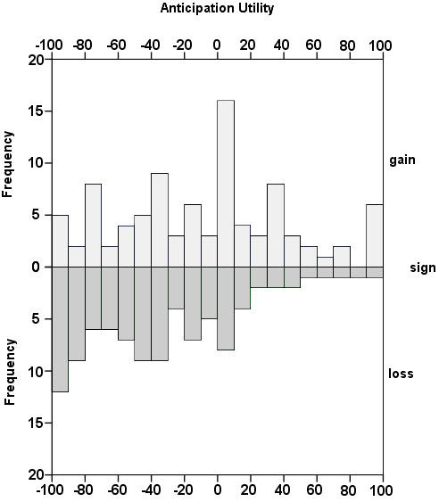
Mediation
As summarized in Figure 2, expected anticipatory emotions mediated the sign effect. The valence of the event in question affected judgments of the associated anticipatory emotions, which in turn predicted preferences between temporally displaced outcomes. Using a bootstrapping test recommended by Shrout & Bolger (2002), was significant (p < .01) but not complete mediation – losses were discounted less than gains, even after controlling for the expected (dis) utility of anticipation. Although participants may have selected anticipation ratings merely to justify their choices (due to experimenter demand or a desire for self-consistency), two pieces of evidence weigh against this interpretation: First, another, similar study (Study A3 in the Appendix) manipulated the order of anticipation ratings and intertemporal choices, and found no order effect, contrary to what would be expected if anticipation ratings were chosen merely to justify choices, or vice versa. 2). Secondly, outcome sign was manipulated between subjects (in both this study and Study A3), so it is unlikely that participants gave specific anticipation ratings so as to justify a difference between gains and losses.
Figure 2. Anticipation partially mediates the effect of sign on time preference in Study 1. Direct effects (with standardized betas) are shown in parentheses, while reduced effects (in the full model) are shown without parentheses.
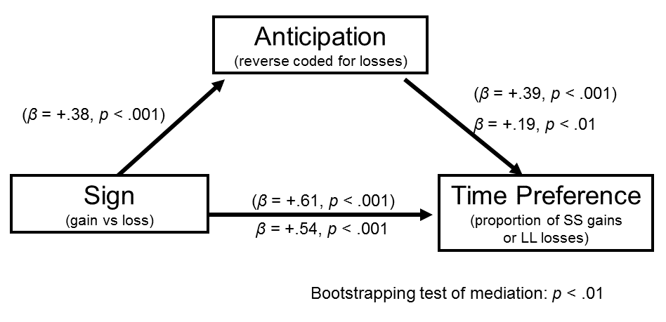
Discussion
As predicted, people dreaded a future financial loss more strongly than they enjoyed looking forward to an objectively equivalent gain. Indeed contemplating future monetary rewards was not even positive, suggesting indifference or conflict. We attempt to discriminate among these in Studies 4 and 5.
Also as predicted, anticipation partially mediated the effect of sign on time preferences, thus partly explaining the sign effect. In other words, people hate contemplating future losses, which makes waiting unattractive, leading people to choose later losses less often (lowering discount rates). In contrast, contemplating future gains is either pallid or bittersweet, and thus preferences for immediate gains remain strong (high discount rates). In another study (Study A4 in the Appendix) we show this same pattern of results in a consumer choice paradigm with air conditioners. Framing future energy usage with a negative frame (energy wasted) rather than a positive frame (energy saved) influences anticipation utility, in turn promoting preferences for the energy efficient option.

Study A4: Anticipation asymmetries mediate the sign effect in energy efficiency
Methods
400 participants were recruited from Mechanical Turk. Participants first completed an attention check (similar to Oppenheimer, Meyvis, and Davidenko 2009), and were randomly assigned to the gain condition or the loss condition. On the next page, the instructions read, "Suppose you were choosing between two window air conditioners, described below:" Participants in the gain [loss] condition considered the following two options:
Model A  Price: $297  10-year energy savings*: $0  [10-year energy wasted*: $920]  BTUs: 12,000  Watts: 2,000  Energy Efficiency Rating: 6.0 | Model B  Price: $776  10-year energy savings*: $920  [10-year energy wasted*: $0]  BTUs: 12,000  Watts: 1,000  Energy Efficiency Rating: 12.0
* Energy savings [wasted] is the estimated difference in energy usage between the two AC units, based on 4 hours usage per day, 182 days per year, with an electricity rate of $0.1264 per kWh.

Participants then answered two questions in counterbalanced order. First (or second) they indicated whether they would choose Model A or Model B. This was the main dependent variable. On the same page, participants read "A choice of Model B over Model A [Model A over Model B] boils down to spending more [less] money up front in exchange for saving [wasting] money later. How would you feel while waiting for the future energy savings [waste]?" and responded with one of three options, either "Negative (Strongly dislike the feeling of waiting)", "Neutral (It is just a calculation; I'd feel nothing)", or "Positive (Strongly like the feeling of waiting)". Finally, participants answered demographic questions.
Results
Twenty-seven participants (7% of the sample) failed the attention check and were excluded, leaving 373 participants for the following analyses. The results are quite similar whether or not inattentive participants are excluded. For analyses with the full sample, see the supplemental online material. Order of presentation of questions had no main effect on choices or anticipation ratings, nor did it interact with positive vs negative framing for either of these, all p = .25 or greater. Therefore, we will collapse across presentation order in the subsequent analyses.
Product preference
Model A was the more "impatient" option, costing less money upfront but higher energy costs in the long run. Therefore, we used the proportion of "Model A" choices as the key measure of time preference. In the positive frame, 61% of participants chose the "impatient" Model A, compared with 48% in the negative frame, t(371) = 2.5, p = .01, replicating the sign effect.
Anticipation utility
In the positive condition, 21% of participants indicated they would feel positive anticipation, 50% indicated neutral, and 30% indicated negative anticipation utility. In the negative condition, 13% indicated positive utility from anticipation, 51% indicated neutral, and 36% indicated negative. Recoding each answer to be -1, 0, or 1, the average anticipation score was -.09 (SD = .70) for gains and -.23 (SD = .66) for losses. Reverse scoring the losses, we see that dread of losses was stronger than positive anticipation of gains, t(371) = 4.5, p < .001.
Mediation
In a regression, anticipation utlity (reverse scored for losses) predicted choices while controlling for sign, standardized beta = .31, p < .001. Moreover, anticipation mediated the effect of sign on choices, as confirmed with a bootstrapping test, p < .001, replicating Study 1. Moreover, the effect of sign on time preference while controlling for anticipation utility dropped to non-significance, b = .06, p = .26, consistent with full mediation.
Discussion
Consumers are more likely to choose a more expensive, energy efficient product when future energy usage is presented in a negative frame (rather than a positive frame). This is consistent with the sign effect, with future gains discounted more than future losses. Furthermore, the effect of framing on choices was mediated by the assymetry in anticipation for gains and losses, replicating the results of Study 1.

Study A5: Anticipation asymmetries across domains

Material and methods
Ten positive and ten negative events (listed in Table 1, below) were selected for the study, drawn from item categories listed most frequently by participants in a pilot study (asking participants to list real-life examples of gains or losses they would like to delay or accelerate) and from several "classic" examples from prior literature, including "a kiss from the movie star of your choice" and "twenty painful (but harmless) electric shocks." While these events certainly do not represent all gain and loss events that people may experience, they offer a broader range of domains than is typically investigated in intertemporal choice studies.
271 US residents (age M=42, SD=14) from a range of socioeconomic backgrounds were recruited from the Virtual Lab subject pool of a university in the northeast (which draws participants from across the US) for an online study. Participants first read a brief introduction and explanation, stating:
The following pages will ask questions about immediate and future gains and losses. When you see the word 'immediate,' it means the very near future -- today or tomorrow. Many of the following questions will ask how you would feel while waiting for things. In some cases, you may enjoy the process of waiting. For example, if a special holiday is a couple weeks away, the waiting may be pleasant. Other times, you may dislike the way you feel while waiting. For example, if you are waiting for a red light to turn green, the waiting may be unpleasant.

Participants then considered each of the twenty events in random order. For each event, participants received the following question: "Assuming this event would definitely happen to you and you knew it were coming, when would you prefer it to happen?" Participants responded by choosing "immediately", "[specified interval]" or "don't care when." The delay of the specified interval was manipulated between subjects to be either three days, one week, one month, one year, or five years. (Therefore, all 20 events had the same delay for a given subject.) Participants then rated the anticipation utility of the event, with the question: "If this event were [delay period] away, how psychologically pleasurable or unpleasurable would the anticipation be? In other words, how would you feel while waiting for it?" Participants responded by clicking on a line (-100 = strongly dislike the feeling of waiting to 100 = strongly like the feeling of waiting, with 0 = neutral). Following these responses, participants completed some demographic questions with an embedded attention check.
Results
After excluding participants who failed the attention check, 169 participants remained for further analysis. The number of exclusions is higher than Study 1 because the attention check was put at the end of the survey (embedded in the demographics), rather than at the beginning, and because a different subject pool was used. The pattern of results with all participants included is quite similar, and analysis with the full sample of participants is provided in the online supplemental.
Our results, shown in Table 1, can be summarized as follows: (1) The anticipation of losses was judged to be much more negative (M=-45, SD=30) than the anticipation of gains was positive (M=18, SD=39), t(168)=8.4, p<.001, d=.65. We tested this for each of the five delay periods separately, and it was significant in every case. (2) Dread of losses was more common than pleasurable anticipation of gains (78% vs. 58%; z=12.9, p<.001). (3) Dread, when it occurred was also stronger than pleasurable anticipation, when it occurred. To test this, we compared only positive anticipation ratings of gains (M=50.4, SD=27.7) with negative anticipation ratings of losses (M=60.4, SD=28.7) and reverse scoring the losses, finding a significant difference between the two with a mixed model, F(1,2292)=40.1, p<.001. (4) Anticipation utility predicted time preference (coded as +1 if participants wanted the event to happen "immediately," as -1 if they wanted it to occur at the end of the specified interval, and as 0 if they did not care), such that the more a participant indicated enjoying the anticipation of an event, the more likely they were to want to delay it (F(1,3377)=138.0, p<.001). (Overall, participants preferred to have the event immediately 49% of the time, to delay 23% of the time, and were indifferent 28% of the time.) (5) Respondents generally wished to accelerate gains (M=.52, SD=.34), but were ambivalent with respect to the timing of losses (M=0, SD=.50), t(168)=12.2, p<.001, d=.93, consistent with previous research (Yates & Watts, 1975). We also tested these findings together with a mixed model with time preference as the dependent variable, participant ID and event as random effects, and sign (positive or negative) and anticipation utility as predictors. The analysis revealed a main effect of anticipation utility, with more positive scores associated with a desire to delay events (b=-0.003, F(1,3376)=147.9, p<.001). It also confirmed a main effect of sign, consistent with typical time preferences: participants were more likely to delay negative events than positive events (b=-0.7, F(1,3376)=548.1, p<.001). There was no interaction, b=0.000, F(1,3376)=0.0, p>.5, indicating that anticipation ratings predicted time preferences equally well for gains and losses. (6) Temporal distance diminished the intensity of anticipatory (dis)utility F(4,164)=6.0, p<.001, η²=.13, as suggested by Loewenstein (1987).
Table 1.
Average anticipation utility and time preference (1 = immediately, 0 = indifferent, -1 = in the future) for each event, followed by the standardized betas for anticipation utility predicting time preference in a regression in Study 2.
Event | Anticipation Utility | Now Preference | beta
a free 5-day vacation to the destination of your choice | 28 | .19 | -.40**
eating a nice meal out at a restaurant | 28 | .29 | -.25**
a kiss from the movie star of your choice | 22 | .32 | -0.04
receiving a good grade or performance review | 21 | .68 | -.22**
getting a gift in the mail from a family member | 21 | .49 | -.29**
spending time with your best friend | 21 | .44 | -.18*
hour of favorite TV or book | 13 | .57 | -.20**
receiving a $50 check | 13 | .78 | -.16*
improved energy and health for 10 days | 9 | .69 | -.28**
winning the lottery | 6 | .79 | -.28**
doing difficult home cleaning and renovation for 5 days | -19 | .02 | -0.08
an hour at the local Department of Motor Vehicles | -26 | .11 | -.19*
paying a $50 fine | -27 | .02 | -.21**
giving a stressful 60 minute improvised speech | -45 | 0.1 | -.20*
being sick for 10 days | -47 | -.15 | -.26**
a painful dental procedure | -53 | .18 | -.30**
receiving a bad grade or performance review | -55 | .15 | -.25**
a confrontation with your co-worker or family member | -57 | .18 | -.17*
twenty painful (but harmless) electric shocks | -58 | .13 | -.23**
having one of your legs amputated | -63 | -.56 | -.13†
Note: **= p<.01, *= p<.01, †= p<.10.
To investigate the robustness of the relation between anticipation utility and time preference, we ran separate regressions for each of the 20 events, with the results summarized in Table 1. All 20 items showed the expected directional trend: the more pleasurable the experience of waiting was predicted to be, the more people wished to defer it. The average standardized beta for anticipation utility predicting time preference was -.22, and seventeen of the regressions showed a significantly negative coefficient.
Discussion
Dread of losses was stronger and more frequent than pleasurable anticipation of gains. Preferences to accelerate gains were more common than preferences to postpone losses, replicating the sign effect. Furthermore, greater positive anticipation for an event was associated with a preference to postpone it. Of course, anticipation utility is only one of many factors driving intertemporal choice. For example, although leg amputation was the most dreaded event that we studied, participants nevertheless preferred to postpone the event, presumably because the benefits of having a leg outweigh the dread of losing it.
In this study, we made no attempt to equate the subjective magnitude of positive and negative events. Thus, our suggestion that dread is stronger than pleasurable anticipation may simply reflect the fact that the set of negative events we chose had a larger subjective magnitude than the set of positive events. We addressed this in Study 3 in the main manuscript, by presenting each participant with a pair of positive and negative events and adjusting the magnitudes until each participant was indifferent between accepting or rejecting the pair, indicating that the positive and negative event had been subjectively equated. We found that the results from this study held — with dread of losses being stronger and more frequent than pleasurable anticipation of gains, gains accelerated more often than losses postponed, and anticipation predicting time preferences — even when the subjective experienced utility of gains and losses were matched.

Study A6: An additional study distinguishing "dread looms larger" from loss aversion
Methods
A national sample of 108 participants were recruited online from Amazon's Mechanical Turk service. Forty-six participants failed the attention check and were excluded from further analysis. (As with the other studies, the results are very similar whether or not these participants are excluded.) The experimental procedure was similar to Study 2, with a few differences. First, participants read a list of all twenty events (the same as used in Study 2), to familiarize them with the range of events and facilitate comparisons between gains and losses. Then, participants were presented with one event at a time, similar to Study 2.
For each event, participants were first asked, "Assuming you knew this event were coming, when would you prefer it to happen? Immediately, or in one week?" They responded on a 7-point scale from (3) "Strongly prefer immediately" to (-3) "Strongly prefer in one week." Subsequently, participants were asked two questions to determine experience utility, following the guidelines of McGraw and colleagues (2010): "Please imagine this event happening one week from now. Would experiencing this event be pleasurable or unpleasurable?" and then "How strongly would experiencing this event affect your feelings at that time?" which they answered by clicking on a number line labeled with "not at all" on one end and "extremely" on the other. Then, participants were asked two questions to determine anticipation utility: first, "If this event were one week away, would the anticipation be psychologically pleasurable or unpleasurable? In other words, how would you feel while waiting for it?" which was answered by choosing "like the feeling of waiting" or "dislike the feeling of waiting" and second, "How strongly would anticipating this event affect your feelings while waiting for the event?" which was answered on a continuous scale from "not at all" to "extremely".
After answering these five questions for all twenty events, participants were then presented with 36 pairs of events (one gain and one loss), in random order. For each pair, participants were asked "If you could choose whether or not to experience both these events immediately, would you accept this pair?", which they answered on a 7-point scale, from "definitely yes" to "definitely no", with "unsure" in the middle. Finally, participants answered demographic questions.
Results
To analyze the experience and anticipation utility data, we combined participants' binary ratings (positive or negative) with the unipolar continuous scale, to produce a -100 to 100 scale comparable to that used in Study 2. As shown in Figure 5, the negative and positive events were comparably significant (-61 vs. 57; F(1,1238)=4.0, p<.05), but the losses were dreaded markedly more than gains were pleasurably anticipated (-50 vs. 22; F(1,1238)=127.1, p<.001). This difference in the anticipation utility of gains and losses persisted even when controlling for the intensity of the predicted experienced utility (F(1,1237)=31.3, p<.001). To test this conservatively, we first ran a mixed model with intensity of experience utility (on a 1-100 scale) and a random effect of subject predicting intensity of anticipation utility (on a 1-100 scale). The relationship was strong, b=.75, F(1,1227.1)=1313.2, p<.001, indicating that more intense experiences were anticipated more strongly. We then used sign (positive or negative, as judged by the participant) to predict the residuals from this model (i.e., anticipation utilities from which loss aversion in experience utility had been removed) in a second mixed model, which revealed losses being anticipated more strongly than gains (mean difference=5.7), F(1,1237)=31.3, p<.001.
As a further test of whether "dread looms larger" after controlling for the subjective magnitude of the experienced utility of the event, we restricted our analysis to the 128 pairs of positive and negative events about which participants were "unsure" whether they would accept – which suggests that these gains and losses were regarded as comparably significant. Among these, losses conferred much more intense anticipation utility than gains (-57 vs. 24) as confirmed by a mixed model with participant ID as a random factor and sign as a fixed factor predicting the intensity of anticipation, F(1,215.1)=53.1, p<.001.
Participants demonstrated the sign effect, wanting to accelerate gains (M=1.2) more strongly than wanting to postpone losses (M=-0.1), as confirmed by a mixed model with sign as a fixed factor and participant ID as a random factor, F(1,1238)=97.0, p<.001.
Finally, we tested whether anticipation utility predicted time preference while controlling for loss aversion by first running a mixed model with experience utility (on a -100 to 100 scale) and a random effect of subject. The relation was significant, b=.010, F(1,1185.5)=152.1, p<.001, indicating that the more positively an event was rated, the more strongly participants wanted to have it immediately. We then ran a mixed model using anticipation utility (on a -100 to 100 scale) to predict the residuals (i.e., time preferences from which experience utilities had been removed). This also revealed a significant relation, b=-.005, F(1,1238)=24.6, p<.001, indicating that the more participants enjoyed anticipating an event, the less strongly they wanted to have it immediately, even after controlling for the utility of experiencing the event.
Figure 5
Average experience utility and anticipation utility for the 10 gains and 10 losses in Study A4. Error bars represent +/- one standard error.
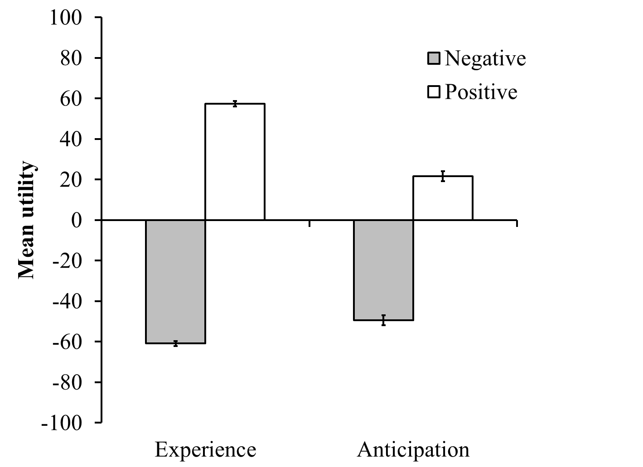
In summary, participants dread losses more than they enjoy anticipating gains, even when controlling for experience utility (ie, when controlling for loss aversion). Furthermore, anticipation utility predicts time preferences, even when controlling for experience utility.

Study A7: An additional study of anticipation of real events
Method
165 undergraduates at a large university were recruited for an unrelated study in exchange for course credit. The study consisted of two half-hour sessions, one week apart. In each session, they first completed the unrelated study, and then completed the current study.
When participants entered the lab, they could see jellybeans on the table in clear plastic bags. The jellybeans were a selection of flavors from Bertie Bott's Every Flavour Beans (though this branding was never made known to participants). At time 1, participants read the instruction "This next study involves eating a jelly bean, that might be delicious or might be gross. As always, participation is voluntary. Are you willing to eat a jelly bean for this next study?" Eight percent of the sample answered "no" and were exempted from the study, leaving 152 participants. These remaining participants were each randomly assigned to one of two jellybean flavor conditions: toasted marshmallow (n = 59) or dirt (n = 93). (Due to an error in the study programming, there were more participants assigned to the dirt condition than the marshmallow condition.) We selected these two flavors based on pre-testing which indicated that students thought they would taste equally good/bad.
On the next page, participants read "You have been assigned to eat a "toasted marshmallow" ["dirt"] flavored jelly bean. However, you will have to wait until one week from now to eat it." Participants then answered two questions to measure their predicted experience utility for eating the jellybean, "As you think about eating the jellybean, how happy or pleasurable do you think the experience will be?" and "As you think about eating the jellybean, how displeasurable or unhappy do you think the experience will be?" They answered each question by clicking on a line (of length 100) labeled with "neutral" on the left and "extremely like the experience" (or "extremely dislike the experience") on the right.
Next, participants answered two questions to measure their current (i.e., actual) anticipation utility, "As you think about the jellybean, how pleasurable or happy is the anticipation? In other words, how do you feel while waiting for it?" and "As you think about the jellybean, how displeasurable or unhappy is the anticipation? In other words, how do you feel while waiting for it?" They answered each question by clicking on a line (of length 100) labeled with "neutral" on the left and "extremely like the feeling of waiting" (or "extremely dislike the feeling of waiting") on the right. Finally, participants indicated their gender, age, and ethnicity.
Eighteen participants (8% of those in the dirt condition and 19% of those in the marshmallow condition) did not return for the second session. In the second session, participants ate a jellybean of the assigned flavor. Participants then answered two questions to measure their actual experience utility of eating the jellybean, "As you eat the jellybean, how happy or pleasurable is the experience?" and "As you eat the jellybean, how displeasurable or unhappy is the experience?" They answered each question by clicking on a line (of length 100) labeled with "neutral" on the left and "extremely like the experience" (or "extremely dislike the experience") on the right.
Results
Predicted experience utility
As summarized in the first row of Table 4, participants predicted that eating the toasted marshmallow flavored jellybean would be an equally good experience as the dirt flavored jellybean would be a bad experience. For each flavor, we subtracted the two ratings (negative and positive) to get a single measure of experience utility for that flavor. As expected (due to pretesting), the predicted experience utility of the dirt (mean = -31.2, SD = 49.8) and toasted marshmallow (mean = 31.0, SD = 40.6) jellybeans were quite similar. Reverse scoring the dirt scores, the predicted experience utility ratings were not significantly different, t(150) = 0.0, p = .98, d = 0.00.
Table 4
Means (with SDs in parentheses) of utility ratings for eating a toasted marshmallow flavored or dirt flavored jellybean in Study A5.
 | Marshmallow |  | Dirt
 | Positive | Negative | Positive | Negative
T1 Predicted experience utility | 46.8  (30.6) | 15.8  (21.6) | 17.5  (25.5) | 48.7  (35.4)
T1 Actual anticipation utility | 27.4  (25.1) | 38.3  (29.9) | 20.2  (26.0) | 42.8  (36.0)
T2 Actual experience utility | 56.9  (30.8) | 13.8  (23.8) | 16.3  (24.3) | 52.3  (34.0)

Actual anticipation utility
The anticipation ratings are summarized in the second row of Table 4. Again, we combined the positive and negative anticipation ratings for each flavor into a single measure of anticipation utility. Replicating the results of previous studies, participants reported dreading the dirt flavored jellybean (mean = -22.6, SD = 47.0) more than enjoying anticipation of the toasted marshmallow jellybean (mean = -1.0, SD = 33.7). Reverse scoring the ratings for dirt flavor, this was a significant difference, t(150) = 3.3, p = .001, d = 0.59.
Actual experience utility
Although not relevant to our hypotheses, at T2 we asked participants to rate the actual experience of eating the jellybean, as seen in the third row of Table 4. Again combining the positive and negative ratings for each flavor, we see that participants enjoyed eating the toasted marshmallow flavor (mean = 43.1, SD = 43.0) roughly equally as strongly as they disliked eating the dirt flavor (mean = -36.0, SD = 50.0). Reverse scoring the dirt flavor, this was not a significant difference, t(132) = 0.8, p = .41, d = 0.15.

Study 1 Materials

[These are the large magnitude conditions – in the small magnitude versions, all dollar amounts are half as large.]
All conditions:
Imagine that you need to buy a new pair of glasses, and you have narrowed your choice down to two pairs, from two different brands. They are virtually identical in appearance and quality, but they offer different pricing plans.
Gain condition:

Brand A costs $122. Brand B includes a rebate. It costs $142 now, but you would receive a $30 rebate in the mail after one month. Which would you choose?

Brand A: pay $122 now
Brand B: pay $142 now, and receive $30 in one month

Loss condition:
Brand A includes a payment plan. It costs $122 now, and you would pay an additional bill of $30 after one month. Brand B costs $142. Which would you choose?

Brand A: pay $122 now, and pay $30 in one month
Brand B: pay $142 now

All conditions:
Imagine receiving a check for $30 [paying a bill of $30] in one month. Would experiencing this event be pleasurable or displeasurable?
- Pleasurable experience
- Displeasurable experience

Imagine receiving a check for $30 [paying a bill of $30] in one month. How strongly would experiencing this event affect your feelings at that time?
 | Not at all | Strongly | Extremely

 | 0 | 10 | 20 | 30 | 40 | 50 | 60 | 70 | 80 | 90 | 100

Imagine expecting to receive a check for $30 [pay a bill of $30] in one month. If this event were one month away, would the anticipation be psychologically pleasurable or displeasurable? In other words, how would you feel while waiting for it?
- Like the feeling of waiting
- Dislike the feeling of waiting

Imagine expecting to receive a check for $30 [pay a bill of $30] in one month. How strongly would anticipating this event affect your feelings while waiting for the event?
 | not at all | strongly | extremely

 | 0 | 10 | 20 | 30 | 40 | 50 | 60 | 70 | 80 | 90 | 100

In your own life, how common are each of the following events?
 | Extremely Rare | Extremely Common

 | 0 | 10 | 20 | 30 | 40 | 50 | 60 | 70 | 80 | 90 | 100

Receiving around $30
Receiving around $15
Paying around $30
Paying around $15

What is your gender?
- Male
- Female
- Other

How old are you?
____________________

What is your annual household income?
- Less than $20,000
- $20,000 to $39,999
- $40,000 to $59,999
- $60,000 to $79,999
- $80,000 to $99,999
- $100,000 or more
- Prefer not to say

Study 2 Materials
[Positive Frame:]

[Negative Frame:]
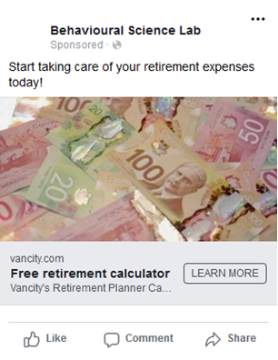

[Positive Frame + Contemplation Message:]

[Negative Frame + Contemplation Message:]

Study 3 Materials
Important Instructions
This survey has many questions that are extremely similar. However, no two questions are identical. Please read each question carefully and answer carefully. The question at the bottom of this page is a test, to be sure you are reading carefully. Please ignore the question below and put the word "reader" (without quotes) as your answer, to demonstrate that you have read these instructions. Thank you for reading carefully.
Roughly many times a day do you think about things you need to do? ________________

[page break]
If you could choose whether to accept the following pair of events, would you take it? Assume that the events would happen right away (today or tomorrow):
50% chance of receiving [25] dollars
AND
50% chance of paying 25 dollars
- Yes
- Unsure
- No
[the following questions were identical but varied the amount in brackets until an indifference point was identified. When participants indicated they were unsure, the values of the good and bad event that made them indifferent were recorded and a qualitatively new pair was presented (such as the traffic/massage pair seen below). Similarly, if the adjusting procedure reached too fine a gradation (operationalized as less than one unit of change), the participant was likewise moved on to the next pair. If a participant maxed out the titration scale (for example, always accepting the gain and loss bundle, even if a $0 gain was offered), they were sent to the next pair, their lack of indifference was recorded, and those items were excluded from further analysis.]
[page break]
If you could choose whether to accept the following pair of events, would you take it? Assume that the events would happen right away (today or tomorrow):
get a free, relaxing massage for [50] minutes
AND
spend time stuck in horrible traffic for 90 minutes
- Yes
- Unsure
- No
[page break]
If you could choose whether to accept the following pair of events, would you take it? Assume that the events would happen right away (today or tomorrow):
watch really funny TV program for 30 minutes
AND
watching boring, annoying commercials for [15] minutes
- Yes
- Unsure
- No
[page break]
If you could choose whether to accept the following pair of events, would you take it? Assume that the events would happen right away (today or tomorrow):
70% chance of receiving [35] dollars
AND
do a really boring online survey for 90 minutes
- Yes
- Unsure
- No
[page break]
If you could choose whether to accept the following pair of events, would you take it? Assume that the events would happen right away (today or tomorrow):
a complimentary dinner at a restaurant of your choice
AND
endure [10] mild (and harmless) electric shocks
- Yes
- Unsure
- No
[page break]
Demographic Questionnaire
Please truthfully answer the following demographic questions about yourself.
1. Your gender:
- Female
- Male
2. Your age:
____ years old
3. Your marital status:
- Single
- Living together
- Married
- Divorced or living separated
- Widowed
4. What is your annual household income? (optional)
- less than $14,999
- $15,000 - $24,999
- $25,000 - $34,999
- $35,000 - $49,999
- $50,000 - $99,999
- $100,000 - $199,999
- greater than $200,000
5. What is your highest completed level of education?
- No degree
- High school diploma
- Associate degree, occupational
- Associate degree, academic
- Bachelor's degree
- Master's degree
- Professional degree
- Doctoral degree
6. What is your primary ethnicity?
- American Indian or Alaskan Native
- Asian
- Black or African American
- Caucasian/White
- Hispanic or Latin American
- Other
7. What is your political affiliation?
- Democrat
- Republican
- Independent
- Libertarian
- Green
- Other
8. Do you smoke cigarettes or otherwise use tobacco products? If so, how often?
- Never
- Rarely
- About once a month
- About once a week
- Daily, or almost every day
9. Imagine that you had to pay an unexpected bill immediately. For example, suppose that you needed an expensive medical treatment that was not covered by insurance. Considering all possible resources available to you (including savings, borrowing, etc.), what is the maximum amount that you could come up with on short notice?
$________________
[page break]
Positive Event 1 of 5
Please consider the following event:
50% chance of receiving [49] dollars
1. Assuming you knew this event were coming, when would you prefer it to happen? Immediately, or in one week?
- Immediately
- in one week
2.a. Please imagine this event happening one week from now. Would experiencing this event be pleasurable or unpleasurable?
- pleasurable experience
- unpleasurable experience
2.b. How strongly would experiencing this event affect your feelings at that time?
(Note: you can click at any point on the line below to indicate your answer.)
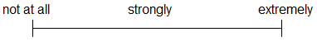
3.a. If this event were one week away, would the anticipation be psychologically pleasurable or unpleasurable? In other words, how would you feel while waiting for it?
- like the feeling of waiting
- dislike the feeling of waiting
3.b. How strongly would anticipating this event affect your feelings while waiting for the event?
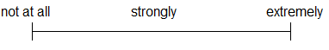
[note that the amount above in brackets was filled in dynamically based on the participant's answer to the previous paired bundle questions before the demographics.]
[page break]
Positive Event 2 of 5
Please consider the following event:
get a free, relaxing massage for 50 minutes
1. Assuming you knew this event were coming, when would you prefer it to happen? Immediately, or in one week?
- Immediately
- in one week
2.a. Please imagine this event happening one week from now. Would experiencing this event be pleasurable or unpleasurable?
- pleasurable experience
- unpleasurable experience
2.b. How strongly would experiencing this event affect your feelings at that time?
(Note: you can click at any point on the line below to indicate your answer.)
3.a. If this event were one week away, would the anticipation be psychologically pleasurable or unpleasurable? In other words, how would you feel while waiting for it?
- like the feeling of waiting
- dislike the feeling of waiting
3.b. How strongly would anticipating this event affect your feelings while waiting for the event?
[page break]
Positive Event 3 of 5
Please consider the following event:
watch really funny TV program for 30 minutes
1. Assuming you knew this event were coming, when would you prefer it to happen? Immediately, or in one week?
- Immediately
- in one week
2.a. Please imagine this event happening one week from now. Would experiencing this event be pleasurable or unpleasurable?
- pleasurable experience
- unpleasurable experience
2.b. How strongly would experiencing this event affect your feelings at that time?
(Note: you can click at any point on the line below to indicate your answer.)
3.a. If this event were one week away, would the anticipation be psychologically pleasurable or unpleasurable? In other words, how would you feel while waiting for it?
- like the feeling of waiting
- dislike the feeling of waiting
3.b. How strongly would anticipating this event affect your feelings while waiting for the event?
[page break]
Positive Event 4 of 5
Please consider the following event:
70% chance of receiving [26] dollars
1. Assuming you knew this event were coming, when would you prefer it to happen? Immediately, or in one week?
- Immediately
- in one week
2.a. Please imagine this event happening one week from now. Would experiencing this event be pleasurable or unpleasurable?
- pleasurable experience
- unpleasurable experience
2.b. How strongly would experiencing this event affect your feelings at that time?
(Note: you can click at any point on the line below to indicate your answer.)
3.a. If this event were one week away, would the anticipation be psychologically pleasurable or unpleasurable? In other words, how would you feel while waiting for it?
- like the feeling of waiting
- dislike the feeling of waiting
3.b. How strongly would anticipating this event affect your feelings while waiting for the event?
[note that the amount above in brackets was filled in dynamically based on the participant's answer to the previous paired bundle questions before the demographics.]
[page break]
Positive Event 5 of 5
Please consider the following event:
a complimentary dinner at a restaurant of your choice
1. Assuming you knew this event were coming, when would you prefer it to happen? Immediately, or in one week?
- Immediately
- in one week
2.a. Please imagine this event happening one week from now. Would experiencing this event be pleasurable or unpleasurable?
- pleasurable experience
- unpleasurable experience
2.b. How strongly would experiencing this event affect your feelings at that time?
(Note: you can click at any point on the line below to indicate your answer.)
3.a. If this event were one week away, would the anticipation be psychologically pleasurable or unpleasurable? In other words, how would you feel while waiting for it?
- like the feeling of waiting
- dislike the feeling of waiting
3.b. How strongly would anticipating this event affect your feelings while waiting for the event?
[page break]
Negative Event 1 of 5
Please consider the following event:
50% chance of paying 25 dollars
1. Assuming you knew this event were coming, when would you prefer it to happen? Immediately, or in one week?
- Immediately
- in one week
2.a. Please imagine this event happening one week from now. Would experiencing this event be pleasurable or unpleasurable?
- pleasurable experience
- unpleasurable experience
2.b. How strongly would experiencing this event affect your feelings at that time?
(Note: you can click at any point on the line below to indicate your answer.)
3.a. If this event were one week away, would the anticipation be psychologically pleasurable or unpleasurable? In other words, how would you feel while waiting for it?
- like the feeling of waiting
- dislike the feeling of waiting
3.b. How strongly would anticipating this event affect your feelings while waiting for the event?
[page break]
Negative Event 2 of 5
Please consider the following event:
spend time stuck in horrible traffic for [50] minutes
1. Assuming you knew this event were coming, when would you prefer it to happen? Immediately, or in one week?
- Immediately
- in one week
2.a. Please imagine this event happening one week from now. Would experiencing this event be pleasurable or unpleasurable?
- pleasurable experience
- unpleasurable experience
2.b. How strongly would experiencing this event affect your feelings at that time?
(Note: you can click at any point on the line below to indicate your answer.)
3.a. If this event were one week away, would the anticipation be psychologically pleasurable or unpleasurable? In other words, how would you feel while waiting for it?
- like the feeling of waiting
- dislike the feeling of waiting
3.b. How strongly would anticipating this event affect your feelings while waiting for the event?
[note that the amount above in brackets was filled in dynamically based on the participant's answer to the previous paired bundle questions before the demographics.]
[page break]
Negative Event 3 of 5
Please consider the following event:
watching boring, annoying commercials for [11] minutes
1. Assuming you knew this event were coming, when would you prefer it to happen? Immediately, or in one week?
- Immediately
- in one week
2.a. Please imagine this event happening one week from now. Would experiencing this event be pleasurable or unpleasurable?
- pleasurable experience
- unpleasurable experience
2.b. How strongly would experiencing this event affect your feelings at that time?
(Note: you can click at any point on the line below to indicate your answer.)
3.a. If this event were one week away, would the anticipation be psychologically pleasurable or unpleasurable? In other words, how would you feel while waiting for it?
- like the feeling of waiting
- dislike the feeling of waiting
3.b. How strongly would anticipating this event affect your feelings while waiting for the event?
[note that the amount above in brackets was filled in dynamically based on the participant's answer to the previous paired bundle questions before the demographics.]

[page break]
Negative Event 4 of 5
Please consider the following event:
do a really boring online survey for 90 minutes
1. Assuming you knew this event were coming, when would you prefer it to happen? Immediately, or in one week?
- Immediately
- in one week
2.a. Please imagine this event happening one week from now. Would experiencing this event be pleasurable or unpleasurable?
- pleasurable experience
- unpleasurable experience
2.b. How strongly would experiencing this event affect your feelings at that time?
(Note: you can click at any point on the line below to indicate your answer.)
3.a. If this event were one week away, would the anticipation be psychologically pleasurable or unpleasurable? In other words, how would you feel while waiting for it?
- like the feeling of waiting
- dislike the feeling of waiting
3.b. How strongly would anticipating this event affect your feelings while waiting for the event?
[page break]
Negative Event 5 of 5
Please consider the following event:
endure [10] mild (and harmless) electric shocks
1. Assuming you knew this event were coming, when would you prefer it to happen? Immediately, or in one week?
- Immediately
- in one week
2.a. Please imagine this event happening one week from now. Would experiencing this event be pleasurable or unpleasurable?
- pleasurable experience
- unpleasurable experience
2.b. How strongly would experiencing this event affect your feelings at that time?
(Note: you can click at any point on the line below to indicate your answer.)
3.a. If this event were one week away, would the anticipation be psychologically pleasurable or unpleasurable? In other words, how would you feel while waiting for it?
- like the feeling of waiting
- dislike the feeling of waiting
3.b. How strongly would anticipating this event affect your feelings while waiting for the event?
[note that the amount above in brackets was filled in dynamically based on the participant's answer to the previous paired bundle questions before the demographics.]

Study 4 Materials

The following pages will ask questions about immediate and future gains and losses. You will answer many questions about the following 20 events. Please read this list of events now:
- getting twenty painful (but harmless) electric shocks in a research experiment
- receiving a $50 check
- paying a $50 fine
- a painful dental procedure
- filling out paperwork and waiting around for an hour at the local Department of Motor Vehicles (DMV)
- a free 5-day vacation to the destination of your choice
- a kiss from the movie star of your choice
- getting a gift in the mail from a family member
- receiving a good grade or performance review
- receiving a bad grade or performance review
- a confrontation with your co-worker or family member
- eating a nice meal out at a restaurant
- watching your favorite TV show or reading a good book for an hour
- being sick for 5 days
- improved energy and health for 5 days
- giving a stressful 60 minute improvised speech
- having one of your legs amputated
- winning the lottery
- doing difficult home cleaning and renovation for 5 days
- spending time with your best friend
[page break]
Anticipation
Many of the following questions will ask how you would feel while waiting for things.
In some cases, you may enjoy the process of waiting. For example, if a special holiday is a couple weeks away, the waiting may be pleasant. Other times, you may dislike the way you feel while waiting. For example, if you are waiting for a red light to turn green, the waiting may be unpleasant.
In some cases, you might feel conflicted, and feel both happiness and unhappiness while waiting for an event. In other cases, you might not care about an event, and so feel neither happiness nor unhappiness while waiting.
[page break]
Please imagine the following event:
[receiving a $50 check]
1. Assuming you knew this event were coming, when would you prefer it to happen? Immediately, or in one week?
- Strongly prefer immediately
- Probably immediately
- Leaning towards immediately
- Indifferent
- Leaning towards in one week
- Probably in one week
- Strongly prefer in one week
2.a. Please imagine this event happening one week from now. How happy or pleasurable would the experience be? (Note: you can click at any point on the line below to indicate your answer.)
2.b. How displeasurable or unhappy would the experience be?
3.a. If this event were one week away, how pleasurable or happy would the anticipation be? In other words, how would you feel while waiting for it?
3.b. If this event were one week away, how displeasurable or unhappy would the anticipation be? In other words, how would you feel while waiting for it?
[page break]
[this set of questions was repeated for each of the 20 events listed above, in random order]
Demographic Questionnaire
This section asks many demographic questions about yourself. Some of the questions are personal in nature (such as income and weight). Although you are not required to answer the sensitive questions, it will help this research project very much if you do so. Please remember that all your answers will remain anonymous.
1. Your gender:
- Female
- Male
2. Your age:
____ years old
3. Your marital status:
- Single
- Living together
- Married
- Divorced or living separated
- Widowed
The first item below (question number four) is a test, to make sure you are reading these instructions. Please ignore the question and just write the word "reader" as your answer to number four. (We are keeping track of your time, so we know the answer to that question already.) Thank you for reading!
4. How long did it take you to complete this survey?
5. What is your annual household income?
- less than $14,999
- $15,000 - $24,999
- $25,000 - $34,999
- $35,000 - $49,999
- $50,000 - $99,999
- $100,000 - $199,999
- greater than $200,000
6. What is your highest completed level of education?
- No degree
- High school diploma
- Associate degree, occupational
- Associate degree, academic
- Bachelor's degree
- Master's degree
- Professional degree
- Doctoral degree
7. Which of the following categories best describes your current employment?
- No job / Unemployed
- Working in household
- Student
- Academic (teacher or researcher)
- Office worker
- Government employee
- Manager
- Entrepreneur
- Other
8. How many children do you have? ____
9. What is your primary ethnicity?
- Black or African American
- American Indian or Alaskan Native
- White
- Hispanic or Latin American
- Asian
- Other
10. What is your political affiliation?
- Democrat
- Republican
- Independent
- Libertarian
- Green
- Other
11. Do you smoke cigarettes or otherwise use tobacco products? If so, how often?
- Never
- Rarely
- About once a month
- About once a week
- Daily, or almost every day

Study 5 Materials
[Note that this study involved two experimental sessions, one week apart.]
[T1 Survey]
Jelly Bean Study
This next study involves eating a jelly bean, whose flavor may range from delicious to disgusting. As always, participation is voluntary. Are you willing to eat a jelly bean for this next study?
Yes
No
[page break]
You have been assigned to eat a ["dirt"] ["toasted marshmallow"] flavored jelly bean one week from today.
1.a. How happy or pleasurable do you think the experience will be? (Note: you can click at any point on the line below to indicate your answer.)
neutral | extremely like the  experience of eating
1.b. How displeasurable or unhappy do you think the experience will be?
neutral | extremely dislike the  experience of eating
2.a. How pleasurable or happy is the anticipation? In other words, how do you feel now, while waiting for it?
neutral | extremely like the  feeling of waiting
2.b. How displeasurable or unhappy is the anticipation? In other words, how do you feel now, while waiting for it?
neutral | extremely dislike the  feeling of waiting

[page break]
Demographic Questionnaire
Please truthfully answer the following demographic questions about yourself.
1. Your gender:
Female
Male
Other
2. What is your age?
years old
3. What is your primary ethnicity?
Aboriginal or Native American
Asian
Black or African American
Caucasian or White
Hispanic or Latin American
Other
[page break]
[T2 Survey]
For this next study, you will eat a jellybean of the following flavor:
[dirt] [toasted marshmallow]
Please tell the experimenter that you are ready for the jellybean. Then, the experimenter will enter a verification code below.
Verification code:
[page break]
Jelly Bean Study
Please eat the ["dirt"] ["toasted marshmallow"] flavored jelly bean.
a. How happy or pleasurable is the experience? (Note: you can click at any point on the line below to indicate your answer.)
neutral | extremely like the  experience of eating
b. How displeasurable or unhappy is the experience?
neutral | extremely dislike the  experience of eating

Study 6 Materials

This next study may involve eating a jelly bean with an unusual flavor, which could range from delicious to disgusting. As always, participation is voluntary. Are you willing to possibly eat a jelly bean for this next study? (If you have any questions, please feel free to ask the study administrator at any time.)
Yes / No
[Self choice condition instructions and questions:]
Today, you will be eating a jellybean with the following flavor:
Glazed Blueberry Cake (Good-tasting with sweet aftertaste)
[Soap (Bad-tasting, soapy flavor with sweet aftertaste)]
[Black Pepper (Bad-tasting, spicy flavor with sweet aftertaste)]
[French Vanilla (Good-tasting with sweet aftertaste)]
You will need to decide when to eat the jellybean.
Have you ever had a jelly bean of this flavor before?
Yes / Maybe / No
As mentioned, you will be making a decision about when to eat a jellybean. Please predict your reaction to eating the jellybean flavor:
[Glazed Blueberry Cake (Good-tasting with sweet aftertaste)]
How pleasurable or happy will the experience of eating the jelly bean be?
(-100= “Not at all pleasurable” to 100=”Extremely pleasurable”)

How displeasurable or unhappy will the experience of eating the jelly bean be?
(-100= “Not at all displeasurable” to 100=”Extremely displeasurable”)

What is your level of certainty about how much pleasure/displeasure you would feel while eating the jelly bean (as you indicated in the two questions above)?
(-100= “Not at all certain that I will feel this way” to 100=”Extremely certain that I will feel this way”)

How common/ uncommon or usual/ unusual is this jelly bean flavor?
(-100= “Extremely uncommon or unusual” to 100=”Extremely common or usual”)
You will either eat the jellybean now or in 15 minutes (after doing some other studies). You can choose when to eat the jellybean.
When do you want to eat it?
Eat it immediately / Eat it after 15 minutes
[Other choice condition instructions and questions:]
Today, you will be making a decision for another participant about when they will eat a jellybean. They don't know it yet, but they will eat the following flavor:
Glazed Blueberry Cake (Good-tasting with sweet aftertaste)
[Soap (Bad-tasting, soapy flavor with sweet aftertaste)]
[Black Pepper (Bad-tasting, spicy flavor with sweet aftertaste)]
[French Vanilla (Good-tasting with sweet aftertaste)]
They won't know it's coming until it is time to eat it. Furthermore, your choice of when they eat it will be anonymous, and you will never meet the other participant. Also, you yourself may or may not eat a jellybean at some point.
Have you ever had a jelly bean of this flavor before?
Yes / Maybe / No
As mentioned, you will be making a decision for another participant about when they will eat a jellybean. Please predict their reaction to eating the jellybean flavor:
[Glazed Blueberry Cake (Good-tasting with sweet aftertaste)]

How pleasurable or happy will the experience of eating the jelly bean be?
(-100= “Not at all pleasurable” to 100=”Extremely pleasurable”)

How displeasurable or unhappy will the experience of eating the jelly bean be?
(-100= “Not at all displeasurable” to 100=”Extremely displeasurable”)

What is your level of certainty about how much pleasure/displeasure they would feel while eating the jelly bean (as you indicated in the two questions above)?
(-100= “Not at all certain that they will feel this way” to 100=”Extremely certain that they will feel this way”)

How common/ uncommon or usual/ unusual is this jelly bean flavor?
(-100= “Extremely uncommon or unusual” to 100=”Extremely common or usual”)
The other participant will either eat the jellybean immediately at the beginning of the study or after 15 minutes (after doing some other studies). In either case, it will be a surprise; they won't know it's coming. Furthermore, your choice will be anonymous, and you will never meet the other participant. You just choose when they eat the jellybean.
When do you want them to eat it?
Eat it immediately / Eat it after 15 minutes

Study 7 Materials

Near the end of this study (in about 5 minutes), you will look at 10 photos of puppies [cockroaches].
[page break]
Quiz: what will you see in the photos? ______________
[page break]
How certain are you that you will see these photos? (1=Not at all certain, 4=Fairly certain, 7=100% certain)
How certain are you about how you will react to the photos? (1=Not at all certain, 4=Fairly certain, 7=100% certain)
[page break]
Please consider your uncertainty about the photos. How does the uncertainty make you feel? (0 = I strongly dislike the feeling of uncertainty, 50 = Neutral, 100 = I strongly like the feeling of uncertainty)
[page break]
Imagine if you could choose when to look at the photos, either now or at the end of the study, which would you choose? (1 = Now, 0 = At the end of the study)
[page break]
As you think about the photos you will see at the end of the study, how pleasurable or happy is the anticipation? In other words, how how do you feel now while waiting for them? (0=neutral, 50=somewhat like the feeling of waiting, 100=extremely like the feeling of waiting)
As you think about the photos you will see at the end of the study, how displeasurable or unhappy is the anticipation? In other words, how do you feel now while waiting for them? (0=neutral, 50=somewhat dislike the feeling of waiting, 100=extremely dislike the feeling of waiting)
When you think about the photos, do you feel like in some sense, they belong to you? In other words, that they are your due? (1=Not at all, 4=Somewhat, 7=Completely)
[page break]
How characteristic are the following statements about yourself in general? (1=extremely characteristic, 5 = extremely uncharacteristic)
I consider how things might be in the future, and try to influence those things with my day to day behavior.
Often I engage in a particular behavior in order to achieve outcomes that may not result for many years.
I only act to satisfy immediate concerns, figuring the future will take care of itself.
My behavior is only influenced by the immediate (i.e., a matter of days or weeks) outcomes of my actions.
My convenience is a big factor in the decisions I make or the actions I take.
I am willing to sacrifice my immediate happiness or well-being in order to achieve future outcomes.
I think it is important to take warnings about negative outcomes seriously even if the negative outcome will not occur for many years.
I think it is more important to perform a behavior with important distant consequences than a behavior with less-important immediate consequences.
I generally ignore warnings about possible future problems because I think the problems will be resolved before they reach crisis level.
I think that sacrificing now is usually unnecessary since future outcomes can be dealt with at a later time.
I only act to satisfy immediate concerns, figuring that I will take care of future problems that may occur at a later date.
Since my day to day work has specific outcomes, it is more important to me than behavior that has distant outcomes.
[page break]
How much do you agree with each of the following statements about yourself in general? (1=Strongly disagree, 6=Strongly agree)
I don't like situations that are uncertain.
I dislike questions which could be answered in many different ways.
I find that a well ordered life with regular hours suits my temperament.
I feel uncomfortable when I don't understand the reason why an event occurred in my life.
I feel irritated when one person disagrees with what everyone else in a group believes.
I don't like to go into a situation without knowing what I can expect from it.
When I have made a decision, I feel relieved
When I am confronted with a problem, I’m dying to reach a solution very quickly.
I would quickly become impatient and irritated if I would not find a solution to a problem immediately.
I don't like to be with people who are capable of unexpected actions.
I dislike it when a person's statement could mean many different things.
I find that establishing a consistent routine enables me to enjoy life more.
I enjoy having a clear and structured mode of life.
I do not usually consult many different opinions before forming my own view.
I dislike unpredictable situations.
[page break]
Now, please look at these 10 photos of puppies [cockroaches].
[Show 10 photos as appropriate, one per page.]

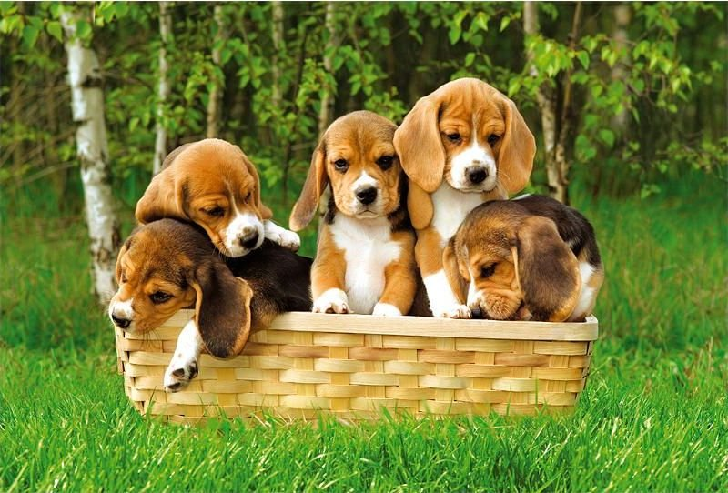
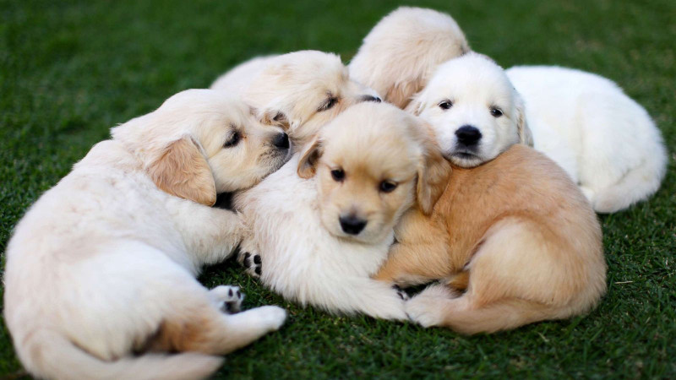
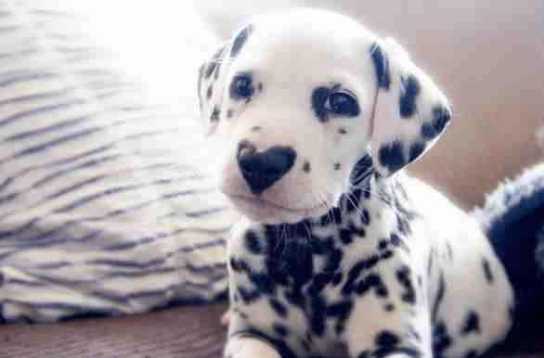

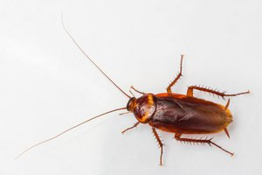
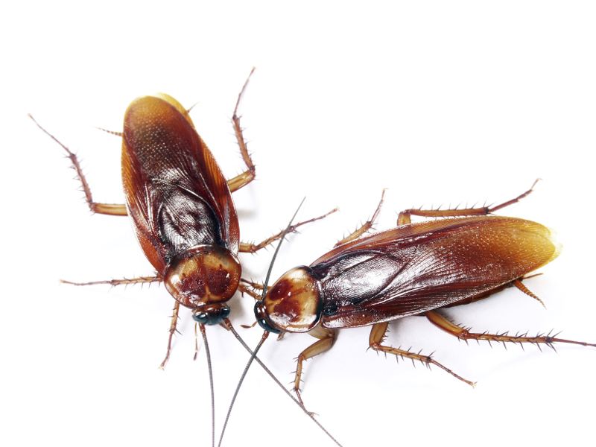
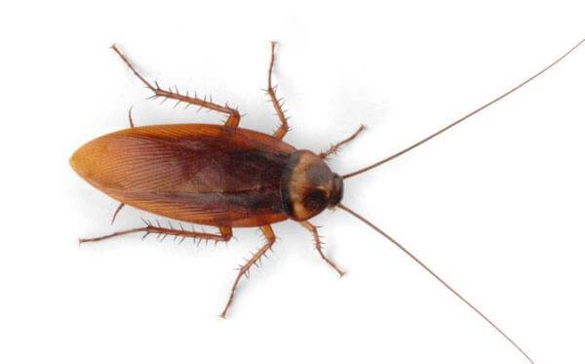
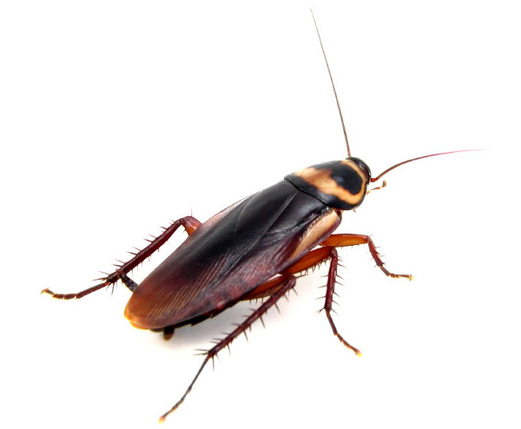
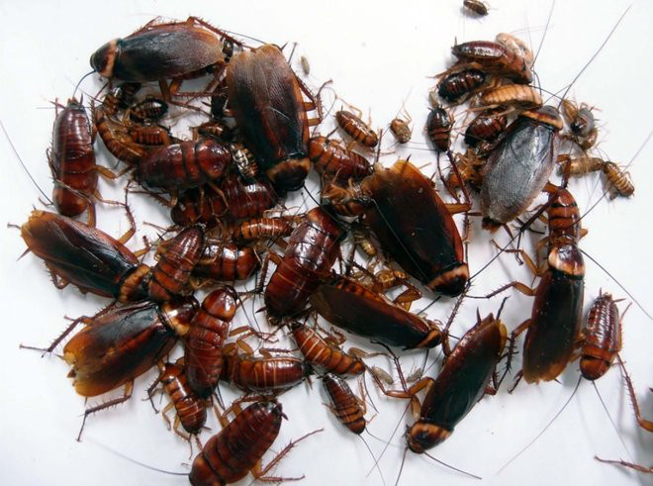
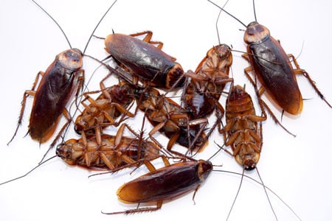
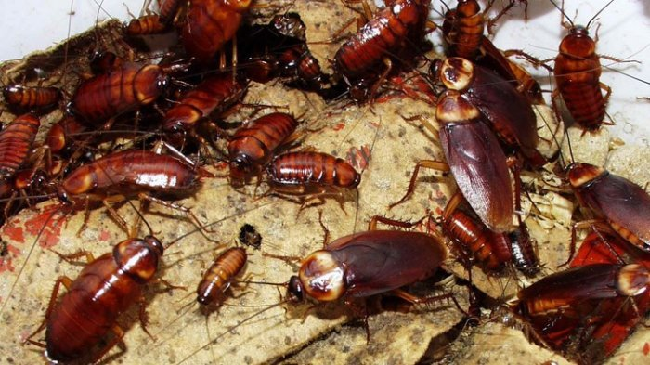
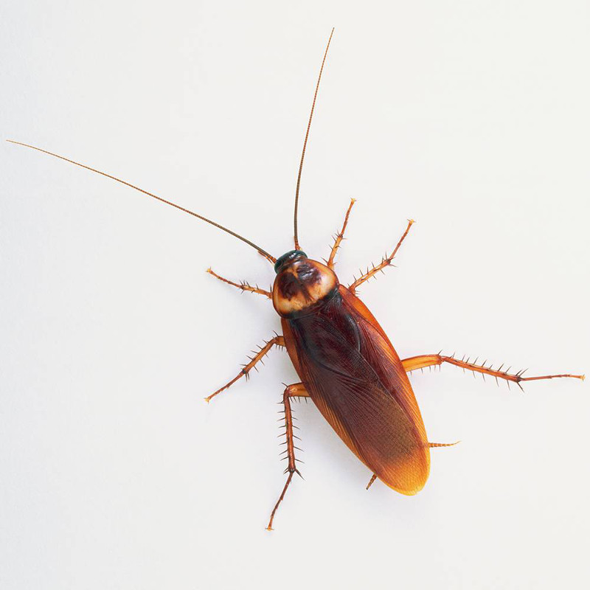
[page break]
What is your gender? (1=Male, 2=Female, 3=Other)
How old are you? ______________

Study A1 Materials

Events (1 of 5)
1. What is the most you would pay now to obtain four dollars immediately (no delay)?
$ ________________
2. What is the most you would pay now to obtain four dollars in three hours?
$________________
3. What is the most you would pay now to obtain four dollars in twenty-four hours?
$________________
4. What is the most you would pay now to obtain four dollars in three days?
$________________
5. What is the most you would pay now to obtain four dollars in one year?
$________________
6. What is the most you would pay now to obtain four dollars in ten years?
$________________

[page break]
Events (2 of 5)
1. What is the most you would pay now to avoid losing four dollars immediately (no delay)?
$________________
2. What is the most you would pay now to avoid losing four dollars in three hours?
$________________
3. What is the most you would pay now to avoid losing four dollars in twenty-four hours?
$________________
4. What is the most you would pay now to avoid losing four dollars in three days?
$________________
5. What is the most you would pay now to avoid losing four dollars in one year?
$________________
6. What is the most you would pay now to avoid losing four dollars in ten years?
$________________
[page break]
Events (3 of 5)
1. What is the most you would pay now to avoid losing one thousand dollars immediately (no delay)?
$________________
2. What is the most you would pay now to avoid losing one thousand dollars in three hours?
$________________
3. What is the most you would pay now to avoid losing one thousand dollars in twenty-four hours?
$________________
4. What is the most you would pay now to avoid losing one thousand dollars in three days?
$________________
5. What is the most you would pay now to avoid losing one thousand dollars in one year?
$________________
6. What is the most you would pay now to avoid losing one thousand dollars in ten years?
$________________
[page break]
Events (4 of 5)
1. What is the most you would pay now to avoid receiving a (non-lethal) one hundred and ten volt shock immediately (no delay)?
$________________
2. What is the most you would pay now to avoid receiving a (non-lethal) one hundred and ten volt shock in three hours?
$________________
3. What is the most you would pay now to avoid receiving a (non-lethal) one hundred and ten volt shock in twenty-four hours?
$________________
4. What is the most you would pay now to avoid receiving a (non-lethal) one hundred and ten volt shock in three days?
$________________
5. What is the most you would pay now to avoid receiving a (non-lethal) one hundred and ten volt shock in one year?
$________________
6. What is the most you would pay now to avoid receiving a (non-lethal) one hundred and ten volt shock in ten years?
$________________
[page break]
Events (5 of 5)
1. What is the most you would pay now to obtain a kiss from the movie star of your choice immediately (no delay)?
$________________
2. What is the most you would pay now to obtain a kiss from the movie star of your choice in three hours?
$________________
3. What is the most you would pay now to obtain a kiss from the movie star of your choice in twenty-four hours?
$________________
4. What is the most you would pay now to obtain a kiss from the movie star of your choice in three days?
$________________
5. What is the most you would pay now to obtain a kiss from the movie star of your choice in one year?
$________________
6. What is the most you would pay now to obtain a kiss from the movie star of your choice in ten years?
$________________
[page break]
Demographic Questionnaire
Please remember that all your answers will remain anonymous.
1. Your gender:
- Female
- Male
2. Your age:
________________years old
3. Your marital status:
- Single
- Living together
- Married
- Divorced or living separated
- Widowed
The first item below (question number four) is a test, to make sure you are reading these instructions. Please ignore the question and just write the word "reader" as your answer to number four. (We are keeping track of your time, so we know the answer to that question already.) Thank you for reading!
4. How long do you think you have spent on the survey so far? ________________
5. What is your annual household income?
- less than $14,999
- $15,000 - $24,999
- $25,000 - $34,999
- $35,000 - $49,999
- $50,000 - $99,999
- $100,000 - $199,999
- greater than $200,000
6. What is your highest completed level of education?
- No degree
- High school diploma
- Associate degree, occupational
- Associate degree, academic
- Bachelor's degree
- Master's degree
- Professional degree
- Doctoral degree
7. Which of the following categories best describes your current employment?
- No job / Unemployed
- Working in household
- Student
- Academic (teacher or researcher)
- Office worker
- Government employee
- Manager
- Entrepreneur
- Other
8. What is your primary ethnicity?
- Black or African American
- American Indian or Alaskan Native
- White
- Hispanic or Latin American
- Asian
- Other
9. Do you smoke cigarettes or otherwise use tobacco products? If so, how often?
- Never
- Rarely
- About once a month
- About once a week
- Daily, or almost every day

Study A2 Materials
[NOTE: The complete materials from this pair of studies have been lost. The only stimuli we have a record of are the stimuli that are reported in the methods description.]
[first study]
(1) What is the most you would be willing to pay for a kiss from your favorite movie star tonight?
(2) What is the most you would be willing to pay for a kiss from your favorite movie star three days from tonight?
(3) If you gave a different answer to the previous two questions, please explain why:
_________________________________________________________________________
[second study]
[Description of mealworms which was lost, something like the following:
Mealworms are the larval form of the mealworm beetle, Tenebrio molitor, a species of darkling beetle. Larvae typically measure about 2.5 cm or more, whereas adults are generally between 1.25 and 1.8 cm in length. Mealworms are edible for humans. Baked or fried mealworms are marketed as a healthy snack food.]
- Which would you prefer?
- Eat 9 mealworms today
- Eat 9 mealworms next week

- Which would you prefer?
- Eat 9 mealworms today
- Eat 8 mealworms next week

Study A3 Materials
Sports Participation
This survey is about receiving different amounts of money at different times. In order to demonstrate that you read instructions, please ignore the sports items below, as well as the continue button. Instead, simply click on the title at the top of this screen (i.e., "sports participation") to proceed to the next screen. Thank you very much.
Which of these activities do you engage in regularly?
(check all that apply)
- skiing
- soccer
- snowboarding
- running
- hockey
- football
- swimming
- tennis
- basketball
- cycling
[page break]
Gaining Money [(condition 1)]
1. Which would you choose?
- Receive $49 today
OR
- Receive $60 in 89 days
2. Imagine receiving $60 in 89 days. How positive or negative would the experience of the event be? (Note: you can click at any point on the line below to indicate your answer.)
3. Imagine expecting to receive $60 in 89 days. How psychologically pleasurable or displeasurable would the anticipation be? In other words, how would you feel while waiting for it?
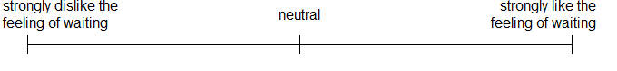
Which would you choose?
- Receive $25 today
OR
- Receive $30 in 80 days
[page break]
[This was followed by 26 additional questions varying in $ amount and time delay, in random order. Amounts and delays were the same as those used in Kirby, Petry, & Bickel (1999), as shown in the following table:
Q Num | SS | LL | Days
1 | $49 | $60 | 89
2 | $34 | $35 | 186
3 | $54 | $55 | 117
4 | $78 | $80 | 162
5 | $28 | $30 | 179
6 | $47 | $50 | 160
7 | $80 | $85 | 157
8 | $22 | $25 | 136
9 | $54 | $60 | 111
10 | $67 | $75 | 119
11 | $25 | $30 | 80
12 | $69 | $85 | 91
13 | $19 | $25 | 53
14 | $40 | $55 | 62
15 | $55 | $75 | 61
16 | $24 | $35 | 29
17 | $34 | $59 | 30
18 | $54 | $80 | 30
19 | $14 | $25 | 19
20 | $27 | $50 | 21
21 | $41 | $75 | 20
22 | $15 | $35 | 13
23 | $25 | $60 | 14
24 | $33 | $80 | 14
25 | $11 | $30 | 7
26 | $20 | $55 | 7
27 | $31 | $85 | 7
]

Losing Money [(condition 2)]
1. Which would you choose?
- Pay $49 today
OR
- Pay $60 in 89 days
2. Imagine paying $60 in 89 days. How positive or negative would the experience of the event be?(Note: you can click at any point on the line below to indicate your answer.)
3. Imagine expecting to pay $60 in 89 days. How psychologically pleasurable or displeasurable would the anticipation be? In other words, how would you feel while waiting for it?
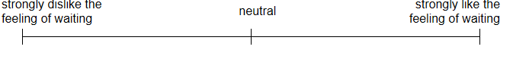
Which would you choose?
- Pay $55 today
OR
- Pay $75 in 61 days
[page break]
[This was followed by 26 additional questions varying in $ amount and time delay, in random order. Amounts and delays were the same as those used in Kirby, Petry, & Bickel (1999).]

Demographic Questionnaire
Please truthfully answer the following demographic questions about yourself.
1. Your gender:
- Female
- Male
2. What is your age?
________________years old
3. Your marital status:
- Single
- Living together
- Married
- Divorced or living separated
- Widowed
4. What is your annual household income? (optional)
- less than $14,999
- $15,000 - $24,999
- $25,000 - $34,999
- $35,000 - $49,999
- $50,000 - $99,999
- $100,000 - $199,999
- greater than $200,000
5. What is your highest completed level of education?
- No degree
- High school diploma
- Associate degree, occupational
- Associate degree, academic
- Bachelor's degree
- Master's degree
- Professional degree
- Doctoral degree
6. What is your primary ethnicity?
- American Indian or Alaskan Native
- Asian
- Black or African American
- Caucasian/White
- Hispanic or Latin American
- Other
7. What is your political affiliation?
- Democrat
- Republican
- Independent
- Libertarian
- Green
- Other
8. Do you smoke cigarettes or otherwise use tobacco products? If so, how often?
- Never
- Rarely
- About once a month
- About once a week
- Daily, or almost every day
9. Imagine that you had to pay an unexpected bill immediately. For example, suppose that you needed an expensive medical treatment that was not covered by insurance. Considering all possible resources available to you (including savings, borrowing, etc.), what is the maximum amount that you could come up with on short notice?
$________________

Study A4 Materials
Instructions
This survey is about choosing an air conditioner. On the following page, one question will ask how you would feel while waiting for something. In some cases, you may enjoy the process of waiting. For example, if a special holiday is a couple weeks away, the waiting may be pleasant. Other times, you may dislike the way you feel while waiting. For example, if you are waiting for a red light to turn green, the waiting may be unpleasant. In order to demonstrate that you read these instructions, please ignore the sports items below, as well as the continue button. Instead, simply click on the title at the top of this screen (i.e., "instructions") to proceed to the next screen. Thank you very much.
Which of these activities do you engage in regularly?
(check all that apply)
- skiing
- soccer
- snowboarding
- running hockey
- football
- swimming
- tennis
- basketball
- cycling

[page break]

Air Conditioner Purchase
Suppose you were choosing between two window air conditioners, described below:
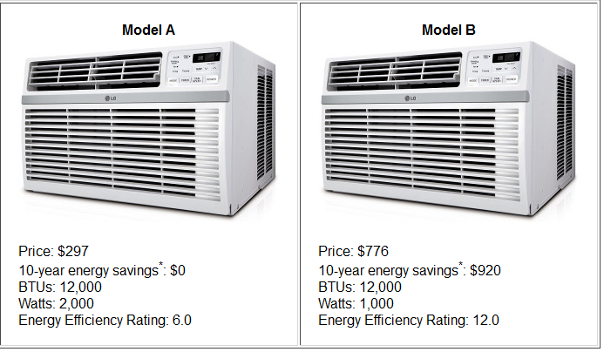
* Energy savings is the estimated difference in energy usage between the two AC units, based on 4 hours usage per day, 182 days per year, with an electricity rate of $0.1264 per kWh.
1. Which one would you choose?
- Model A
- Model B
2. A choice of Model B over Model A boils down to spending more money up front in exchange for saving money later. How would you feel while waiting for the future energy savings?
- Negative (Strongly dislike the feeling of waiting)
- Neutral (It is just a calculation; I'd feel nothing)
- Positive (Strongly like the feeling of waiting)

[page break]

Demographic Questionnaire
Please truthfully answer the following demographic questions about yourself.
1. Your gender:
- Female
- Male
2. What is your age?
________________years old
3. What is your primary ethnicity?
- American Indian or Alaskan Native
- Asian
- Black or African American
- Caucasian/White
- Hispanic or Latin American
- Other

Study A5 Materials

The following pages will ask questions about immediate and future gains and losses. When you see the word "immediate," it means the very near future -- today or tomorrow.
You will answer many questions about the following 20 events. Please read this list of events now:
- receiving a good grade or performance review
- giving a stressful 60 minute improvised speech
- watching your favorite TV show or reading a good book for an hour
- a confrontation with your co-worker or family member
- paying a $50 fine
- filling out paperwork and waiting around for an hour at the local Department of Motor Vehicles (DMV)
- winning the lottery
- receiving a $50 check
- a painful dental procedure
- spending time with your best friend
- a kiss from the movie star of your choice
- receiving a bad grade or performance review
- improved energy and health for 5 days
- eating a nice meal out at a restaurant
- getting a gift in the mail from a family member
- having one of your legs amputated
- being sick for 5 days
- a free 5-day vacation to the destination of your choice
- doing difficult home cleaning and renovation for 5 days
- getting twenty painful (but harmless) electric shocks in a research experiment

[page break]
Anticipation
Many of the following questions will ask how you would feel while waiting for things.
In some cases, you may enjoy the process of waiting. For example, if a special holiday is a couple weeks away, the waiting may be pleasant. Other times, you may dislike the way you feel while waiting. For example, if you are waiting for a red light to turn green, the waiting may be unpleasant.

[page break]
Please imagine the following event:
[watching your favorite TV show or reading a good book for an hour]
1. Assuming you knew this event were coming, when would you prefer it to happen? Immediately, or in one week?
- strongly prefer immediately
- probably immediately
- leaning towards immediately
- indifferent
- leaning towards in one week
- probably in one week
- strongly prefer in one week
2.a. Please imagine this event happening one week from now. Would experiencing this event be pleasurable or unpleasurable?
- pleasurable experience
- unpleasurable experience
2.b. How strongly would experiencing this event affect your feelings at that time?
(Note: you can click at any point on the line below to indicate your answer.)
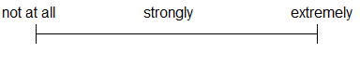
3.a. If this event were one week away, would the anticipation be psychologically pleasurable or unpleasurable? In other words, how would you feel while waiting for it?
- like the feeling of waiting
- dislike the feeling of waiting
3.b. How strongly would anticipating this event affect your feelings while waiting for the event?
[page break]
[the set of questions above were repeated for each of the 20 events described above, in random order.]
[page break]
Demographic Questionnaire
This section asks many demographic questions about yourself. Some of the questions are personal in nature (such as income and weight). Although you are not required to answer the sensitive questions, it will help this research project very much if you do so. Please remember that all your answers will remain anonymous.
1. Your gender:
- Female
- Male
2. Your age:
____ years old
3. Your marital status:
- Single
- Living together
- Married
- Divorced or living separated
- Widowed
4. How tall are you?
____ feet____inches
5. How much do you weigh?
____ pounds
The first item below (question number six) is a test, to make sure you are reading these instructions. Please ignore the question and just write the word "reader" as your answer to number six. (We are keeping track of your time, so we know the answer to that question already.) Thank you for reading!
6. How long did it take you to complete this survey?_________
7. What is your annual household income?
- less than $14,999
- $15,000 - $24,999
- $25,000 - $34,999
- $35,000 - $49,999
- $50,000 - $99,999
- $100,000 - $199,999
- greater than $200,000
8. What is your highest completed level of education?
- No degree
- High school diploma
- Associate degree, occupational
- Associate degree, academic
- Bachelor's degree
- Master's degree
- Professional degree
- Doctoral degree
9. Which of the following categories best describes your current employment?
- No job / Unemployed
- Working in household
- Student
- Academic (teacher or researcher)
- Office worker
- Government employee
- Manager
- Entrepreneur
- Other
10. How many children do you have? _________
11. What is your primary ethnicity?
- Black or African American
- American Indian or Alaskan Native
- White
- Hispanic or Latin American
- Asian
- Other
12. What is your political affiliation?
- Democrat
- Republican
- Independent
- Libertarian
- Green
- Other
13. Do you smoke cigarettes or otherwise use tobacco products? If so, how often?
- Never
- Rarely
- About once a month
- About once a week
- Daily, or almost every day

Study A6 Materials

Introduction
The following pages will ask questions about immediate and future gains and losses. When you see the word "immediate," it means the very near future -- today or tomorrow.
[page break]
Anticipation
Many of the following questions will ask how you would feel while waiting for things.
In some cases, you may enjoy the process of waiting. For example, if a special holiday is a couple weeks away, the waiting may be pleasant. Other times, you may dislike the way you feel while waiting. For example, if you are waiting for a red light to turn green, the waiting may be unpleasant.
[page break]

Please imagine the following event:
[event text here]
1. Assuming this event would definitely happen to you and you knew it were coming, when would you prefer it to happen?
- immediately OR
- don't care when OR
- one week [one month][one year][five years][three days] from now
2. If this event were to happen to you one week from now, how positive or negative would the event be at that time?
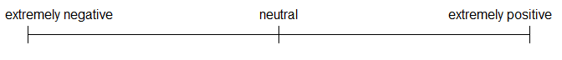
3. If this event were one week away, how psychologically pleasurable or unpleasurable would the anticipation be? In other words, how would you feel while waiting for it?
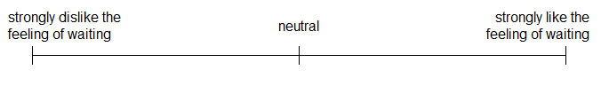
[page break]
[These same questions were repeated for each of the following 20 events (in random order):
- filling out paperwork and waiting around for an hour at the local Department of Motor Vehicles (DMV)
- getting twenty painful (but harmless) electric shocks in a research experiment
- a confrontation with your co-worker or family member
- winning the lottery
- a painful dental procedure
- a kiss from the movie star of your choice
- receiving a good grade or performance review
- improved energy and health for 10 days
- doing difficult home cleaning and renovation for 5 days
- having one of your legs amputated
- spending time with your best friend
- receiving a bad grade or performance review
- eating a nice meal out at a restaurant
- giving a stressful 60 minute improvised speech
- paying a $50 fine
- being sick for 10 days
- receiving a $50 check
- a free 5-day vacation to the destination of your choice
- watching your favorite TV show or reading a good book for an hour
- getting a gift in the mail from a family member
]
Imagine you have a rare medical condition and your doctor tells you that you need to take medicine that will make you sick for several days with a headache, low energy, and nausea. You have a choice between beginning doing the treatment immediately and being sick for 10 days, or doing the treatment one week from now and being sick for a different length of time. Either way, the long term benefits will be the same. Please choose which option you would prefer in each pair:
- 10 day sickness starting immediately OR
- 6 day sickness starting one week [three days][one month][one year][five years] from now

- 10 day sickness starting immediately OR
- 8 day sickness starting one week [three days][one month][one year][five years] from now

- 10 day sickness starting immediately OR
- 10 day sickness starting one week [three days][one month][one year][five years] from now

- 10 day sickness starting immediately OR
- 12 day sickness starting one week [three days][one month][one year][five years] from now

- 10 day sickness starting immediately OR
- 14 day sickness starting one week [three days][one month][one year][five years] from now

Please fill in the blank below so that the two options seem equally attractive (or equally unattractive) to you:
- 10 day sickness starting immediately OR
- ____ day sickness starting one week [three days][one month][one year][five years] from now

[page break]
Imagine that you win a free vacation to the destination of your choice. Your schedule and work and home responsibilities are light (or can wait) so you are happy to take it. You are offered the choice between a 5 day vacation beginning immediately or a vacation one week from now for a different length of time. Please choose which option you would prefer in each pair:

- 5 day vacation starting immediately OR
- 3 day vacation starting one week [three days][one month][one year][five years] from now

- 5 day vacation starting immediately OR
- 4 day vacation starting one week [three days][one month][one year][five years] from now

- 5 day vacation starting immediately OR
- 5 day vacation starting one week [three days][one month][one year][five years] from now

- 5 day vacation starting immediately OR
- 6 day vacation starting one week [three days][one month][one year][five years] from now

- 5 day vacation starting immediately OR
- 7 day vacation starting one week [three days][one month][one year][five years] from now

Please fill in the blank below so that the two options seem equally attractive (or equally unattractive) to you:
- 5 day vacation starting immediately OR
- ____ day vacation starting one week [three days][one month][one year][five years] from now

[page break]
Imagine that a city building inspector informs you that your house or apartment needs cleaning and renovations to comply with the city building codes. Many of these chores will be difficult -- for example, the insulation in the ceilings must be replaced. Even if you hire someone else to do the work, you will need to be around to supervise, and the renovations will be a major disruption in your home. The building inspector gives you a choice between making a number of changes immediately, that will require about 5 days of work, or doing different changes one week from now, which would require a different amount of time. Please choose which option you would prefer in each pair:
- 5 days of housework starting immediately OR
- 3 days of housework starting one week [three days][one month][one year][five years] from now

- 5 days of housework starting immediately OR
- 4 days of housework starting one week [three days][one month][one year][five years] from now

- 5 days of housework starting immediately OR
- 5 days of housework starting one week [three days][one month][one year][five years] from now

- 5 days of housework starting immediately OR
- 6 days of housework starting one week [three days][one month][one year][five years] from now

- 5 days of housework starting immediately OR
- 7 days of housework starting one week [three days][one month][one year][five years] from now

Please fill in the blank below so that the two options seem equally attractive (or equally unattractive) to you:
- 5 days of housework starting immediately OR
- ____days of housework starting one week [three days][one month][one year][five years] from now
[page break]
Imagine that your local department of motor vehicles (DMV) or city hall has made an error, and you need to go in and fill out some bureacratic paperwork. The office is crowded and inefficient, and they estimate the paperwork will take 60 minutes if you come in immediately. They are also giving you the option to do the paperwork one week from now, when the paperwork will take a different length of time, due to differences in the staff on hand. Please choose which option you would prefer in each pair:

- 60 minutes of paperwork immediately OR
- 36 minutes of paperwork one week [three days][one month][one year][five years] from now

- 60 minutes of paperwork immediately OR
- 48 minutes of paperwork one week [three days][one month][one year][five years] from now

- 60 minutes of paperwork immediately OR
- 60 minutes of paperwork one week [three days][one month][one year][five years] from now

- 60 minutes of paperwork immediately OR
- 72 minutes of paperwork one week [three days][one month][one year][five years] from now

- 60 minutes of paperwork immediately OR
- 84 minutes of paperwork one week [three days][one month][one year][five years] from now

Please fill in the blank below so that the two options seem equally attractive (or equally unattractive) to you:
- 60 minutes of paperwork immediately OR
- ____minutes of paperwork one week [three days][one month][one year][five years] from now

[page break]
Imagine you have to pay a fine for a parking ticket or other minor legal infraction. The city government is giving you the option of paying $50 immediately, or a different amount one week from now. Please choose which option you would prefer in each pair:

- Pay $ 50 immediately OR
- Pay $ 30 one week [three days][one month][one year][five years] from now

- Pay $ 50 immediately OR
- Pay $ 40 one week [three days][one month][one year][five years] from now

- Pay $ 50 immediately OR
- Pay $ 50 one week [three days][one month][one year][five years] from now

- Pay $ 50 immediately OR
- Pay $ 60 one week [three days][one month][one year][five years] from now

- Pay $ 50 immediately OR
- Pay $ 70 one week [three days][one month][one year][five years] from now

Please fill in the blank below so that the two options seem equally attractive (or equally unattractive) to you:
- Pay $ 50 immediately OR
- Pay $____ one week [three days][one month][one year][five years] from now

[page break]
Imagine that you agree to participate in a research experiment that involves electric shocks. The experimenters are giving you the option between receiving 20 painful (but harmless) shocks immediately or a different number of shocks one week from now. Please choose which option you would prefer in each pair:

- 20 painful shocks immediately OR
- 12 painful shocks one week [three days][one month][one year][five years] from now

- 20 painful shocks immediately OR
- 16 painful shocks one week [three days][one month][one year][five years] from now

- 20 painful shocks immediately OR
- 20 painful shocks one week [three days][one month][one year][five years] from now

- 20 painful shocks immediately OR
- 24 painful shocks one week [three days][one month][one year][five years] from now

- 20 painful shocks immediately OR
- 28 painful shocks one week [three days][one month][one year][five years] from now

Please fill in the blank below so that the two options seem equally attractive (or equally unattractive) to you:
- 20 painful shocks immediately OR
- ____painful shocks one week [three days][one month][one year][five years] from now

[page break]
Imagine you won a prize in a raffle. The raffle commission is giving you the option of receiving $50 immediately, or a different amount one week from now. Please choose which option you would prefer in each pair:

- Get $ 50 immediately OR
- Get $ 30 one week [three days][one month][one year][five years] from now

- Get $ 50 immediately OR
- Get $ 40 one week [three days][one month][one year][five years] from now

- Get $ 50 immediately OR
- Get $ 50 one week [three days][one month][one year][five years] from now

- Get $ 50 immediately OR
- Get $ 60 one week [three days][one month][one year][five years] from now

- Get $ 50 immediately OR
- Get $ 70 one week [three days][one month][one year][five years] from now

Please fill in the blank below so that the two options seem equally attractive (or equally unattractive) to you:
- Get $ 50 immediately OR
- Get $____ one week [three days][one month][one year][five years] from now

[page break]
Imagine your doctor has free trials of a new, safe drug that will give you energy and a sense of well-being, without any negative side effects, but it only lasts a short time. He can give you a dose immediately, or a different dose one week from today that will last a different amount of time. Please choose which option you would prefer in each pair:

- 10 days of increased energy immediately OR
- 6 days of increased energy one week [three days][one month][one year][five years] from now

- 10 days of increased energy immediately OR
- 8 days of increased energy one week [three days][one month][one year][five years] from now

- 10 days of increased energy immediately OR
- 10 days of increased energy one week [three days][one month][one year][five years] from now

- 10 days of increased energy immediately OR
- 12 days of increased energy one week [three days][one month][one year][five years] from now

- 10 days of increased energy immediately OR
- 14 days of increased energy one week [three days][one month][one year][five years] from now

Please fill in the blank below so that the two options seem equally attractive (or equally unattractive) to you:
- 10 days of increased energy immediately OR
- ____days of increased energy one week [three days][one month][one year][five years] from now

[page break]
Imagine that your best friend wants to spend time with you and can travel to see you, but he/she is very busy and is only available immediately or in one week. Your friend can either spend 2.5 hours with you immediately, or a different amount of time one week from now. Please choose which option you would prefer in each pair:

- 2.5 hours immediately OR
- 1.5 hours one week [three days][one month][one year][five years] from now

- 2.5 hours immediately OR
- 2 hours one week [three days][one month][one year][five years] from now

- 2.5 hours immediately OR
- 2.5 hours one week [three days][one month][one year][five years] from now

- 2.5 hours immediately OR
- 3 hours one week [three days][one month][one year][five years] from now

- 2.5 hours immediately OR
- 3.5 hours one week [three days][one month][one year][five years] from now

Please fill in the blank below so that the two options seem equally attractive (or equally unattractive) to you:
- 2.5 hours immediately OR
- ____hours one week [three days][one month][one year][five years] from now

[page break]
Imagine that, as a birthday present, a friend of yours will take care of your chores so that you can just sit and watch TV or read a good book, guilt free. You friend offers to do this immediately, for 60 minutes, or one week from today, for a different length of time. Please choose which option you would prefer in each pair:

- 60 minutes of TV/reading immediately OR
- 36 minutes of TV/reading one week [three days][one month][one year][five years] from now

- 60 minutes of TV/reading immediately OR
- 48 minutes of TV/reading one week [three days][one month][one year][five years] from now

- 60 minutes of TV/reading immediately OR
- 60 minutes of TV/reading one week [three days][one month][one year][five years] from now

- 60 minutes of TV/reading immediately OR
- 72 minutes of TV/reading one week [three days][one month][one year][five years] from now

- 60 minutes of TV/reading immediately OR
- 84 minutes of TV/reading one week [three days][one month][one year][five years] from now

Please fill in the blank below so that the two options seem equally attractive (or equally unattractive) to you:
- 60 minutes of TV/reading immediately OR
- ____ minutes of TV/reading one week [three days][one month][one year][five years] from now

[page break]
Thoughts and Motivation
This page is a test, to confirm that you are reading the instructions carefully. For the three questions which follow this paragraph, please give the following answer to each question: reader. Please just ignore the text of the questions, and type the word reader as your answer for all three items. Thank you for reading carefully.
1. On average, how many times a day do you think about getting something you want? Please give your best estimate: ________________
2. On average, how many times a day do you think about avoiding something unpleasant? Please give your best estimate: ________________
3. On average, how many times a day do you think about things you need to do? Please give your best estimate: ________________

[page break]

Below are 3 problems that vary in difficulty. Try to answer as many as you can.

1. A bat and a ball cost $1.10 in total.
The bat costs $1.00 more than the ball.
How much does the ball cost?
________________cents
Only numbers may be entered in this field

2. If it takes 5 machines 5 minutes to make 5 widgets, how long would it take 100 machines to make 100 widgets?
________________minutes
Only numbers may be entered in this field

3. In a lake, there is a patch of lily pads.
Every day, the patch doubles in size.
If it takes 48 days for the patch to cover the entire lake, how long would it take for the patch to cover half of the lake?
________________days

[page break]

Demographics
Gender
- Female
- Male
Month of Birth
Choose one of the following answers
- January
- February
- March
- April
- May
- June
- July
- August
- September
- October
- November
- December

Year of birth (i.e. 1945): ________________

Marital Status
Choose one of the following answers
- Single
- Living together
- Married
- Divorced or living separated
- Widowed

Household income
Choose one of the following answers
- less than $10,000
- $10,000 - $19,999
- $20,000 - $34,999
- $35,000 - $49,999
- $50,000- $99,999
- $100,000 - $199,999
- greater than $200,000
- No answer

Do you smoke?
- Yes
- No

What is your highest level of education?
Choose one of the following answers
- No degree
- High school diploma
- Associate degree, occupational
- Associate degree, academic
- Bachelor's degree
- Master's degree
- Professional degree
- Doctoral degree

How many children do you have? ________________
Only numbers may be entered in this field

Race
Check all that apply
- Black or African American
- American Indian or Alaskan Native
- White
- Hispanic
- Asian
- Hawaiian or Pacific Islander
- Other

Which of the following describes your current employment?
Choose one of the following answers
- No job/unemployed
- Working in household
- Student
- Worker/farmer
- Civil servant/employee
- Manager
- Entrepreneur
- Teacher
- Researcher
- Doctor, Nurse, or other medicine related
- Retired
- Other

What is your political affiliation?
Choose one of the following answers
- Democrat
- Independent
- Republican
- Other

Study A7 Materials
[Note that this study involved two experimental sessions, one week apart.]
[T1 Survey]
Jelly Bean Study
This next study involves eating a jelly bean, that might be delicious or might be gross. As always, participation is voluntary. Are you willing to eat a jelly bean for this next study?
Yes
No
[page break]
You have been assigned to eat a ["toasted marshmallow"] ["dirt"] flavored jelly bean. However, you will have to wait until one week from now to eat it.
1.a. As you think about eating the jellybean, how happy or pleasurable do you think the experience will be? (Note: you can click at any point on the line below to indicate your answer.)
neutral | extremely like  the experience
1.b. As you think about eating the jellybean, how displeasurable or unhappy do you think the experience will be?
neutral | extremely dislike  the experience
2.a. As you think about the jellybean, how pleasurable or happy is the anticipation? In other words, how do you feel while waiting for it?
neutral | extremely like the  feeling of waiting
2.b. As you think about the jellybean, how displeasurable or unhappy is the anticipation? In other words, how do you feel while waiting for it?
neutral | extremely dislike the  feeling of waiting

[page break]
Demographic Questionnaire
Please truthfully answer the following demographic questions about yourself.
1. Your gender:
Female
Male
Other
2. What is your age?
years old
3. What is your primary ethnicity?
Aboriginal or Native American
Asian
Black or African American
Caucasian or White
Hispanic or Latin American
Other
[page break]
[T2 Survey]
For this next study, you will eat a jellybean of the following flavor:
[toasted marshmallow] [dirt]
Please tell the experimenter that you are ready for the jellybean.
[page break]
Jelly Bean Study
Please eat the ["toasted marshmallow"] ["dirt"] flavored jelly bean.
a. As you eat the jellybean, how happy or pleasurable is the experience? (Note: you can click at any point on the line below to indicate your answer.)
neutral | extremely like  the experience
b. As you eat the jellybean, how displeasurable or unhappy is the experience?
neutral | extremely dislike  the experience

Alternative data analyses

Study 3: Controlling for subjective value
Method
Twenty-eight participants failed the attention check, but are included in the following analyses.
Creating matched pairs
... Items for which this procedure could not create indifference for a given participant were excluded from the analysis. (For the five pairs of events, this occurred, respectively 5%, 10%, 2%, 3% and 28% of the time.)
Results
Event Pair Titration
It took participants an average of 6.5 questions (SD=3.6) to reach their indifference point on each pair. Indifference points for each pair were positively skewed, so we report both the means and the medians in Table 2. Notably, the median participant was indifferent about playing a gamble with a 50% chance to lose $25 and 50% chance to gain $55, roughly replicating the 2:1 ratio typically found for loss aversion (Kahneman and Tversky 1979).
Table 2
Mean and median indifference points, average experience utility (-100 to 100), anticipation utility (-100 to 100), and time preference (1 = immediately, 0 = indifferent, -1 = in one week) for each event in Study 3.
Event |  | Experience Utility |  | Anticipation Utility |  | Now Preference
Gain | Loss | Gain | Loss | Gain | Loss | Gain | Loss
50% chance of receiving [M=$103, Mdn=$55] | 50% chance of paying $25 | 37 | -37 | -13 | -17 | .90 | -.16
get a free, relaxing massage for 50 minutes | spend time stuck in horrible traffic for [M=68, Mdn=50] minutes | 53 | -54 | 6 | -27 | .26 | -.16
watch really funny TV program for 30 minutes | watch boring, annoying commercials for [M=19, Mdn=13] minutes | 34 | -28 | -4 | -15 | .72 | .28
70% chance of receiving [M=$105, Mdn=$30] | do a really boring online survey for 90 minutes | 33 | -37 | -18 | -16 | .88 | .22
a complimentary dinner at a restaurant of your choice | endure [M=65, Mdn=10] mild (and harmless) electric shocks | 49 | -47 | 17 | -32 | .02 | .54

Ratings of Experience Utility
For data analysis, we converted the two questions on experience utility (positive or negative and then 0 to 100) into a single -100 to 100 scale, with the means summarized in Table 2. Participants rated the experience utility of positive and negative events to be of similar magnitude (ie, not statistically different) for all five pairs, as would be expected because those events were individually titrated and tailored for each participant.
Ratings of Anticipation Utility
On the first question, asking whether anticipation was positive or negative, negative events induced dread more frequently (74%) than positive events brought pleasurable anticipation (48%), a significant difference as confirmed with a mixed model test, F(1,1338)=131.3, p<.001. Moreover, pairwise proportion tests confirmed that pairs one through four all showed the predicted effect, p < .01 or lower, while the fifth pair showed a non-significant difference in the predicted direction (z=1.5, p=.12). To compare the intensity of dread versus pleasurable anticipation, we compared only positive anticipation ratings of gains with negative anticipation ratings of losses, and the average intensity of dread exceed the average intensity of pleasurable anticipation (M=-39.5 vs. 34.9; F(1,726)=9.9, p<.01). Moreover, the interaction of sign and pair was not significant, F(1,726)=1.2, p=.31, indicating that the difference between gains and losses was roughly equal for all five pairs.
For an overall summary, we converted the two questions on anticipation utility (positive or negative and 0 to 100) into a single -100 to 100 scale, with the means summarized in Table 2. The anticipation asymmetry was confirmed for each pair with a series of paired t-tests (reverse scoring the anticipation ratings for losses). In every case, the difference was significant at p = .01 or lower.
Time Preference
As shown in Table 2, people generally preferred to have the positive events right away. (The exception was the complimentary dinner out, which half the participants preferred to have right away, and half preferred to postpone for a week.) In contrast, people's desire to postpone the negative events was much weaker, and in fact they often preferred the immediate loss. This difference between gains and losses was significant, F(1,1208)=212.8, p<.001, replicating the sign effect.
Ratings of anticipation utility predicted time preference, replicating the results of Studies 1 and 2, F(1,1198)=47.4, p<.001. In other words, the more participants enjoyed anticipating a positive event, the more likely they were to choose to delay it, and the more participants dreaded a negative event, the more likely they were to choose to have it immediately, consistent with Loewenstein (1987). This power of anticipation ratings to predict time preferences was equally true for different types of outcomes: there was no interaction with sign or with event pair, nor was there a three-way interaction (all ps > .18).

Study 4: Understanding the anticipation asymmetry
Results
Thirty-six participants failed the attention check, but are included in the following analyses.
Time preference
We replicated the sign effect in intertemporal choice. Averaging across all 20 events, participants generally preferred to have gains now (M = 1.4, SD = 0.9) but were neutral as to the timing of losses (M = -.2, SD = 1.4), a significant difference (reverse scoring the losses), t(104) = 8.0, p < .001, d = 0.8. Focusing on the $50 gain and $50 loss scenarios, participants showed the same pattern, preferring gains now (M = 2.4, SD = 1.2) and losses later (M = -.1, SD = 2.5), t(68) = 7.3, p < .001, d = 0.8.
Anticipation utility
Participants reported a mixture of positive and negative anticipation for positive events, but reported mainly negative anticipation for negative events. Figure 3 shows the results for the matched $50 gain and $50 loss scenarios. When considering receiving $50 in a week, participants felt some positive anticipation and some negative anticipation. In contrast, when considering losing $50 in a week, participants felt notable negative anticipation, but little positive anticipation. This difference between the anticipation of the positive and negative events was confirmed by swapping the positive and negative anticipation scores for negative events and then examining the interaction term for the 2x2, which was significant, F(1,104) = 24.4, p < .001, η² = .19.
Figure 3
Average positive and negative anticipation for a future $50 gain and $50 loss, in Study 4. Error bars show +/- one standard error.

This same pattern was seen across the full set of 20 events. Averaging the 10 gain events, participants felt some positive anticipation (M = 49, SD = 24) and some negative anticipation (M = 29, SD = 25). In contrast, when averaging the 10 loss events, participants felt notable negative anticipation (M = 63, SD = 20), but little positive anticipation (M = 14, SD = 15). This difference between differences was confirmed by swapping the positive and negative anticipation scores for negative events and examining the interaction term, which was significant, F(1,104) = 70.7, p < .001, η² = .41.
Mixed anticipation
The results above suggest that anticipation of gains is a mixed emotional experience. However, it is possible that some people experience positive anticipation of gains and other people experience negative anticipation of gains, and no one person experiences both at once. Therefore, we developed a measure of "mixed" anticipation: a participant is said to experience mixed anticipation for an event that elicits at least 10 (out of 100) positive anticipation and at least 10 (out of 100) negative anticipation for that same event. When considering a future $50 gain, 40% of participants reported mixed anticipation, while when considering a future $50 loss, 25% of participants reported mixed anticipation, a significant difference, t(104) = 2.7, p = .01. Likewise, averaging across all 20 gain events, participants reported mixed anticipation for 34% of positive experiences, as compared to 22% for the negative experiences, t(104) = 5.4, p < .001. We conducted a sensitivity analysis and found similar results: when the threshold for "mixed anticipation" is set to 5 (out of 100), 43% report mixed anticipation of gains and 27% report mixed anticipation of losses, t(104) = 6.9, p < .001. When the threshold is set to 20 (out of 100), 22% report mixed anticipation of gains, and 15% report mixed anticipation of losses, t(104) = 3.6, p < .001.

Study 5: Real anticipation, Additional Analyses
Results
A notable subset of participants had unusual predictions, predicting that they would dislike the toasted marshmallow jellybean (i.e., negative utility equal or greater than positive utility for eating the marshmallow) or enjoy the dirt jellybean (i.e., positive utility equal or greater than negative utility for eating the dirt). Specifically, 21% of those considering the toasted marshmallow flavor indicated they would dislike the experience, and 32% of those considering the dirt flavor indicated they would like it. These ratings could be the result of inattention (not noticing the jelly bean flavor or answering randomly) or unusual tastes (disliking sweet overly sweet things such as marshmallow flavor, or liking novel flavors such as dirt flavor). Therefore, we have excluded these participants from the analyses below, leaving 65 participants in the positive condition and 69 in the negative condition.
Predicted experience utility
As summarized in the first row of Table 3, participants predicted that eating the toasted marshmallow flavored jellybean would be an equally good experience as the dirt flavored jellybean would be a bad experience. For each flavor, we subtracted the two ratings (negative and positive) to get a single measure of experience utility for that flavor. As expected (due to pretesting), the predicted experience utility of the dirt (mean = -57.4, SD = 28.9) and toasted marshmallow (mean = 50.6, SD = 26.5) jellybeans were quite similar. Reverse scoring the dirt scores, the predicted experience utility ratings were not significantly different, t(132) = 1.5, p = .13, d = 0.27.
Table 3. Means (with SDs in parentheses) of utility ratings for eating a toasted marshmallow flavored or dirt flavored jellybean in Study 5, with particiants excluded who liked dirt or disliked marshmallows.
 | Marshmallow |  | Dirt
 | Positive | Negative | Positive | Negative
T1 Predicted experience utility | 60.1  (24.4) | 9.6  (11.7) | 7.1  (12.0) | 65.0  (26.2)
T1 Actual anticipation utility | 32.6  (28.3) | 24.8  (22.9) | 13.7  (21.6) | 47.1  (37.1)
T2 Actual experience utility | 65.0  (23.8) | 6.1  (12.3) | 12.9  (20.6) | 56.6  (37.5)

Actual anticipation utility
The anticipation ratings are summarized in the second row of Table 3. Again, we combined the positive and negative anticipation ratings for each flavor into a single measure of anticipation utility. Replicating the results of previous studies, participants reported dreading the dirt flavored jellybean (mean = -33.4, SD = 41.4) more than enjoying anticipation of the toasted marshmallow jellybean (mean = 7.8, SD = 27.2). Reverse scoring the ratings for dirt flavor, this was a significant difference, t(132) = 2.6, p < .01, d = 0.40.
As in Study 4, a participant is said to experience mixed anticipation for an event that elicits at least 10 (out of 100) positive anticipation and at least 10 (out of 100) negative anticipation for that same event. When considering the toasted marshmallow flavor, 88% of participants reported mixed anticipation, while when considering the dirt flavor, 29% of participants reported mixed anticipation, a significant difference, t(132) = 8.5, p < .001. When the threshold for "mixed anticipation" is set to 5 (out of 100), 79% report mixed anticipation of marshmallow and 41% report mixed anticipation of dirt, t(132) = 5.7, p < .001. When the threshold is set to 20 (out of 100), 31% report mixed anticipation of marshmallow, and 17% report mixed anticipation of dirt, t(132) = 1.8, p = .07.
Actual experience utility
Although not relevant to our hypotheses, at T2 we asked participants to rate the actual experience of eating the jellybean, as seen in the third row of Table 3. Again combining the positive and negative ratings for each flavor, we see that participants enjoyed eating the toasted marshmallow flavor (mean = 58.9, SD = 27.4) more than they disliked eating the dirt flavor (mean = -43.6, SD = 52.4). Reverse scoring the dirt flavor, this was a significant difference, t(124) = 2.0, p = .04, d = 0.38.

