Moments that Last:
Meaningfulness Slows Happiness Decay

RHIA CATAPANO DAVID HARDISTY JENNIFER AAKER

Abstract
Previous research suggests that in general, happiness is fleeting, and the happiness gained from reflecting on a past experience decreases with time. However, little is known about how to change this trajectory. The results of four field and laboratory experiments reveal that one important factor in the trajectory of happiness is meaning, which can serve as both a moderator and mediator of happiness decay. In general, the happiness gained from reflecting on a past experience decays rapidly – sometimes even after a single day. However, these happiness decay patterns are mitigated when moments are more meaningful. Meaningfulness slows happiness decay, which in turn increases consumer purchase intent. Finally, this process can be facilitated by focusing on meaning through connection with others, which increases meaning, thereby decreasing happiness decay.

Imagine that you are home for the holidays and deciding which activities you should spend your vacation on. You could spend time with your family or old friends, or you could spend a personal day at the spa for some much needed relaxation. How should you make this decision, in order to maximize your own happiness? What if you want to maximize happiness not only in the moment, but weeks later, when you have returned “back to the grind”?
The present research explores this question of how to maximize the long-term happiness from an experience. Although consumers frequently make decisions with the goal of maximizing their own happiness (Chang and Pham 2003; Mogilner, Aaker and Kamvar 2012; Mogilner, Aaker and Kamvar, 2011), little is known about the experience of happiness over time. What we do know indicates that generally, happiness is fleeting and difficult to hold on to. In most circumstances, people adapt to positive experiences and outcomes, whether it’s winning the lottery, a promotion, relationships, a recent purchase, or even watching an episode of a TV show (Brickman et al 1978; Boswell, Boureau, and Tichy 2005; Bao and Lyubomirsky 2013; Nelson, Meyvis and Galak 2009, Nicolao, Irwin and Goodman 2009). This phenomenon is known as hedonic adaptation (Frederick and Loewenstein 1999).
Previous research suggests a few ways to decrease adaptation. Specifically, giving up something that is enjoyed, breaking up an experience, or seeing sentimental value can all decrease adaptation to a repeated stimulus (Quoidbach and Dunn 2013; Nelson and Meyvis 2008; Yang and Galak 2015). However, all of these cases explore preventing hedonic adaptation in response to a repeated stimulus, commonly referred to as satiation (Nelson and Meyvis 2008). Little work has explored how to prevent hedonic adaptation in the context of a single experience, and how to derive happiness from the experience for longer. To differentiate between the category of adaptation discussed herein and other forms, such as satiation, we will refer to this kind of adaptation in response to a single, non-repeated experience, as happiness decay. In previous work on this type of hedonic adaptation, researchers find that experiential purchases are less susceptible to happiness decay than material purchases (Nicolao, Irwin and Goodman 2009). However, this previous work has not addressed the question of which experiential purchases are less susceptible to happiness decay, thereby resulting in more prolonged happiness.
Understanding what experiences provide long-term happiness has a number of practical and theoretical implications. From a theoretical perspective, it contributes to a growing body of literature on how to prevent hedonic adaptation, in order to increase long-term happiness. This knowledge is also important for consumers, who often try to maximize not only their short-term outcomes, but also long-term outcomes (Shiv 1999). With slogans emerging like “fewer, better things,” (Cuyana, 2017), more and more companies are trying to leverage this consumer desire for long-term value in their products. By slowing happiness decay, companies can better serve their customers by increasing the value of their products. Further, from a policy perspective, this research aims to provide insight into ways to help consumers get off the purchase treadmill. Stepping off the purchase treadmill is particularly important given the prevalence of overspending, whereby some consumers overspend hoping that each purchase will transform their lives, but instead finding that the positive emotions from each new purchase fade quickly (Richins, 2013).
In this paper, we suggest that one way to prolong happiness is through meaning. Meaningful experiences are generally considered to be those that move individuals toward important goals by connecting them to other points in time, to other people, or to the world more broadly (Baumeister et al., 2013, Deci and Ryan 2008). The extent to which a particular experience is meaningful is based on whether it is fulfilling, worthwhile, purposeful, and important to the individual (Carter and Williams 2016). A growing body of research suggests that actions and activities that are meaningful may be associated with lasting positive consequences. While these actions and activities are often less pleasurable than other alternatives, often involving some form of cost or pain, they give people a sense of purpose and allow them to connect to something larger than the present moment (Bronk 2014; Carter and Williams 2016), two elements that may be key to stepping off of the hedonic treadmill.
To explore the role of meaning in the time-course of happiness, we ran four studies in the field and laboratory. The results suggest that although the happiness derived from an experience decays with time, happiness decays to a lesser extent for meaningful experiences. In addition, happiness decay is not only linked to specific experiences, but can be affected by both individual differences in the meaningful content of the experience, and shifts in focus to meaningful elements of an experience. Specifically, we find that focusing on meaning through connection with others throughout an experience increases the level of meaning experienced, which in turn decreases happiness decay. Furthermore, these decreases in happiness decay improve consumer outcomes such as purchase intent. In addition, the impact of meaningfulness was examined through both moderation (studies 2-4) and mediation (studies 3 and 4) for convergent validity. Together, these results illuminate the role of meaning in slowing happiness decay in real life and in the laboratory (studies 1-4), that meaningful content is influenced by both individual differences (studies 2-3) and focus during an experience (study 4), and in turn this decay affects consumer outcomes (study 3).

The Time Course of Happiness

Much of the research exploring the time course of happiness centers around the idea of hedonic adaptation. Hedonic adaptation refers to “a reduction in the affective intensity of favorable and unfavorable circumstances” over time (Frederick and Loewenstein 1999). Hedonic adaptation is a ubiquitous feature of human psychology, and occurs in response to both major life events such as winning the lottery, and more mundane occurrences such as a new purchase (Brickman et al 1978; Boswell, Boureau, and Tichy 2005; Bao and Lyubomirsky 2013; Nelson, Meyvis and Galak 2009, Nicolao, Irwin and Goodman 2009). This effect also occurs to a greater extent for things that are initially enjoyed or liked more (DePaoli and Khan 2016).
Previous research tends to focus on two general classes of hedonic adaptation: adaption to a continually repeated stimulus (e.g. chocolate (Quoidbach and Dunn 2013) or music (Nelson and Meyvis 2008)), and adaptation to a stimulus that occurs only once (e.g. a new purchase (Frank 1999), or a promotion (Boswell, Boureau, and Tichy 2005). In both of these cases, hedonic adaptation predicts that as time passes, the happiness derived from an experience will decline. For example, in one experiment, participants chose either between a set of possible material purchases (such as a keychain), or a set of possible experiential purchases (such as a video). Immediately after the purchase, participants in both groups reported equal levels of happiness with their purchase. However, as time passed from the initial purchase, those who had purchased a material good experienced more adaptation, expressing less happiness with their purchase as time passed. While those who purchased an experience also experienced adaptation, they experienced it to a lesser extent (Nicolao, Irwin and Goodman 2009). This study suggests that the amount of happiness associated with an experience declines with time, as implied by hedonic adaptation. It also suggests that rates of hedonic adaptation may be slowed by various factors, in this case, whether the purchase was material or experiential.

The Role of Meaning

We propose that another factor that may slow hedonic adaptation is the extent to which the original experience is meaningful. Meaningful experiences are generally defined as those that facilitate connection to something bigger than the present moment, by connecting individuals to the past or future, to others, or to the world more broadly (Baumeister, Vohs, Aaker, and Garbinsky 2013, Deci and Ryan 2008). In general, people believe that meaningful consumption requires more effort to be put in, but will pay longer lasting dividends (Carter and Williams 2016). However, whether meaningful experiences will also be happy in the long term (rather than simply retaining their meaning) has yet to be explored. Extant research suggest that meaning and purpose are likely to promote subjective well-being in general, suggesting that meaning may help promote lasting happiness. In addition, activities and personal projects that are found to be meaningful and rewarding are often experienced as enjoyable and satisfying (Csikszentmihalyi 1990; Reker and Wong 1988; Ryan and Deci 2001; Ryff 1989; Steger, Oishi, and Kashdan 2009).
Although happiness and meaning are generally viewed to be related constructs, the two are discrete and many activities lead to meaning but not happiness, and vice versa (Baumeister, Vohs, Aaker, and Garbinsky 2013; Choi, Catapano, and Choi 2016). Although serious involvement with things beyond the self and one’s own pleasure in the present moment often do not promote happiness, they are considered meaningful. Relatedly, many difficult undertakings in a person’s life tends to be associated with less happiness, but can increase a person’s sense of meaning. (Baumeister et al 2013). Actions taken for the betterment of the future self, such as studying or working, often do not make individuals happy, yet contribute to a sense of meaning. On the other hand, passive activities such as watching TV contribute to happiness, but not meaning (Choi, Catapano and Choi, 2016). Thus, although happiness and meaning may sometimes move in conjunction, the two are separable, and sometimes the same activity can have opposite effects on happiness and meaning.
Much research has gone into one striking example of this, known as “the parenthood paradox.” Although parents are less happy than their non-parent counterparts, people continue to have children and express that these children bring them joy. One reason posited for this discrepancy is meaning, such that while parents may experience less hedonic happiness, they experience a great deal of meaning from parenting-related activities (Baumeister 1991; Baumeister, Vohs, Aaker and Garbinsky 2012).
Although happiness and meaning are distinct and separable, the extent to which an experience is meaningful may have downstream consequences on happiness. Our basic premise is that for more meaningful experiences, the happiness garnered by the original experience will decay more slowly than for less meaningful experiences. In other words, more meaningful experiences will stay happy for longer than their less meaningful counterparts. Two lines of research give rise to such a premise.
First, one mediator of hedonic adaptation is sentimental value. An item can be said to have sentimental value if its value is increased due to associations with significant others, or special events or time in a person’s life. In Yang and Galak (2015), study 3, participants uploaded a photograph of a beautiful place with personal sentimental value to them. When other participants without sentimental associations viewed the photographs multiple times, the happiness garnered from each viewing declined over the viewings. On the other hand, when the individuals who considered the photographs sentimental viewed them, the happiness garnered over the course of the viewings declined significantly less. Sentimental value bears much similarity to meaning, by connecting individuals with other people and points in time. Thus, this study suggests a potential role for meaning in slowing hedonic adaptation.
Second, evidence for the role of meaning in lasting happiness comes from work on the affective benefits of prosocial spending. In the morning, participants were given $5 or $20, which they were told to spend by the end of the day. Half of the individuals were told to spend the money on themselves, while the other half were told to spend the money on someone else. When participants were contacted that evening, those who had spent the money on others (regardless of the amount of money) reported being happier than those who had spent the money on themselves (Dunn, Aknin and Norton 2014). In general, prosocial behaviors are viewed as meaningful (Baumeister, Vohs, Aaker, and Garbinsky 2013). Therefore, the enduring nature of the happiness (or “warm glow” (Andreoni 1989, 1990; Harbaugh 1998)) from spending on others suggests that meaning may be one way to prolong happiness from past actions.
Therefore, we propose that while the happiness derived from reflecting on a past experience decays with time, meaning can moderate this relationship. Therefore, higher meaning activities will result in less happiness decay than their less meaningful counterparts. In addition, we suggest that the experience of meaning can be facilitated by a focus on meaning through connection to others, which will in turn will slow hedonic adaptation. This hypothesis is supported by previous research suggesting the enduring nature of happiness from relationally meaningful experiences such as engaging with sentimental content (Yang and Galak 2015), and prosocial behavior (Dunn, Aknin and Norton 2014).

Deriving Happiness from the Past in the Present

To explore the trajectory of happiness from meaningful experiences, we focused on the happiness garnered from past experiences. Much of the past research on hedonic adaptation has focused on either major life events (eg. Brickman et al 1978; Boswell, Boureau, and Tichy 2005) or repeated experiences (eg. Quoidbach and Dunn 2013; Nelson and Meyvis 2008; Yang and Galak 2015), while less attention has been paid to the effects of a single past experience on current happiness. Several studies suggest that the reflecting on enjoyable memories from the past can increase happiness in the present.
First, Bryant et al. (2005; study 2) find evidence that reminiscing on positive events in the past increases happiness in the present. In one study, students were asked to reminisce on the past using cognitive imagery, using memorabilia, or to think about current concerns for 10 minutes, twice daily for a week. Those who reminisced, regardless of mode, reported feeling more happiness over the past week than those who did not reminisce on positive experiences. Second, Zhang et al (2014) demonstrated that rediscovering experiences from the past is more pleasurable than anticipated. Participants were asked to create a time capsule at the beginning of the summer, consisting of answers to numerous prompts such as the last social event they attended. They also predicted how curious and interested they would be to open the time capsule in a few months. When participants opened the time capsules, they were more curious and interested to rediscover their responses than they anticipated. Thus, rediscovering even mundane elements of the past can lead to happiness in the present.
Understanding how to create lasting happiness has important implications for consumer behavior. In general, consumers often make purchasing decisions based on a desire to be happy (Chang and Pham 2003; Mogilner, Aaker and Kamvar 2012; Mogilner, Aaker and Kamvar, 2011). Therefore, if the happiness from a purchase lasts, this increases the value of the product or experience, which should influence future purchase decisions. Previous research supports this idea, as lingering positive affect and satisfaction indeed tend to drive future purchase decisions (Oliver, 1993). Based on this work, we suggest that slowing happiness decay for brand-related moments will also increase purchase intent. More formally, we predict:
H1: Present happiness garnered from remembering a past experience decays with time
H2: Happiness decay depends on meaningfulness, whereby meaningful happy experiences decay more slowly than non-meaningful happy experiences
H3: Greater meaningfulness during a brand-related moment slows happiness decay, thereby increasing purchase intent
H4: Focusing on meaning through connection with others (relative to not focusing on meaning) contributes to meaningfulness, in turn slowing happiness decay

Overview

To test these hypotheses, we used a variety of unique methods to explore different contexts under which the happiness associated with more meaningful events decays more slowly. Previous work suggests that the most reliable way to understand real-world emotion is through experience sampling (Killingsworth and Gilbert). In experience sampling studies, individuals report on their daily thoughts, feelings, and activities in real-time. Unfortunately, experience sampling tends to be difficult to implement, particularly for large samples, and thus has rarely been used to investigate the happiness and meaning in the real world, for real events as they are occurring (for an exception, see Choi, Catapano, and Choi 2016).
To address this problem, we created an application available for both iPhones and iPod touch devices. The application allowed participants to upload photos representing real moments throughout their normal lives, asking them to then evaluate the present moment. Over the course of XXX days, XXX participants rated the happiness and meaning of XXX moments using the application. Participants reported a variety of moments ranging from XXX to XXX. This interface also allowed us to follow-up with participants, who were later asked to reflect on and evaluate the moments that they had recorded. The happiness associated with the moments declined, and continued to decline for at least a month after the experience. However, for meaningful moments, happiness decayed more slowly over the course of the next month.
We replicated this finding in a controlled laboratory setting (Study 2) where participants enjoyed a cupcake. One week later, the happiness of the cupcake memories decayed more slowly when that moment was more meaningful. Next, we explored the downstream consequences of this enduring happiness on consumer behavior online (Study 3). Specifically, participants who viewed a commercial as more meaningful reported more happiness when thinking about the commercial later, and in turn showed greater purchase intent. Finally, we explored one means of influencing meaningfulness – by focusing on meaning through connection with others. In our last study (Study 4), participants who spent time on a social media site while focusing on finding meaning through connection with others experienced more meaning, and in turn less happiness decay when they later reflected on their experiences. Together, these studies demonstrate that meaning creates more lasting happiness for many different kinds of life moments across a variety of contexts.

Happiness Decay in the Field: Study 1

To understand the trajectory of the happiness garnered by reflecting on past experiences, we built an app to gather real life moments in a naturalistic field study. XXX individuals captured a total XXX moments in the course of their normal week, allowing us to track the happiness garnered from real life experiences in real-time. Then, we compared initial levels of happiness to levels of happiness while reflecting on the experience one day, week, and month later. In addition, we explored whether the meaningfulness of the initial experience would influence the trajectory of happiness.

Method
Eighty-five students between the ages of 18 and 24 were recruited at Stanford University and paid $15 for participation. Thus, participants were required to have an iPhone, iPad, or iPod touch to participate in the study. Eighty-three students were included in final analysis (M_{age} = 21; 64% female), and two participants were excluded due to failure to complete follow-up surveys.
All participants were required to capture five moments in a single day, using their device. To indicate the initial happiness associated with the moment, we then asked participants "How happy is this moment?" (1 = extremely unhappy, 10 = extremely happy). A single-item self-report was chosen as preferred measure of happiness based on previous work suggesting that even single item self-reports tend to correlate well with both longer scales and other non-self-report measures (Sandvik, Diener, and Seidlitz 1993). Participants were also asked “How meaningful is this moment?” (1 = not very meaningful, 10 = very meaningful), and to write a short description describing the moment. Participants were asked to space out the moments evenly over the course of the day to reflect a snapshot of their day.
One day later, one week later, and one month later, participants were contacted via email to complete follow-up surveys. If participants did not answer this email within one day, they were reminded via email. In order to measure the current levels of happiness garnered by reflecting on the previous experience, the survey displayed each of the five photos the participant captured and asked "How happy do you feel now as you look back on this moment?" (1 = extremely unhappy, 10 = extremely happy) (adapted from Van Boven and Gilovich, 2003).

Results and Discussion
Methodological Approach
In this paper, we focus on the temporal dynamics of happy moments, and set aside unhappy moments as a topic for future investigations, for several reasons. First, previous research shows negative events are seen differently over time in a number of ways, both prospectively and retrospectively (Wilson, Meyers, & Gilbert, 2003; Thaler, 1981), and can even reverse moderating factors such as the magnitude of the event (Hardisty, Appelt, & Weber, 2013). Indeed, we observed a reversal between positive and negative events in the Study 1 results: as dramatically seen in Figure 1, happy moments decayed over time, while unhappy moments showed the mirror image, growing less bad over time. In other words, all moments converged towards the middle of the scale. Therefore, to study the decay of happy moments, we used the scale midpoint to divide the data, classifying all moments initially rated 6-10 as happy moments and those rated 1-5 as unhappy moments. (This also matches the scale labels that participants saw, as 1 was labeled as “extremely unhappy”, 10 was “extremely happy”, and a vertical line clearly differentiated the happy side of the scale from the unhappy side.) All of our subsequent analyses (in this study and all other studies) are conducted on the happy moments and exclude the unhappy moments (unless otherwise noted). The happy moments comprise 62% of the moments in Study 1, XX% in Study 2, XX% in Study 3, and XX% in Study 4.
Also notable in Figure 1 is the fact that extremely happy moments (e.g., those rated 9 or 10) decay more than moderately happy moments (e.g., those rated 6 or 7). In other words, happiness at time 1 is a strong predictor of happiness decay, r = .46, p < .001. This result is consistent with previous research suggesting more positive experiences lead to faster hedonic adaptation (DePaoli and Khan, 2016). Furthermore, happiness and meaningfulness at t1 are significantly correlated; happier moments also tend to be more meaningful, r = .15, p = .02. (These same relationships were significant in all of our subsequent studies as well.) Therefore, to isolate the impact of meaningfulness on happiness decay, we control for T1 happiness in all our analyses of the effect of meaningfulness on happiness decay (unless otherwise noted).
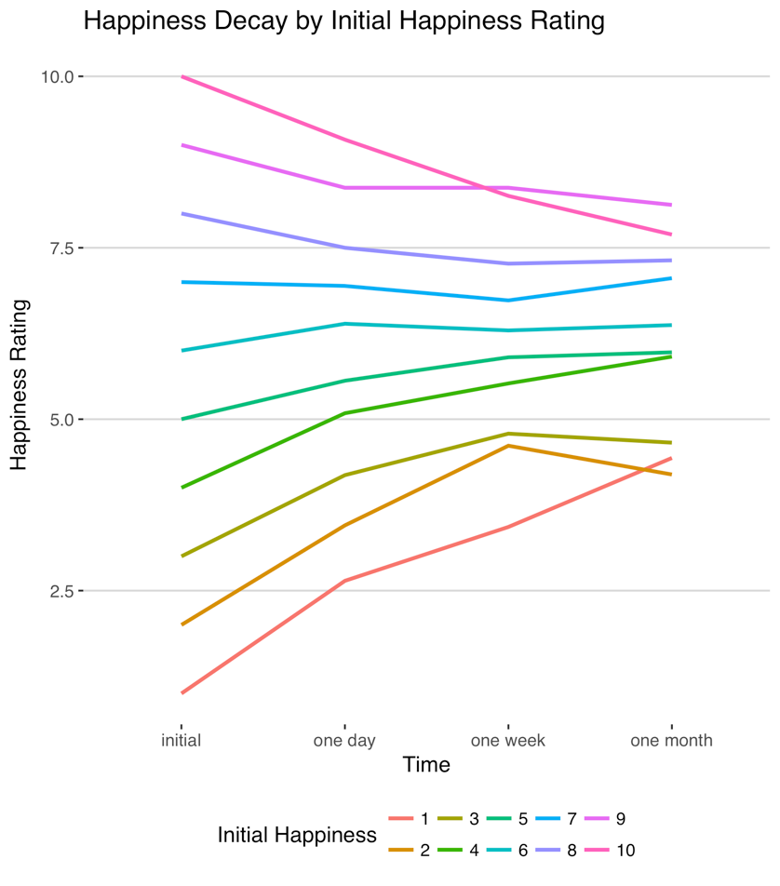
Figure 1: Trajectories of happiness at each time point depend on initial happiness.
Meaningfulness and Happiness Over Time
A mixed model with random effects for subject and original experience revealed that in general, the happiness associated with happy experiences decayed linearly with time (b = -.41, t(774) = -5.9, p < 0.001), in support of hypothesis 1. To examine whether meaningfulness was associated with less happiness decay over time, we conducted another mixed model analysis on the difference between initial happiness and subsequent happiness from an experience, controlling for initial happiness as explained in our methodological approach. Consistent with hypothesis 2, the results revealed a significant effect of meaningfulness on happiness decay, such that more meaningful experiences showed less decay after a single day (b = 0.13, t(231) = . -2.2, p = .028), a week (b = -0.18, t(231) = -3.0, p = .003) and one month (b = -0.23, t(244) = -4.3, p < 0.001), as shown in Figure 2.
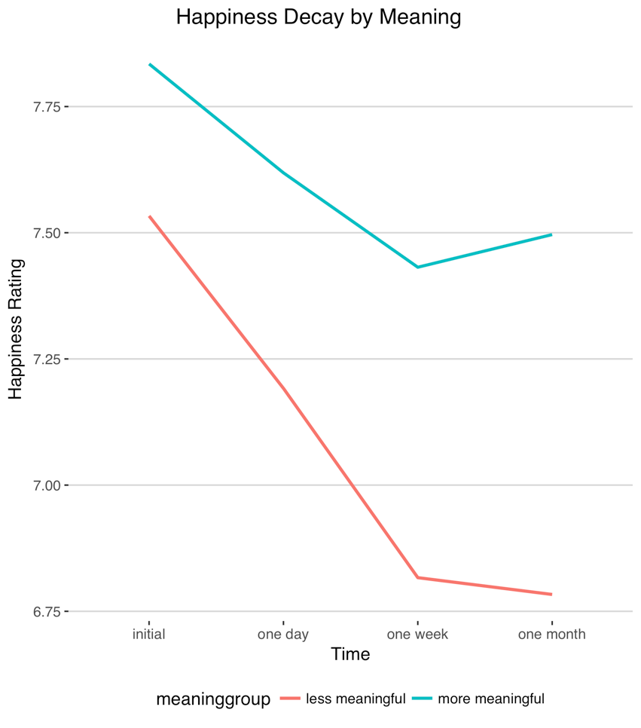
Figure 1 : More meaningful experiences show less happiness decay than less meaningful experiences
(more meaningful > 5.5 initial meaning rating, less meaningful < 5.5 initial meaning rating)

What is meaningfulness: Ancillary Analysis
To better understand various aspects of the captured photo moments, users from Mechanical Turk, an online worker service from Amazon.com, were paid $0.25 per photo to code a photo’s contents (e.g. does it focus on people, food, etc.), adapted from XXX. All coders had to pass an accuracy check with a test photo before they could participate.
Using the photo content coding from the MTurk coders, we also explored which types of moments were more meaningful. Moments with people vs. no people (mean = 7.1 vs. 5.4; t(257) = 2.8, p < .01) were more meaningful, as were moments working or studying (mean = 6.4 vs 5.3, p < .01). In contrast, moments focused on food (mean = 4.6 vs 5.7, p < .01) were less meaningful, as were moments focused on leisure or recreation (mean = 5.1 vs 5.9, p < .01). These relationships all remained significant when controlling for happiness.
Discussion
In the context of real-life moments, this study shows that in general, the happiness garnered by reflecting on a past experience decays with time. However, meaningful experiences show less decay than less meaningful experiences. The question remains whether this finding was driven by the difference in experience content (eg. close relationships are both more meaningful and decay less). The following study, therefore, moves to a laboratory setting where the experience can be held constant, examining only fluctuations due to meaning.

Happiness Decay in the Lab: Study 2

Next, study 2 examined the relationship between meaning and happiness decay in a more controlled laboratory setting. In line with previous literature (eg. Baumeister et. al. 2013; Choi, Catapano, and Choi, 2016) study 1 looks at the different levels of meaning derived from different experiences. Study 2 instead focuses on a single experience, eating a cupcake. We selected this experience because in study 1, food-related moments were generally considered less meaningful than other experiences. Thus, by anchoring on an experience that not typically considered meaningful, study 2 allows us to explore the scope of this effect.

Method
One-hundred-thirty-four students were recruited from introductory business classes at University of British Columbia and compensated with extra credit upon completion of the study. To be eligible for the study, participants had to be at least 18 years old, fluent in English, and willing to eat the cupcake. Participants ate as much or as little of the cupcake as they wanted, then opened a laptop and filled out the survey in which they first were asked to rate how happy and meaningful their experience of eating the cupcake was (on 10-point scales as in study 1). After rating the cupcake, participants each wrote a short description about their experience eating the cupcake.
One week later, participants were contacted via email to complete a follow-up survey. If participants did not answer this email within one day, they were reminded via email. The follow-up survey asked participants to think back on the cupcake they enjoyed one week earlier. Specifically, participants were asked, "How happy do you feel now as you look back on this moment?" (on a 10-point scale).

Results and Discussion
XXX participants reported happy moments and completed both the initial and follow-up survey. Consistent with hypothesis 1, happiness decayed from initial experience to recall (Minitial = 7.95, Mrecall = 5.86, t(120)=11.31, p < 0.001). Further, as predicted in hypothesis 2, when the cupcake was rated as more meaningful during the initial experience, happiness decayed more slowly, as indicated by a regression with meaningfulness (controlling for initial happiness) predicting happiness change scores (b = -0.26, t(118)=-2.77, p = 0.007).
These results provide converging evidence that meaning can slow happiness decay. This is true even for experiences that may not be traditionally considered meaningful, such as eating a cupcake, such that relative differences in meaning are associated with differences in happiness decay. In the next study, we explore the consequences of slowing happiness decay on consumer behavior in a new context, video commercials.

Happiness Decay from a Commercial: Study 3

In Study 3, we sought to expand happiness decay to a common consumer setting, advertising. Specifically, study explored whether a video commercial for GoPro that is viewed as more meaningful would show less happiness decay. In addition, study 3 also examined consumer consequences of decreasing happiness decay, specifically on purchase intent.

Method
Four hundred participants were recruited through Amazon Mechanical Turk. To be eligible for the study, participants were required to be over 18 years of age and reside in the United States. Of these participants, 335 completed the follow-up survey one week later, and were used in analysis.
All participants watched an excerpt from a 60 second video commercial for a GoPro camera (which can be viewed at https://www.youtube.com/watch?v=eVKNDQ42hz8). The video includes a number of scenes including extreme sports and activities, being filmed on a GoPro handheld camera. Participants then rated their level of happiness and meaning on a 10-point scale after watching the video.
One week later, participants were contacted via email to complete an additional survey. Participants had approximately 24 hours to complete the follow-up survey. First, participants answered questions regarding their brand attitudes toward GoPro and the video commercial.
Four items were combined into an index representing purchase intent (“How likely would you be to purchase a GoPro?”, “How much would you be willing to pay for the GoPro featured in the video?”, “How positively do you feel about the brand GoPro?”, “How interested are you in GoPro products?”; alpha = 0.81). Participants also completed the same happiness and meaning measures as in the initial session.

Results and Discussion
311 participants reported initial happy experiences and completed the follow-up survey and were included in the analysis. As in previous studies, happiness from the advertisement decayed from the initial experience to later recall one week later (Minitial = 8.2, Mrecall = 7.9; t(310) = 3.6, p < .001), consistent with hypothesis 1. Further, as predicted in hypothesis 2, when the advertisement was rated as more meaningful during the initial viewing, happiness decayed more slowly, as indicated by a regression with meaningfulness predicting happiness change scores (controlling for initial happiness), (b = -0.15, t(308) = -2.23, p = 0.03. Subsequently, lower happiness decay predicted greater purchase intent one week later (b = -0.2, t(309) = -3.74, p < 0.001) (see supplemental materials for item-level analyses). This relationship holds while controlling for initial happiness (b=-0.42, t(308)=-8.5, p < 0.001.
Further, in support of hypothesis 3, a mediation analysis (with bootstrapping procedures as recommended by Preacher and Hayes (2008)) of the relationship between meaning and purchase intent (controlling for initial happiness) revealed a mediating role of happiness decay (indirect effect = 0.06, CI:[0.01, 0.12]). In other words, more meaningful experiences show less happiness decay, relative to their less meaningful counterparts. In turn, this happiness decay influences consumer attitudes, such that those who experienced less happiness decay expressed greater purchase intent. Therefore, study 3 suggests that preventing happiness decay through increasing initial meaning has beneficial downstream consequences for consumer behavior.

Manipulating Happiness Decay: Study 4

The studies so far show that for everyday life experiences, food, and video commercials, more meaningful experiences are less prone to happiness decay. However, in the preceding studies, meaning is never directly manipulated, but rather varies as a function of the experience captured (study 1) or individual differences in meaning experienced (studies 2 and 3). This drawback is in some ways influenced by the very nature of meaning which is personal (Baumeister, Vohs, Aaker, and Garbinsky 2013; Choi, Catapano, and Choi 2016), and therefore difficult to manipulate. Yet, several questions linger given the measured treatment of meaningful, such as what exactly makes a moment experienced meaningful?
To answer that question and to directly test the causal role of meaning in the trajectory of happiness, we sought to experimentally shift the meaning experienced from the same event. Although there are a number of ways individuals may derive meaning from experiences (e.g., Deci and Ryan 2008), we focused on increasing the salience of connection to others for two reasons. First, previous research suggests that connection to others (e.g., through prosocial behavior) can be meaningful (Choi, Catapano, and Choi 2016) and contribute to enduring happiness (Dunn, Aknin and Norton, 2014). Further, the stimuli in experiment 1 suggested that while the presence of others makes moments more meaningful, there are ways in which one can interact with others but feel no more connected (thereby not increasing meaning). Thus, by focusing on the ways in which an interaction with another improves feelings of connection may influence meaningfulness. Thus, for both theoretical and practical reasons, study 4 focuses on one way of increasing the levels of meaning experienced: by shifting focus to meaning through connection with others.

Methods
We recruited 141 Stanford students between the ages of 18 and 25 (Mage = 22.6, % female = 66.6%) to participate in a two-part experiment in exchange for $7. During Part 1, participants were randomly assigned to spend 10 minutes on Facebook in one of two conditions. In the manipulated condition, participants were asked to spend their time doing things that are happy, with a focus on activities that are meaningful by connecting them with others. In the control condition, participants were instructed to spend their time doing things that are happy, but not particularly meaningful. In both conditions, participants were also given the same example activities, watching a video or sending a message to someone. Instructions for the two conditions are provided in appendix A. Participants were also asked to take a screenshot of one moment that represented their time on Facebook.
After spending 10 minutes on Facebook, participants rated how happy and meaningful their time on Facebook was on a 10-point scale (not at all – very much) in the lab. Then they uploaded the screenshot representing their time on Facebook, and reported the happiness and meaning they felt during the moment in the representative screenshot as a manipulation check. Three days later, participants were contacted with a link to a follow-up survey. In the follow-up survey, they were asked to rate their happiness now as they reflected on their time on Facebook in the lab. Participants who did not respond to the initial follow-up were contacted again. In total, 128 participants completed both the initial and follow-up surveys, and will be used in subsequent analyses.

Results and Discussion
XXX people rated their time as happy and completed the follow-up survey. A manipulation check indicated that individuals in the meaningful condition considered the moment in their representative screenshot to be more meaningful (Mmeaning = 7.27, Mno_meaning = 5.78, t(101.85) = 3.5, p < 0.001), while happiness ratings for the screenshots did not vary by condition (Mmeaning = 7.89, Mno_meaning = 7.83, t(108.25) = 0.22, p = 0.825).
As in Studies 1-3, the overall happiness from the experience decayed from the initial experience to recall three days later (Minitial = 7.12, Mrecall = 6.09, t(110) = 6.4, p < 0.001), consistent with hypothesis 1. To test the effect of the manipulation on happiness decay, we ran a mediation analysis (while controlling for overall happiness as in previous studies) using recommended bootstrapping procedures. Specifically, we tested the hypothesis that focusing on meaning through connections increases experienced meaning, which in turn decreases happiness decay. The analysis revealed a significant indirect effect for the meaning focus condition on happiness decay (indirect effect = -0.36; CI = [-0.67:-0.13]). The full mediation model is present in Figure 3.

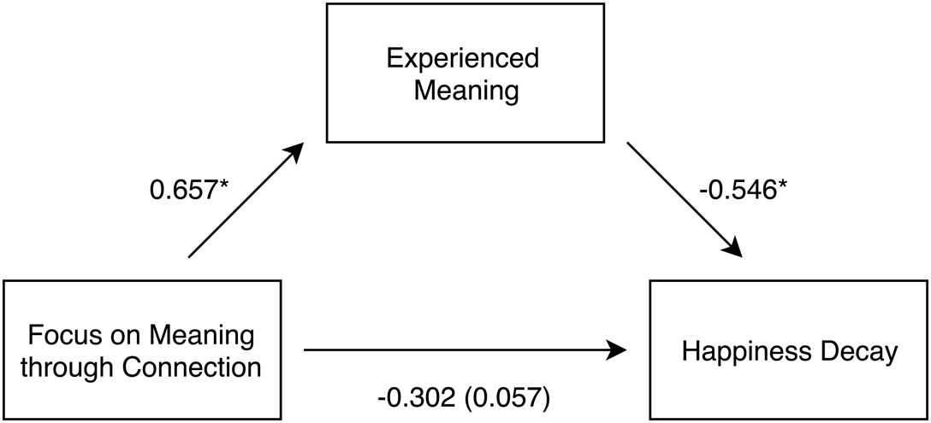
* indicates p < 0.001
Figure 2: Focus on meaning through connection increases the experience of meaning, which in turn decreases happiness decay. (Indirect effect = 0.359; CI = [-0.67:-0.13]).

In addition, to compare the activities that the two groups engaged in, we ran a series of generalized linear models predicting the content of the screenshots participants uploaded. Condition did not significantly affect the likelihood of individuals to take a screenshot of reading an article (p = 0.443), watching a video (p = 0.09), interacting with friends or family (p = 0.24), looking at photos or posts (p = 0.39), or other activities (p = 0.995).
These results suggest that meaning can be shifted not only through the general activity individuals choose to engage in (as suggested in Baumeister, Vohs, Aaker, and Garbinsky 2013; Choi, Catapano, and Choi 2016), but also through an individual’s focus during an activity. Specifically, by focusing on meaning through connection with others, participants reported enhanced meaning they experienced in their time on Facebook, which in turn slowed their happiness decay.

General Discussion

The findings of four field and lab experiments show that meaning can influence the time-course of happiness. We found that in general, the happiness garnered from reflecting on a past experience decays with time, declining significantly after a single day, and continuing to decay for at least a month after the original event. However, this decay can be slowed by meaning, such that meaningful moments decay less than those that are considered less meaningful. This is true both when moments are more meaningful due to their actual content and an individual’s interpretation of the moment. In addition, we see this relationship across a variety of experiences including eating, watching a video, and spending time on social media. In addition, meaning moderates happiness decay not only in controlled laboratory settings, but also for real-life moments.
The present research also explored the antecedents and consequences of this effect. By focusing on the ways the current moment may be meaningful through connection with others, individuals can increase their own levels of meaning experienced. In turn, this increase in meaning slows happiness decay. In addition, slowing happiness decay also has consequences for consumer outcomes. When consumers are exposed to a more meaningful brand-related moment (for example, watching a commercial), the happiness associated with the moment lasts longer. In turn, this decrease in happiness decay leads to greater purchase intent.
While the present research explored focusing on meaning through connection to others to create meaningful experiences, much work remains how to best increase the levels of meaning experienced. In the present study, participants focused on meaning through a specific prompt, meaning through connection with others. However, it is still an open question whether merely focusing on meaning, without a specific prompt, can also increase levels of meaning. Drawing on happiness research, Mauss et. al. (2011) suggest that focusing on happiness can often backfire. When individuals focus too much on their goal to be happy, this can to decreased levels of happiness when the goal is not easily achieved (see also Gruber, Mauss, and Tamir, 2011). If meaning operates in a similar way, focusing on meaning alone may have counterproductive effects, leading to decreased levels of meaning when meaning is hard to find. Further empirical work is necessary to explore whether a focus on meaning alone contributes to more meaningful experiences, or if this increased focus can backfire without specific prompts or actions to facilitate meaning.
In addition, focus on meaning through other specific avenues may also have a similar positive impact on the experience of meaning, and in turn, long term happiness. For example, previous research suggests that experiences that connect individuals to their past or future are also considered to be meaningful (Baumeister, Vohs, Aaker and Garbinsky 2013). Therefore, prompting individuals to focus on meaning through connection to their past or future selves may also promote more meaningful experiences, slowing happiness decay. Future research is needed to examine other effective ways to influence the experience of meaning, and the consequences of these meaningful experiences on happiness.
Our findings suggest that for happy moments, meaningfulness prevents decay, thereby allowing the levels of happiness garnered from later reflection later to stay closer to the original levels from the experience. However, the present research does not explore the role of meaning in the negative domain. In study 1, we find that while happy memories become less happy with time, unhappy memories generally become less unhappy with time. Future research could explore the role of meaning in this trajectory. On the one hand, meaningful unhappy memories may stay unhappy for longer, as meaning creates a stronger connection between the memory and our present selves. On the other hand, meaningful unhappy memories may become happier with time, as we begin to fit them into a bigger picture of our lives, and form connections between these unhappy memories and happy memories that they relate to. Thus, further empirical research is necessary to fully understand the relationship between meaning and the time-course of happiness in both the positive and negative domains.
Our findings also have implications for consumer well-being. Overspending is often cited as a pressing issue in the United States, with Americans spending an average of $1.33 for every dollar that they earn. One reason that has been suggested for this overspending is hedonic adaptation, such that Americans feel the need to continue buying more and more, as they acclimate to the things they have and the experiences they have already had (Wang, Novemsky, and Dhar 2009). The present research suggests that one strategy to ameliorate overspending may be to spend discretionary income on happy, meaningful experiences, rather than material possessions or experiences that are only happy. By spending on meaningful experiences, consumers can get more “bang for their buck,” by investing in happiness not only in the here and now, but also for the future.
This work fits into a growing body of literature exploring what makes people happy. The current work adds an extra dimension, exploring not only what makes people happy in the moment, but also how to prolong the happiness gained from a single experience. Although it seems that almost all experiences are susceptible to hedonic adaptation, this research suggests that there is hope, and explores a new way to slow hedonic adaptation to experiences, through incorporating meaning.
Appendix A: Study 4 Instructions

Focus on meaning through connection:

For this study, we are interested in how individuals use Facebook. Previous research suggests that going on Facebook can be both a happy and a meaningful experience for individuals, by connecting them to others. So, we would like you to spend the next 10 minutes on Facebook doing things that make you feel happy that you feel are truly meaningful. For example, you may watch a video on your newsfeed that you think is meaningful, or send a meaningful message to someone. Try to focus on activities that are happy or enjoyable, but also meaningful or important (which is typical when people use Facebook).

Please take a screenshot of at least one of the meaningful things you did while on Facebook. You will be asked to upload this screenshot at the end of the survey.

You should spend the entire allotted 10 minutes on Facebook. Advance to the next page, then please begin your time on Facebook. Please do not use your phone or other devices in this time. Enjoy!

Control:

For this study, we are interested in how individuals use Facebook. Previous research suggests that going on Facebook can be a happy experience for individuals, even if it is not very meaningful. So, we would like you to spend the next 10 minutes on Facebook doing things that make you feel happy. For example, you may watch a video from your newsfeed that you think is enjoyable, or send a happy message to someone. Try to focus on activities that are happy or enjoyable, but not necessarily meaningful or important (which is typical when people use Facebook).

Please take a screenshot of at least one of the happy things you did while on Facebook. You will be asked to upload this screenshot at the end of the survey.

You should spend the entire allotted 10 minutes on Facebook. Advance to the next page, then please begin your time on Facebook. Please do not use your phone or other devices in this time. Enjoy!

Supplemental Materials: Study 1

Supplemental Materials: Study 2

Supplemental Materials: Study 3

Supplemental Materials: Study 4

REFERENCES

Andreoni, James. "Giving with impure altruism: Applications to charity and Ricardian equivalence." The Journal of Political Economy (1989): 1447-1458.
Andreoni, James. "Impure altruism and donations to public goods: A theory of warm-glow giving." The economic journal 100, no. 401 (1990): 464-477.
Baumeister, Roy F. Meanings of life. Guilford Press, 1991.
Baumeister, Roy F., Kathleen D. Vohs, Jennifer L. Aaker, and Emily N. Garbinsky. "Some key differences between a happy life and a meaningful life." The Journal of Positive Psychology 8, no. 6 (2013): 505-516.
Bao, Katherine Jacobs, and Sonja Lyubomirsky. "Making it last: Combating hedonic adaptation in romantic relationships." The Journal of Positive Psychology 8, no. 3 (2013): 196-206.
Boswell, Wendy R., John W. Boudreau, and Jan Tichy. "The relationship between employee job change and job satisfaction: the honeymoon-hangover effect." Journal of applied psychology 90, no. 5 (2005): 882.
Bronk, Kendall Cotton. Purpose in life: A critical component of optimal youth development. Springer Science & Business Media, 2013.
Brickman, Philip, Dan Coates, and Ronnie Janoff-Bulman. "Lottery winners and accident victims: Is happiness relative?." Journal of personality and social psychology 36, no. 8 (1978): 917.
Bryant, Fred B., Colette M. Smart, and Scott P. King. "Using the past to enhance the present: Boosting happiness through positive reminiscence." Journal of Happiness Studies 6, no. 3 (2005): 227-260.
Carter, Erin Percival, and Dan Williams. “Long lasting benefits at a high cost: The temporal qualities of meaningful consumption.” Working paper.
Chang, Hannah H., and Michel Tuan Pham. "Affect as a decision-making system of the present." Journal of Consumer Research 40, no. 1 (2013): 42-63.
Choi, Jongan, Rhia Catapano, and Incheol Choi. "Taking Stock of Happiness and Meaning in Everyday Life: An Experience Sampling Approach." Social Psychological and Personality Science (2016).
Csikszentmihalyi, Mihaly. "Flow: The psychology of optimal performance." NY: Cambridge University Press (1990).
DePaoli, Alexander and Uzma Khan. “Favorites Fall Faster: Greater liking leads to greater satiation.” Working paper.
Deci, Edward L., and Richard M. Ryan. "Hedonia, eudaimonia, and well-being: An introduction." Journal of Happiness Studies 9, no. 1 (2008): 1-11.
Dunn, Elizabeth W., Lara B. Aknin, and Michael I. Norton. "Prosocial spending and happiness using money to benefit others pays off." Current Directions in Psychological Science 23, no. 1 (2014): 41-47.
Frank, Robert H. Luxury fever: Money and happiness in an era of excess. Princeton University Press, 1999.
Frederick, Shane, and George Loewenstein. "Hedonic adaptation." (1999).
Gruber, June, Iris B. Mauss, and Maya Tamir. "A dark side of happiness? How, when, and why happiness is not always good." Perspectives on Psychological Science 6, no. 3 (2011): 222-233.
Harbaugh, William T. "What do donations buy?: A model of philanthropy based on prestige and warm glow." Journal of Public Economics 67, no. 2 (1998): 269-284.
Mauss, Iris B., Maya Tamir, Craig L. Anderson, and Nicole S. Savino. "Can seeking happiness make people unhappy? Paradoxical effects of valuing happiness." Emotion 11, no. 4 (2011): 807.
Mogilner, Cassie, Jennifer Aaker, and Sepandar D. Kamvar. "How happiness affects choice." Journal of Consumer Research 39, no. 2 (2012): 429-443.
Mogilner, Cassie, Jennifer Aaker, and Sepandar Kamvar. "How the Meaning (s) of Happiness Impacts Choice." NA-Advances in Consumer Research Volume 39 (2011).
Morris, Jon D., Chongmoo Woo, James A. Geason, and Jooyoung Kim. "The power of affect: Predicting intention." Journal of Advertising Research 42, no. 3 (2002): 7-17.
Nelson, Leif D., and Tom Meyvis. "Interrupted consumption: Disrupting adaptation to hedonic experiences." Journal of Marketing Research 45, no. 6 (2008): 654-664.
Nelson, Leif D., Tom Meyvis, and Jeff Galak. "Enhancing the television-viewing experience through commercial interruptions." Journal of Consumer Research 36, no. 2 (2009): 160-172.
Nicolao, Leonardo, Julie R. Irwin, and Joseph K. Goodman. "Happiness for sale: do experiential purchases make consumers happier than material purchases?." Journal of Consumer Research 36, no. 2 (2009): 188-198.
Quoidbach, Jordi, and Elizabeth W. Dunn. "Give it up a strategy for combating hedonic adaptation." Social Psychological and Personality Science 4, no. 5 (2013): 563-568.
Reker, Gary T., and Paul TP Wong. "Aging as an individual process: Toward a theory of personal meaning." (1988).
Rucker, Derek D., Kristopher J. Preacher, Zakary L. Tormala, and Richard E. Petty. "Mediation analysis in social psychology: Current practices and new recommendations." Social and Personality Psychology Compass 5, no. 6 (2011): 359-371.
Ryan, Richard M., and Edward L. Deci. "On happiness and human potentials: A review of research on hedonic and eudaimonic well-being." Annual review of psychology 52, no. 1 (2001): 141-166.
Ryff, Carol D. "Happiness is everything, or is it? Explorations on the meaning of psychological well-being." Journal of personality and social psychology 57, no. 6 (1989): 1069.
Sandvik, Ed, Ed Diener, and Larry Seidlitz. "Subjective well‐being: The convergence and stability of self‐report and non‐self‐report measures." Journal of personality 61, no. 3 (1993): 317-342.
Shiv, Baba, and Alexander Fedorikhin. "Heart and mind in conflict: The interplay of affect and cognition in consumer decision making." Journal of consumer Research 26, no. 3 (1999): 278-292.
Steger, Michael F., Shigehiro Oishi, and Todd B. Kashdan. "Meaning in life across the life span: Levels and correlates of meaning in life from emerging adulthood to older adulthood." The Journal of Positive Psychology 4, no. 1 (2009): 43-52.
Wang, Jing, Nathan Novemsky, and Ravi Dhar. "Anticipating adaptation to products." Journal of Consumer Research 36, no. 2 (2009): 149-159.
Wirtz, Derrick, Justin Kruger, Christie Napa Scollon, and Ed Diener. "What to do on spring break? The role of predicted, on-line, and remembered experience in future choice." Psychological Science 14, no. 5 (2003): 520-524.
Yang, Yang, and Jeff Galak. "Sentimental value and its influence on hedonic adaptation." Journal of personality and social psychology 109, no. 5 (2015): 767.
Zhang, Ting, Tami Kim, Alison Wood Brooks, Francesca Gino, and Michael I. Norton. "A “Present” for the Future: The Unexpected Value of Rediscovery." Psychological science (2014): 0956797614542274.

In Studies 1-4, time focus of participants was also manipulated Present focus also tends to slow happiness, to a lesser extent than meaningfulness. However, this manipulation did not interact with any of our other conditions and is not related to our current hypotheses, so we collapse across these conditions in the analyses to follow and will not discuss these conditions any further.
Participants were also randomly assigned to either an experiential or material condition. In the experiential condition, a GoPro was framed as being primarily an experience, while in the material condition it was framed as being primarily something to own. However, a manipulation check indicated that the two groups did not view the GoPro differently, and there were no other significant differences between groups. Thus, the two groups have been collapsed for further analysis.
Although there is no direct effect of the meaning focus manipulation on happiness decay, previous work suggests that even in the absence of a direct effect of one variable on another, indirect effects can still be observed and be theoretically meaningful (Rucker, Preacher, Tormala, and Petty 2011).

