The Sign Effect in Past and Future Discounting

Supplementary online materials, reviewed (SOM-R)

Note: Research data can be accessed at the following link: https://osf.io/v4qys/files/

Table of Contents
Part A: Sample Stimuli 2
Part B: Full Presentation of order effects from Studies 1a and 1b 25
Part C: Study 3 pretest results 33
Part D: Replication of Yi, Gatchalian, & Bickel (2006) 35
Part E: Individualized Utility Curvature Adjustment in Study 2 37

Part A: Sample Stimuli
Study 1a pretest
A separate sample of N=100 participants rated monetary gains and losses on their present subjective impact by indicating whether or not they would accept various gambles. Participants were asked whether they would accept a gamble with a 50% chance of gaining $10 and a 50% change of losing varying amounts, ranging from 50 cents to $10, in 50 cent increments. Order was randomly assigned such that half the participants were presented the losses in increasing order and the other half in decreasing order. For each respondent, the indifference point was calculated as the first loss in the series for which the participant indicated that they would accept the gamble. If a participant indicated that they would never accept the gamble, their indifference point was assumed to occur at the lowest loss amount presented (50 cents) and if they indicated they would always accept the gamble, their indifference point was assumed to occur at the highest loss amount presented ($10).
Sample questions, descending loss order:
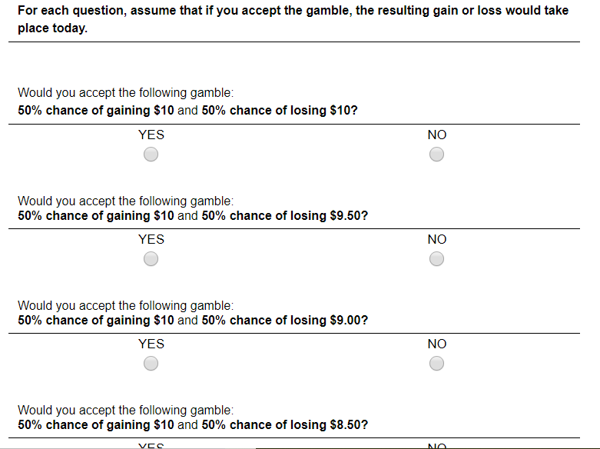

The overall mean indifference point of all participants suggested that a $5 loss had equivalent subjective impact to a $10 gain. These were used in Study 1a as the baseline loss and gain amounts.

Study 1a
Discounting measure (future gain condition)
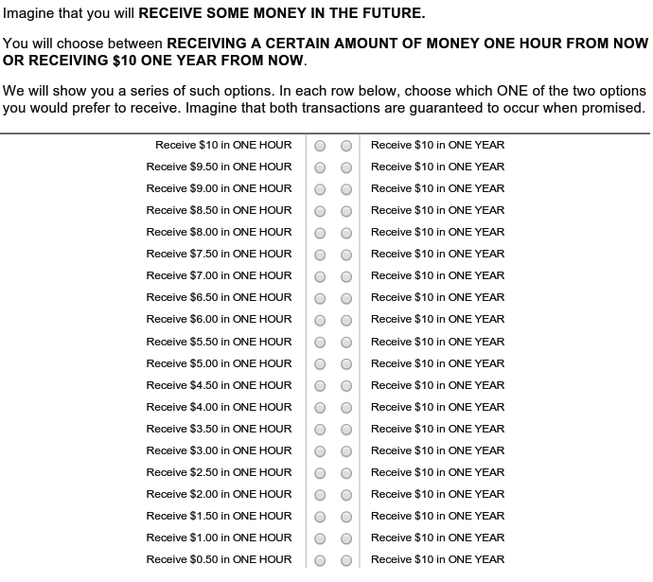

Discounting measure (past loss condition)
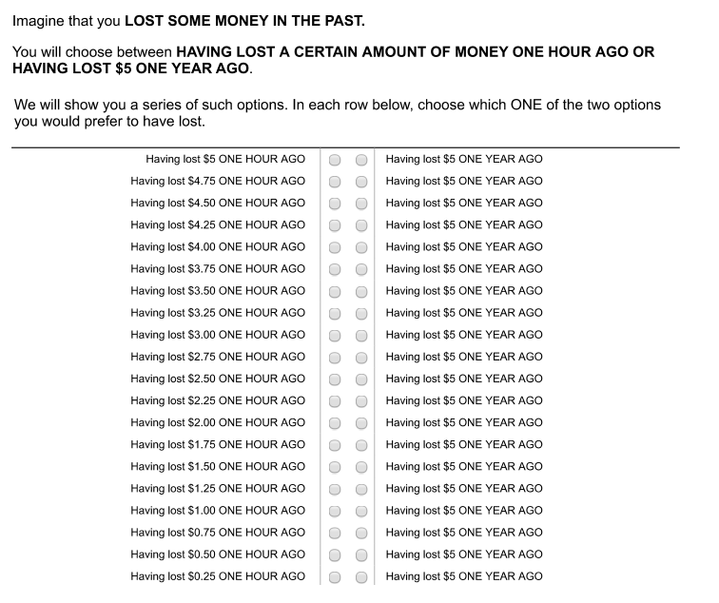
Contemplation emotion measure (future gain condition)
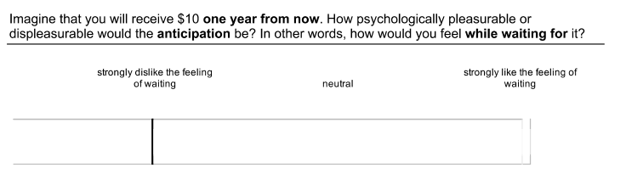
Contemplation emotion measure (past loss condition)
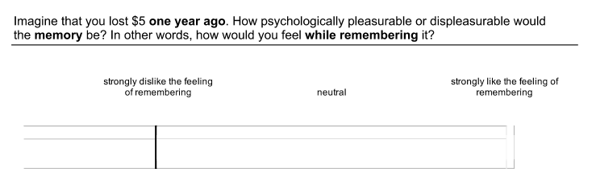

Study 1b pretest
A separate sample of N=100 participants rated shocks and massages on their present subjective impact by indicating whether or not they would accept various gambles. Participants were asked whether they would accept a gamble with a 50% chance of receiving a pleasant 1 hour massage and a 50% change of receiving a painful (but non-harmful) electric shock of various durations, ranging from 1 second to 1 hour. Order was randomly assigned such that half the participants were presented the shocks in increasing order and the other half in decreasing order. For each respondent, the indifference point was calculated as the first shock in the series for which the participant indicated that they would accept the gamble. If a participant indicated that they would never accept the gamble, their indifference point was assumed to occur at the lowest shock duration presented (1 second) and if they indicated they would always accept the gamble, their indifference point was assumed to occur at the highest shock duration presented (1 hour).
Sample questions, ascending shock order:
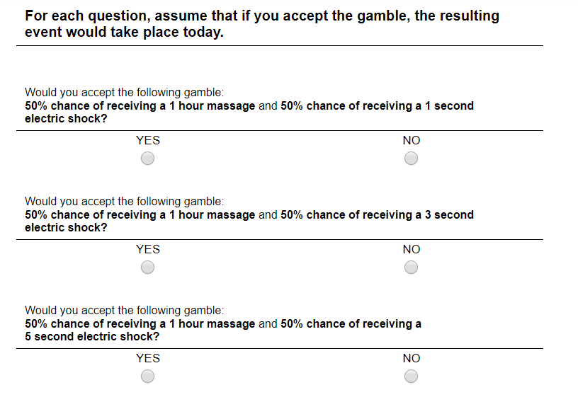

The overall mean indifference point of all participants suggested that a 1 minute shock had equivalent subjective impact to a 1 hour massage. These were used in Study 1b as the baseline negative and positive events.

Study 1b
Discounting measure (past negative condition)
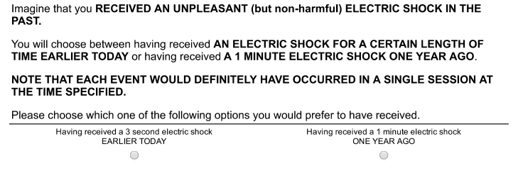
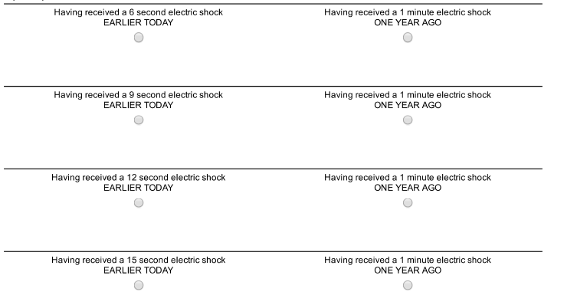
(continues increasing until left hand side is equal to a 1 minute electric shock earlier today)

Contemplation emotion measure (future negative condition)
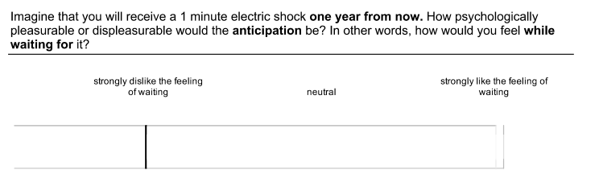
Contemplation emotion measure (past positive condition)
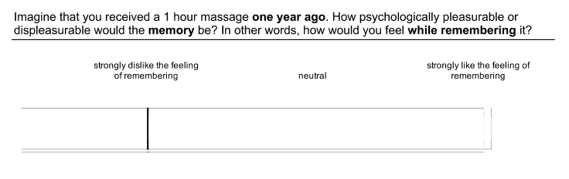

Study 2a
Individual loss titration measure: See pretest for Study 1a. Each participant completed the same measure, except they completed it both in ascending and descending order and results of the two blocks were averaged to determine an individualized indifference point. This indifference point was then used as the baseline loss amount for that specific participant in the remainder of the study.
Discounting measure: Sample ToAD questions from future gain, future loss, past gain, past loss conditions; specific amounts presented vary based on participant’s responses and ToAD algorithm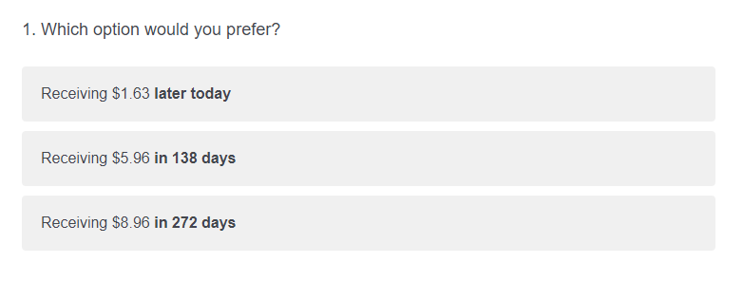
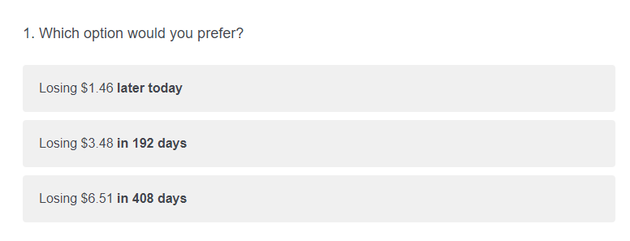
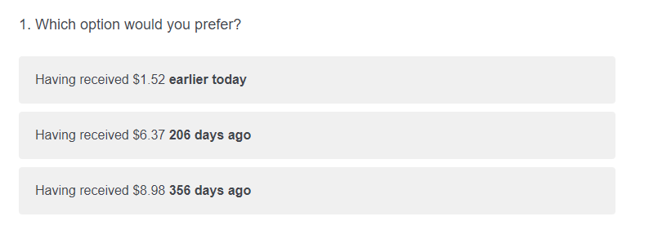
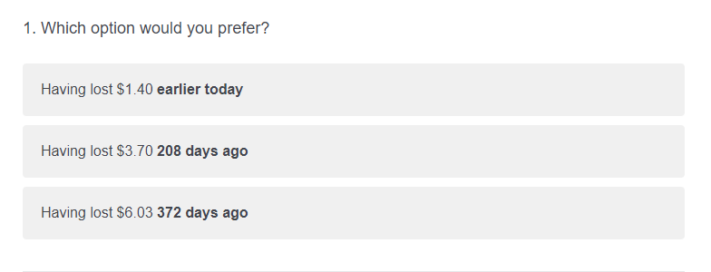

Contemplation emotion measure
Same measure was used as in Study 1a.
Utility curvature measure
First gain curvature question:
Consider the following two events. Imagine that each of these events occurs in the present moment.

A: You expect to receive $0 but instead learn you are about to receive $2.50.

B: You expect to receive $2.50 but instead learn you are about to receive ...
In the blank space above, please indicate the amount that you would have to receive so that the impact of Event B would be the same as that of Event A. In other words, write an amount in the space such that experience Event B would bring you the same amount of pleasure or displeasure as experiencing Event A would. Please enter numbers only (decimal points are okay).

First loss curvature question (initial loss amount presented varies based on participant’s baseline loss amount calculated from indifference point):
Consider the following two events. Imagine that each of these events occurs in the present moment.

A: You expect to lose $0 but instead learn you are about to lose $1.44.

B: You expect to lose $1.44 but instead learn you are about to lose ...
In the blank space above, please indicate the amount that you would have to lose so that the impact of Event B would be the same as that of Event A. In other words, write an amount in the space such that experience Event B would bring you the same amount of pleasure or displeasure as experiencing Event A would. Please enter numbers only (decimal points are okay).

Study 2b
Individual loss titration measure: See pretest for Study 1b. Each participant completed the same measure, except they completed it both in ascending and descending order and results of the two blocks were averaged to determine an individualized indifference point. This indifference point was then used as the baseline shock duration for that specific participant in the remainder of the study.
Discounting measure: Sample ToAD questions from future massage, future shock, past massage, past shock conditions; specific durations presented vary based on participant’s responses and ToAD algorithm
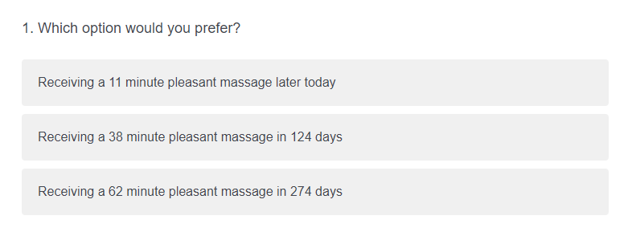
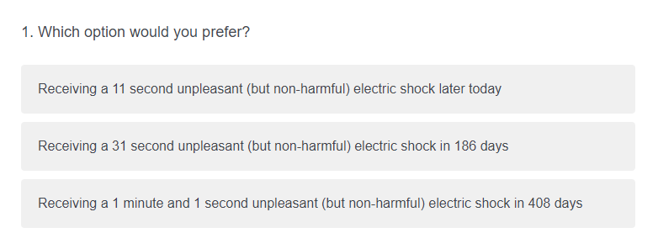
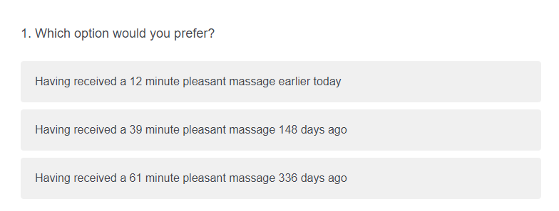
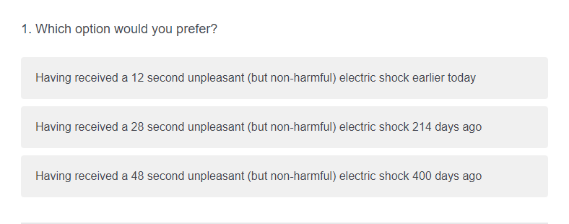
Contemplation emotion measure:
Same measure was used as in Study 1b
Utility curvature measure
First gain curvature question:
Consider the following two events. Imagine that each of these events occurs in the present moment.

A: You expect to receive 0 minutes of a pleasant massage, but instead learn you are about to receive 15 minutes of a pleasant massage.

B: You expect to receive 15 minutes of a pleasant massage, but instead learn you are about to receive ... minutes of a pleasant massage.
In the blank space above, please indicate the amount (in minutes) that you would have to receive so that the impact of Event B would be the same as that of Event A. In other words, write an amount in the space such that experience Event B would bring you the same amount of pleasure or displeasure as experiencing Event A would.

First loss curvature question (duration of initial shock presented varies based on participant’s baseline shock amount calculated from indifference point):
Consider the following two events. Imagine that each of these events occurs in the present moment.

A: You expect to receive a 0 second electric shock but instead learn you are about to receive a 0 minute and 11.25 second unpleasant (but non-harmful) electric shock.

B: You expect to receive a 0 minute and 11.25 second electric shock, but instead learn you are about to receive a ... minute and ... second unpleasant (but non-harmful) electric shock.
Minute
Second
In the blank spaces above, please indicate the amount (in minutes and seconds) that you would have to receive so that the impact of Event B would be the same as that of Event A. In other words, write an amount such that experience Event B would bring you the same amount of pleasure or displeasure as experiencing Event A would.

Study 3
In this study, you will be eating a jelly bean and answering some questions about your experience.

The flavor of the jelly bean you will be eating has been randomly selected.
Note that participants in this study may either be assigned to eat a standard, good-tasting jelly bean flavor, or, they may be assigned to eat a flavor which is intentionally bad-tasting.

The flavor you have been assigned to is:
____________________________
This jelly bean has been placed in front of you.

Have you ever had a jelly bean of this flavor before? (please circle one):

YES NO NOT SURE
15 minutes from now, you will be eating this jelly bean.

1a. How pleasurable or happy will the experience of eating the jelly bean be?
(Please place an “X” anywhere on the line below to indicate your answer.)

Neutral
Will extremely like
the experience

1b. How displeasurable or unhappy will the experience of eating the jelly bean be?

Neutral
Will extremely dislike the experience

The questions below ask about how you feel while anticipating or waiting to eat the jelly bean. In some cases, you may enjoy the process of waiting. For example, if a holiday is a couple weeks away, the waiting may be pleasant. Other times, you may dislike the way you feel while waiting. For example, if you are waiting for a red light to turn green, the waiting may be unpleasant.

2a. How pleasurable or happy is the anticipation of eating the jelly bean? In other words, how do you feel right now while waiting for it?

Neutral
Extremely like the feeling of waiting

2b. How displeasurable or unhappy is the anticipation of eating the jelly bean? In other words, how do you feel right now while waiting for it?

Please eat this jelly bean, and answer the questions below as you are eating it.
Neutral
Extremely dislike the feeling of waiting

1. How pleasurable or happy is your experience of eating the jelly bean? In other words, how do you feel right now while eating it?

Extremely like
the experience
Neutral

2. How displeasurable or unhappy is your experience of eating the jelly bean? In other words, how do you feel right now while eating it?

Extremely dislike
the experience
Neutral

15 minutes ago, you ate a jelly bean.

1a. How pleasurable or happy was the experience of eating the jelly bean?

Neutral
Extremely liked
the experience

1b. How displeasurable or unhappy was the experience of eating the jelly bean?

Neutral
Extremely disliked
the experience

Now, please think about how you are feeling right now as you remember this experience.

2a. How pleasurable or happy is the memory of eating the jelly bean? In other words, how do you feel right now while remembering it?

Neutral
Extremely like the feeling of remembering

2b. How displeasurable or unhappy is the memory of eating the jelly bean? In other words, how do you feel right now while remembering it?

Neutral

Extremely dislike the feeling of remembering
Study 4
Near the middle of this study (in about 5 minutes), you will look at 10 photos of puppies [cockroaches].
[page break]
Quiz: what will you see in the photos?
__________
[page break]
How certain are you that you will see the puppy [cockroach] photos?
1=Not at all certain, 4=Fairly Certain, 7=Completely certain
How certain are you about how much you will like or dislike the puppy [cockroach] photos? In other words, how certain are you about how you will react to the puppy [cockroach] photos?
1=Not at all certain, 4=Fairly Certain, 7=Completely certain
Please consider your uncertainty about the puppy [cockroach] photos. How does the uncertainty make you feel?
0=I strongly dislike the feeling of uncertainty, 50=Neutral, 100=I strongly like the feeling of uncertainty
[page break]
When would you prefer to see the puppy [cockroach] photos? (With the overall length of the HIT being fixed, regardless of your preference.)
I would prefer:
- Seeing the photos now
- Seeing the photos in 5 minutes
[page break]
As you think about the puppy [cockroach] photos you will see in 5 minutes, how pleasurable or happy is the anticipation? In other words, how how do you feel now while waiting for them?
0=neutral, 50=somewhat like the feeling of waiting, 100=extremely like the feeling of waiting
As you think about the puppy [cockroach] photos you will see in 5 minutes, how displeasurable or unhappy is the anticipation? In other words, how do you feel now while waiting for them?
0=neutral, 50=somewhat dislike the feeling of waiting, 100=extremely dislike the feeling of waiting
[page break]

[First 5-min Filler task]
In this part of the study, you will be reading sentences as they appear on the screen.
The timing of the sentences you read is controlled - please do not try to advance or skip ahead while they are playing.

After the video, we will ask you questions about some of the sentences you read. So, please pay attention and try to answer these questions to the best of your ability.

Once you are ready, click the arrow below to begin reading the sentences.
[4-min video plays]
You will now be answering some questions about the sentences that you just finished reading. Please click the arrow to proceed.
At the supermarket there, were one thousand:
cucumbers
Bananas
Peaches
Watermelons
One of the sentences mentions travelling to:
The Bahamas
Florida
California
Mexico
Why was John saving money?
To pay off his student loans
To buy a new computer
To buy a new phone
To impress his girlfriend
How many fish did I catch?
Zero
One
Two
Four
My sister got a cat named:
Oscar
Felix
Fluffy
Orange
[page break]
Now, please look at these 10 photos of puppies [cockroaches].
[Example: Puppy photo 1]

[Example: Cockroach photo 1]
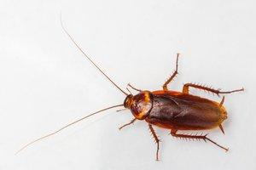

[Second 5-min Filler task]
In this next part of the study, you will again be reading sentences as they appear on the screen.
As before, the timing of the sentences you read is controlled - please do not try to advance or skip ahead while they are playing. Please pay attention and try to answer the questions that follow the video, to the best of your ability.

Once you are ready, click the arrow below to begin reading the sentences.

[4-min video plays]

In one of the sentences, the writer's sister plays on a:
soccer team
gymnastics team
softball team
basketball team
Yesterday, while at the cafe, I saw
my friend
a famous musician
my favorite movie star
my teacher
What happened when the power went out?
I was scared of the dark
I borrowed my neighbor’s generator
the computer was damaged
the food in the refrigerator spoiled
I hope the weather tomorrow is
sunny
rainy
snowy
hot
Today I took the kids to the
arcade
swimming pool
art gallery
zoo
[page break]
Quiz: what did you see in the photos?
___________________
[page break]
How certain are you that you saw the puppy [cockroach] photos?
1=Not at all certain, 4=Fairly Certain, 7=Completely certain
How certain are you about how much you liked or disliked the puppy [cockroach] photos? In other words, how certain are you about how you reacted to the puppy [cockroach] photos?
1=Not at all certain, 4=Fairly Certain, 7=Completely certain
Please consider your uncertainty about the puppy [cockroach] photos. How does the uncertainty make you feel?
0=I strongly dislike the feeling of uncertainty, 50=Neutral, 100=I strongly like the feeling of uncertainty
[page break]
When would you prefer to have seen the puppy [cockroach] photos? (With the overall length of the HIT being fixed, regardless of your preference.)
I would prefer:
having seen the photos just now
having seen the photos 5 minutes ago
[page break]
As you think about the puppy [cockroach] photos you saw 5 minutes ago, how pleasurable or happy is the memory? In other words, how how do you feel now while remembering them?
0=neutral, 50=somewhat like the feeling of remembering, 100=extremely like the feeling of remembering
As you think about the puppy [cockroach] photos you saw at the end of the study, how displeasurable or unhappy is the memory? In other words, how do you feel now while remembering for them?
0=neutral, 50=somewhat dislike the feeling of remembering, 100=extremely dislike the feeling of remembering
How much do you agree with each of the following statements about yourself in general? (1=Strongly disagree, 6=Strongly agree)
I don't like situations that are uncertain.
I dislike questions which could be answered in many different ways.
I find that a well ordered life with regular hours suits my temperament.
I feel uncomfortable when I don't understand the reason why an event occurred in my life.
I feel irritated when one person disagrees with what everyone else in a group believes.
I don't like to go into a situation without knowing what I can expect from it.
When I have made a decision, I feel relieved
When I am confronted with a problem, I’m dying to reach a solution very quickly.
I would quickly become impatient and irritated if I would not find a solution to a problem immediately.
I don't like to be with people who are capable of unexpected actions.
I dislike it when a person's statement could mean many different things.
I find that establishing a consistent routine enables me to enjoy life more.
I enjoy having a clear and structured mode of life.
I do not usually consult many different opinions before forming my own view.
I dislike unpredictable situations.
[page break]
How much do you agree with each of the following statements about yourself in general? (1=Strongly Disagree, 4=Neither agree nor disagree, 7=Strongly agree)
I try to avoid situations which are ambiguous
I dislike ambiguous situations
I’m just a little uncomfortable with people unless I feel that I can understand their behavior
I get pretty anxious when I’m in a social situation over which I have no control
It bothers me when I am unable to follow another person’s train of thought
It bothers me when I don’t know how other people react to me
I have always felt that there is a clear difference between right and wrong
A good job is one where what is to be done and how it is to be done are always clear
What we are used to is always preferable to what is unfamiliar
The sooner we all acquire similar values and ideas the better
I try to avoid situations which are ambiguous
I am good at managing unpredictable situations
I’m tolerant of ambiguous situations
I enjoy tackling problems that are complex enough to be ambiguous
I try to avoid problems that don’t seem to have only one “best” solution
I pursue problem situations which are so complex some people call them “mind-boggling”
I prefer familiar situations to new ones
I often find myself looking for something new, rather than trying to hold things constant in my life
I generally prefer novelty over familiarity
I prefer a situation in which there is some ambiguity
I can easily and willingly take big risks
I like to fool around with new ideas, even if they turn out later to be a total waste of time
What we are used to is always preferable to what is unfamiliar
[page break]
What is your gender?
Male
Female
Other

How old are you?
_____________

Part B: Full Presentation of order effects from Studies 1a and 1b
Table B1. Discounting results from Study 1a
Past/future order | F(1,180) = 0.09, p = .766, η_{p}² < .01
Gain/loss order | F(1,180) = 4.38, p = .038, η_{p}² = .02
Tense | F(1,180) = 19.54, p < .001, η_{p}² = .10
Valence | F(1,180) = 5.67, p = .018, η_{p}² = .03
Past/future order X Gain/loss order | F(1,180) = 0.65, p = .423, η_{p}² < .01
Past/future order X Tense | F(1,180) = 1.42, p = .235, η_{p}² = .01
Gain/loss order X Tense | F(1,180) = 0.00, p = .944, η_{p}² < .01
Past/future order X Valence | F(1,180) = 0.03, p = .854, η_{p}² < .01
Gain/loss order X Valence | F(1,180) = 3.75, p = .054, η_{p}² = .02
Tense X Valence | F(1,180) = 5.42, p = .021, η_{p}² = .03
Past/future order X Gain/loss order X Tense | F(1,180) = 0.06, p = .810, η_{p}² < .01
Past/future order X Gain/loss order X Valence | F(1,180) = 1.05, p = .306, η_{p}² = .01
Past/future order X Tense X Valence | F(1,180) = 0.46, p = .500, η_{p}² < .01
Gain/loss order X Tense X Valence | F(1,180) = 1.41, p = .236, η_{p}² = .01
Past/future order X Gain/loss order X Tense X Valence | F(1,180) = 2.77, p = .098, η_{p}² = .02

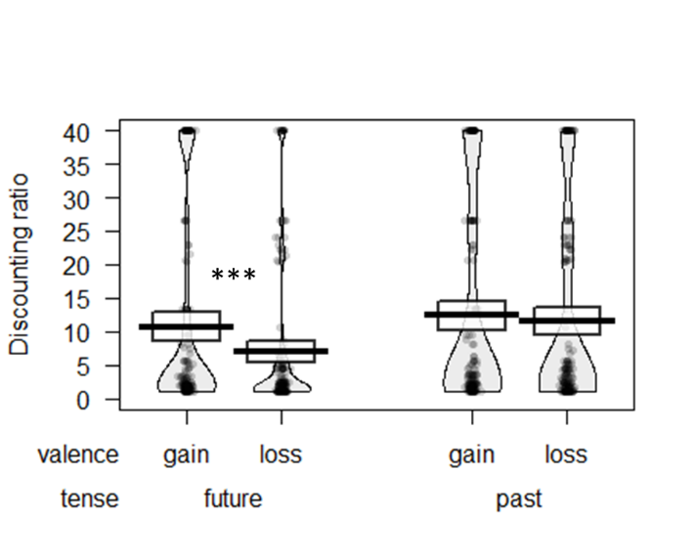
A
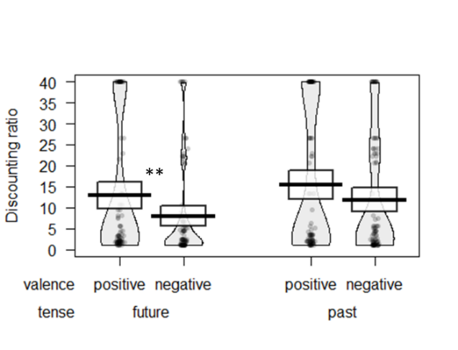  B | C  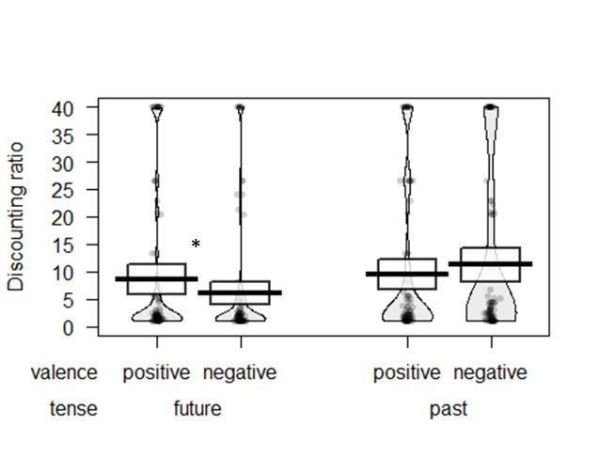
D  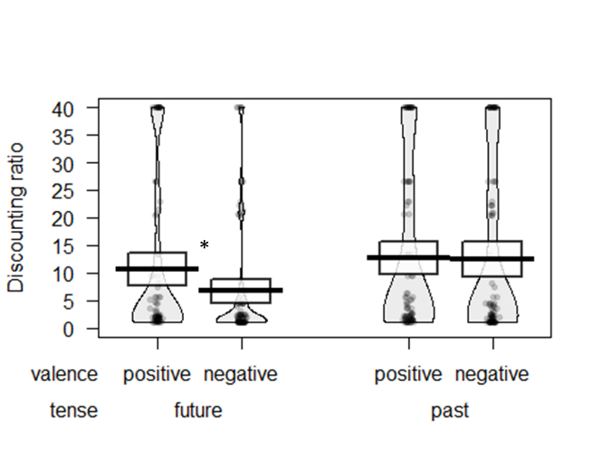 | E  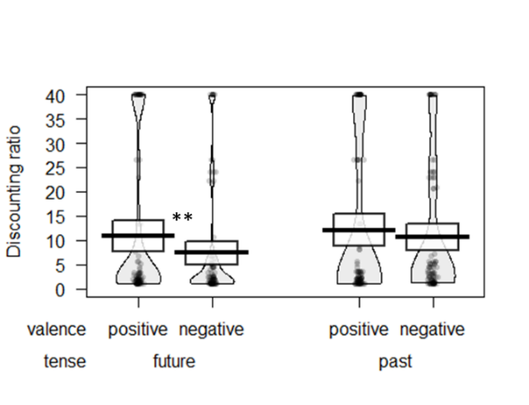

Figure B1. Study 1a discounting results, grouped by order of gain/loss, past/future blocks
- Overall; B) Gain first; C) Loss first; D) Future first; E) Past first

Thick bars show the means, bands (around the means) show the 95% Confidence Intervals, points show the raw data, and beans show the smoothed density curves. * p < .05; ** p < .01; *** p < .001.
Table B2. Contemplation emotion results from Study 1a
Past/future order | F(1,180) = 7.34, p = .007, η_{p}² = .04
Gain/loss order | F(1,180) = 7.54, p = .007, η_{p}² = .04
Tense | F(1,180) = 68.15, p < .001, η_{p}² = .27
Valence | F(1,180) = 61.70, p <.001, η_{p}² = .26
Past/future order X Gain/loss order | F(1,180) = 0.05, p = .817, η_{p}² < .01
Past/future order X Tense | F(1,180) = 1.28, p = .260, η_{p}² = .01
Gain/loss order X Tense | F(1,180) = 5.90, p = .016, η_{p}² = .03
Past/future order X Valence | F(1,180) = 5.54, p = .020, η_{p}² = .03
Gain/loss order X Valence | F(1,180) = 23.15, p < .001, η_{p}² = .11
Tense X Valence | F(1,180) = 126.58, p < .001, η_{p}² = .41
Past/future order X Gain/loss order X Tense | F(1,180) = 1.83, p = .178, η_{p}² = .01
Past/future order X Gain/loss order X Valence | F(1,180) = 0.00, p = .997, η_{p}² < .01
Past/future order X Tense X Valence | F(1,180) = 2.30, p = .131, η_{p}² = .01
Gain/loss order X Tense X Valence | F(1,180) = 0.06, p = .813, η_{p}² < .01
Past/future order X Gain/loss order X Tense X Valence | F(1,180) = 0.88, p = .350, η_{p}² < .01

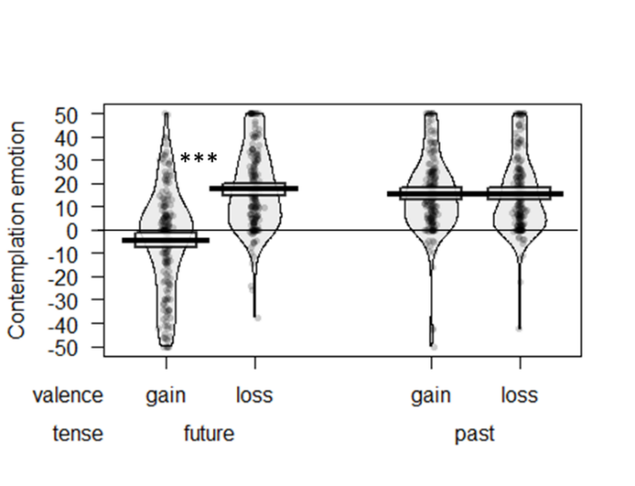
A
B  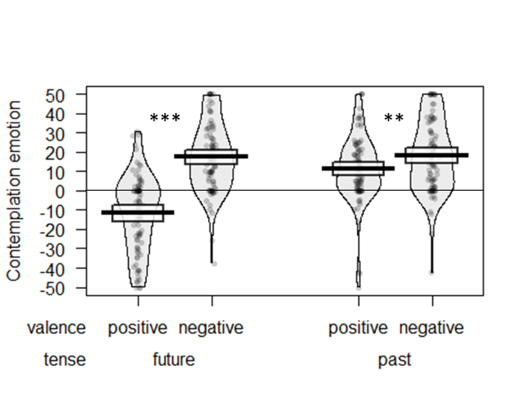 | C  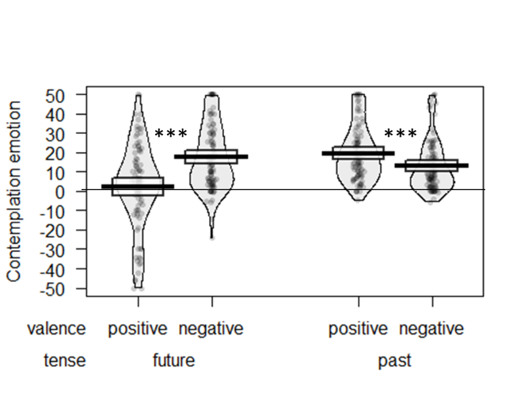
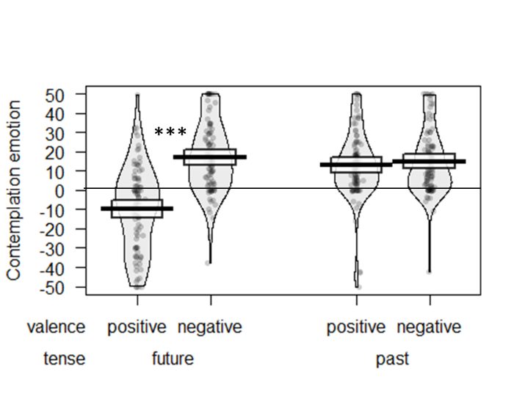  D | E  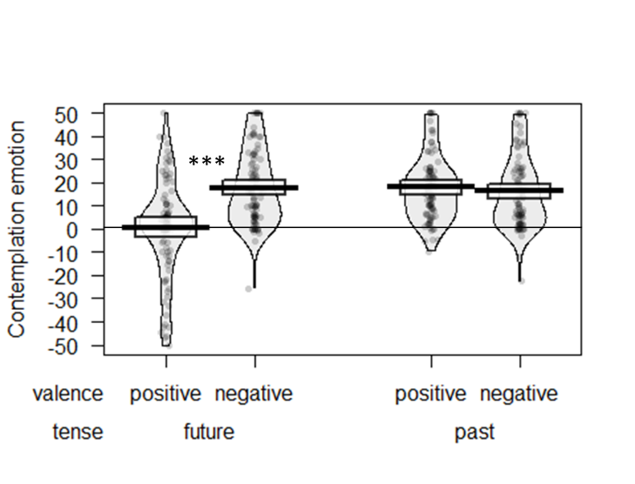

Figure B2. Study 1a contemplation emotion results grouped by order of gain/loss, past/future blocks
- Overall; B) Gain first; C) Loss first; D) Future first; E) Past first
Thick bars show the means, bands (around the means) show the 95% Confidence Intervals, points show the raw data, and beans show the smoothed density curves. * p < .05; ** p < .01; *** p < .001.

Table B3. Discounting results from Study 1b
Past/future order | F(1,173) = 0.88, p = .350, η_{p}² = .01
Pos/neg order | F(1,173) = 8.75, p = .004, η_{p}² = .05
Tense | F(1,173) = 41.51, p < .001, η_{p}² = .19
Valence | F(1,173) = 12.80, p <.001, η_{p}² = .07
Past/future order X Pos/neg order | F(1,173) = 0.17, p = .680, η_{p}² < .01
Past/future order X Tense | F(1,173) = 0.07, p = .787, η_{p}² < .01
Pos/neg order X Tense | F(1,173) = 0.01, p = .932, η_{p}² < .01
Past/future order X Valence | F(1,173) = 4.14, p = .043, η_{p}² = .02
Gain/loss order X Valence | F(1,173) = 0.81, p = .369, η_{p}² < .01
Tense X Valence | F(1,173) = 8.35, p = .004, η_{p}² = .05
Past/future order X Pos/neg order X Tense | F(1,173) = 1.47, p = .228, η_{p}² = .01
Past/future order X Pos/neg order X Valence | F(1,173) = 0.16, p = .689, η_{p}² < .01
Past/future order X Tense X Valence | F(1,173) = 0.13, p = .718, η_{p}² < .01
Pos/neg order X Tense X Valence | F(1,173) = 2.89, p = .091, η_{p}² = .02
Past/future order X Pos/neg order X Tense X Valence | F(1,173) = 1.50, p = .222, η_{p}² = .01

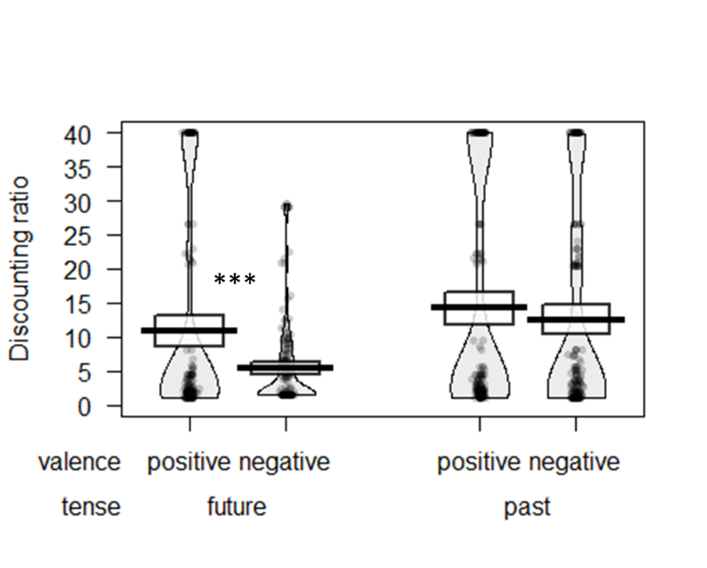
A
B  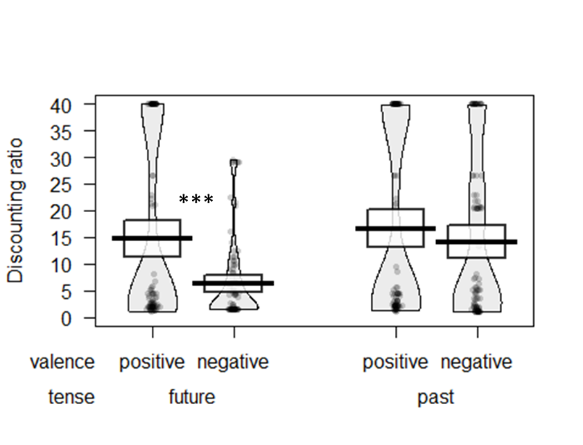 | C  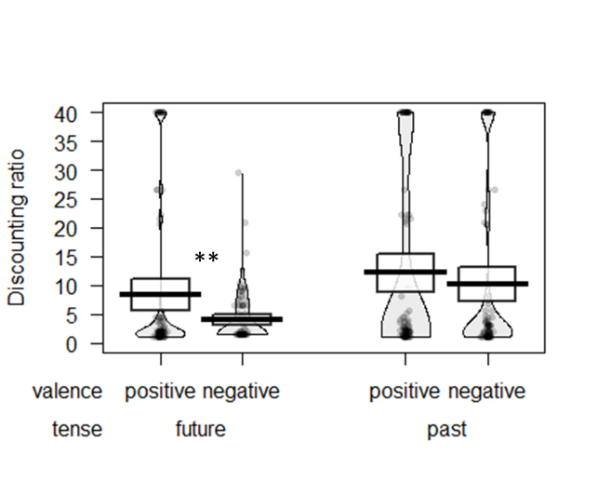
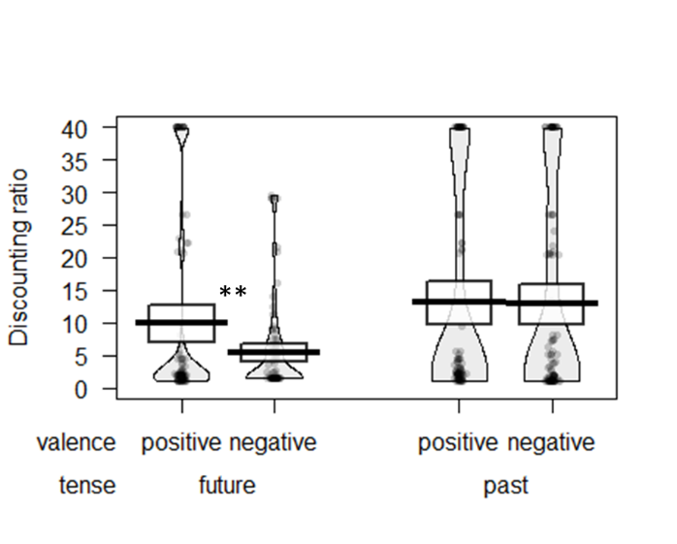  D | 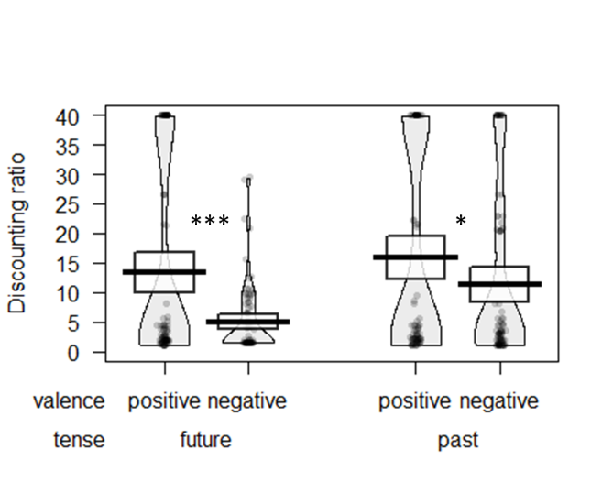  E

Figure B3. Study 1b discounting results grouped by order of pos/neg, past/future blocks
- Overall; B) Gain first; C) Loss first; D) Future first; E) Past first
Thick bars show the means, bands (around the means) show the 95% Confidence Intervals, points show the raw data, and beans show the smoothed density curves. * p < .05; ** p < .01; *** p < .001.

Table B4. Contemplation emotion results from Study 1b
Past/future order | F(1,173) = 1.20, p = .274, η_{p}² = .01
Pos/neg order | F(1,173) = 0.34, p = .562, η_{p}² < .01
Tense | F(1,173) = 70.87, p < .001, η_{p}² = .29
Valence | F(1,173) = 126.18, p <.001, η_{p}² = .42
Past/future order X Pos/neg order | F(1,173) = 0.28, p = .598, η_{p}² < .01
Past/future order X Tense | F(1,173) = 0.27, p = .606, η_{p}² < .01
Pos/neg order X Tense | F(1,173) = 17.99, p <.001, η_{p}² = .09
Past/future order X Valence | F(1,173) = 0.31, p = .581, η_{p}² < .01
Pos/neg order X Valence | F(1,173) = 21.47, p < .001, η_{p}² = .11
Tense X Valence | F(1,173) = 133.86, p < .001, η_{p}² = .44
Past/future order X Pos/neg order X Tense | F(1,173) = 0.00, p = .967, η_{p}² < .01
Past/future order X Pos/neg order X Valence | F(1,173) = 0.15, p = .697, η_{p}² < .01
Past/future order X Tense X Valence | F(1,173) = 2.04, p = .155, η_{p}² = .01
Pos/neg order X Tense X Valence | F(1,173) = 2.74, p = .100, η_{p}² = .02
Past/future order X Pos/neg order X Tense X Valence | F(1,173) = 2.08, p = .151, η_{p}² = .01

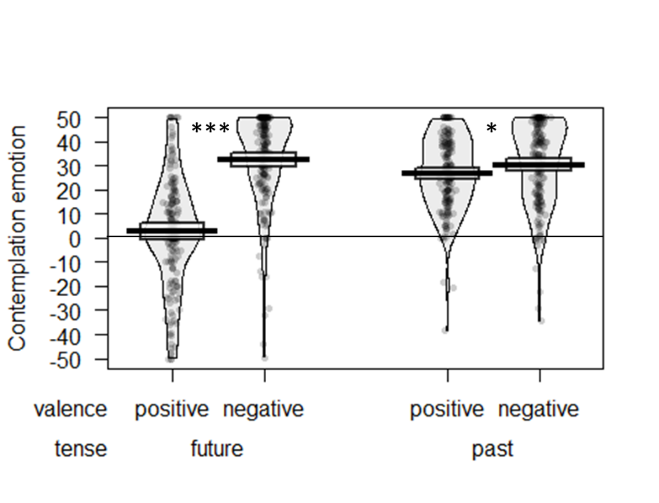
A
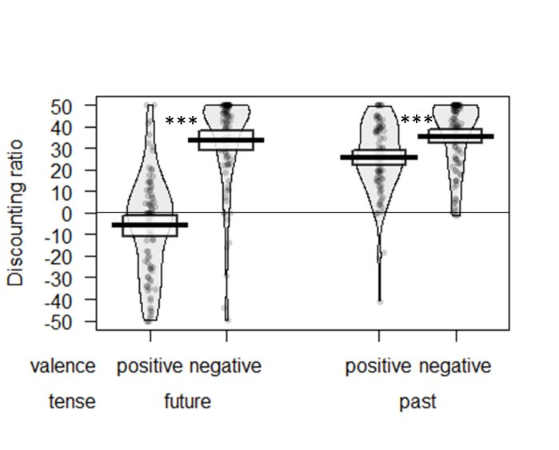  B | 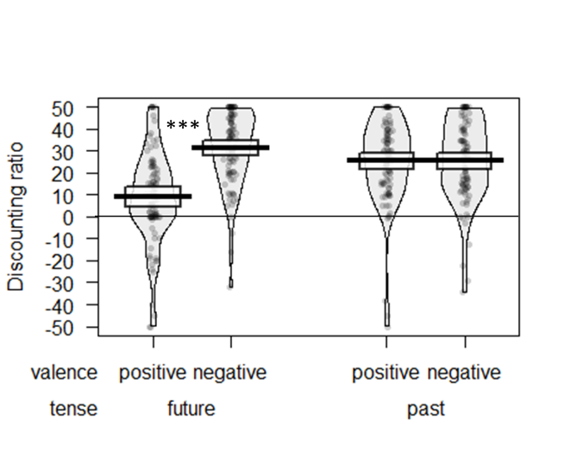  C
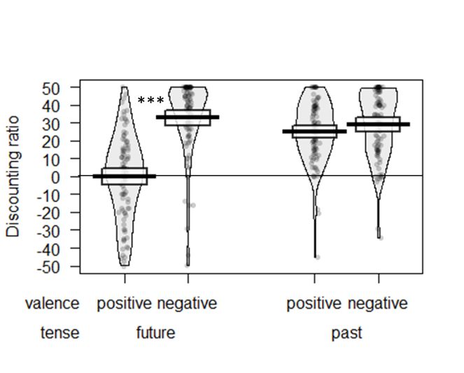  D | 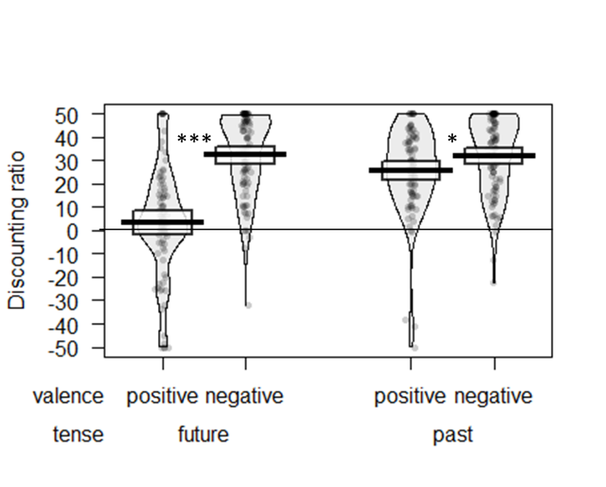  E

Figure B4. Study 1b contemplation emotion results grouped by order of gain/loss, past/future blocks
- Overall; B) Gain first; C) Loss first; D) Future first; E) Past first
Thick bars show the means, bands (around the means) show the 95% Confidence Intervals, points show the raw data, and beans show the smoothed density curves. * p < .05; ** p < .01; *** p < .001.

Part C: Study 3 pretest results
Pretest 1: Ratings of predicted experience
Two-hundred participants rated the extent to which they predicted the taste of a specified flavor of jelly bean would be positive and negative, by marking their response for each on a line measuring a total of 16.5 centimeters long. Participants were aware that the flavor provided could describe either a good-tasting or a bad-tasting jelly bean. Each participant only rated a single flavor of jelly bean. Each positive and negative rating was expressed as the distance between the left side of line and the participant’s mark. The participant’s net intensity rating was computed as the difference between their positive and negative ratings (for standard, good-tasting flavors) or the difference between their negative and positive ratings (for novelty, bad-tasting flavors). The net intensity ratings for the four flavors selected for Study 3 were:
Watermelon: M=6.95, SD=5.67
Orange Sherbet: M=6.16, SD=4.61
Dirt: M=5.74, SD=5.83
Rotten Egg: M=8.63, SD=7.57
None of the net ratings were significantly different from each other using pairwise t-tests, all ps > .13.
Pretest 2: Ratings of actual experience
Two-hundred twenty-two participants each tasted a single jelly bean and rated the extent to which they thought the taste was positive and negative, by marking their response for each on a line measuring a total of either 16.5 or 15.5 centimeters long (some participants received a ratings sheet upon which both lines appeared shorter on the page due to a copying error; the significance of the results was not affected if these participants were excluded). Before tasting the jelly bean, participants had been made aware that it could be either good-tasting or bad tasting, and each participant only rated a single flavor of jelly bean. Each positive and negative rating was expressed as the distance between the left side of line and the participant’s mark, divided by total line length. The participant’s net intensity rating was then computed as the difference between their positive and negative ratings (for standard, good-tasting flavors) or the difference between their negative and positive ratings (for novelty, bad-tasting flavors). The net intensity ratings for the four flavors selected for Study 3 were:
Watermelon: M=0.53, SD=0.29
Orange Sherbet: M=0.53, SD=0.34
Dirt: M=0.57, SD=0.40
Rotten Egg: M=0.50, SD=0.48
None of the net ratings were significantly different from each other using pairwise t-tests, all ps > .69.

Part D: Replication of Yi, Gatchalian, & Bickel (2006)

Participants
Two hundred participants from Amazon’s Mechanical Turk (46.0% female, mean age=33 years) participated in an online study in return for $0.70 compensation.
Procedure
Instructions at the top of each screen asked participants to imagine gaining or losing money in the past or future. Each participant completed all four conditions of a 2 (gain vs. loss) x 2 (past vs. future) design in counterbalanced order. Within each block, participants were presented with two columns. The right-hand column contained 20 rows with a fixed gain ($10) or loss ($10) at a distant time point of one year in the future or 1 year in the past, depending on condition. The left-hand column presented ascending or descending amounts in 5% intervals of the right-hand amount, occurring at one hour in the future or past (modeled after Yi, Gatchalian, & Bickel, 2006). Participants made a choice for each row.
Discounting computation. We identified each participant’s indifference point in each block as the row where he or she switched to preferring the amount in the fixed (distant) column. A simple measure of discounting was then calculated by dividing the distant amount by the proximal amount in the row corresponding to the participant’s indifference point. In this paradigm, higher values indicate greater discounting of the temporally distant amount. The overall discounting value for each condition was computed as the average of the values from the ascending and descending versions of each block.
Results and Discussion
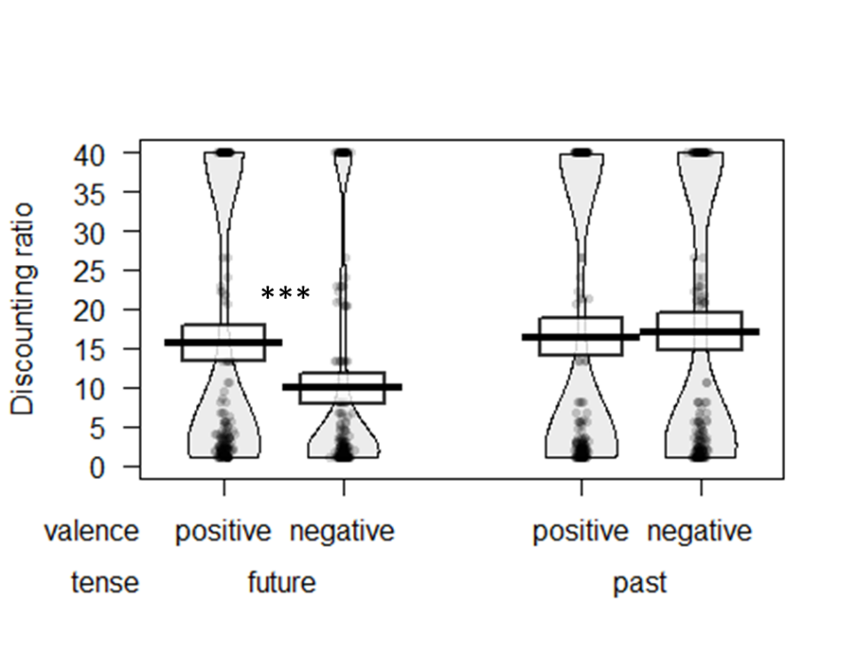
Discounting measure. We observed a main effect of tense F(1, 199)= 18.63, p <.001, η_{p}²=.09, such that participants generally discounted past outcomes (M=16.74, SD=17.50) more than the future outcomes (M=12.74, SD=15.77), and a main effect of valence F(1, 199)=6.57, p=.011, η_{p}²=.03, such that participants generally discounted gains (M=16.02, SD=17.37) more than losses (M=13.44, SD=16.06). Furthermore, we observed a significant time X valence interaction, F(1,199)=19.67, p<.001, η_{p}²=.09. Specifically, participants discounted the future $10 gain (M=15.63, SD=17.04) significantly more than the future $10 loss (M=9.84, SD=13.83), F(1, 199)=24.51, p<.001, η_{p}²=.11, but participants did not discount the past $10 gain (M=16.41, SD=17.23) more than the past $10 loss (M=17.06, SD=17.31), F(1, 199)=0.24, p=.622, η_{p}²<.01. This pattern demonstrates the sign effect for future, but not past, outcomes (see Figure D1).

Figure D1. Discounting of past and future outcomes.
Thick bars show the means, bands (around the means) show the 95% Confidence Intervals, points show the raw data, and beans show the smoothed density curves. * p < .05; ** p < .01; *** p < .001.

Part E: Individualized Utility Curvature Adjustment in Study 2

In Study 2a and Study 2b, a substantial proportion of participants gave non-monotonic answers to the utility curvature questions, which could indicate confusion or inattention. (For example, some participants indicated that the difference between $0 and $2.50 felt the same as the difference between $2.50 and $2.50, or that the difference between $0 and $2.50 felt the same as the difference between $2.50 and $0.) In the main manuscript, therefore, we analyzed data using the median utility curve, so that we could include all participants without giving undue weight to inattentive or confused participants. However, this analysis is somewhat course, and it is also instructive to adjust for utility curvature on an individual basis (each participant’s answers are adjusted according to his/her own utility curve) and to exclude confused participants. In the sections that follow, we do just that, and the major conclusions are unchanged.

Study 2a: Additional Analyses
Utility curvature. The median participant was indifferent about a gamble with a 50/50 chance of gaining $10 or losing $5, consistent with previous research on loss aversion. The individually titrated loss magnitude values were dynamically carried through the rest of the survey for each participant, controlling for loss aversion through the experimental design.
We calculated utility curvature adjusted discount rates for each participant, through the following steps: 1) we required monotonically increasing utility for gains and losses (getting more money is always better, losing more money is always worse), and discarded data from the substantial proportion of participants who violated this principle (39% of gain answers, 45% of loss answers), as these participants either misunderstood the task or were not responding carefully. 2) We created a series of dollar/utility data coordinates for each participant. We set $0 equal to 0 utility, the largest gain for that participant (median=$25) equal to 1 utility, and the largest loss for that participant (median= -$8.86) equal to -1 utility. The remaining coordinate pairs were filled in by linear interpolation, as can be seen in Figure E1 below. The result looks similar to a Prospect Theory utility form (Kahneman & Tversky, 1979). 3) We converted the dollar values from the intertemporal choice task into utilities using linear interpolation (rather than imposing a particular functional form on participants’ utility curves, such as an exponential function). 4) We calculated new discount rates based on current vs future utility values (in place of dollar values).

Figure E1. Median utility values in Study 2a, with non-monotonic participants excluded. Note that the y-axis values are fixed at increments of 0.2, and the x-axis values show the median dollar equivalence measured for each participant.

The utility curvature adjusted discount rates were very highly correlated with their corresponding nominal discount rates, all r=.99, p<.001. We re-calculated the key inferential statistics for discounting and contemplation utility, and found essentially the same results: including the main effect of sign on discounting, F(1,107)=26.72, p<.001, η_{p}²=.20, and the sign X tense interaction on discounting, F(1,107)=6.15, p=.01, η_{p}²=.05. In a mixed model, contemplation utility predicted discounting on its own, β=-.006, F(1,474)=4.92, p=.03. When including tense, sign, and the interaction, contemplation utility remains significant, β=-.007, F(1,471)=5.31, p=.02, and the sign X tense interaction drops to marginal significance, β=.74, F(1,471)=3.02, p=.08 (consistent with partial mediation). Using a bootstrapped mediation model with 5000 replications, the indirect effect was significant, β=.033, CI₉₅ [.009, .072], p<.01. The fact that our results remain robust when expressing outcomes in terms of their computed utility suggest that our focal result is not caused by systematic differences in utility in the gain vs. loss domain, such as may be caused by differing risk preferences for monetary gains and losses.

Study 2b: Additional Analyses
Utility curvature. The median participant was indifferent about a 50% chance of receiving a 1 hour massage and a 50% chance of receiving a 10 second electric shock. The individually titrated values were dynamically carried through the rest of the survey for each participant, controlling for loss aversion (and subjective utility more generally) through the experimental design.
We calculated utility curvature adjusted discount rates for each participant using the same procedure as used in Study 2a, with the results visualized in Figure E2.
Minutes of massage
Seconds of electric shock
Figure E2. Median utility values in Study 2b, with non-monotonic participants excluded. Note that the x-axis shows seconds of electric shock, to the left, and minutes of massage, to the right. The y-axis values are fixed at increments of 0.2, and the x-axis values show the median time equivalence measured for each participant.

The utility curvature adjusted discount rates were very highly correlated with their corresponding nominal discount rates, all r=.94 or higher, all p<.001. We re-calculated the key inferential statistics for discounting and contemplation utility, and found the essentially the same results: including the main effect of sign on discounting, F(1,62)=127.14, p<.001, η_{p}²=.67, the main effect of tense, F(1,62)=22.98, p<.001, η_{p}²=.27, and the sign X tense interaction on discounting, F(1,62)=15.51, p<.001, η_{p}²=.20. In a mixed model, contemplation utility predicts discounting on its own, β=-.015, F(1,322)=27.77, p<.001. When including tense, sign, and the interaction, contemplation utility remains significant, β=-.008, F(1,319)=11.25, p=.001, and the sign X tense interaction is reduced but remains significant, β=1.184, F(1,319)=9.12, p=.003 (consistent with partial mediation). The indirect effect of the mediation model going from sign X tense, through contemplation utility to predict discounted utility was significant, β=.071, CI₉₅ [.028, .126], p<.001.

There were no cases in which a participant switched between columns more than once. If a participant selected all choices in the varying (ascending/descending) column, we assumed an indifference point corresponding to the lowest amount in the varying column, and if a participant selected all choices in the fixed column, we assumed an indifference point corresponding to the highest amount in the varying column.

