The Sign Effect in Past and Future Discounting

Sarah Molouki^{a*}, David J. Hardisty^{b}, Eugene M. Caruso^{c}
ª University of Chicago, Booth School of Business
^{b} University of British Columbia, Sauder School of Business
^{c} University of California Los Angeles, Anderson School of Management

* Corresponding Author:
Sarah Molouki; s.molouki@chicagobooth.edu

Abstract
We compare the extent to which people discount positive and negative events in the future and in the past. We find that the tendency to discount gains more than losses (i.e., the sign effect) emerges more strongly for future than for past outcomes. We present evidence from six studies (N=1,077) that the effect of tense on discounting is tied to differences in the contemplation emotion of these events, which we assess by measuring the emotions experienced while either anticipating or remembering the event. We rule out loss aversion, uncertainty, utility curvature, thought frequency, and connection to future/past self as explanations for this phenomenon, and discuss why people experience a distinct mixture of emotions when contemplating upcoming events.

Keywords: Discounting, Intertemporal Choice, Sign Effect, Anticipation, Memory, Dread, Contemplation, Emotion

The Sign Effect in Past and Future Discounting
Imagine that you are a contestant on a game show where you compete to be the last one remaining on a desert island. After days of eating only paltry rice rations, you win a competition that entitles you to a delicious steak dinner. You would likely have a much stronger preference for a dinner later that evening than later that month (suggesting delay discounting of the desired event). In contrast, imagine that an upcoming competition requires that you eat a live cockroach. In this case, your distaste for your fate would likely be similar regardless of whether it is happening in a few hours or a few weeks (suggesting minimal delay discounting of the dreaded event). Indeed, a large body of work on temporal discounting has demonstrated that people discount future positives more than future negatives, a phenomenon known as the sign effect (Mischel, Grusec, & Masters, 1969; Read, 2004; Thaler, 1981). Thus, although the perceived impact of both good and bad events decreases as the time to their occurrence increases, time delay will weaken the mental impact of eating an upcoming steak more than eating an upcoming cockroach.
The sign effect has implications for evaluating a broad range of distant events, and yet it remains unknown whether the sign effect is unique to the anticipatory nature of future gains and losses, or whether it is related to a more general discrepancy in the subjective impact of positive and negative events. To distinguish between these two possibilities, we explore whether the sign effect also occurs in the evaluation of past outcomes. If the sign effect is driven by a general difference in the perceived subjective impact of positive and negative events, we would expect to see evidence of the sign effect when judging both past and future outcomes. In contrast, if the sign effect is instead tied to the process of prospective thought, we might expect to see the sign effect only when making judgments about future events. In examining this research question, we aim both to advance our understanding of the mechanism underlying the sign effect and to better delineate contexts in which it affects consequential decisions.
The Psychology of the Sign Effect
Two prevailing accounts have been offered to explain the sign effect. The loss aversion account suggests that increased sensitivity to the magnitude of negative outcomes leads to lower discounting. In general, perceived change in utility from a loss is larger than that from an equivalent gain (Kahneman & Tversky, 1979). Therefore, losses seem consistently more impactful, and are discounted less, than gains of equivalent magnitude (Baucells & Belleza, 2017; Loewenstein & Prelec, 1992). This possibility is supported by evidence of an inverse association between loss discounting and neural activation associated with the magnitude of negative events (Tanaka, Yamada, Yoneda, & Ohtake, 2014; Xu, Liang, Wang, Li, & Jiang, 2009).
The contemplation emotion account instead suggests that the sign effect is driven by the greater relative emotional impact not of a distant negative event itself, but of the process of waiting for it to occur. This possibility is supported by people’s preference for expediting negative experiences associated with high amounts of dread (i.e., high amounts of negative emotion during the intervening time period, such as seen with electric shocks; see Berns et al., 2006; Loewenstein, 1987). This preference indicates minimal discounting; if a dreaded event were discounted with time, one would choose to delay it, and yet people instead choose to “get it over with” immediately. In contrast, people do prefer to delay negative experiences that are comparatively low in anticipatory discomfort (e.g., losing money), reflecting a behavior pattern consistent with classic delay discounting for negative events (Berns et al., 2006; Harris, 2012). On this account, these differences occur because the intervening experience of contemplating the event is the main driver of discounting behavior, rather than the perceived magnitude of the event itself.
In contrast to negative events, discounting of positive events is reflected by desire to expedite the event (because we would rather experience a positive event when it is perceived to be more impactful, rather than weakened with the passage of time). Emotions experienced while waiting for a positive event can also counteract discounting; for example, enjoyment derived from the process of waiting for a positive event, such as a vacation, may lessen our desire to expedite the event and reduce discounting (Loewenstein, 1987). However, an important feature of waiting for a gain is that enjoyment is often mixed with future-oriented negative emotion such as impatience. As a result of these mixed emotions, the overall enjoyment of contemplating a positive event may be less impactful than the overall pain of waiting for a bad experience, which tends to be more uniformly negative (Hardisty & Weber, 2019; Nowlis, Mandel, & McCabe, 2004). Thus, although contemplating both positive and negative future events may be associated with emotion that reduces discounting, asymmetry in the net strength of these emotions might produce the sign effect.
Comparing Future and Past
We provide a critical test to differentiate between the loss aversion account and the contemplation emotion account by systematically comparing the discounting of future outcomes to the discounting of identical past outcomes. Although the discounting of past events has been less extensively studied and is perhaps less intuitive than discounting of future events, there is some evidence that the perceived impact of a past event also decreases as distance from the event grows (e.g., Yi, Gatchalian, & Bickel, 2006). Therefore, examining determinants of time preferences for past events can also reveal information about the cognitive mechanisms driving discounting.
In our experimental paradigm, we hold constant the perceived magnitude of outcomes and measure the extent to which discounting is driven by the intensity of emotional experience while contemplating each type of event. Building on previous research linking discounting with intensity of anticipatory emotion (as distinct from predicted experience of the outcome itself; see e.g. Berns et al., 2006; Harris, 2012), we focus on assessing the emotional quality of the intervening period between the present moment and the event’s occurrence. We extend this assessment to past events by examining the emotional intensity experienced while remembering the event (as distinct from recalled experience of the event itself). We compare the emotional experience of contemplating positive and negative events by measuring the net intensity of valence-congruent emotion (in other words, the degree of net positive emotion associated with contemplating positive events is compared with the degree of net negative emotion associated with contemplating negative events).
If the sign effect is attributable to a general positive-negative emotional asymmetry where negative events are more impactful in general than positive events (i.e., loss aversion), we would expect to see the sign effect for both past and future. Furthermore, under this account, controlling for loss aversion by equating the subjective value of present outcomes should eliminate the sign effect in both past and future.
In contrast, if the difference in discounting is driven by a specific pattern of emotion related to anticipatory thought about future positive (versus negative) events (Hardisty & Weber, 2019), we would expect the sign effect to be unique to future events and emerge even when controlling for perceived magnitude of the outcomes themselves. But, we would expect to see little difference in discounting and intensity of emotion when comparing past gains and losses.
We suggest that the differences in the intensity of contemplation emotion may be indeed related specifically to the nature of emotions evoked by upcoming events. Namely, the positive intensity of contemplating an upcoming positive event is reduced by impatience (an emotion commonly called upon in the discounting literature and unique to events that have not yet occurred), whereas the negative intensity of contemplating an upcoming negative event is not tempered, but rather is likely to be strengthened, by anxiety (also an emotion closely associated with events that have not yet occurred). Although experiencing the memory of past events may also be accompanied by emotion that contrasts the valence of the event, we have no a priori reason to predict that these countervailing emotions will demonstrate the same asymmetrical pattern for positive versus negative events as their future counterparts. Based on this account, we expect to see the sign effect exclusively, or at least more strongly, for future events rather than past events.
We make three predictions for our current research. First, based on research documenting some differences in valuation and emotional intensity of future and past outcomes (e.g., Caruso, 2010; Caruso, Gilbert, & Wilson, 2008; Caruso & Van Boven, 2019; He, Huang, Yuan, & Chen, 2012; Van Boven & Ashworth, 2007), we predict that past events will be discounted more than future events. Second, we expect to replicate the basic sign effect whereby people discount positive future events more than negative future events (Mischel et al., 1969; Read, 2004; Thaler, 1981). Third, most critically, we predict an interaction such that the sign effect will be larger for future events than for past events, and that this difference will be associated with more intense net emotion related to the contemplation of future negative (versus positive) events. We test these predictions in six studies.
Study 1a
Participants
One hundred and eighty-four participants from Amazon’s Mechanical Turk (45.7% female, mean age=32 years) participated in an online study in return for $1.50 compensation.
Procedure
Instructions at the top of each screen asked participants to imagine gaining or losing money in the past or future. Each participant completed all four cells of a 2 (gain vs. loss) x 2 (past vs. future) design in counterbalanced order. Within each block, participants were presented with two columns. The right-hand column contained 20 rows with a fixed gain ($10) or loss ($5) at a distant time point of one year in the future or one year in the past, depending on condition. Monetary values were chosen based on pretesting such that they would have equivalent subjective present impact. This was done to control for differences in emotional experience due to perceptions of the outcomes themselves (loss aversion), rather than to differences in experience of the intervening waiting period. The left-hand column presented ascending or descending amounts in 5% intervals of the right-hand amount, occurring at one hour in the future or past (modeled after Yi et al., 2006; see SOM-R for sample stimuli). Participants made a choice from each row.
Though the repeated-measures nature of our discounting elicitation method has some drawbacks due to the possibility of carryover effects across questions, we aimed to minimize the impact of these effects on our results by a) testing for order effects across blocks (discussed further in the results section), and b) presenting discounting questions within blocks in both ascending and descending order to mitigate effects of anchoring on earlier questions within a block. Furthermore, though previous research on discounting methodology in particular has noted the presence of carryover effects with instruments that use multiple questions, such titration methods are generally viewed as among the most accurate ways of eliciting meaningful discount rates (e.g., see Hardisty, Thompson, Krantz, & Weber, 2013; Li, Wall, Johnson, & Toubia, 2016).
After completing the discounting measures, participants reported their subjective feelings of anticipation or memory (contemplation emotion measure) for the distant fixed amount in that block ($10 gain or $5 loss). They were asked, “How psychologically pleasurable or displeasurable would the [anticipation/memory] of [event] be? In other words, how would you feel while [waiting for/remembering] it?” and responded on a sliding scale ranging from -50 (strongly dislike the feeling of [waiting/remembering]) to +50 (strongly like the feeling of [waiting/remembering]).
Discounting computation. We identified each participant’s indifference point for each block as the row where he or she switched to preferring the amount in the fixed (distant) column. A simple ratio measure of discounting was then calculated by dividing the distant amount by the proximal amount in the row corresponding to the participant’s indifference point. In this paradigm, higher values indicate greater discounting of the temporally distant amount. The overall discounting value for each condition was computed as the average of the participant’s values from ascending and descending versions of each block.
Results
Order effects. Several effects related to order of presentation of the gain/loss and past/future blocks were observed on both the discounting measure and contemplation emotion measure. However, none of these order effects significantly affected the focal tense X valence interaction. Thus, order effects will not be discussed further in the main text of this paper. Order effects from both Study 1a and Study 1b are presented in the SOM-R.
Discounting measure. We observed a main effect of tense, F(1, 183)= 19.61, p <.001, η_{p}²=.10, such that participants generally discounted past outcomes (M=11.95, SD=14.73) more than future outcomes (M=8.85, SD=12.97), and a main effect of valence, F(1, 183)=5.38, p=.021, η_{p}²=.03, such that participants generally discounted gains (M=11.54, SD=14.86) more than losses (M=9.25, SD=12.92). Furthermore, we observed a significant tense X valence interaction, F(1, 183)=5.54, p=.020, η_{p}²=.03. Specifically, participants discounted the future gain (M=10.71, SD=14.56) significantly more than the future loss (M=6.99, SD=10.88), F(1, 183)=12.92, p<.001 , η_{p}²=.07, but discounted the past gain (M=12.38, SD=15.14) and past loss (M=11.52, SD=14.35) to an equal extent, F(1, 183)=0.46, p>.250, η_{p}²<.01 (Figure 1). This pattern demonstrates the sign effect for future, but not past, outcomes.
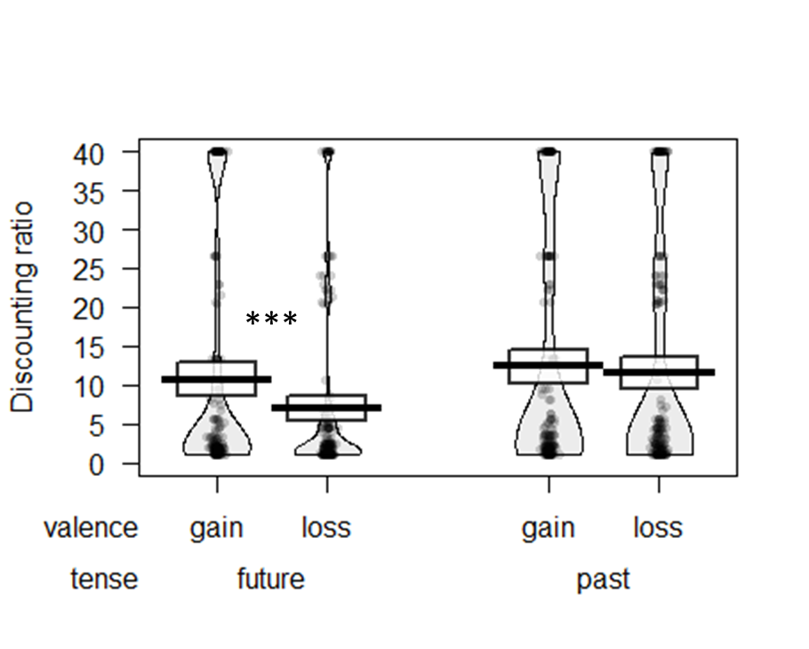
Figure 1. Discounting of past and future outcomes in Study 1a. Thick bars show the means, bands (around the means) show the 95% Confidence Intervals, points show the raw data, and beans show the smoothed density curves. * p < .05; ** p < .01; *** p < .001.

Contemplation emotion. To directly compare the intensity of contemplation emotion for positive and negative events, we reverse scored the emotion ratings for losses (so that more negative emotion was represented by higher values). We observed a main effect of tense, F(1, 183)= 65.20, p <.001, η_{p}²=.26, with higher contemplation emotion for past outcomes (memory; M=15.58, SD=16.34) than future outcomes (anticipation; M=6.50, SD=22.73), and a main effect of valence, F(1, 183)=52.42, p<.001, η_{p}²=.22, with higher contemplation emotion for losses (M=16.54, SD=16.78) than gains (M=5.55, SD=21.97). These were qualified by a significant tense X valence interaction, F(1, 183)=126.21, p < .001, η_{p}²=.41. For future events, contemplation emotion associated with losses (dread; M=17.45, SD=17.22) was significantly stronger than that for gains (positive anticipation; M=-4.43, SD=22.33), F(1, 183)=115.85, p<.001, η_{p}²=.39. We note that the contemplation emotion for future gains was in fact significantly below zero, t(183)= -2.69, p=.008, d=0.199, suggesting that on average, anticipating future gains was associated with negative (rather than positive) emotion. In contrast, the contemplation emotion associated with past losses (M=15.62, SD=16.32) was no higher than that of past gains (M=15.54, SD=16.40), F(1, 183)=0.003, p>.250, η_{p}²<.01 (Figure 2).
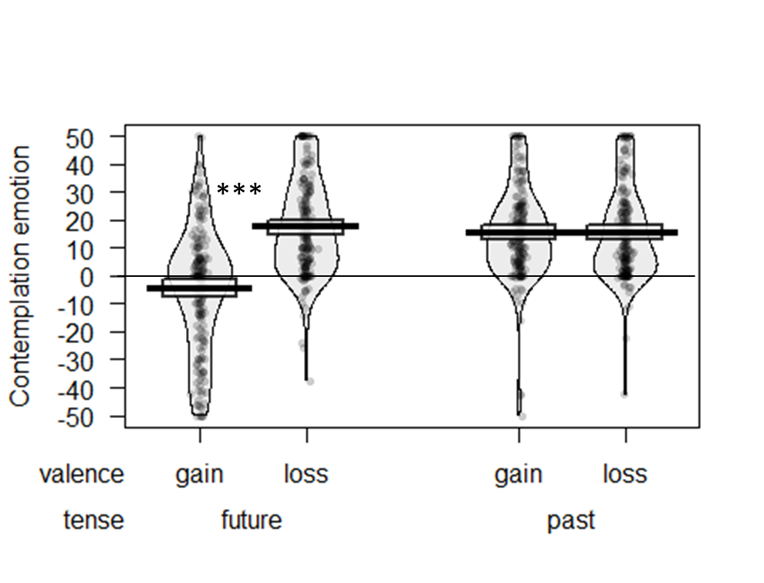
Figure 2. Contemplation emotion related to past and future outcomes in Study 1a. Thick bars show the means, bands (around the means) show the 95% Confidence Intervals, points show the raw data, and beans show the smoothed density curves. * p < .05; ** p < .01; *** p < .001.

Mediation analysis. A mediated moderation model (Muller, Judd, & Yzerbyt, 2005) was used to examine whether the interactive effect of tense and valence on discounting was mediated by contemplation emotion. A mediation effect of this form would suggest that the sign effect is associated with the differing impact of contemplating distant positive and negative events, which, as seen from Figure 2, emerges only when these events are located in the future.
A bootstrap model with 5000 samples revealed the following values for the indirect effect of the tense X valence interaction on discounting via contemplation emotion, B = 1.09, 95% bias-corrected CI = [-0.048, 2.58], p = .053 (see Figure 3). Although not statistically significant, the pattern of results suggests that contemplation emotion may be related to the observed relationship between tense X event valence and discounting. In other words, the weaker contemplation emotion of positive (compared to negative) events is unique to the future, and accompanies a discounting difference (contributing to the sign effect for future events but not past events).

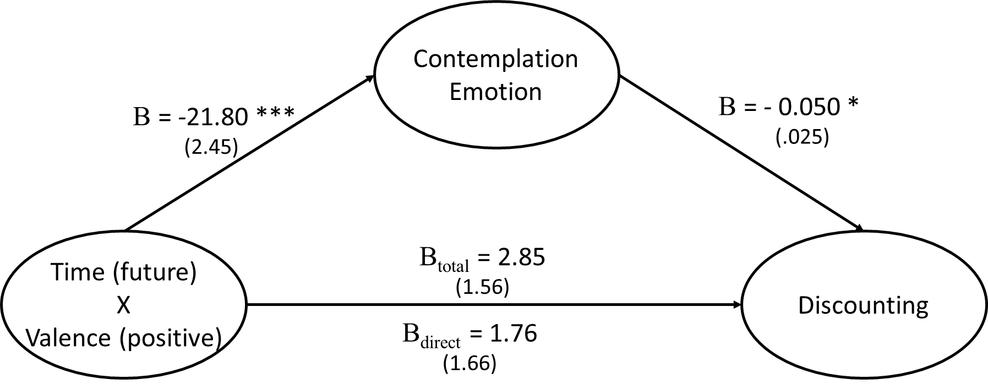
Figure 3. Mediation model for Study 1a. All reported coefficients are unstandardized; standard errors in parentheses.
*p< .05; **p< .01; ***p<.001.

Study 1b
To generalize beyond monetary gains and losses, Study 1b tests non-monetary hedonic events.
Participants
One hundred and eighty-six participants from Amazon’s Mechanical Turk (39.8% female, mean age=35.1 years) completed an online study in return for $1.50. We excluded nine participants from analysis for reporting in a screening question that they would perceive our intended negative event as pleasurable and/or our intended positive event as displeasurable.
Procedure
The procedure and calculation of discount rates was identical to that of Study 1a, except that the monetary gains and losses were replaced with hedonic events. The events of fixed magnitude were “receiving a pleasant 1 hour massage” and “receiving an unpleasant (but non-harmful) 1 minute electric shock,” occurring either one year in the future or the past. These events were chosen because each is associated with a time-limited hedonic experience that has few lasting implications other than the contemplation emotion associated with anticipating or recalling its occurrence. A column containing the distant fixed event was paired with a column containing the same event type occurring at one hour in the future or past, and with event duration varying by 5% of the fixed amount in ascending or descending order (see SOM-R for sample stimuli). Participants made a choice for each pair, which was used to calculate their indifference point for the discounting measure as in Study 1a.
Results
Order effects. As in Study 1a, some effects related to order of presentation of the positive/negative and past/future blocks were observed on both the discounting measure and contemplation emotion measure. These did not significantly affect the main tense X valence interaction of interest, and are presented in the SOM-R.
Discounting measure. We again observed a main effect of tense, F(1, 176)= 41.45, p <.001, η_{p}²=.19, such that participants discounted past outcomes (M=11.95, SD=14.73) more than future outcomes (M=8.85, SD=12.97), and a main effect of valence, F(1, 176)=12.18, p=.001, η_{p}²=.06, such that participants generally discounted positive (M=12.53, SD=15.93) more than negative events (M=8.91, SD=12.07). We also observed a significant tense X valence interaction, F(1, 176)=8.13, p=.005, η_{p}²=.04. Specifically, participants discounted the future massage (M=10.89, SD=15.13) significantly more than the future shock (M=5.32, SD=6.46), F(1, 176)=23.43, p<.001, η_{p}²=.12. However, participants discounted the past massage (M=14.17, SD=16.57) and the past shock (M=12.50, SD=14.98) to a similar extent, F(1, 176)=1.57, p=.213, η_{p}²=.01 (Figure 4). This result is again consistent with the existence of the sign effect for future, but not past, events.
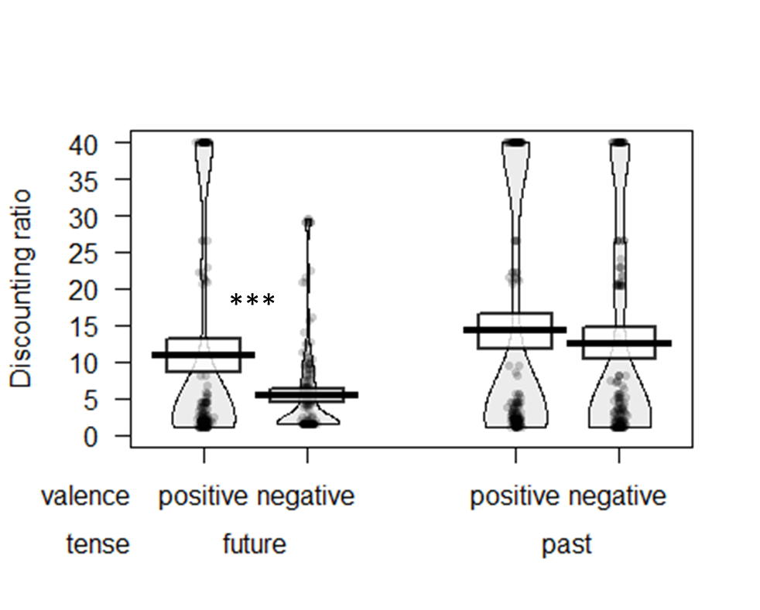
Figure 4. Discounting of past and future events in Study 1b. Thick bars show the means, bands (around the means) show the 95% Confidence Intervals, points show the raw data, and beans show the smoothed density curves. * p < .05; ** p < .01; *** p < .001.

Contemplation emotion. As in Study 1a, we found that past events (M=28.69, SD=16.61) had a higher contemplation emotion than future events (M=17.46, SD=25.91), F(1, 176)=65.53, p<.001, η_{p}²=.27, and negative events (M=31.41, SD=18.38) had a higher contemplation emotion than positive events (M=14.74, SD=23.09), F(1, 176)=115.70, p<.001, η_{p}²=.40. We also found a significant tense X valence interaction, F(1, 176)=131.84, p<.001, η_{p}²=.43. For future events, contemplation emotion associated with the massage (positive anticipation; M=2.55, SD =23.07) was significantly weaker than that associated with the shock (dread; M=32.38, SD=19.14), F(1, 176)=176.83, p<.001, η_{p}²=.50. When recalling past events, contemplation emotion associated with the massage was again lower (M=26.93, SD=15.42) than that associated with the electric shock, (M=30.44, SD=17.58) F(1, 176)=5.16, p=.024, η_{p}²=.03, but the significant interaction effect indicates that this difference was significantly smaller than it was for future events (Figure 5).
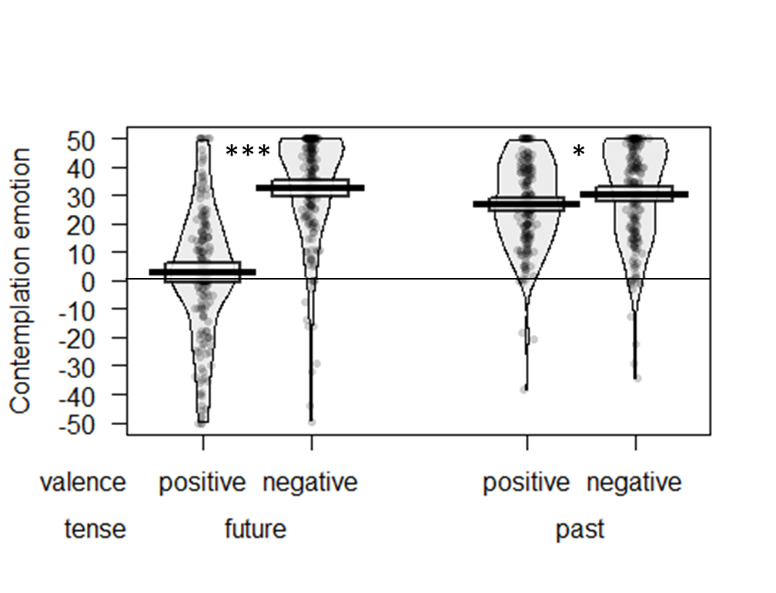
Figure 5. Contemplation emotion associated with past and future outcomes in Study 1b. Thick bars show the means, bands (around the means) show the 95% Confidence Intervals, points show the raw data, and beans show the smoothed density curves. *p<.05; **p<.01; ***p<.001.

Mediation analysis. As in Study 1a, we examined whether the interactive effect of tense and valence on discounting was mediated by contemplation emotion. A bootstrap model with 5000 samples revealed a significant indirect effect of the tense X valence interaction on discounting via contemplation emotion (B = 1.59, 95% bias-corrected CI = [0.345, 2.996], p = .025), and the direct effect of the tense X valence interaction on discounting was reduced from 3.91 to 2.32 when including contemplation emotion in the model (see Figure 6). This pattern suggests that the sign effect in future discounting is associated with differences unique to anticipatory thoughts.

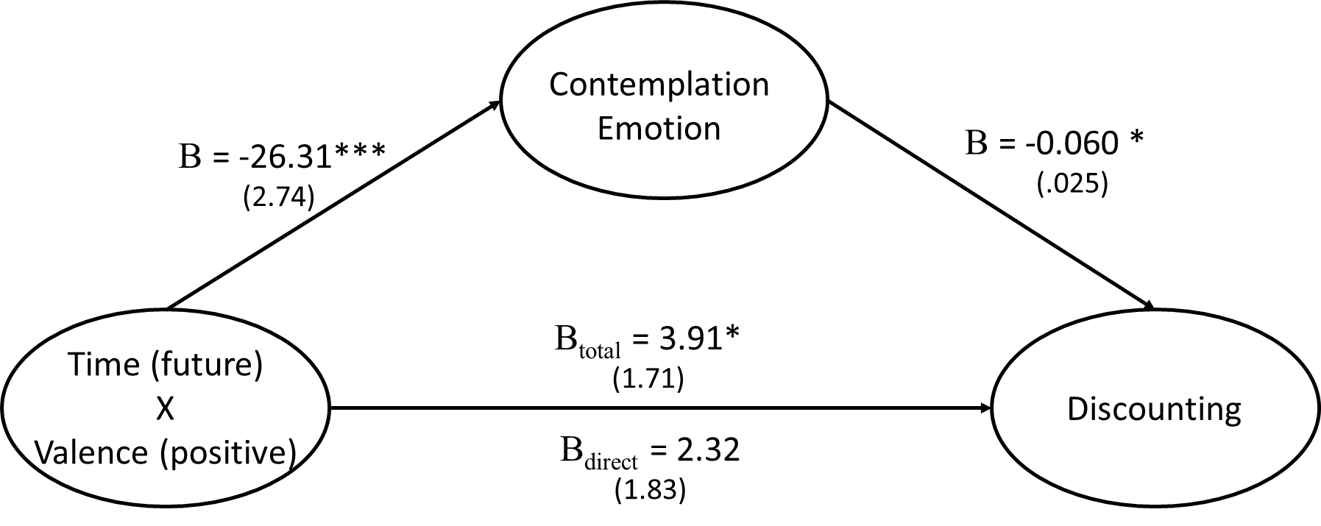
Figure 6. Mediation model for Study 1b. All reported coefficients are unstandardized.
* p < .05; ** p < .01; *** p < .001.

Study 2a
Studies 2a and 2b had several goals: 1) to improve range and precision, discount rates were measured with a dynamic algorithm; 2) loss aversion was measured for each participant and incorporated into the measure of discounting; 3) utility curvature for gains and losses was measured and controlled for; 4) thought frequency and connection to future/past self were assessed as alternative mediators of the sign effect.
Participants
Two hundred and six participants from Amazon’s Mechanical Turk (38% female, mean age=35.5 years) participated in an online study in return for $2.00 compensation. One participant indicated in the comments that she misunderstood the materials and was excluded from the dataset prior to all analyses, leaving 205 participants for further analysis.
Procedure
First, participants answered a series of 20 questions designed to measure loss aversion. The first question asked “Would you accept the following gamble: 50% chance of receiving $10 and 50% chance of losing $10? (Y/N)” The next 19 questions incrementally reduced the amount of the loss by $0.50, down to “50% chance of receiving $10 and 50% chance of losing $0.50?” On the next page, the same 20 questions were asked in the opposite order (ascending vs. descending, counterbalanced between subjects). The point at which participants switched between rejecting and accepting the gamble was identified as their indifference point. The indifference points from the two scales (ascending vs. descending) were averaged together and used as the measure of loss aversion for each participant. Then, participants read an introduction and answered example questions, similar to those they would answer soon in the main survey.
Next, each participant completed all four conditions of a 2 (gain vs. loss) x 2 (past vs. future) design in counterbalanced order. Within each block, participants first were informed that “all gains or losses would be guaranteed to occur at the specified time.” They then completed the Three-Option Adaptive Discount rate (ToAD) measure to compute their discount rate (Yoon & Chapman, 2016). For gains, the base outcome was $10 with a delay of 365 days. For losses, the base outcome ($X in 365 days) was individually piped in, based on each participant’s indifference point calculated earlier in the loss aversion scale. On each of 10 questions, the participants faced a choice between three options: the base option (jittered), such as “Receiving $9.45 in 348 days”, an immediate option, such as “Receiving $1.74 later today”, and an intermediate option, such as “Receiving $5.68 in 146 days.” Depending on the participant’s choices, the immediate and intermediate options were systemically adjusted, according to a series of dynamic confidence intervals for the log of the hyperbolic discount rate. If the confidence intervals indicated likely zero or negative discount rates, special probe questions assessed these, following the standard ToAD procedure (see Yoon & Chapman, 2016, for the computational and procedural details).
Next, within each block, participants answered a series of questions about the base outcome (e.g., about receiving “$10 one year from now”). First, they estimated the positive experience emotion of the event, “Imagine that you will receive $10 one year from now. How pleasurable or positive would the experience of the event be at that time?” answered on a slider from 0 (“Experience would be not at all pleasurable”) to 100 (“Experience would be extremely pleasurable”). Next, they estimated the negative experience emotion of the event, “Imagine that you will receive $10 one year from now. How displeasurable or negative would the experience of the event be at that time?” answered on a slider from 0 (“Experience would be not at all displeasurable”) to 100 (“Experience would be extremely displeasurable”).
After that, within each block, participants indicated their contemplation emotion, with the instruction, “please think about how you would feel right now while [waiting for/remembering] the described event.” They were first asked, “How pleasurable or positive would the [anticipation/memory] of this event be? In other words, how would you feel right now while [waiting for/remembering] it?” and responded on a sliding scale ranging from 0 (“[waiting/remembering] would be not at all pleasurable”) to 100 (“[waiting/remembering] would be extremely pleasurable”). Next, participants were asked “How displeasurable or negative would the [anticipation/memory] of this event be? In other words, how would you feel right now while [waiting for/remembering] it?” and responded on a sliding scale ranging from 0 (“[waiting/remembering] would be not at all displeasurable”) to 100 (“[waiting/remembering] would be extremely displeasurable”).
Next within each block, participants were asked “How frequently would you think about this event? In other words, how often would it cross your mind in the time [before/since] it occurred?” and answered on a scale from 0 (“It would never be on my mind”) to 100 (“It would always be on my mind”).
Last within each block, participants were asked “Think about the important characteristics that make you the person you are now—your personality, temperament, major likes and dislikes, beliefs, values, ambitions, life goals, and ideals. Please indicate your opinion about the degree of connectedness or overlap held between the person you are now and the person you [will be one year from now/were one year ago]”, shown diagrams to illustrate the concept (following the methodology of Bartels & Rips, 2010), and answered on a scale from 0 (“No Overlap”) to 100 (“Complete Overlap”).
After completing all four blocks, participants answered questions to assess their utility curvature for financial gains and losses. Following the procedure recommended by Chapman (1996), participants were asked a series of indifference questions, starting with:
Consider the following two events. Imagine that each of these events occurs in the present moment.
A: You expect to receive $0 but instead learn you are about to receive $2.50
B: You expect to receive $2.50 but instead learn you are about to receive ___.
In the blank space above, please indicate the amount that you would have to receive so that the impact of Event B would be the same as that of Event A. In other words, write an amount in the space such that experience Event B would bring you the same amount of pleasure or displeasure as experiencing Event A would. Please enter numbers only (decimal points are okay).
This was followed by three additional questions of the same nature, with the amounts filled in dynamically, based on participants’ answers to the previous questions. Next, participants went through the same utility measurement procedure for financial losses, with the initial amount determined uniquely for each participant, based on their earlier answers to the loss aversion questions.
Finally, participants provided their age, gender, and income, and had an opportunity to describe any questions or problems they had with the survey.
Discounting computation. LN hyperbolic discount rates were dynamically estimated by the ToAD (Yoon & Chapman, 2016). In this paradigm, higher values indicate greater discounting of the temporally distant amount. As the ToAD is designed to measure LN discount rates between -7 and +2 (equivalent to untransformed discount rates between approximately .001 and 7.39; Yoon & Chapman, 2016), we “capped” all discount rates to this range, with any result with a LN discount rate of higher than +2 being assigned a value of +2, and any result with an LN discount rate of less than -7 being assigned a value of -7. As a result, participants whose answers indicated no time preference (e.g., $10 today equivalent to $10 in one year) or “negative” time preference (e.g., $10 today equivalent to $9 in one year) were assigned the minimum value of ln(k) = -7 (untransformed discount rate of .001).
Results
Order effects. There were no main effects or interactions with order when predicting discount rates or contemplation emotion, all p > .10.
Discounting measure. As seen in Figure 7, we observed a main effect of valence F(1, 204)=58.5, p<.001, η_{p}²=.22, such that participants generally discounted gains (M=-1.94, SD=1.87) more than losses (M=-3.40, SD=2.74), but no main effect of tense, F(1, 204)=1.6, p=.21, η_{p}²=.01. Furthermore, we observed a significant tense X valence interaction, F(1, 204)=6.8, p=.01, η_{p}²=.03, indicating that the sign effect was stronger in the future, t(204)=8.0, p<.001, d=0.56 than in the past, t(204)=5.1, p<.001 d=0.35. Thus, the sign effect was reduced, but not eliminated, for past outcomes.
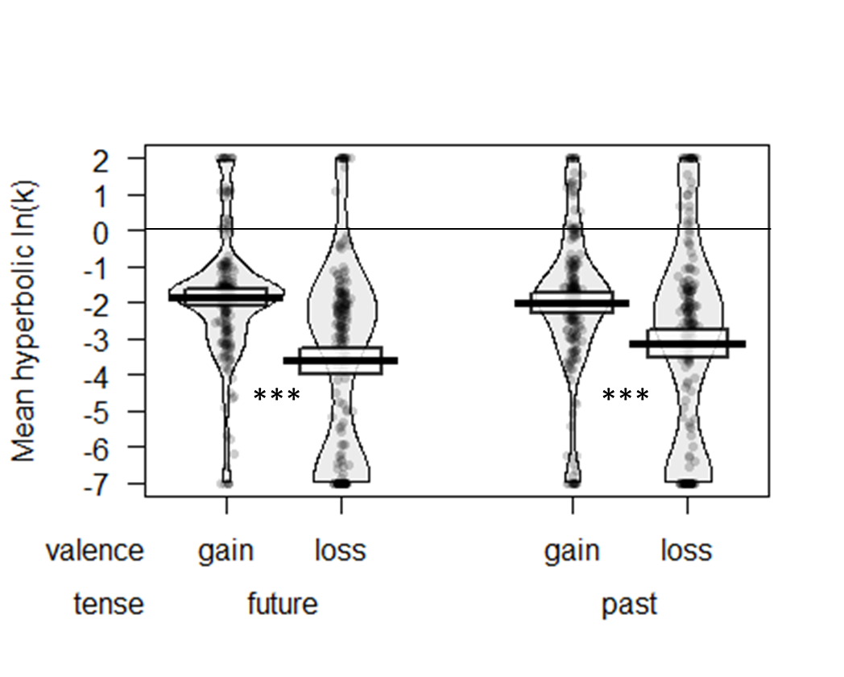
Figure 7. Discounting of past and future outcomes in Study 2a. Thick bars show the means, bands (around the means) show the 95% Confidence Intervals, points show the raw data, and beans show the smoothed density curves. * p < .05; ** p < .01; *** p < .001.

As seen in Table 1, discount rates are correlated across tense, but not across sign. In other words, future and past discounting are correlated more strongly than gain and loss discounting are correlated. This is consistent with previous correlation results for gains vs. losses (Hardisty & Weber, 2009; Hardisty, Thompson, Krantz, & Weber 2013), and suggests that discounting for gains vs. losses is driven by qualitatively different processes, casting doubt on a simple loss aversion account of the sign effect.
 | Future Gains | Future Losses | Past Gains | Past Losses
Future Gains | --
Future Losses | .02 | --
Past Gains | .56** | .08 | --
Past Losses | .03 | .43** | .13 | --

Table 1. Correlations between discount rates in Study 2a. ** indicates p<.01.

Contemplation emotion. To directly compare the intensity of contemplation emotion for gains and losses, we first computed a net score (positive minus negative emotion) and then we reverse scored the emotion ratings for losses (so that more negative emotion was represented by higher values). We observed a main effect of tense (F(1, 204)= 45.93, p <.001, η_{p}²=.18), with greater net contemplation emotion for past outcomes (memory; M=27.34, SD=35.83) than future outcomes (anticipation; M=13.21, SD=37.12), and no main effect of valence (F(1, 204)=0.2, p=.70, η_{p}²=.00), with roughly equal net contemplation emotion for losses (M=19.8, SD=34.76) compared to gains (M=20.77, SD=38.18).
These findings were qualified by a significant tense X valence interaction, F(1, 204)=25.26, p < .001, η_{p}²=.11. For future events, net contemplation emotion of losses (dread; M=17.83, SD=34.85) was significantly stronger than that of gains (positive anticipation; M=8.59, SD=39.38), F(1, 204)=6.10, p=.01, η_{p}²=.03. However, the contemplation emotion of past events reversed this pattern, with the contemplation of past losses (M=21.74, SD=34.68) being weaker than the contemplation of past gains (M=32.94, SD=36.98), F(1, 204)=128.03, p<.001, η_{p}²=.08 (Figure 8).
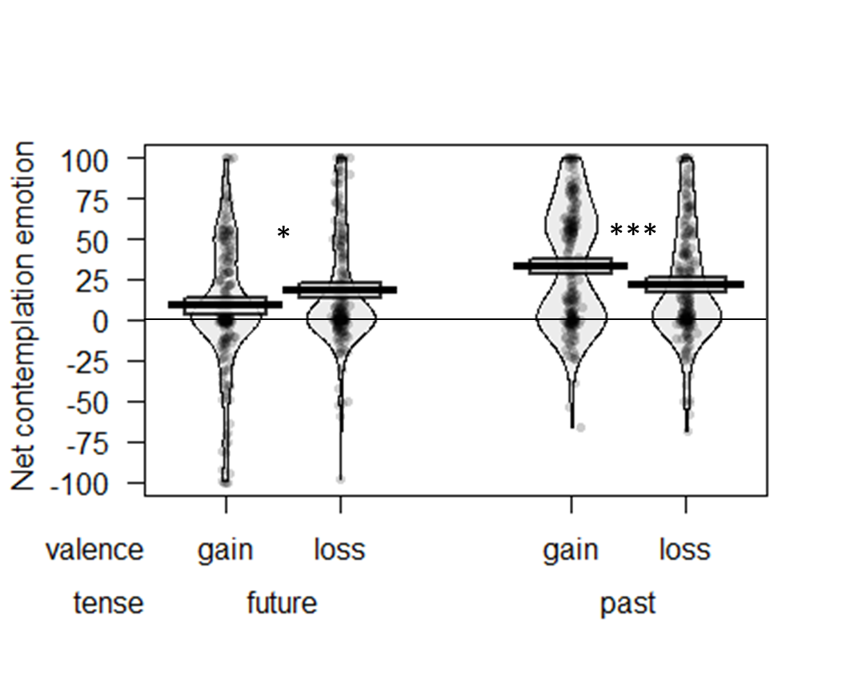
Figure 8. Contemplation emotion associated with past and future outcomes in Study 2a. Thick bars show the means, bands (around the means) show the 95% Confidence Intervals, points show the raw data, and beans show the smoothed density curves. * p < .05; ** p < .01; *** p < .001.

Mediation analysis. As in Study 1, a mediated moderation model (Muller et al., 2005) was used to examine whether the interactive effect of tense and valence on discounting was mediated by contemplation emotion. A bootstrap model with 5000 samples revealed that the indirect effect of the tense X valence interaction on discounting via contemplation emotion was significant (B = 0.03, 95% bias-corrected CI₉₅ [.009, .061], p=.005, Figure 9). These results are suggestive that contemplation emotion may partially mediate the observed relationship between tense X event valence and discounting. In other words, the weaker contemplation emotion of positive (compared to negative) events is unique to the future, which is associated with a discounting difference (the sign effect for future events but not past events).

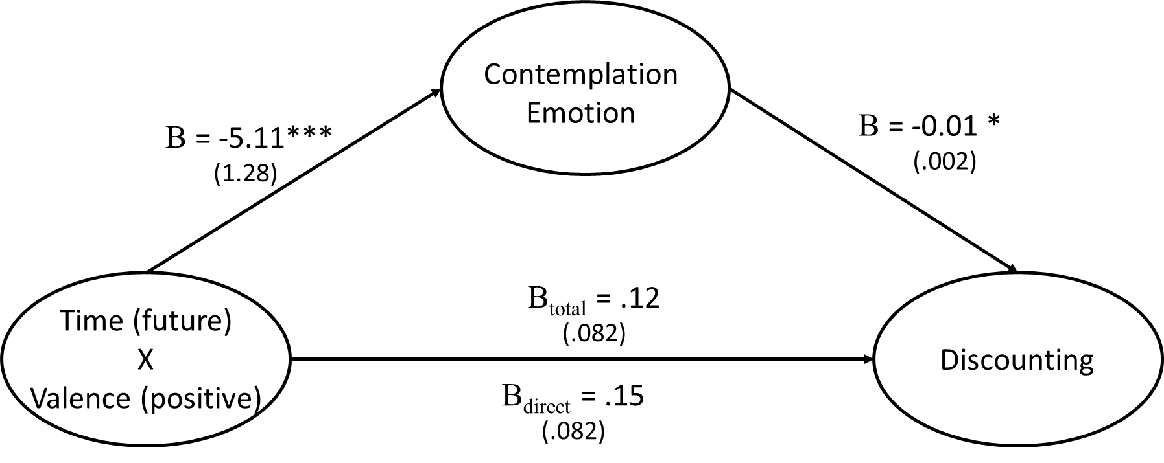
Figure 9. Mediation model for Study 2a. All reported coefficients are unstandardized; standard errors in parentheses. *p< .05; **p< .01; ***p<.001.

Frequency. Participants reported that they would think about gains (M=28.92, SD=28.75) more frequently than they would think about losses (M=25.66, SD=28.55), F(1, 204)=14.88, p<.001, η_{p}²=.07, and that they would think about things in the future (M=28.74, SD=28.86) more than things in the past (M=25.83, SD=28.43), F(1, 204)=9.49, p<.01, η_{p}²=.04, but there was no interaction, F(1, 204)=0.03, p=.86, η_{p}²=.00.
Frequency of thoughts predicted discount rates in a mixed model, β=0.008, F(1, 818)=6.29, p=.01, such that the more frequently participants thought about the distant event, the more strongly they discounted it. When adding fixed effects for sign, tense, and the interaction to the model, the predictive power of thought frequency remains significant, β=0.006, F(1, 815)=4.74, p = .03. Note that this account is inconsistent with a “savoring” effect for gains, whereby people might want to delay a pleasant event in order to enjoy the process of thinking about it—rather, it suggests that frequently thinking about a distant positive outcome is associated with a desire to accelerate its occurrence. Taken together, these results suggest a complementary explanation for the sign effect: People believe they will think about gains more frequently than losses, and this greater thought frequency is associated with higher discount rates. However, given the lack of a valence X tense interaction, thought frequency does not explain the difference between the size of the sign effect in the future vs. in the past, and the mediation pathway was not significant (β = 0.000, 95% bias-corrected CI₉₅ [-.016, .013], p>.99).
Although thought frequency is positively correlated with greater positive contemplation, r = .44, p < .001, and greater negative contemplation, r = .49, p < .001, it is not correlated with overall (net) contemplation emotion, r = -.05, p = .17, nor with reverse scored contemplation emotion (reverse scoring the losses), r = -.04, p = .23. As such, thought frequency does not explain the differences in contemplation emotion we observe between gains and losses.
Connection to distant self. Participants reported being more connected to their temporally distant self when considering gains (M=71.62, SD=26.01) than when considering losses (M=68.66, SD=28.43), F(1, 204)=14.88, p<.001, η_{p}²=.07. However, there were no differences in connection for future vs. past self, F(1, 204)=0.47, p=.49, η_{p}²=.00, nor was there an interaction, F(1, 204)=0.65, p=.42, η_{p}²=.00, therefore mediation of the focal sign X tense interaction was not significant (β = 0.003, 95% bias-corrected CI₉₅ [-.017, .025], p=.70). Connection to distant self was negatively correlated with discount rates, r=-.10, p=.01, such that the more connected someone felt to their distant self, the less they discounted distant outcomes, consistent with previous research (Bartels & Rips, 2010; Bartels & Urminsky 2011; 2015). Moreover, in a mixed model with sign, tense, the interaction, and connection predicting discount rates, the effect of connection remained significant, β=-0.01, F(1, 815)=11.83, p=.001. The overall model here actually indicates significant suppression of the sign effect (rather than mediation): being in the gain domain increases the connection to distant self, and connection reduces discount rates, yet gains are discounted more than losses (especially in the future). The indirect suppression pathway (main effect of sign predicting greater connection, in turn predicting lower discount rates) was significant (β = -0.725, 95% bias-corrected CI₉₅ [-1.124, -0.308], p<.001).
Utility curvature. The median participant was indifferent about a gamble with a 50/50 chance of gaining $10 or losing $5, consistent with previous research on loss aversion. The individually titrated loss magnitude values were dynamically carried through the rest of the survey for each participant, controlling for loss aversion through the experimental design.
We calculated utility curvature adjusted discount rates for all participants, through the following steps. First, we created median dollar/utility data coordinates: We set $0 equal to 0 utility, the largest gain (median=$12.50) equal to 1 utility, and the largest loss (median= -$3.00) equal to -1 utility. The remaining median coordinate pairs were inferred through linear interpolation (consistent with Chapman, 1996) with utility values evenly spaced at increments of 0.2 and the dollar values provided by participants’ answers, as can be seen in Figure 10. The result clearly shows loss aversion, but is otherwise fairly linear. Third, we converted the dollar values from the intertemporal choice task into utility values using linear interpolation where necessary (rather than imposing a particular functional form on the utility curve). Fourth, we calculated discounted utility rates based on current vs. distant utility values (in place of dollar values).

Figure 10. Median utility values in Study 2a. Note that the y-axis values (utility) are fixed at increments of 0.2, and the x-axis values show the median dollar equivalence measured from participants.

The utility curvature adjusted discount rates were very highly correlated with their corresponding nominal discount rates, all r=.99, p<.001. We re-calculated the key inferential statistics for discounting and contemplation emotion, and found essentially the same results: including the main effect of sign on discounted utility, F(1, 204)=43.18, p<.001, η_{p}²=.18, and the sign X tense interaction on discounted utility, F(1, 204)=6.55, p=.01, η_{p}²=.03. In a mixed model, contemplation emotion predicted discounted utility on its own, β=-0.006, F(1, 818)=5.61, p=.02. When including tense, sign, and the interaction, contemplation emotion remains significant, β=-0.006, F(1, 815)=6.50, p=.01, and the sign X tense interaction was reduced, β=0.503, F(1, 815)=2.17, p=.14 (consistent with mediation). Using a bootstrapped mediation model with 5000 replications, the indirect effect was significant (B = 0.12, 95% bias-corrected CI₉₅ [.035, .259], p=.004). The fact that our results remain robust when examining discounted experience (rather than discounted outcomes) suggests that our focal result is not produced by systematic differences in experience in the gain vs. loss domain.

Study 2b
Participants
Two hundred participants from Amazon’s Mechanical Turk (55% female, mean age=33.6 years) participated in an online study in return for $2.00 compensation.
Procedure
First, participants answered a series of 20 questions designed to measure subjective utility and control for loss aversion. The first question asked “Would you accept the following gamble: 50% chance of receiving a 1 hour massage and 50% chance of receiving a 1 second electric shock? (Y/N)” The next 19 questions incrementally increased the amount of the shock in increasing increments (from seconds to minutes), up to a maximum of “50% chance of receiving a 1 hour massage and 50% chance of receiving a 1 hour electric shock?” On the next page, the same 20 questions were asked in the opposite order (ascending vs. descending, counterbalanced between subjects). The point at which participants switched between rejecting and accepting the gamble was identified as their indifference point. The indifference points from the two scales (ascending vs. descending) were averaged together and used as the measure of equivalent subjective utility for each participant. Then, participants read an introduction and answered example questions, similar to those they would answer soon in the main survey.
Next, each participant completed all four conditions of a 2 (massage vs. shock) x 2 (past vs. future) design in counterbalanced order. Within each block, participants first were informed that “all events would be guaranteed to occur at the specified time.” Next, participants completed the Three-Option Adaptive Discount rate (ToAD) measure (Yoon & Chapman, 2016). For massage, the base outcome was a 1 hour massage with a delay of 365 days. For shocks, the base outcome (X seconds in 365 days) was individually piped in, based on each participant’s indifference point calculated earlier in the utility titration scale. On each of 10 questions, the participants faced a choice between three options: the base option (jittered), such as “Receiving a 55 minute pleasant massage in 408 days”, an immediate option, such as “Receiving a 5 minute and 23 second pleasant massage later today”, and an intermediate option, such as “Receiving a 31 minute pleasant massage in 188 days.” Depending on the participant’s choices, the immediate and intermediate options were systemically adjusted, according to a series of dynamic confidence intervals for the log of the hyperbolic discount rate. If the confidence intervals indicated likely zero or negative discount rates, special probe questions assessed these, following the standard ToAD procedure (Yoon & Chapman, 2016).
Next, within each block, participants answered a series of questions about the base outcome (e.g., about receiving “a 60 minute pleasant massage one year from now”). First, they estimated the positive experience emotion of the event, “Imagine that you will receive a 60 minute pleasant massage one year from now. How pleasurable or positive would the experience of the event be at that time?” answered on a slider from 0 (“Experience would be not at all pleasurable”) to 100 (“Experience would be extremely pleasurable”). Next, they estimated the negative experience emotion of the event, “Imagine that you will receive a 60 minute pleasant massage one year from now. How displeasurable or negative would the experience of the event be at that time?” answered on a slider from 0 (“Experience would be not at all displeasurable”) to 100 (“Experience would be extremely displeasurable”).
After that, within each block, participants indicated their contemplation emotion, with the instruction, “please think about how you would feel right now while [waiting for/remembering] the described event.” They were first asked, “How pleasurable or positive would the [anticipation/memory] of this event be? In other words, how would you feel right now while [waiting for/remembering] it?” and responded on a sliding scale ranging from 0 (“[waiting/remembering] would be not at all pleasurable”) to 100 (“[waiting/remembering] would be extremely pleasurable”). Next, participants were asked “How displeasurable or negative would the [anticipation/memory] of this event be? In other words, how would you feel right now while [waiting for/remembering] it?” and responded on a sliding scale ranging from 0 (“[waiting/remembering] would be not at all displeasurable”) to 100 (“[waiting/remembering] would be extremely displeasurable”).
Next within each block, participants were asked “How frequently would you think about this event? In other words, how often would it cross your mind in the time [before/since] it occurred?” and answered on a scale from 0 (“It would never be on my mind”) to 100 (“It would always be on my mind”).
Lastly within each block, participants were asked “Think about the important characteristics that make you the person you are now—your personality, temperament, major likes and dislikes, beliefs, values, ambitions, life goals, and ideals. Please indicate your opinion about the degree of connectedness or overlap held between the person you are now and the person you [will be one year from now/were one year ago]”, shown diagrams to illustrate the concept (following the methodology of Bartels & Rips, 2010), and answered on a scale from 0 (“No Overlap”) to 100 (“Complete Overlap”).
After completing all four blocks, participants answered questions to assess their utility curvature for massages and electric shocks, following the same procedure used in Study 2a (modelled after Chapman, 1996). For example, the first shock question asked:
Consider the following two events. Imagine that each of these events occurs in the present moment.
A: You expect to receive a 0 second electric shock but instead learn you are about to receive a 0 minute and 1.31 second unpleasant (but non-harmful) electric shock.
B: You expect to receive a 0 minute and 1.31 second electric shock, but instead learn you are about to receive a ... minute and ... second unpleasant (but non-harmful) electric shock.
In the blank spaces above, please indicate the amount (in minutes and seconds) that you would have to receive so that the impact of Event B would be the same as that of Event A. In other words, write an amount such that experience Event B would bring you the same amount of pleasure or displeasure as experiencing Event A would.

Finally, participants provided their age, gender, and income, and had an opportunity to describe any questions or problems they had with the survey.
Discounting computation. LN hyperbolic discount rates were dynamically estimated by the ToAD (Yoon & Chapman, 2016) and capped at -7 and +2 in the same manner as Study 2a.

Results
Order effects. There was a small but significant order effect on discount rates, such that the size of the focal sign X tense interaction depended on the order in which sign and tense were presented, interaction F(1,196)=4.66, p=.03, η_{p}²=.02. Specifically, the sign X tense interaction was strongest when participants first considered future massage. We split the data into the four different order conditions, and found that the focal sign X tense interaction predicting discount rates was in the same direction and was significant in all four order conditions, all p = .02 or lower and η_{p}²=.11 or larger. When looking at contemplation emotion, the effect of order on the focal sign X tense interaction was not significant, F(1,196)=3.40, p=.07, η_{p}²=.02. Even so, we split the data into the four order conditions, and found that the focal interaction was in the same direction and was significant in all four order conditions, all p=.05 or lower and η_{p}²=.07 or larger. Therefore, given that the pattern of results for discounting and contemplation emotion were the same in all order conditions and significant in all order conditions (and given that the order effect sizes are small), we collapse across order in the analyses to follow.
Discounting measure. As seen in Figure 11, we observed a main effect of valence F(1, 199)=383.39, p<.001, η_{p}²=.66, such that participants generally discounted gains (M=-1.19, SD=1.44) more than losses (M=-4.10, SD=2.07), and a main effect of tense, F(1,199)=54.5, p<.001, η_{p}²=.22, indicating that the past (M=-2.29, SD=2.07) was discounted more than the future (M=-3.00, SD=2.56). Furthermore, we observed a significant tense X valence interaction, F(1,199)=47.67, p<.001, η_{p}²=.19, indicating that the sign effect was stronger in the future, t(199)=19.79, p<.001, d=1.40 than in the past, t(199)=12.67, p<.001 d=0.90. Thus, the sign effect was reduced, but not eliminated, for past outcomes.
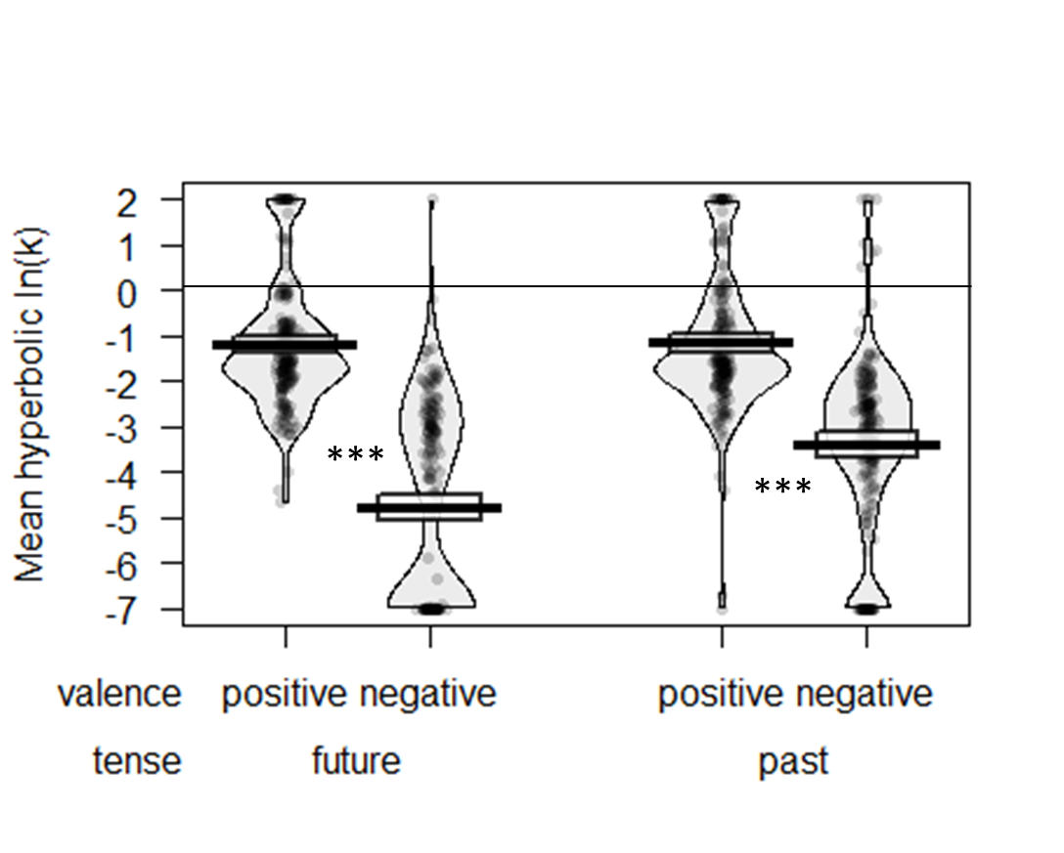
Figure 11. Discounting of past and future outcomes in Study 2b. Thick bars show the means, bands (around the means) show the 95% Confidence Intervals, points show the raw data, and beans show the smoothed density curves. * p < .05; ** p < .01; *** p < .001.

As seen in Table 2, discount rates are correlated across tense, but not across sign. In other words, future and past discounting are correlated more strongly than massage and shock discounting are correlated. This is consistent with the previous correlation results for gains vs. losses in Study 2a, and suggests that discounting for massage vs. shocks is driven by qualitatively different processes, casting doubt on a simple loss aversion account of the sign effect.

 | Future Massage | Future Shocks | Past Massage | Past Shocks
Future Massage | --
Future Shocks | .02 | --
Past Massage | .59** | .04 | --
Past Shocks | .01 | .32** | -.01 | --

Table 2. Correlations between discount rates in Study 2b. , ** indicates p<.01.

Contemplation emotion. To directly compare the intensity of contemplation emotion for the massage and shock events, we first computed a net score (positive minus negative emotion) and then we reverse scored the emotion ratings for losses (so that more negative emotion was represented by higher values). As seen in Figure 12, we observed a main effect of tense, F(1, 199)= 81.46, p <.001, η_{p}²=.29, with greater net contemplation emotion for past outcomes (memory; M=48.99, SD=42.61) than future outcomes (anticipation; M=29.28, SD=42.63), and a main effect of valence, F(1, 199)=38.95, p<.001, η_{p}²=.16, with greater net contemplation emotion for shocks (M=49.13, SD=41.92) compared to massage (M=29.14, SD=43.32). These findings were qualified by a significant tense X valence interaction, F(1, 199)=66.92, p < .001, η_{p}²=.25.
For future events, net contemplation emotion of shocks (dread; M=48.13, SD=42.19) was significantly stronger than that of massage (positive anticipation; M=10.42, SD=43.07), t(199)=8.88, p<.001, d=0.63. However, the net contemplation emotion of past events was roughly equivalent, with the contemplation of past shocks (M=50.13, SD=41.64) being similar to the contemplation of past massage (M=47.85, SD=41.64), t(199)=0.66, p=.51, d=0.05 (Figure 12).

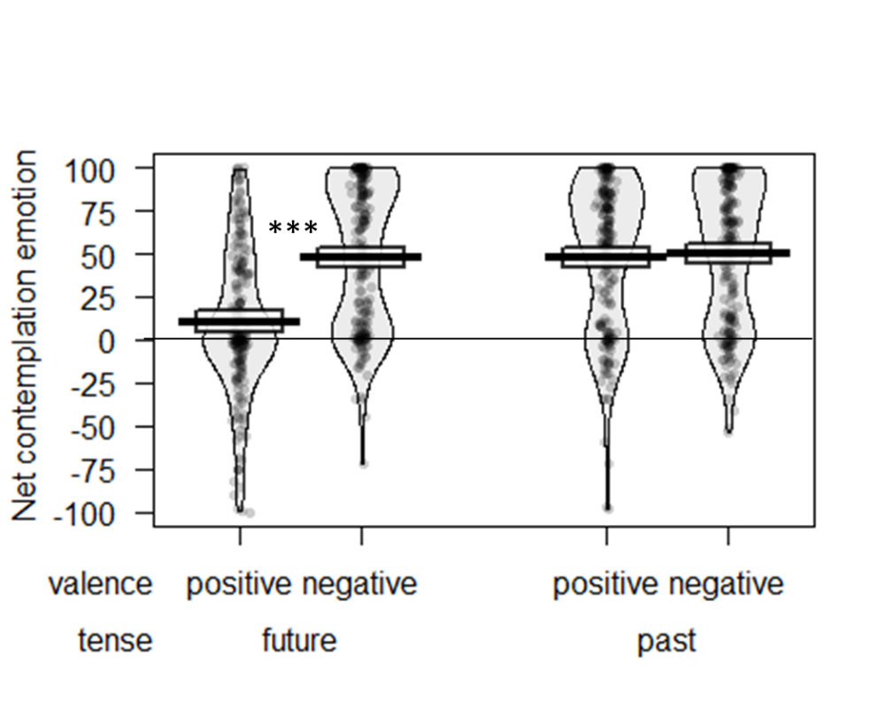
Figure 12. Contemplation emotion associated with past and future outcomes in Study 2b. Thick bars show the means, bands (around the means) show the 95% Confidence Intervals, points show the raw data, and beans show the smoothed density curves. * p < .05; ** p < .01; *** p < .001.

Mediation analysis. As in Study 2a, a mediated moderation model (Muller, et al., 2005) was used to examine whether the interactive effect of tense and valence on discounting was mediated by contemplation emotion. A bootstrap model with 5000 samples revealed that the indirect effect of the tense X valence interaction on discounting via contemplation emotion was significant, B = 0.057, 95% bias-corrected CI₉₅ [.028, .096], p<.001 (see Figure 13). These results show that contemplation emotion partially mediates the observed relationship between tense X event valence and discounting. In other words, the weaker contemplation emotion of positive (compared to negative) events is unique to the future, which is associated with a discounting difference (the sign effect for future events but not past events).

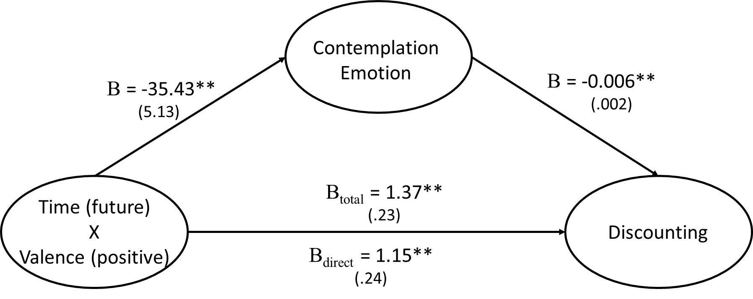

Figure 13. Mediation model for Study 2b. All reported coefficients are unstandardized; standard errors in parentheses. *p< .05; **p< .01; ***p<.001.

Frequency. Participants reported that they would think about massage (M=44.93, SD=28.56) equally often as they would think about shocks (M=44.77, SD=28.81), F(1,199)=0.01, p=.93, η_{p}²=.00, but that they would think about things in the future (M=51.62, SD=28.11) more than things in the past (M=38.08, SD=29.26), F(1,199)=74.40, p<.001, η_{p}²=.27. However, these were qualified by a sign X tense interaction, F(1,199)=16.78, p<.001, η_{p}²=.08, such that when looking forward, people would think about future shocks (M=53.66, SD=28.95) more than future massage (M=49.57, SD=27.27), but when looking backward people would think about past massage (M=40.29, SD=29.85) more than past shocks (M=35.87, SD=28.66).
Frequency of thoughts did not predict discount rates in a mixed model, β=-0.002, F(1,798)=0.77, p=.38. When adding fixed effects for sign, tense, and the interaction to the model, the predictive power of thought frequency remains non-significant, β=0.001, F(1,795)=0.21, p = .64. Therefore, the effect of the sign X tense interaction on discount rates is not mediated by reported thought frequency, and thought frequency does not mediate the effect of sign X tense on discounting, B = -0.002, 95% bias-corrected CI₉₅ [-.017, .007], p>.99.
Finally, thought frequency is not correlated with strength of contemplation emotion (reverse scoring the losses), r = -.03, p = .38. As such, thought frequency does not explain the differences in contemplation emotion we observe between gains and losses.
Connection to distant self. Participants reported being more connected to their temporally distant self when considering massage (M=70.16, SD=24.33) than when considering shocks (M=68.11, SD=25.54), F(1,199)=4.17, p=.04, η_{p}²=.02. However, there were no differences in connection for future vs. past self, F(1,199)=0.00, p=.99, η_{p}²=.00, nor was there an interaction, F(1,199)=1.29, p=.26, η_{p}²=.01. Connection to distant self was not correlated with discount rates, r=.00, p=.99. Therefore, connection to distant self does not account for the effect of the sign X tense interaction on discount rates, and the mediation is not significant (B = -0.001, 95% bias-corrected CI₉₅ [-.014, .003], p>.99).
Utility curvature. The median participant was indifferent about a 50% chance of receiving a 1 hour massage and a 50% chance of receiving a 10 second electric shock. The individually titrated values were dynamically carried through the rest of the survey for each participant, controlling for loss aversion (and subjective utility more generally) through the experimental design.
We calculated utility curvature adjusted discount rates for each participant using the same procedure as used in Study 2a. The utility curves were again quite linear. Therefore, the utility curvature adjusted discount rates were very highly correlated with their corresponding nominal discount rates, all r=.99 or higher, all p<.001. We re-calculated the key inferential statistics for discounting and contemplation emotion, and found the essentially the same results: including the main effect of sign on discounted utility, F(1,199)=477.13, p<.001, η_{p}²=.71, the main effect of tense, F(1, 199)=53.43, p<.001, η_{p}²=.21, and the sign X tense interaction on discounted utility, F(1, 199)=45.75, p<.001, η_{p}²=.19. In a mixed model, contemplation emotion predicts discounted utility on its own, β=-0.013, F(1,798)=51.90, p<.001. When including tense, sign, and the interaction, contemplation emotion remains significant, β=-0.007, F(1,795)=20.31, p<.001, and the sign X tense interaction is reduced but remains significant, β=1.109, F(1,795)=18.94, p<.001 (consistent with partial mediation). The indirect effect of the mediation model going from sign X tense, through contemplation emotion to predict discounted utility was significant (B = 0.234, 95% bias-corrected CI₉₅ [.117, .387], p<.001). Again, the fact that our results remain robust when examining discounted experience (rather than discounted outcomes) suggests that our focal result is not produced by systematic differences in experience in the positive vs. negative domain.
Study 3
While Studies 1 and 2 employed hypothetical scenarios, Study 3 measures contemplation emotion of actual events and explicitly distinguishes contemplation emotion from predicted and recalled experience. We also specifically examine the occurrence of mixed emotions in different conditions.
Participants
One hundred college students completed a 45-minute study in a campus lab in exchange for $9. Four participants were excluded because they did not complete the dependent measures.
Procedure
Based on the results of a pretest (see SOM-R for more detail), we selected four flavors of novelty jelly beans to represent good and bad flavors of matched intensity: watermelon, orange sherbet, dirt, and rotten egg.
Participants were informed of their randomly assigned jelly bean flavor (manipulated between subjects) and told that they would be eating this jelly bean in 15 minutes. They answered two questions about how pleasurable and displeasurable they thought the future experience of eating this jelly bean would be (predicted experience measure), as well as both the pleasure and displeasure associated with their current feelings while waiting to eat the jelly bean (contemplation emotion). All answers were provided by placing a mark on a line with a total length of 16.5 centimeters, with the left endpoint marked Neutral and the right endpoint indicating either extreme like or dislike (see SOM-R for sample questionnaires).
After completing a filler task for 15 minutes (word puzzles or mazes), participants consumed the jelly bean and answered questions regarding how pleasurable and displeasurable they perceived the current experience of eating the jelly bean to be (experience measure). After another 15 minutes of filler tasks, participants reported how pleasurable and displeasurable the past experience of eating the jelly bean was (recalled experience measure), and as well as the pleasure and displeasure associated with their current feelings while remembering this experience (contemplation emotion).
Results
For each measure, we calculated the net contemplation emotion by taking the difference between ratings of pleasure and displeasure (for those assigned to a good-tasting jelly bean), or the difference between ratings of displeasure and pleasure (for those assigned to a bad-tasting jelly bean). We observed a significant tense X valence interaction on contemplation emotion across past, present, and future conditions, F(2, 188)=7.27, p=.001 (Greenhouse-Geisser adjusted p=.002), η_{p}²=.07. Looking at the simple effects of valence within future and past events, we found that participants reported significantly lower net contemplation emotion for future positive events (compared to future negative events, F(1, 94)=11.55, p=.001, η_{p}²=.11), but similar contemplation emotion for past positive and negative events, F(1, 94)=0.14, p>.250, η_{p}²<.01 (see Figure 14).
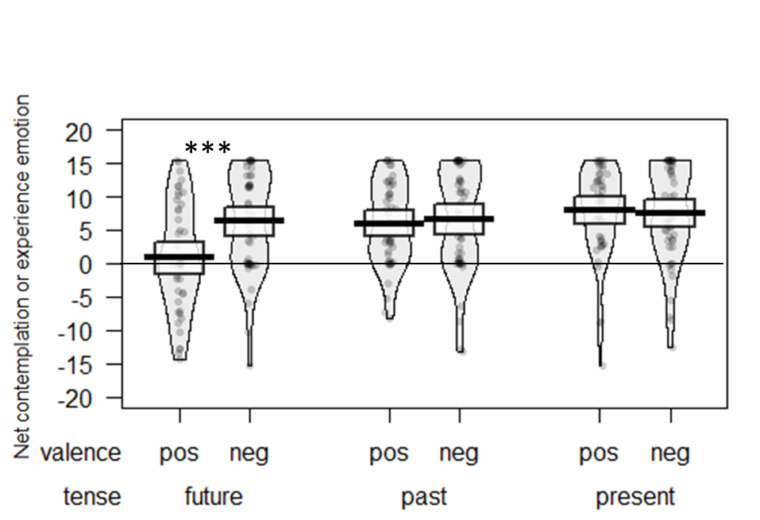
Figure 14. Contemplation emotion related to past and future outcomes and experience emotion related to present outcomes in Study 3. Thick bars show the means, bands (around the means) show the 95% Confidence Intervals, points show the raw data, and beans show the smoothed density curves. * p < .05; ** p < .01; *** p < .001.

The tense X valence interaction remained significant when controlling for both pre- and post-consumption perceptions of the actual experience of eating the jelly bean (i.e., our predicted and recalled experience measures), F(2, 188)=7.75, p<.001, η_{p}²=.07. Mean predicted and recalled experience measures often differed from the corresponding contemplation emotion measures, and correlations between these two types of measures ranged from r=0.26 to 0.75 (see Table 3). Thus, participants were generally able to distinguish the impact of contemplating the event from their imagined or recalled experience of the event itself. Importantly, we note that the condition in which contemplation emotion was the lowest (positive anticipation) was not accompanied by a corresponding drop in the predicted experience measure. Furthermore, the magnitude of the predicted and recalled experience measures did not differ based on whether the flavor was positive or negative, as reported either 15 minutes before tasting the bean (t(89)=0.60, p>.250, d=0.12), or 15 minutes after tasting the bean, t(94)=0.26, p>.250, d=0.05. These findings suggest that differences in discounting stem from the phenomenological impact of contemplating an upcoming event, rather than from differing perceptions of the nature of the experience itself.

Time X valence | A) Contemplation Emotion | B) Predicted or recalled experience | Difference between A and B | Correlation between A and B
Future positive | M=0.87, SD=8.12 | M=7.67, SD=6.40 | A-B =-6.80,  t(46)= -5.22,  d =0.76, p <.001 | r = 0.26
Future negative | M=6.31, SD=7.55 | M₌6.75, SD=8.57 | A-B = -0.44,  t(49)= -0.45,  d =0.06, p >.250 | r = 0.50
Past positive | M=6.02, SD=6.37 | M=7.87, SD=7.07 | A-B = -1.85,  t(47)= -2.20,  d =0.32, p =.030 | r = 0.67
Past negative | M=6.57, SD=7.95 | M₌7.47, SD=7.70 | A-B = -0.90,  t(48)= -1.13,  d =.03, p >.250 | r = 0.75

Table 3. Comparison of contemplation emotion measures and predicted or recalled experience measures from Study 3.

We measured positive and negative emotion on separate unipolar scales, which allows us to compare the mix of both emotions for each event. A mixed ANOVA revealed a significant three-way interaction between tense, event valence, and type of emotion measured (i.e., positive or negative), F(2, 188)=12.79, p < .001, η_{p}²=.12 (see Figure 15). Notably, when comparing past and future positive events, there was a significant interaction between tense and type of emotion measured; F(1, 46)=14.27, p< .001, η_{p}²=.24. The amount of anticipatory negative emotion associated with positive events (M=4.43, SD=4.88) was just as high as the amount of anticipatory positive emotion (M=5.30, SD=5.38), F(1, 46)=0.54, p>.250, η_{p}²=.01. This suggests that the contemplation emotion of future positive events is a mixed state characterized by both positive and negative emotion. In contrast, the contemplation emotion of past positive events was predominantly characterized by positive (M=7.40, SD=5.59) over negative emotion (M=1.37, SD=2.51), F(1, 46)=41.94, p<.001, η_{p}²=.48.
However, there was no analogous interaction between tense and type of emotion measured for negative events; F(1, 48)=0.04, p>.250, η_{p}²<.01. In this case, the amount of positive emotion associated with the contemplation emotion of negative events (M=1.99, SD=3.63) was significantly lower than the amount of negative emotion (M=8.43, SD=5.95) across both tenses, F(1, 48)=53.88, p<.001, η_{p}²=.53. Thus, it seems that the mixed emotional state is unique to future positive events. This results in a net lowering of associated positive emotion in the contemplation of positive future events, which is consistent with the greater discounting of positive (vs. negative) upcoming events.
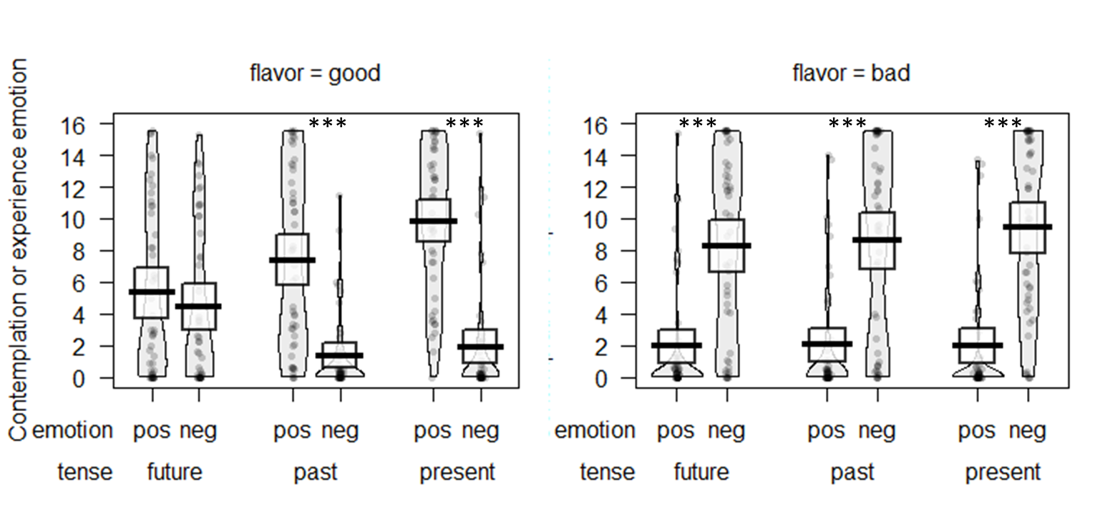
Figure 15. Strength of positive and negative emotion related to contemplation of past and future outcomes and experience of present outcomes in Study 3. Thick bars show the means, bands (around the means) show the 95% Confidence Intervals, points show the raw data, and beans show the smoothed density curves. * p < .05; ** p < .01; *** p < .001.

Study 4
Study 4 again uses actually experienced events and also included time preference measures. In addition, uncertainty about event occurrence or reaction to the event were examined as possible alternative explanations.
Participants
Two hundred and one participants from Amazon’s Mechanical Turk (58.7% female, mean age=36 years) were recruited through TurkPrime and participated in an online study in return for $1.70 compensation.
Procedure
Participants were randomly assigned to either the puppy condition or the cockroach condition. Participants first read the instruction “Near the middle of this study (in about 5 minutes), you will look at 10 photos of puppies [cockroaches].” On the next page, participants were given an attention check, “Quiz: what will you see in the photos?”, answered with a fill-in-the-blank free response.
Next, participants answered questions about uncertainty, time preference and contemplation emotion for the future puppy or cockroach photos, listed in Table 4. Participants then completed a 5-min distractor task, which involved watching a video which showed various neutral sentences being typed out on the screen, one letter at a time (e.g., “I drove my car to the supermarket today. I would estimate that there were something like one thousand peaches”), and then answering questions about the sentences. Then, participants viewed ten photos of puppies or cockroaches as appropriate. After the photos, participants completed another 5-min distractor task, with another video of neutral sentences and questions. Once the 5 minutes had passed, participants answered questions about uncertainty, time preference and contemplation emotion for the past puppy or cockroach photos, listed in Table 4.
Finally, participants completed the 15-item, brief version of the Need for Cognitive Closure (NFC) scale (Roets & Van Hiel, 2011), and the 23-item Multiple Stimulus Types Ambiguity Tolerance (MSTAT) scale (McLain, 1993), and indicated their gender and age.

Questions and Response Options | Puppies  Mean (SD) | Cockroaches Mean (SD)
- Prospective questions (before seeing photos):
How certain are you that you will see the [puppy/cockroach] photos?  1=Not at all certain, 4=Fairly certain, 7=Completely certain | 5.8 (1.5) | 5.7 (1.5)
How certain are you about how much you will like or dislike the [puppy/cockroach] photos? In other words, how certain are you about how you will react to the [puppy/cockroach] photos?  1=Not at all certain, 4=Fairly certain, 7=Completely certain | 5.3 (1.6) | 5.5 (1.4)
Please consider your uncertainty about the [puppy/cockroach] photos. How does the uncertainty make you feel?  0=I strongly dislike the feeling of uncertainty, 50=Neutral, 100=I strongly like the feeling of uncertainty | 42.1 (21.4) | 37.3 (17.8)
When would you prefer to see the [puppy/cockroach] photos? (With the overall length of the HIT being fixed, regardless of your preference.)  I would prefer:  - seeing the photos now [coded 1]  - seeing the photos in 5 minutes [coded 0] | 0.5 (0.5) | 0.8 (0.4)
As you think about the [puppy/cockroach] photos you will see in 5 minutes, how pleasurable or happy is the anticipation? In other words, how do you feel now while waiting for them?  0=neutral, 50=somewhat like the feeling of waiting, 100=extremely like the feeling of waiting | 38.8 (28.3) | 13.6 (21.3)
As you think about the [puppy/cockroach] photos you will see in 5 minutes, how displeasurable or unhappy is the anticipation? In other words, how do you feel now while waiting for them?  0=neutral, 50=somewhat dislike the feeling of waiting, 100=extremely dislike the feeling of waiting | 29 (28.7) | 50.7 (34.8)
- Retrospective questions (after seeing photos):
How certain are you that you saw the [puppy/cockroach] photos?  1=Not at all certain, 4=Fairly certain, 7=Completely certain | 6.8 (0.8) | 6.8 (0.8)
How certain are you about how much you liked or disliked the [puppy/cockroach] photos? In other words, how certain are you about how you reacted to the [puppy/cockroach] photos?  1=Not at all certain, 4=Fairly certain, 7=Completely certain | 6.6 (0.9) | 6.3 (1.2)
Please consider your uncertainty about the [puppy/cockroach] photos. How does the uncertainty make you feel?  0=I strongly dislike the feeling of uncertainty, 50=Neutral, 100=I strongly like the feeling of uncertainty | 44.6 (21.4) | 36.3 (22.7)
When would you prefer to have seen the [puppy/cockroach] photos? (With the overall length of the HIT being fixed, regardless of your preference.)  I would prefer:  - having seen the photos just now [coded 1]  - having seen the photos 5 minutes ago [coded 0] | 0.5 (0.5) | 0.3 (0.4)
As you think about the [puppy/cockroach] photos you saw 5 minutes ago, how pleasurable or happy is the memory? In other words, how do you feel now while remembering them?  0=neutral, 50=somewhat like the feeling of remembering, 100=extremely like the feeling of remembering | 66.5 (27.2) | 12.4 (22.1)
As you think about the [puppy/cockroach] photos you saw 5 minutes ago, how displeasurable or unhappy is the memory? In other words, how do you feel now while remembering them?  0=neutral, 50=somewhat dislike the feeling of remembering, 100=extremely dislike the feeling of remembering | 18.6 (28.8) | 53.5 (35)

Table 4. a) Prospective and b) retrospective questions and answer options, and mean responses (standard deviation in parentheses) about the puppy and cockroach photos in Study 4.

Results
Answers to the attention check were marked correct if participants mentioned puppies or cockroaches as appropriate to their condition. 99% of participants answered correctly, and all will be included in the analyses to follow.
Time preferences. As seen in Table 4, people had different time preferences for puppies vs. cockroaches, depending on whether they were looking forward or backward. In prospection, 52% would prefer to see the puppy photos immediately, while only 20% would prefer to delay the cockroach photos, z=4.74, p<.001. This is consistent with previous research on the sign effect: people want immediate positives more strongly than they want to postpone negatives. In retrospection, 49% would prefer to have just seen the puppies, whereas 73% would prefer to have seen the cockroaches farther in the past, z=-4.12, p<.001. This shows a reversal of the sign effect: when looking backwards, people want to have bad things farther away in time more strongly than they want to have good things near in time.
Contemplation emotion. As is apparent from Table 4, there is an asymmetry between the contemplation of future puppies and the contemplation of future cockroaches. Contemplation of future puppy photos brings a combination of positive contemplation (M=38.8, SD=28.3) and negative contemplation (M=29.0, SD=28.7), paired t(97)=2.51, p=0.01, d=0.25, while contemplation of future cockroaches mainly feels negative (M=50.7, SD=34.8) and not positive (M=13.6, SD=21.3), paired t(102)=9.90, p<.001, d=0.98. In contrast, when looking backward, the contemplation of puppies versus cockroaches is more symmetric. Recalling puppies mainly feels positive (M=66.5, SD=27.2) and not negative (M=18.6, SD=28.8), paired t(97)=11.79, p<.001, d=0.98; while recalling cockroaches mainly feels negative (M=53.5, SD=34.0) and not positive (M=12.4, SD=22.1), paired t(102)=10.22, p<.001, d=1.01. Thus, as in Study 3, the pattern of mixed positive and negative emotion was most pronounced when contemplating future positive events.
We calculated net contemplation emotion scores for each participant by subtracting negative contemplation from positive contemplation, and reverse scoring the cockroach scores so that we can compare the strength of contemplation emotion for positive (puppy) versus negative (cockroach) events (as in previous studies). When looking forward, net contemplation emotion of the cockroach photos (M= 37.10, SD=38.02) was stronger than net contemplation emotion of the puppy photos (M=9.78, SD=38.52), t(199)=5.06, p<.001 d=0.71. In retrospection, net contemplation emotion of the puppy (M=47.88, SD=40.20) and cockroach (M=41.16, SD=40.83) photos were about equally strong, reverse-scored t-test t(199)=1.18, p=.24 d=0.17. An overall ANOVA found a sign X tense interaction, F(1,199)=32.01, p<.001, η_{p}²=.14, confirming the overall pattern seen in Figure 16.
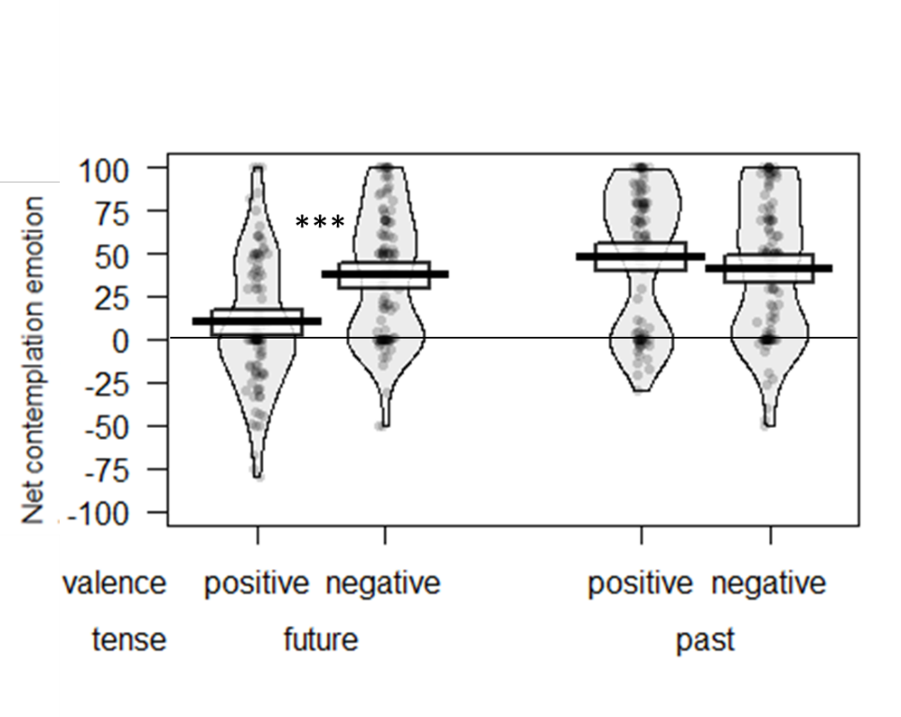
Figure 16. Contemplation emotion related to past and future outcomes in Study 4. Thick bars show the means, bands (around the means) show the 95% Confidence Intervals, points show the raw data, and beans show the smoothed density curves. * p < .05; ** p < .01; *** p < .001.

Furthermore, contemplation emotion was a significant predictor of discounting. A mixed model with sign, tense, the interaction, and contemplation emotion as fixed factors predicting discounting found a significant effect of contemplation emotion, B=-0.002, F(1,397)=11.37, p=.001. The indirect pathway of a mediation model (going from the sign X tense interaction to contemplation emotion to discounting) using a bootstrapping test with 5000 replications was significant, B=.017, 95% bias-corrected CI₉₅ [.007, .032], p<.01.
Uncertainty. As seen in Table 4, we asked three questions about uncertainty: uncertainty about the event ("will it happen?"), uncertainty about the participant's reaction ("will I like it?"), and feelings about uncertainty ("how does the uncertainty make me feel?").
Regarding outcome uncertainty: people are more certain about the past (M=6.84, SD=0.78) than about the future (M=5.76, SD=1.52), main effect F(1,199)=80.39, p<.001, η_{p}²=.29, but there is no difference between puppies and cockroaches, F(1,199)=0.24, p=.63, η_{p}²=.00, and no interaction, F(1,199)=0.42, p=.52, η_{p}²=.00. Furthermore, ratings of outcome uncertainty do not predict time preferences: a mixed model with sign, tense, the interaction, and outcome uncertainty predicting discounting found no effect of outcome uncertainty, B=-0.01, F(1,397)=0.46, p=.50.
Turning to reaction uncertainty: participants were more sure of their reaction for the past (M=6.46, SD=1.11) than the future (M=5.42, SD=1.54), main effect F(1,199)=83.09, p<.001, η_{p}²=.30, but there was no overall difference between puppies and cockroaches, F(1,199)=0.10, p=.75, η_{p}²=.00. This was qualified by a sign by tense interaction, F(1,199)=6.09, p=.01, η_{p}²=.03, indicating that the difference in reaction uncertainty for future vs. past was larger for puppies than for cockroaches. When looking forward, people were equally certain about their reaction to puppies (M=5.30, SD=1.63) and cockroaches (M=5.53, SD=1.45), t(199)=-1.10, p=.27, d=-0.16, but when looking backward people were more certain about their reaction to puppies (M=6.63, SD=0.94) than cockroaches (M=6.30, SD=1.24), t(199)=2.13, p=.03, d=0.30. Reaction uncertainty did not predict discounting, however, B=0.004, F(1,397)=0.05, p=.83.
Regarding feelings about uncertainty: participants disliked feelings of uncertainty overall, with an average rating (M=40.00, SD=18.46) below the scale mid-point of 50, t(201)=-7.69, p<.001. Moreover, participants enjoyed the feeling of uncertainty about puppies (M=43.37, SD=21.40) more than the feeling of uncertainty about cockroaches (M=36.79, SD=21.40), main effect F(1,199)=6.56, p=.01, η_{p}²=.03, but there was no difference between future and past, F(1,199)=0.26, p=.61, η_{p}²=.00, and no interaction, F(1,199)=1.43, p=.23, η_{p}²=.01. Moreover, feelings of uncertainty did not predict discounting, F(1,397)=0.04, p=.84, η_{p}²=.00. However, feelings of uncertainty did moderately predict contemplation emotion, r=.24, p<.001, such that those who enjoyed feelings of uncertainty (e.g., feeling excitement about the unknown) also tended to enjoy contemplating temporally distant events.
Finally, turning to individual differences measures of attitudes towards uncertainty: the need for cognitive closure (NFC) and intolerance for ambiguity (MSTAT) were highly correlated with each other, r=.84, p<.001. Both NFC and MSTAT predicted lower contemplation emotion (r=-.24, p<.001, r=-.23, p<.001, respectively). In other words, people who need closure (and do not like ambiguity) do not enjoy the feeling of thinking about distant events. However, NFC and MSTAT did not predict time preferences, whether in aggregate or when looking separately at every combination of future vs. past or positive vs. negative, all p=.11 or greater. Neither did NFC or MSTAT moderate the effects of sign, tense, or the sign X tense interaction: all interactions with NFC or MSTAT were p=.14 or larger.
In summary, none of the measures of uncertainty explain the sign effect in future discounting and its reversal in past discounting, but attitudes towards uncertainty do contribute to contemplation emotion.
General Discussion
People’s tendency to discount gains more than losses emerges more strongly and consistently for future events than for past ones, even when positive and negative events are equated on subjective present impact. This suggests that the sign effect is not driven by loss aversion. Rather, our work reveals that the sign effect is uniquely related to the mixed nature of the contemplation emotion of future positive events.
Although we have shown that contemplation is associated with time preferences, there are of course many other factors that determine the overall utility of, and time preferences for, an event. For example, research suggests that future losses loom closer in time, which is consistent with lower discount rates for losses (Bilgin & LeBoeuf, 2010).
An important boundary condition is that we designed our stimuli to study the discounting of time-limited events. Judgments about people may well show different patterns, for a variety of reasons (Brandimarte, Vosgerau, & Acquisti, 2018).
Because current actions can affect future, but not past, outcomes, it may make sense that people are generally more invested in experiences that are forthcoming rather than foregone. Beyond a mere difference in intensity, this asymmetry can also lead to a difference in the composition of emotions. For instance, once a past reward has already been secured, one may be purely happy in remembering the achievement. When attempting to secure a future reward, however, both positive and negative emotions could be useful: The unpleasant experience of impatience may actually aid in focusing attention on potential future rewards that need to be secured sooner rather than later. Just as the tendency to value the future more than the past may serve an adaptive function (Caruso & Van Boven, 2019; Suhler & Callendar, 2012), so too may the unique presence of varying emotions related to upcoming positive events, thus contributing to the sign effect in anticipatory thought.
References
Bartels, D. M., & Rips, L. J. (2010). Psychological connectedness and intertemporal choice. Journal of Experimental Psychology: General, 139(1), 49-69.
Bartels, D. M., & Urminsky, O. (2011). On intertemporal selfishness: How the perceived instability of identity underlies impatient consumption. Journal of Consumer Research, 38(1), 182-198.
Bartels, D. M., & Urminsky, O. (2015). To know and to care: How awareness and valuation of the future jointly shape consumer spending. Journal of Consumer Research, 41(6), 1469-1485.
Baucells, M., & Belleza, S. (2017). Temporal profiles of instant utility during anticipation, event, and recall. Management Science, 63(3), 729-748.
Berns, G. S., Chappelow, J., Cekic, M., Zink, C. F., Pagnoni, G., & Martin-Skurski, M. E. (2006). Neurobiological substrates of dread. Science, 312(5774), 754-758.
Bilgin, B., & LeBoeuf, R. A. (2010). Looming losses in future time perception. Journal of Marketing Research, 47(3), 520-530.
Brandimarte, L., Vosgerau, J., & Acquisti, A. (2018). Differential discounting and present impact of past information. Journal of Experimental Psychology: General, 147(1), 74-92.
Caruso, E. M. (2010). When the future feels worse than the past: A temporal inconsistency in moral judgment. Journal of Experimental Psychology: General, 139(4), 610-624.
Caruso, E. M., Gilbert, D. T., & Wilson, T. D. (2008). A wrinkle in time: Asymmetric valuation of past and future events. Psychological Science, 19(8), 796-801.
Caruso, E. M., & Van Boven, L. (2019). Temporal asymmetries in prospection and retrospection. Working paper.
Chapman, G. B. (1996). Temporal discounting and utility for health and money. Journal of Experimental Psychology: Learning, Memory, and Cognition, 22(3), 771-791.
Hardisty, D. J., & Weber, E. U. (2009). Discounting future green: money versus the environment. Journal of Experimental Psychology: General, 138(3), 329-340.
Hardisty, D. J., & Weber, E. U. (2019). Kisses vs. shocks: Anticipation asymmetries explain time preferences for gains vs. losses. Working paper. Retrieved from https://papers.ssrn.com/sol3/papers.cfm?abstract_id=1961370
Hardisty, D. J., Thompson, K. F., Krantz, D. H., & Weber, E. U. (2013). How to measure time preferences: An experimental comparison of three methods. Judgment & Decision Making, 8(3), 236-249.
Harris, C. R. (2012). Feelings of dread and intertemporal choice. Journal of Behavioral Decision Making, 25(1), 13-28.
He, J. M., Huang, X. T., Yuan, H., & Chen, Y. G. (2012). Neural activity in relation to temporal distance: Differences in past and future temporal discounting. Consciousness and Cognition, 21(4), 1662-1672.
Kahneman, D., & Tversky, A. (1979). Prospect theory: An analysis of decision under risk. Econometrica, 47(2), 263-292.
Loewenstein, G. (1987). Anticipation and the valuation of delayed consumption. The Economic Journal, 97(387), 666-684.
Loewenstein, G., & Prelec, D. (1992). Anomalies in intertemporal choice: Evidence and an interpretation. The Quarterly Journal of Economics, 107(2), 573-597.
Li, Y., Wall, D., Johnson, E., & Toubia, O. (2016). Cognitively Optimized Measurement of Preferences. In P. Moreau & S. Puntoni (Eds.), NA Advances in Consumer Research, Vol. 44 (pp. 532-535). Duluth, MN: Association for Consumer Research. Retrieved from: http://www.acrwebsite.org/volumes/1022597/volumes/v44/NA-44
McLain, D. L. (1993). The MSTAT-I: A new measure of an individual's tolerance for ambiguity. Educational and Psychological Measurement, 53(1), 183-189. doi: 10.1177/0013164493053001020
Mischel, W., Grusec, J., & Masters, J. C. (1969). Effects of expected delay time on the subjective value of rewards and punishments. Journal of Personality and Social Psychology, 11(4), 363-373.
Muller, D., Judd, C. M., & Yzerbyt, V. Y. (2005). When moderation is mediated and mediation is moderated. Journal of Personality and Social Psychology, 89(6), 852-863.
Nowlis, S. M., Mandel, N., & McCabe, D. B. (2004). The effect of a delay between choice and consumption on consumption enjoyment. Journal of Consumer Research, 31(3), 502-510.
Read, D. (2004). Intertemporal choice. In D. J. Koehler & N. Harvey (Eds.), Blackwell Handbook of Judgment and Decision Making (pp. 424-443). Malden, MA: Blackwell.
Roets, A., & Van Hiel, A. (2011). Item selection and validation of a brief, 15-item version of the need for closure scale. Personality and Individual Differences, 50(1), 90-94. doi: 10.1016/j.paid.2010.09.004
Suhler, C., & Callender, C. (2012). Thank goodness that argument is over: Explaining the temporal value asymmetry. Philosopher’s Imprint, 12(15), 1-16.
Tanaka, S. C., Yamada, K., Yoneda, H., & Ohtake, F. (2014). Neural mechanisms of gain–loss asymmetry in temporal discounting. The Journal of Neuroscience, 34(16), 5595-5602.
Thaler, R. H. (1981). Some empirical evidence on dynamic inconsistency. Economics Letters, 8(3), 201-207.
Tversky, A., & Kahneman, D. (1991). Loss aversion in riskless choice: A reference-dependent model. The Quarterly Journal of Economics, 106(4), 1039-1061.
Van Boven, L., & Ashworth, L. (2007). Looking forward, looking back: anticipation is more evocative than retrospection. Journal of Experimental Psychology: General, 136(2), 289-300.
Xu, L., Liang, Z. Y., Wang, K., Li, S., & Jiang, T. (2009). Neural mechanism of intertemporal choice: From discounting future gains to future losses. Brain Research, 1261, 65-74.
Yoon, H., & Chapman, G. B. (2016). A closer look at the yardstick: A new discount rate measure with precision and range. Journal of Behavioral Decision Making, 29(5), 470-480.
Yi, R., Gatchalian, K. M., & Bickel, W. K. (2006). Discounting of past outcomes. Experimental and Clinical Psychopharmacology, 14(3), 311-317.

Author Contributions
All authors developed the study concept and contributed to the study design. Data collection and data analysis were performed by S. Molouki and D. J. Hardisty. S. Molouki and D. J. Hardisty drafted the manuscript, and E. M. Caruso provided critical revisions. All authors approved the final version of the manuscript for submission.

Acknowledgments
We thank Dale Griffin and Daniel Read for helpful suggestions on an earlier draft. This research was supported by the Social Sciences and Humanities Research Council of Canada, the Charles E. Merrill Faculty Research Fund at The University of Chicago Booth School of Business, and a grant from the John Templeton Foundation to Eugene M. Caruso. Opinions expressed in this publication are those of the authors and do not necessarily reflect the views of the John Templeton Foundation.

Adequate sample sizes were confirmed by power calculations using effect sizes from a replication of Yi et al. (2006) using N=200 participants. Results of this replication are in the Supplementary Online Materials (SOM-R), Part D.
For Studies 1a and 1b, we pretested a separate sample (N=100) to select the fixed gain and loss amounts presented in the right-hand column. Present gains were subjectively equivalent to losses of half their size, consistent with the loss aversion literature (Tversky & Kahneman, 1991). See SOM-R for more pretest details.
No participants switched between columns more than once. If a participant selected all choices in the varying column, we assumed an indifference point corresponding to the lowest amount in this column. If a participant selected all choices in the fixed column, we assumed an indifference point corresponding to the highest amount in the varying column.
The initial amount presented was one quarter of the base amount, which was $10 in the gain condition.
Because zero and “negative” time preferences were the most common in the future loss condition, setting these responses to the equivalent of a small positive discount rate would raise average discount rates the most for future losses, providing a conservative test of our hypothesized interaction.
We also performed utility curvature analyses in an alternative, more individualized way (reported in the supplemental material), in which we calculated separate utility curves for each participant, excluded non-monotonic utility curves, and applied each participant’s own utility curve to his/her discounting choices. This alternative set of analyses yielded utility curves very similar to prospect theory (concave for gains and convex for losses), yet the discounted utility results were nearly identical. However, we found that a large number of participants did in fact demonstrate non-monotonicity in their responses (e.g., preferring less money to more money), suggesting that our stimuli may have been confusing to some respondents. Thus, although the current results provide preliminary support for the robustness of our contemplation emotion results to utility curvature, further research is warranted.
The initial amount presented was one quarter of the base amount, which in the loss condition was determined by the participant’s earlier responses in the present subjective utility titration section, and thus varied for each participant.

