Figure A1
Analogous to Figure 1 of main paper, for Study 1b (n = 1960).

Figure A2
Analogous to Figure 1 of main paper, for Study 1c (n = 423).

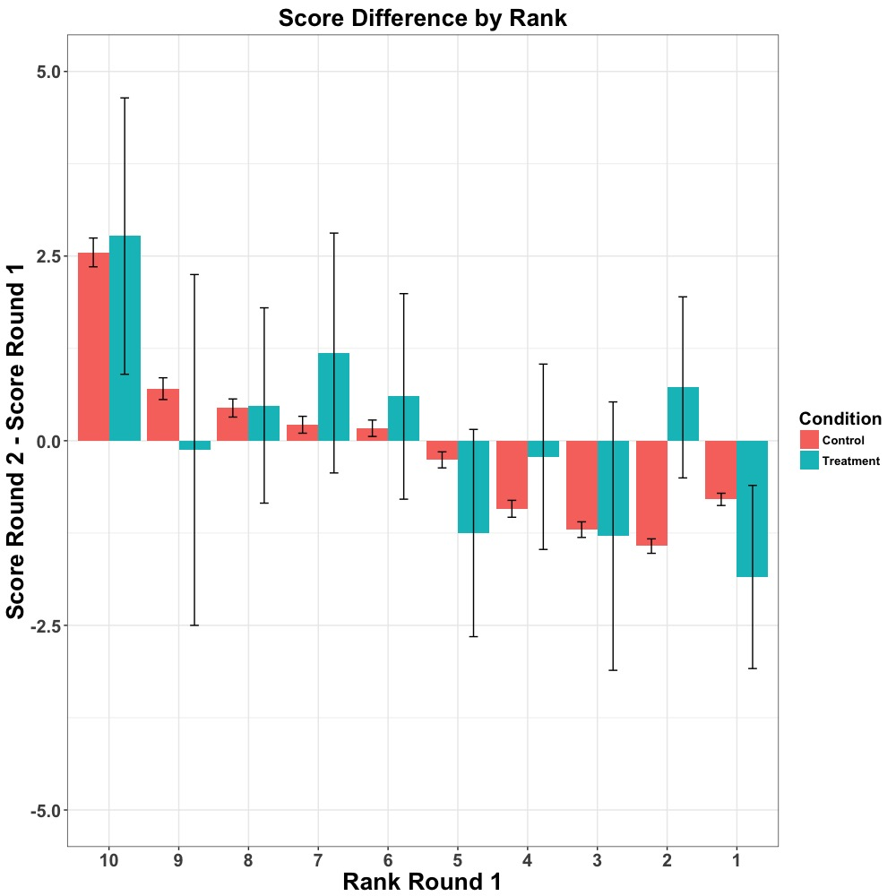
Figure A3
Change in puzzle score from round 1 to round 2, by rank (Study 2).

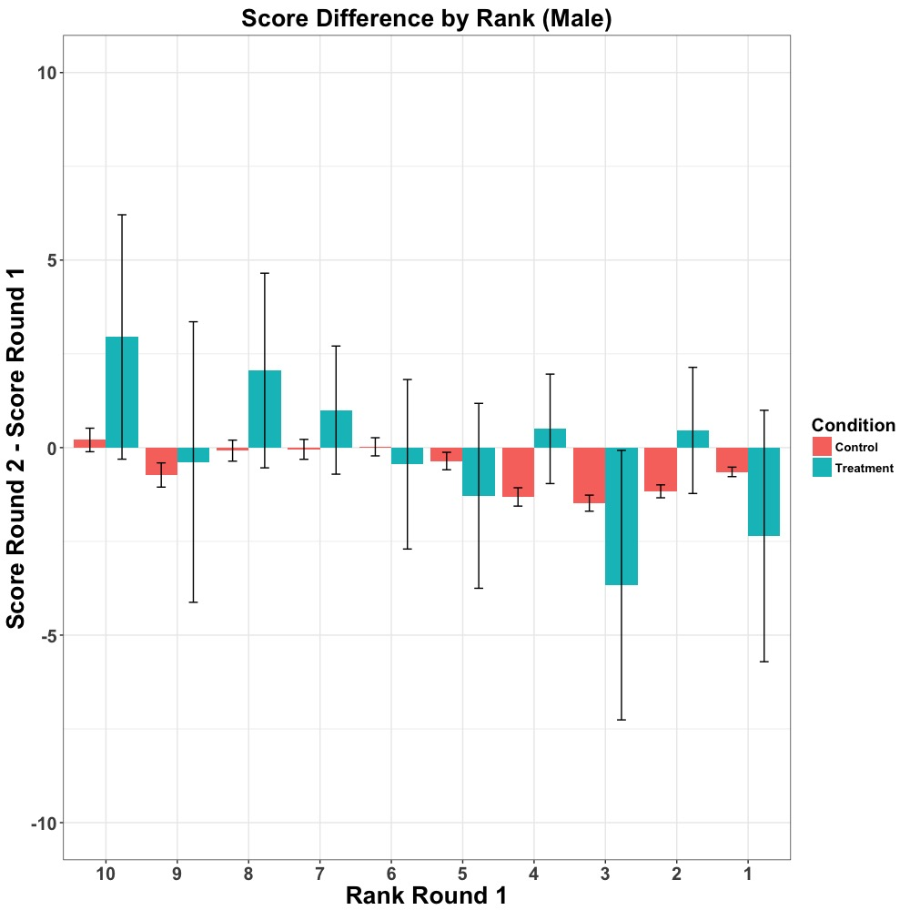

Figure A4
Change in male puzzle score from round 1 to round 2, by rank (Study 2).
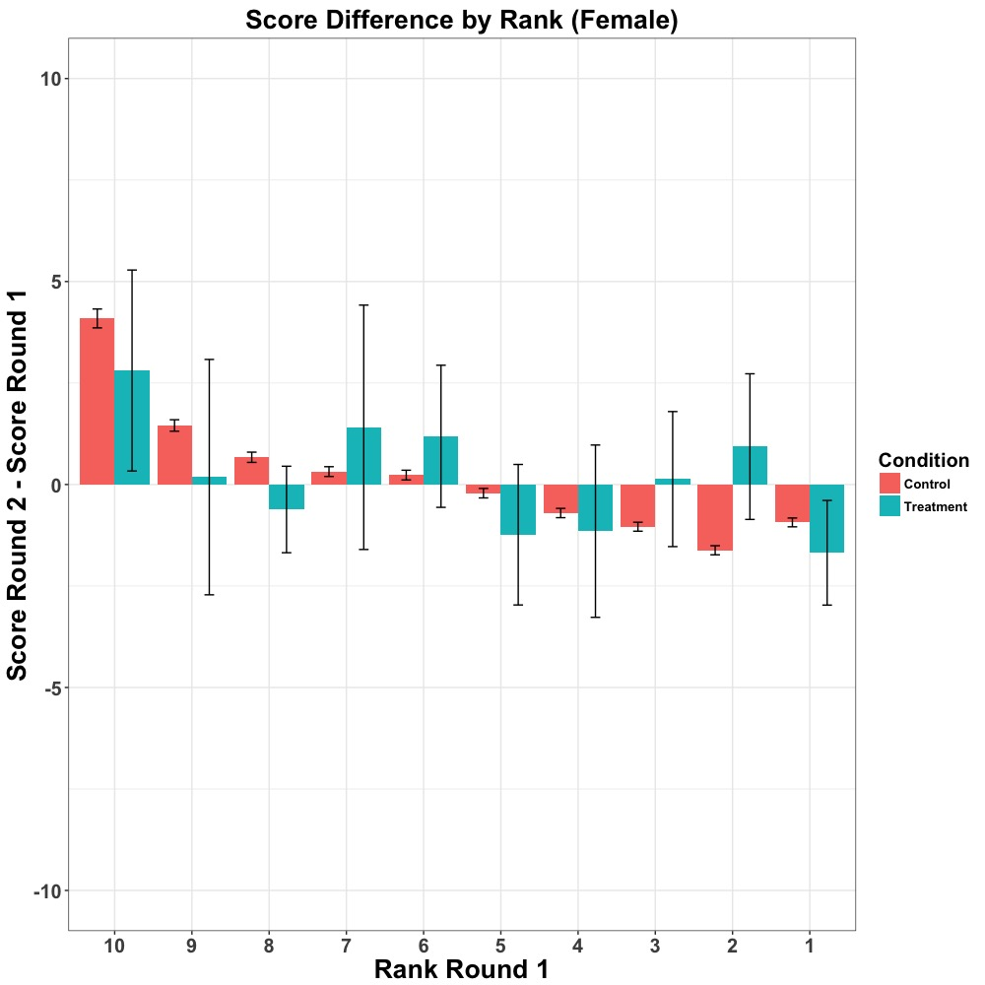
Figure A5
Change in female puzzle score from round 1 to round 2, by rank (Study 2).

Study label | Utility Second> Utility Second-to-Last | Convex at Second | Concave at Second-to-Last | Drop from First >  Drop to Last
1b | 87% | 79% | 72% | 68%
1c | 91% | 79% | 68% | 70%
Table A1
Analogous to Table 2 of main paper, for studies 1b and 1c.

Study label | Utility Second> Utility Second-to-Last | Convex at Second | Concave at Second-to-Last | Drop from First >  Drop to Last
1a (males) | 84% | 81% | 64% | 73%

Table A2
Analogous to Table 2 of main paper, for Study 1a, male subjects (n = 494).

Study label | Utility Second> Utility Second-to-Last | Convex at Second | Concave at Second-to-Last | Drop from First >  Drop to Last
1a (females) | 87% | 80% | 72% | 64%

Table A3
Analogous to Table 2 of main paper, for studies 1a, female subjects (n = 498).

 | Estimate | Std Error | t | Pr(>|t|)
Intercept | -44.23 | 0.55 | -79.82 | < .001
Condition | 18.60 | 6.37 | 2.92 | < .01
RankR1 | 12.78 | 0.14 | 89.79 | < .001
Condition*RankR1 | -2.93 | 1.65 | -1.77 | < .10

Table A4
Regression model for Study 2 (step competition), with round 2 - round 1 steps as the dependent variable and condition (treatment or control) and round 1 rank as the independent variables, along with their interaction term. The controls are from the bootstrapped samples.

 | Estimate | Std Error | t | Pr(>|t|)
Intercept | -93.30 | 1.71 | -54.63 | < .001
Condition | 70.07 | 20.33 | 3.45 | < .001
RankR1 | 21.30 | .44 | 48.63 | < .001
Gender | 33.49 | 1.08 | 30.95 | < .001
Condition*Gender | -35.12 | 12.50 | -2.81 | < .01
RankR1*Gender | -5.88 | .28 | -21.17 | < .001
Condition*RankR1 | -16.62 | 5.36 | -3.10 | < .01
Condition*RankR1*Gender | 9.05 | 3.26 | 2.77 | < .01

Table A5
Regression model for Study 2 (step competition), with gender included as a predictor, along with all 2- and 3-way interactions.

Treatment or Control | Sample size | % male | Avg age | Avg male comp | Avg female comp
Treatment | 248 | 41% | 21.2 | 5.4 | 4.9
Control | 180 | 36% | 22.0 | 5.1 | 4.8

Table A6
Summary of subjects from Study 2, puzzle competition

Rank | 1 | 2 | 3 | 4 | 5 | 6 | 7 | 8 | 9 | 10
Overall | 0.109 | 0.002 | 0.926 | 0.285 | 0.180 | 0.551 | 0.254 | 0.960 | 0.501 | 0.820
Male | 0.356 | 0.086 | 0.268 | 0.032 | 0.490 | 0.698 | 0.258 | 0.146 | 0.860 | 0.134
Female | 0.270 | 0.015 | 0.189 | 0.690 | 0.263 | 0.303 | 0.494 | 0.036 | 0.410 | 0.332

Table A7
p-values for t-tests of difference in mean score differences (from round 1 to round 2) at each rank, overall and by gender, for the puzzle competition of Study 2

