Matching costs to context:
Status quo bias, temporal framing, and household energy decisions

Carrie A. Gill
Environmental and National Resource Economics, University of Rhode Island
Kingston Coastal Institute, 1 Greenhouse Road, Kingston, RI 02881
410-241-6638
cannegill@gmail.com

Stephen A. Atlas*
Assistant Professor of Marketing
College of Business, University of Rhode Island
Ballentine Hall, 7 Lippitt Road, Kingston, RI 02881
401.874.4190
satlas@uri.edu

David J. Hardisty
Assistant Professor
Sauder School of Business at the University of British Columbia
2053 Main Mall Vancouver, BC V6T 1Z2, Canada
604-827-3158
david.hardisty@sauder.ubc.ca

*Corresponding Author
Acknowledgement: The authors would like to thank Qualtrics for their financial support on this project, as well as the Social Sciences and Humanities Research Council of Canada. We also would like to thank the members of the Society for Judgement and Decision Making and the members of the Association of Environmental and Resource Economists for their feedback which was instrumental in the process of refining our manuscript. Finally, the authors would like to thank Ethan Rix for research assistance and Corey Lang for helpful comments.

Matching costs to context:
Status quo bias, temporal framing, and household energy decisions

Abstract

One challenge of promoting energy-efficient behavior change is status quo bias: consumers are reluctant to change away from their current level of energy usage, even if their energy usage is higher than they would actively choose. Using experimental data, this paper examines what temporal frame (e.g. daily, monthly, or yearly) minimizes status quo bias and encourages energy-efficient choices. The authors find that individuals exhibit status quo bias in their choices when costs are framed as daily and yearly, but not when costs are framed as monthly. The authors investigate whether cognitive fluency – the perceived ease of processing information – could be an underlying mechanism. The authors find suggestive evidence that individuals are most fluent when energy costs are framed on a monthly basis, the most common frame for energy bills. Energy efficiency intentions are greatest when consumers are given a context for total energy spending in a matching frame.

Keywords: Status Quo Bias, Temporal Framing, Energy Conservation, Energy Efficiency, Behavior Change

The US residential sector had a total consumption of 19,969 trillion BTU of energy in 2017, amounting to billions of dollars spent on household energy bills in addition to negative environmental and health externalities from conventional energy generation (EIA, 2017). Uptake of energy efficient technologies has been quite slow, in spite of the large savings available, presenting a problem known as the "energy paradox" (Jaffe & Stavins, 1994). One low-cost way to nudge more energy-efficient decisions is to make the costs and savings of energy choices more salient. Beginning in 1975 with the Energy Policy and Conservation Act, information about costs has been a prevalent feature of consumer energy decisions (e.g. cost comparisons of CFL versus incandescent light bulbs on product packaging, and savings of energy-efficient alternatives for household decisions on utility electric bills) and consumer responses to energy labels have been studied for nearly four decades (e.g. McNeill & Wilke, 1979). Yet there is substantial variation in how these costs and savings are presented (e.g. per day, per month, per year) and prior research lacks a comprehensive framework to understand how individuals respond to these different timescales.
With large potential for savings on energy bills and information about the costs of energy-inefficiency, why aren’t individuals making more energy-efficient choices? For individuals who typically engage in energy-inefficient household habits and purchases, status quo bias could be a contributing factor towards energy consumption and persistent inefficiency (Samuelson & Zeckhauser, 1988). For example, individuals were more likely to keep a contractor’s arbitrary light bulb choice, despite zero switching cost and the potential for future monetary savings (Dinner et al., 2011). In addition, limiting energy use often requires sacrificing comfort or convenience, which may make behavior change difficult (Kahneman, Knetsch, & Thaler, 1990). Emphasizing the costs of energy-inefficient choices and the benefits of energy efficiency may help overcome reluctance to energy-efficient behavior change (Novemsky & Kahneman, 2005).
This paper examines which temporal frame (per day, per month, per year) for presenting how energy costs best promote energy-efficient choices. This research contributes to two bodies of literature. First, we show that ease of processing may present a boundary of status quo bias. Second, we contribute to the literature on choice architecture, specifically regarding household energy decisions. Recent literature has compared the effects of long-term temporal framing on energy efficient choices, and has generally found that longer timeframes that are within the lifecycle of the product are most effective Hardisty, Shim, Sun & Griffin (2016). Information, plays an important role and influences which energy frame to be used to promote energy-efficient choices.
Section 2 reviews the choice architecture literature, in particular non-price strategies known to encourage energy efficiency and conservation. We consider concepts from behavioral economics (Hutton and Wilkie, 1980) and marketing (Hardisty et al., 2016) in order to give context. We present a framework in Section 3 considering how cost frames can affect status quo bias, and examining cognitive fluency as a possible mechanism. Section 4 we present the results from our four studies. Our findings indicate that presenting monthly costs of energy-inefficient behaviors decreases the influence of status quo energy behaviors (Study 1). We hypothesize this is because individuals are more easily able to think about monthly costs relative to daily or yearly costs (Studies 2 and 3). We find that supplementing information about costs of energy inefficiency with explicit information about typical energy spending in a matching frame increases intentions to engage in energy efficiency relative to providing the same information in mismatching frames (Study 4). Section 5 concludes with a general discussion of all four studies and implications for energy policy.

Literature Review
There exists a common interest for energy companies to identify policies and interventions which reduce energy use: energy conservation can save consumers money on their electricity bills, save utility companies money, reduce greenhouse gas emissions and mitigate climate change, and reduce pollution. Given the extent of energy consumption in the residential sector, encouraging household energy-efficient behavior change represents a significant strategy to conserve energy and mitigate externalities of electricity generation (Dietz et al., 2009). Economists, policy makers, and others have developed strategies to encourage energy efficiency ranging in degree of autonomy for the decision maker.
On one end of the spectrum, policies like residential direct load control – where utility providers control the level of electricity consumption of household appliances, such as by setbacks on air conditioning temperatures during hours of peak demand – and regulations that mandate certain levels of energy efficiency, such as fuel efficiency standards for cars, energy efficiency standards for appliances, or prohibition of energy-inefficient products like incandescent light bulbs. While such policies may be effective in reducing energy use, they take away autonomy from the individual and lead to unintended negative consequences.
At the other end of the spectrum are nudges and non-price strategies that preserve individual freedom of choice while still encouraging energy efficient choices. Recently, choice architecture has emerged to provide a framework and series of tools to guide policymakers about how to present choices, including what content to present and how to present it (Johnson et al., 2012; Thaler et al., 2014). There is an emerging body of literature on the effects of choice architecture on decisions (see Johnson et al., 2012 for a review of choice architecture tools). While neoclassical microeconomic theory predicts individual choice is independent of how the choice is described, there is a vast body of literature documenting violations of descriptive invariance. Conditions of these violations inform choice architecture. For example, one prevalent tool of choice architecture is defaults. Johnson and Goldstein (2003) showed that individuals were more likely to be organ donors when defaulted into the program and allowed to opt out rather than having to actively opt into the program. Each individual is faced with the same alternatives – to be enrolled as an organ donor or to not be enrolled as an organ donor – but the way the decision is set up affects the end choice. Similarly, previous research finds when prices are framed in periodic time frames, consumers are more likely to agree to many contracts (Gourville 1998; Atlas & Bartels 2018). Specifically, by framing out the benefits more narrowly, it highlights the costs more substantially.
Policy makers have turned to concepts from choice architecture as a low-cost and politically feasible way to encourage pro-environmental behaviors without restricting the consumer’s choice set (Attari, DeKay, Davidson, and De Bruin, 2010). Within the larger context of measures to reduce energy consumption, choice architecture is a non-price strategy that fits alongside recommended behavioral interventions (Allcott & Mullainathan, 2010), including peer comparisons (Allcott, 2011; Allcott & Rogers, 2014), commitment devices and goal setting (Becker, 1978; Harding & Hsiaw, 2014), feedback (Jessoe & Rapson, 2014; Carrico & Riemer, 2011), and education (Agarwal et al., 2017; Gill & Lang, 2017).
Enacted in 1975, the Energy Policy and Conservation Act requires that new appliances be labeled with energy consumption information and new vehicles be labeled with information about fuel consumption. This information necessarily enters into the choice architecture of energy-consuming product purchase decisions and energy-related behavior decisions. Therefore, the way information about energy consumption and costs is presented affects individual choice. Over the years, these labels have been subject to criticism and redesign to improve ease of use and information communication. For example, Larrick and Soll (2008) highlight the difficulty in interpreting the miles per gallon figure in terms of fuel-efficient vehicle choices.
The recently revised fuel economy labels (2013) additionally report gallons per hundred miles, two measures of fuel cost, and information about greenhouse gas emissions. These additional measures not only make information about comparative fuel use easier to access, but the number of measures add weight to the fuel attribute in consumer choice, provide a signpost to consider environmental preferences, and provide a reference point against which to weigh attribute levels (Ungemach et al., 2017; Weber et al., 1988; Costa & Kahn, 2013; Larrick et al., 2015). These labels provide otherwise missing information about energy consumption and cost to consumers, and remove one barrier to consumers considering this attribute in their decision-making process (Newell & Siikimaki, 2014). Information like energy labels is inherently subject to choice architecture, and decisions about what information to present and how to present it affect the consumer’s choices. In this paper, we seek to understand the role of temporal framing – over what time period energy-related costs and benefits are aggregated – in energy-related household choices.
Prior research has explored effects of temporal framing of energy costs in product evaluation, but there are gaps in the literature that prevent comprehensive understanding of these effects (Kaenzig & Wustenhagen, 2010). Most of this literature has focused on long-term temporal frames (per year or longer) and suggest that consumers put more weight on attributes whose levels are framed on longer terms (Larrick et al., 2015; Burson et al., 2009; Pandelaere et al., 2011; Kaenzig & Wustenhagen, 2010). Hutton and Wilkie (1980) found increased purchase intentions for energy-efficient refrigerators when lifecycle cost information was provided more so than when annual cost information was provided. Similarly, Hardisty et al. (2014) find that providing 10-year energy costs generally encourages more energy-efficient choices than providing 1-year or 5-year costs. While long-term temporal frames make intuitive sense for durable goods, like vehicles and houses, unreasonably long frames may prompt the consumer to feel manipulated, be too abstract to fully comprehend, or be unreasonable timeframes to consider for behavior change or short-term decisions. For example, it may not make sense to the consumer to think of the cost savings of washing a load of laundry with cold water rather than hot water on a yearly or ten-yearly basis.
One notable study looks at shorter-term temporal frames. McNeill and Wilke (1979) found no differences in a set of measures regarding refrigerator evaluation when typical energy costs were framed in monthly versus yearly terms. In a study on preferences for fuel efficiency, Camilieri and Larrick (2014) find that providing information about fuel costs per 100 miles encouraged more fuel-efficient vehicle choices than when fuel costs were framed per 15,000 miles, and less efficient choices than a per 100,000 mile framing. In sum, the literature suggests that presenting energy costs on larger scales may be most effective at encouraging energy-efficient choices, but the findings are inconclusive for how individuals respond to smaller scales and suggest there may be a nonlinearity in response.
Literature to date has compared energy efficient choices with temporal framing although none have explained why. We propose and show that individuals exhibit status quo bias in their choices when costs are framed as daily and yearly, but not when costs are framed as monthly. In addition, we show that the ease of processing information also plays an important role in this process. This is of particular importance to policymakers as framing costs that are easier to process could lead to more positive consumer decisions.

Conceptual Underpinnings and Hypotheses
How we frame costs and savings influences how individuals perceive their choices. Since we are considering gains and losses with respect to individuals’ budgets and changes in comfort and convenience, it is reasonable to look to prospect theory for inspiration for how to present the costs and savings of energy behavior change. Central to prospect theory is the concept of loss aversion: individuals dislike losses more than they like equivalent gains (Kahneman & Tversky, 1979). Under the framework of prospect theory (Kahneman & Tversky, 1979) and principles of hedonic editing (Thaler, 1985), individuals can maximize utility by aggregating losses (pay $y in lifecycle costs) and segregating gains (save $x each day). This allows individuals to capitalize on the asymmetric shape of prospect theory’s value function. However, other research suggests individuals have limited ability to cope with multiple losses at the same time (Linville & Fischer, 1991). Individuals prefer to break up negative events to different days, which seemingly points toward segregating costs instead.
Evidence from a third vein of literature suggests individuals tend to neglect small recurring costs, a phenomenon known as Pennies-a-Day (PAD) (Gourville, 1998; 2003). Under the PAD framework, individuals may be more likely to spend small monetary amounts per day to obtain comfort and convenience associated with energy-inefficient choices (Gourville, 1998). However, there is no research on whether consumers similarly neglect small, recurring monetary gains, such as savings and associated benefits from engaging in an energy-efficient household behavior, or whether individuals stick with energy-inefficient behaviors when the costs are framed narrowly. If PAD extends to small gains, individuals will neglect small recurring savings from engaging in energy efficiency. There is evidence, though, that periodic pricing prompts individuals to consider repeat experiences of the purchase in question. As applied to recurring decisions about energy-related behaviors, narrowly framed savings may make the inconveniences or discomforts associated with a switch to energy efficiency more salient (Atlas & Bartels, 2017). In other words, messaging about saving $x per day by taking energy-efficient colder showers may call to mind the daily discomfort of each colder shower and steer individuals away from efficient choices.
Novemsky and Kahneman (2005) posit several boundaries of loss aversion. They find that loss aversion is attached to the benefits of the good rather than the attributes. In other words, an individual is willing to freely give up one good for another that provides the same benefits. They also find loss aversion does not apply for goods intended to be exchanged (e.g. cash). Our research investigates whether choices about temporal framing can minimize loss aversion for energy inefficiency. We operationalize this through a scenario that sets up a status quo level of energy consumption and present individuals with relative costs of energy-inefficient and energy-efficient choice alternatives. Theory is conflicted about how consumers may react to narrow cost frames when it comes to behavior decisions. Theory generally supports broader frames as most encouraging product uptake, but gives little guidance on how broader frames affect behavior change decisions. As we describe later, we posit that frames that make cost information most easy to process will best encourage energy-efficient choices. Specifically, we test the hypothesis:
H1: Temporal frames (e.g. daily, monthly and yearly) will influence intentions to engage in energy efficient behaviors
We look to ease of cognitive processing (i.e. fluency) to understand when and how temporal frames influence energy efficiency. Cognitive fluency – the subjective experience of ease of processing information – may further influence how individuals perceive information about costs and savings when making energy decisions. Fluency has been shown to affect several areas of judgment, with messages that are easier to process being linked to judgments of truth, preference, confidence, and familiarity (Alter & Oppenheimer, 2009). For example, Song and Schwarz (2008) found that individuals had stronger intentions to exercise and cook when the instructions were visually easy to read. In relation to fuel-efficient vehicle choices, Camilleri and Larrick (2014) find preliminary evidence that scale familiarity may be driving their finding of more fuel-efficient vehicle choices when fuel costs were presented per 100 miles rather than per 15,000 miles. Individuals have an intuitive sense for which units and scales are most familiar, and place more decision weight on attributes with familiar scales (Lembregts & Pandelaere, 2013). Furthermore, individuals find it difficult to translate between units and are prone to incorrect comparisons when performing calculations to determine impacts of fuel and energy consumption (e.g. Heinzle, 2012; Larrick & Soll, 2008). Moreover, weighing tradeoffs between energy alternatives and their attributes can feel difficult, and this disfluency may encourage individuals to stick with status quo behaviors (Novemsky et al., 2007). This body of literature suggests that we may be able to overcome decision avoidance and encourage energy-efficient behavior choices by increasing fluency when presenting costs of inefficiency.
We hypothesize that individuals are most familiar with monthly energy bills, and are therefore able to process cost savings information most easily when the framing matches their implicit context. By providing an easy-to-process context for the magnitude of the costs or savings, individuals may be more easily able to understand the benefits of alternatives in the choice set and more likely to overcome status quo bias. We test the hypothesis:
H2: Individuals have the most experience considering monthly energy costs.
We elicit measures of fluency with the temporal frame and confirm that individuals are more fluent with the monthly presentation of costs relative to daily and yearly frames. Furthermore, individuals’ stated familiarity with monthly cost frames provide additional evidence that individuals often think of energy expenditures in monthly terms.
If fluency between the cost frame and an implicit context for that frame can influence individuals’ decisions, then we hypothesize that providing an explicit context for energy spending in a matching frame can make relatively disfluent frames easier to process. We define context as the typical frame of energy costs (i.e. a monthly energy bill). In other words, the monthly energy bill for total household energy use is the context for the marginal costs of energy-related behavior choices. In addition to information about costs of energy-inefficient behavior alternatives, we explicitly provide a context for typical spending on household energy. We manipulate whether these two pieces of information match in temporal frame and compare energy-efficient intentions for participants who were given context and costs in a matching frame to those given costs and context in different frames (i.e. inefficiency costs $x per day and typical energy spending $y per year). We specifically test the hypothesis
H3: Individuals have a higher intention to engage in energy efficiency when energy cost frame matches the familiar total spending context.

Studies
Overview
We test our hypotheses through four experiments. We rely on hypothetical scenarios and self-reported behavior intentions, which could lead to biased estimates of treatment effects in a non-experimental setting. However, we expect such biases (e.g. inflated intentions of pro-environmental behavior) to occur with equal likelihood across all treatment conditions due to random assignment. Therefore, our online studies provide a solid foundation for hypothesis testing. In the four studies that follow, we found that individuals are influenced by status quo behaviors, found it easier to understand decisions about energy use when the costs of choice alternatives are framed as monthly, preferred monthly framing for most activities, and by providing an explicit context for energy spending, we show evidence that consumers may in turn elicit more energy-efficient behavior intentions. We also find that individuals indicated higher intentions for energy-efficiency when given cost and context in matching frames, and particularly if these frames were broad (i.e. per year).
General Experimental Design
We conduct four online surveys from 2015-2016 drawing participants from two online populations: Amazon Mechanical Turk and Qualtrics. Each study was completed in less than 20 minutes and all respondents were compensated for their time.
The primary component similar across all studies was a scenario based around a household energy decision between energy-inefficient and energy-efficient alternatives. The decision varied between studies, but typically included a behavioral choice rather than a purchase. For example, we asked individuals about what water temperature they would use to wash their laundry. The behavior is to choose a water temperature and the alternatives ranged from hot water, which is energy-inefficient because hot water requires energy to heat, to cold water, which is energy-efficient because cold water achieves the same outcome while using less energy comparatively. Individuals read the scenario and were given information about the costs of choosing the energy-inefficient alternative. The main treatment we used was a random assignment of how the cost information is framed – per day, per month, or per year.
Study 1: Boundaries of Status Quo Bias
In our first study, we investigate which temporal framing of costs encourages the most energy-efficient choices. We presented individuals with scenarios about household energy-related behavior decisions. We asked individuals what they would choose given a randomly assigned status quo behavior and information about the energy costs or savings of switching behaviors. According to literature on status quo bias, we expect to find that individuals’ intentions are a function of their randomly assigned status quo, across all cost frame conditions. If individual behavior intention is consistent with the literature on cost framing, we would expect costs aggregated over longer temporal frames would encourage the most energy-efficient choices, while individuals may neglect costs or savings that are framed narrowly. A deviation from expected findings may suggest that existing theory about longer-term cost frames does not extend to narrower frames. Furthermore, any effect of cost frame on status quo bias would provide evidence for a potential boundary of status quo bias, with implications for how to best describe costs of household energy behaviors to motivate behavior change.
Method
Participants. We recruited 353 on-line participants to complete a study on household decisions through Amazon Mechanical Turk. Participants received an average of $1.50 for completing the study. Average time to complete was 11.3 minutes (sd = 6.8 minutes).
Procedure. Participants were presented with two scenarios about household energy-related decisions in a between-subjects design. First, they were faced with a decision between using hot or cold water to wash laundry. Then, they had to choose between using or not using a second household refrigerator. Through random assignment, participants were told to imagine that they were currently engaging in an energy-efficient behavior (e.g. always using cold water to wash laundry; not using a second refrigerator) or a corresponding energy-inefficient behavior (e.g. using warm or hot water to wash laundry; using a second refrigerator). Participants with an energy-efficient (inefficient) status quo were presented with the cost (savings) of switching to the energy-inefficient (efficient) alternative behavior. Costs (savings) were randomly presented as daily, monthly, or yearly for each participant.
All participants first saw a description of the scenario and then answered a question to confirm their scenario status quo. For example, participants assigned the inefficient status quo and yearly frame condition saw: “Suppose you often use warm water, but you are considering whether to use only cold water for your laundry. If you always use cold water, you will save $63.00 per year on energy costs. What do you think you would do?” Participants used a 0-10 slider scale (shown in Appendix A) to indicate their likelihood of engaging in the energy-inefficient or energy-efficient behavior alternative. Our dependent measure is each individual’s response to this question averaged over the two scenarios as both scenarios were similar. Individuals also answered a short series of questions related to the scenarios, environmental concern, construal level, cognitive reflection, and loss aversion.
Results
Figure 1 shows intention to engage in energy efficient behavior, averaged over the two scenarios for each status quo and frame condition. In the daily and yearly frames, participants were influenced by their status quo, but not in the monthly condition. We used analysis of variance to analyze differences in behavior intention between the status quo groups, the temporal frame conditions, and the interaction between the two. There were main effects of status quo, (F(1, 347) = 15.93, p = .0001), temporal frame, (F(2, 347) = 4.67, p = .010), and the interaction, (F(2, 347) = 4.33, p = .014).
[Figure 1 about here]
In the daily condition, participants preferred efficient behaviors more strongly when that was their assigned status quo, (t(113) = 3.938, p = .0001, d = .735). Likewise, participants in the yearly condition also showed statistically significant differences in their behavior intentions, in line with their assigned status quos, (t(117) = 2.785, p = .006, d = .511). However, participants assigned to the monthly frame showed no difference in behavior intention as a function of status quo, (t(117) = .078, p = .938, d = .014), and they tended toward energy-efficient choices relative to participants assigned the inefficient status quo in the daily and yearly conditions. For individuals assigned a status quo energy-efficient behavior, there was no effect of temporal frame, (F(2, 347) = 1.46, p = .233, $η_{ }^{2}$ = .02). However, there was an effect of temporal frame for individuals assigned an energy-inefficient status quo, (F(2, 347) = 7.69, p < .001). We replicate main findings even when controlling for loss aversion, environmental concern, cognitive reflection, stated actual frequency of engaging in the energy efficient behavior, and typical energy bill spending.
We investigated a number of individual differences, including loss aversion, environmental concern, construal level, cognitive reflection and numeracy, stated actual frequency of engaging in the energy efficient behavior, and typical energy bill spending. We find neither a main effect of loss aversion (p = .180) nor an interaction between loss aversion and status quo (p = .404). Environmental concern is significant in predicting behavior intention (p < .001) but does not interact with the treatment (p = .791) or affect main findings. Construal level does not produce a main effect (p = .661) or an interaction (p = .863). Cognitive reflection, given by the number of correct responses to five tasks (e.g. the bat and ball problem), is not significantly correlated with behavior intention (p =.276) and does not interact with treatment (p = .536). Stated actual status quo frequency of engaging in energy-efficient behaviors measured on a 5-point Likert scale and averaged over the two scenarios has neither a main effect (p = .320) nor interaction (p = .535). Finally, we find neither a main effect of typical energy spending (p = .474) nor an interaction with treatment (p = .356).
We also find that individuals tend to neglect small recurring savings. A main effect of temporal frame, (F(1, 347) = 1.426, p < .001), indicates that individuals in the daily condition selected a behavior intention that was less energy efficient than individuals who saw monthly or yearly frames, given an energy-inefficient status quo. This suggests that the Pennies-a-Day effect (Gourville, 1998) extends to the small recurring savings that accrue from adopting energy-efficient household habits and switching to more efficient behavior alternatives. In other words, we found that individuals given an energy-inefficient status quo were more likely to forgo savings from switching to energy-efficient behavior alternatives when the gains from doing so were framed as daily, relative to monthly or yearly.
Discussion
Data support our hypothesis that individuals are influenced by status quo behaviors (H1). Interestingly, we found significant effects of status quo when monetary consequences were framed as yearly or daily, but not monthly. We also found evidence that the Pennies-a-Day effect – neglect for small recurring costs – extends to neglect for small recurring savings. This study showed how costs and savings of energy decisions are framed makes a difference in how likely individuals are to engage in energy efficiency.
One possible explanation for a decreased sensitivity to status quo bias is ease of cognitive processing of monthly costs and savings. Many individuals typically receive a monthly energy bill, and by framing the costs and savings of energy decisions as monthly, individuals may be more readily able to evaluate monetary consequences in relation to their typical household energy expenses. This ease of processing may then make the value of the costs or savings more salient relative to typical energy expenses, and allow individuals to be more calculating in their energy decisions. We test this hypothesis in Studies 2-4.
Study 2: Fluency with monthly framing
In our second study, we test whether individuals are more easily able to process monthly costs relative to other temporal frames. We present individuals with one of five scenarios, with the same experimental conditions as Study 1. Specifically, we randomly assign individuals to either an energy efficient or inefficient status quo and present the costs of changing behavior in either a daily, monthly, or yearly frame. We then ask individuals five questions to measure fluency with the temporal frames. We find that individuals are more fluent with monthly costs and savings than with daily or yearly/seasonal costs and savings.
Method
Participants. We recruited 1,199 online participants to complete a short survey on household decisions through Amazon Mechanical Turk. The average time to complete the survey was 2.4 minutes (sd = 3.9 minutes).
Procedure. Each participant was randomly presented with one of five scenarios regarding shower water temperature, bus ridership, light bulb choice, use of a space heater, and use of a window air conditioning unit. Individuals were randomly assigned to a status quo (energy efficient or inefficient) and temporal frame of costs/savings (per day, per month, per year for scenarios 1-3 or per season for scenarios 4-5) similar to Study 1. Our dependent variable is intention to engage in energy efficiency as measured by individuals’ responses to the question “What would you do?” Individuals indicated their intentions using a 0-10 slider scale between definitely engaging in the energy efficient behavior or the inefficient behavior.
Individuals then indicated their fluency using a seven-point Likert scale on four measures: ease of estimating the financial impacts of the decision, ease understanding of the decision, clarity of the decision, and clarity of the financial impacts. Text of the scenarios and fluency measures are provided in the appendix. We aggregated responses to fluency measures using a standardized Cronbach’s alpha (alpha = .811). Participants also ranked how involved they were in making the decision on a seven-point Likert scale (M_{involvement} = 5.93, sd = 1.18), and how much they care about saving money and the environment on five-point Likert scales (M_{saving money} = 4.49, sd = .77; M_{environment} = 4.02, sd = .95).
Results and Discussion
Using the Cronbach’s alpha index of fluency measures across all five scenarios, we find significantly higher fluency scores for individuals who are presented with monthly costs rather than other temporal frames (M_{month} = .079, M_{other} = -.039, t(1197) = 2.42, p = .016). Analysis of variance confirms a significant effect of frequency on fluency (F(2, 1196) = 3.11, p = .045). Figure 2 plots mean fluency for each temporal frame condition, with higher values indicating higher fluency. Fluency is significantly positively correlated with intention to engage in energy efficiency (beta = .47, se = .119, t(1198) = 3.97, p < .001), though the variance in our dependent measure explained by this effect is small (r-squared = .012).
[Figure 2 about here]
We can further investigate how fluency changes for different temporal frames. Scenarios 1-3 use the temporal frames per day, per month, and per year, while scenarios 4-5 regarding use of AC and heat present costs per season instead of per year. First, we restrict our sample to only individuals who saw scenarios 1-3 and re-index the fluency measures (alpha = .811). We continue to see a marginally significant difference in fluency means between individuals who saw monthly costs and those who saw daily or yearly costs (M_{month} = .066, M_{other} = -.033, t(912) = 1.77, p = .077). We do the same analysis for individuals who saw scenarios 4-5 (alpha = .804) and find a marginally significantly higher level of fluency for individuals in the monthly condition (M_{month} = .118, M_{other} = -.058, t(283) = 1.77, p = .079).
Study 2 reveals that individuals find it easier to understand decisions about energy use when the costs of choice alternatives are framed as monthly, providing support for H2. Despite using a range of scenarios, two of which include seasonal instead of yearly cost frames, fluency seems to be highest with monthly costs. In Study 3, we further explore what temporal frame individuals tend to use when they think about their energy expenditures and costs of energy-related behaviors.
Study 3: Experience with and preference for monthly framing
In contrast to Study 2, which elicits fluency with a randomly assigned cost frame, Study 3 directly asks individuals for their preferences in frame. Among other components (not included in this paper), individuals were given a scenario where they were asked to recommend which cost frame should be used to easily convey costs of energy inefficient behaviors to their neighbors. Then they were asked to indicate their preferred way of thinking about various expenses, including costs of energy-related behaviors and their energy bill. Individuals overwhelmingly prefer monthly cost framing. In combination with Study 2, we build evidence in support of monthly framing of costs being the easiest to process.
Method
Participants. We recruited 315 online participants to complete a short survey on household decisions from the Qualtrics panel of respondents. The average time to complete the survey was 14.3 minutes (sd = 12.2 minutes). All participants were screened to ensure they pay their own energy bills.
Procedure. Individuals were presented with a scenario regarding how to frame costs of energy-related household behaviors. In this scenario, individuals are told that their neighbors each have energy meters in their homes. Each individual was randomly assigned to one of three treatment conditions, and were told that their neighbors saw total household energy expenditures either per day, per month, or per year on their energy meters. They were then asked to advise a neighbor that wanted to design flyers with a cost frame that would be most easy to understand. Individuals ranked each frame on a 7-point Likert scale from “doesn’t make any sense at all” to “make complete sense.” Then individuals chose only one frame to recommend to the neighbor.
Next, individuals were given a scenario in which they were designing a flyer to convey costs of several various activities. Individuals indicated which frame made the most sense for each activity, choosing from a selection of seven frames (per day, per week, per month, per year, trip, per load, per fill-up). Activities included both energy-related activities and non-energy activities. Finally, individuals responded to a set of control questions, not included in this analysis.
Results and Discussion
When asked to rate cost frames on a 7-point Likert scale, individuals rated all frames as making sense (M_{day} = 4.94 sd = .117, M_{month} = 4.99 sd = .115, M_{year} = 4.84 sd = .118). However, monthly framing was rated significantly more sensible than the yearly frame (t(314) = 1.70, p = .091); difference in means not significant between month and day frames (t(314) = .54, p = .587). Individuals then chose one of the three frames to recommend as the frame that made the most sense to use to communicate costs of energy-related household decisions. Figure 3 illustrates the results of this question. A majority of individuals recommended describing costs in the monthly frame (N=130, 41.3%). The remaining individuals were approximately split between daily and yearly frames: N=88 (27.9%) recommended daily framing while N=97 (30.8%) recommended yearly framing. Interestingly, more individuals recommended monthly framing than daily or yearly regardless of the framing used in their neighbors’ energy meters. We argue this is further evidence for the ease of processing energy-related costs per month.
[Figure 3 about here]
Then, we elicited preferred cost frames for nine activities. Table 1 summarizes these results. Individuals preferred monthly framing for all activities except for the activities about washing laundry, driving, and grocery shopping. Of particular interest, 71.4 percent of individuals consider their energy bills on a monthly basis. This exercise provides additional evidence for monthly framing being both easy to process and familiar, and supporting H2.
[Table 1 about here]

Study 4: Providing context for unfamiliar frames
Studies 1-3 showed that individuals respond differently to temporal frames, and that framing costs of energy efficiency may reduce status quo bias (Study 1). The findings regarding fluency in Study 2 suggest that ease of cognitive processing plays a role in the effectiveness of monthly framing in the absence of an explicit context for energy spending (or other relevant comparison metric). Study 3 provides additional evidence that monthly framing is not only easiest to process but also explicitly preferred. The scenarios in Studies 1 and 2 rely on individuals’ implicit contexts for energy decisions, and we posit their monthly energy bills serve as this context. This begs the question of whether we can enhance the fluency of typically less-fluent temporal frames by providing an explicit context (e.g. for energy spending) in the same temporal frame. Study 4 has two aims. First, we explicitly test the hypothesis of cognitive fluency for matching the frame of behavior-specific costs to the frame of typical household energy expenses. In other words, if people are given a daily energy bill, do daily costs work better? Second, we test whether broad (i.e., yearly) framing of both costs and typical expenses encourages more energy-efficient behavior intentions than narrow (i.e., daily) framing.
Method
Participants. We recruited 132 participants for a fifteen-minute online survey through Qualtrics. Participants (51% male, 49% female) had an average age of 48 years and an average household income of $50,000 – 59,999 with at least some college. All participants were screened to ensure they pay their own energy bills.
Procedure. As in our previous studies, participants were presented with three scenarios: laundry water temperature, use of a second fridge, and light bulb choice. Following a description of the scenario, we presented typical household energy spending in a randomly assigned frame (daily or yearly), representing an explicit context for easy evaluation of costs of choosing an energy-inefficient behavior alternative. Participants saw the costs of engaging in the energy-inefficient alternative in a randomly assigned frame (daily or yearly), which either matched the typical spending context or did not. Our dependent measure was similarly defined as in Studies 1 and 2, and we average over the three scenarios to generate our dependent measure for each individual as the categories were similar. Figure 4 shows an example of how typical energy spending and scenario-specific costs were presented. We also solicited fluency using the same four measures as in Study 2.
[Figure 4 about here]
Results and Discussion
Figure 5 shows that intention to choose energy efficient behaviors are strongest when the cost frame and the typical spending frame are matched. In other words, a daily cost frame works best when matched with a daily spending bill, and a yearly cost frame works best when matched with a yearly spending bill. In analysis of variance, we do not see a significant main effect of cost frame (F(1, 128) = .82, p = .366) but there is a marginal main effect of spending frame (F(1, 128) = 3.70, p = .056) and a statistically significant interaction effect (F(1, 128)=5.47, p = .021). Pairwise comparisons reveal a significant effect of cost frame when daily typical spending is presented (t(63) = 2.178, p = .033), but an insignificant effect of cost frame when yearly typical spending is presented (t(65) = 1.070, p = .289). These results provide partial support for H3, though we cannot statistically distinguish between behavior intentions with matching or mismatching contexts when individuals see an annual total spending context.
[Figure 5 about here]
We were unable to test for fluency as a mediator due to suspected ceiling effects. Fluency measures were on seven-point Likert scales (M_{fluency measures} = 6.31, sd = .80). Thirty-eight percent of individuals chose a seven for all measures, while 92 percent had an average raw fluency score greater than five, resulting in very little variation among respondents. We think the potential cause for reported high fluency relative to fluency measures in Study 2 was the clarity of the images used to portray costs and typical spending. We also see higher intentions for energy efficiency in Study 4 relative to Study 1. Though the scenarios are not directly comparable, this suggests that providing an explicit context for energy spending may increase fluency, which may in turn elicit more energy-efficient behavior intentions.

General Discussion
In four studies, we investigate how individuals respond to cost frames within the context of energy-related household decisions. Prior literature has mainly focused on longer-term temporal framing of costs, ranging from one year to the life cycle of the product in question (Kaenzig & Wustenhagen, 2010; Hutton & Wilkie, 1980; Hardisty et al., 2014; Larrick et al., 2015). We extend this work in two ways. First, we focus on short-term temporal frames to build a more comprehensive understanding of how individuals respond to cost framing in general. Second, our scenarios involve costs related to household behaviors rather than product purchases. We find that intentions to engage in energy efficient behaviors are subject to status quo bias when the costs or savings of behavior change are framed as per day or per year. However, individuals who see costs and savings framed on a monthly basis overcome status quo bias in their behavior intentions. This provides evidence that is potentially inconsistent with current thinking about cost framing, which recommends using longer-term frames to promote product purchase (Hardisty et al., 2016). Furthermore, in the same vein as Novemsky et al. (2005) with boundaries of loss aversion, we show a possible boundary of status quo bias.
We postulate that cognitive fluency plays a role in why monthly cost framing minimizes status quo bias. Prior literature on cognitive fluency links easy-to-process attributes to judgments of truth, preference, and ease (Alter & Oppenheimer, 2009). Therefore, a cost frame that is more cognitively fluent may affect individual choices. In two studies, we find evidence that monthly framing is easiest to process and the preferred unit to describe costs of several household choices. This finding is consistent across a randomized experiment that elicits fluency through a set of measures, and in stated preference-style measures. We also see that over seventy percent of individuals think about their energy expenses in monthly terms. Prevalence of monthly energy bills may provide an implicit context against which to evaluate or understand the costs of energy-inefficient behavior alternatives. Findings from these studies point to cognitive fluency as a possible boundary of status quo bias, and one that we may be able to leverage to further encourage energy efficient choices.
A fourth study explores the benefits of providing an explicit context for relatively disfluent cost frames. Since our conceptual framework is an accurate description of the decision making process regarding household energy choices, then we expect that manipulations of explicit context framing to match cost framing would increase energy-efficient behavior intentions. Consistent with this framework, we find that individuals have the greatest intention to engage in energy efficiency when they see a context for total household energy expenditures in a frame that matches information about the costs of a specific energy-inefficient behavior, relative to receiving an explicit context in a mismatched frame.
Our findings suggest two additional tools that choice architects can consider. First, we show that cognitively fluent framing can reduce status quo bias. If a policy maker’s goal were to encourage some behavior that is hindered by attachment to the status quo, then framing the costs of inaction in a frame that is easier to process could lead to more decisions to act. To illustrate with an example outside of energy contexts, consider the choice of whether to purchase relatively healthy fresh produce or comparatively unhealthy prepared foods at the grocery store. Individuals tend to think about their budgets for groceries in weekly terms. Advocates for healthy eating that want to encourage purchases of fresh produce instead of prepared foods could consider framing the additional costs of unhealthy foods relative to fresh produce in terms of costs per week or on longer frames, but probably should avoid framing costs narrowly (e.g. per day). In relation to energy use, in-home energy displays may be more effective in encouraging efficiency when framing energy costs as per month or longer, rather than showing energy costs per hour or per day. Future research should expand on how fluent framing and descriptions might be able to counteract other biases, like default bias and loss aversion.
The second tool available to choice architects is providing a context in order to evaluate disfluent cost frames. We find that providing an explicit context for frames that are relatively difficult to think about increases behavior intention. The PAD literature recommends using narrow framing because doing so elicits comparisons to trivial recurring purchases. However, we find that framing costs as daily is less easy to process than equivalent monthly costs. Future research should investigate how providing explicit contexts could enhance the PAD effect. To illustrate with an example from one of Gourville’s (1998) motivating studies, individuals were asked about intentions to donate to a charity and provided the donation amount in a narrow frame ($0.85 per day) or a broad frame ($300 per year). While individual donation intentions were highest with the narrow cost frame, it is possible that disfluency with daily framing within the context of donations attenuated this effect, and that providing an explicit context for this amount (e.g. average daily spending on other products somehow related to charitable giving, or even perhaps setting up a contrast with daily spending on selfish purchases) could further increase donation intentions.
It is also worth further investigating how fluency with the magnitude of the cost impacts choice. PAD finds that narrowly framed costs call to mind other familiar small costs, like a cup of coffee. But some very small costs (e.g. $0.11 per day relative cost of incandescent light bulbs) may not have a clear comparison, and this disfluency with magnitude may also play a role in how individuals respond to PAD framing. To this point, providing an explicit context against which to compare very small, narrowly framed costs could increase fluency by increasing ease of recall of comparable trivial recurring purchases.
We face several limitations in our studies. Ideally, we would have liked to run a formal statistical test of cognitive fluency as a mediator. However, we were limited by the high fluency ratings of aspects of the energy decisions. One possible cause of high fluency ratings is the explicit (versus implicit) context given. Future research should investigate changes in behavior intention when there is an implicit versus explicit context for total energy expenditures. We suspect that individuals evaluated costs against an implicit context of monthly spending on energy bills in the absence of an explicit context. Study 4 attempted to manipulate fluency by providing an explicit context of total household energy spending in a relatively unfamiliar frame (per day or per year). However, providing an explicit context regardless of frame may render all aspects of the decision easy to process, and hence contributed to the ceiling effects we found with our fluency measure. Instead, future research could compare across product or behavior categories where individuals use contexts in different frames. For example, researchers could present costs in various frames. They could compare intentions for energy efficiency (with the context for total spending being on a monthly basis) to intentions that substitute less expensive produce for more expensive prepared foods (with the context for total grocery budgets being on a weekly basis). To be consistent with findings from this research, we would expect to see status quo bias when energy costs are framed other than monthly and food costs are framed other than weekly.
Additionally, future research should compare monthly cost framing to annual and longer-term framing, to provide a more comparable result to literature on longer-term frames. Future research could also investigate alternative mechanisms that decrease status quo bias, for example evaluability of the costs or the changes in underlying judgments due to increased fluency. Song and Schwarz (2008) found that individuals were significantly more likely to engage in certain behaviors when the instructions for doing so were cognitively fluent. In terms of energy-related household decisions, cognitively fluent cost framing could cause individuals to think of the behavior changes as easy to do, increase preference for the energy efficient alternative, or diminish underlying doubt about actual savings by increasing judgments of ease, preference, or truth. Lastly, future research should include an incentive compatible experiment. Our studies relied on hypothetical scenarios, in which hypothetical bias may affect individuals’ responses and inflate intentions for energy efficiency. A field experiment in particular would be beneficial to understand the external validity of our findings, both within an energy conservation context as well as in other decisions.
Our findings have important implications for how to convey information about energy choices, both in framing and in content. Specifically, policy makers and energy conservation advocates should consider framing costs of energy-inefficient choices in the frame that is most fluent for the target audience. While prior literature recommends describing costs over longer time horizons, our research prompts another call to think of costs in terms of shorter horizons if those frames are easiest to process. We suspect these guidelines are particularly appropriate for costs of energy-related behaviors rather than energy-consuming products. In the case of using a frame that could be less fluent, a context against which to weigh those costs should also be provided.

References
Agarwal, Sumit, Rengarajan, Satyanarain, Sing, Tien Foo, & Yang, Yang (2017). Nudges from school children and electricity conservation: Evidence from the “Project Carbon Zero” campaign in Singapore. Energy Economics, 61, 29-41.

Allcott, Hunt. (2011). Social norms and energy conservation. Journal of Public Economics, 95(9), 1082-1095.

Allcott, Hunt, & Mullainathan, Sendhil. (2010). Behavior and energy policy. Science, 327(5970), 1204-1205.

Allcott, Hunt, & Rogers, Todd. (2014). The short-run and long-run effects of behavioral interventions: Experimental evidence from energy conservation. The American Economic Review, 104(10), 3003-3037.

Alter, Adam L., & Oppenheimer, Daniel M. (2009). Uniting the tribes of fluency to form a metacognitive nation. Personality and social psychology review.

Atlas, Stephen, & Bartels, Daniel M., “Periodic Pricing Revisited: Beyond Pennies-a-Day.” working paper (2016)

Atlas, Stephen, & Bartels, Daniel M., (2018). Periodic pricing and perceived contract benefits. Journal of Consumer Research, 45(2), 350-364.

Attari, Shahzeen Z., DeKay, Michael L , Davidson, Cliff I., & De Bruin, Wändi Bruine. (2010). Public perceptions of energy consumption and savings. Proceedings of the National Academy of sciences, 107(37), 16054-16059.

Becker, Lawrence J. (1978). Joint effect of feedback and goal setting on performance: A field study of residential energy conservation. Journal of applied psychology, 63(4), 428.

Burson, Katherine A., Larrick, Richard P., & Lynch Jr, John G. (2009). Six of one, half dozen of the other: Expanding and contracting numerical dimensions produces preference reversals. Psychological Science, 20(9), 1074-1078.

Camilleri, Adrian R., & Larrick, Richard P. (2014). Metric and scale design as choice architecture tools. Journal of Public Policy & Marketing, 33(1), 108-125.

Carrico, Amanda R., & Riemer, Manuel. (2011). Motivating energy conservation in the workplace: An evaluation of the use of group-level feedback and peer education. Journal of environmental psychology, 31(1), 1-13.

Costa, Dora L., & Kahn, Matthew E. (2013). Energy conservation “nudges” and environmentalist ideology: Evidence from a randomized residential electricity field experiment. Journal of the European Economic Association, 11(3), 680-702.

Dietz, Thomas, Gardner, Gerald T., Gilligan, Jonathan, Stern, Paul C., & Vandenbergh, Michael P. (2009). Household actions can provide a behavioral wedge to rapidly reduce US carbon emissions. Proceedings of the National Academy of Sciences, 106(44), 18452-18456.

Dinner, Isaac, Johnson, Eric J., Goldstein, Daniel G., & Liu, Kaiya. (2011). Partitioning default effects: why people choose not to choose. Journal of Experimental Psychology: Applied, 17(4), 332.

Energy Information Administration. Office of Energy Statistics, US Department of Energy. (2018). October 2018 Monthly Energy Review (DOE/EIA-0035(2018/10)). Washington, DC. https://www.eia.gov/totalenergy/data/monthly/pdf/mer.pdf

Frederick, Shane. (2005). Cognitive reflection and decision making. The Journal of Economic Perspectives, 19(4), 25-42.

Gill, Carrie, & Lang, Corey. (2018). Learn to conserve: The effects of in-school energy education on at-home electricity consumption. Energy Policy, 118, 88-96.

Gourville, John. T. (1998). Pennies-a-day: The effect of temporal reframing on transaction evaluation. Journal of Consumer Research, 24(4), 395-408.

Gourville, John. T. (2003). The effects of monetary magnitude and level of aggregation on the temporal framing of price. Marketing Letters, 14(2), 125-135.

Gromet, Dena M., Kunreuther, Howard, & Larrick, Richard P. (2013). Political ideology affects energy-efficiency attitudes and choices. Proceedings of the National Academy of Sciences, 110(23), 9314-9319.

Harding, Matthew, & Hsiaw, Alice. (2014). Goal setting and energy conservation. Journal of Economic Behavior & Organization, 107, 209-227.

Hardisty, David, Shim, Yoonji, Sun, Daniel, & Griffin, Dale. (2016). Encouraging energy efficiency: Product labels activate temporal tradeoffs. ACR North American Advances.

Hardisty, David, Shim, Yoonji, Sun, Daniel, & Griffin, Dale. Encouraging energy efficiency: Product labels activate temporal tradeoffs. Vancouver, British Columbia, Canada: University of British Columbia Sauder School of Business. Contact David Hardisty.

Heinzle, Stefanie Lena. (2012). Disclosure of energy operating cost information: A silver bullet for overcoming the energy-efficiency gap?. Journal of Consumer Policy, 35(1), 43-64.

Hutton, R. Bruce, & Wilkie, William L. (1980). Life cycle cost: A new form of consumer information. Journal of Consumer Research, 6(4), 349-360.

Jaffe, Adam B., & Stavins, Robert N. (1994). The energy paradox and the diffusion of conservation technology. Resource and Energy Economics, 16(2), 91-122.

Jessoe, Katrina, & Rapson, David. (2014). Knowledge is (less) power: Experimental evidence from residential energy use. The American Economic Review, 104(4), 1417-1438.

Johnson, Eric J., & Goldstein, Daniel. (2003). Do defaults save lives?. Science, 302(5649), 1338-1339.

Johnson, Eric J., Shu, Suzanne B., Dellaert, Benedict GC, Fox, Craig, Goldstein, Daniel G., Häubl, Gerald, Larrick, Richard P. et al. (2012). Beyond nudges: Tools of a choice architecture. Marketing Letters, 23(2), 487-504.

Kaenzig, Josef, & Wüstenhagen, Rolf. (2010). The effect of life cycle cost information on consumer investment decisions regarding eco‐innovation. Journal of Industrial Ecology, 14(1), 121-136.

Kahneman, Daniel, Knetsch, Jack L., & Thaler, Richard H. (1990). Experimental tests of the endowment effect and the Coase theorem. Journal of political Economy, 98(6), 1325-1348.

Tversky, Amos, & Wakker, Peter. (1979). Prospect theory: An analysis of decision under risk. Econometrica: Journal of the econometric society, 263-291.

Larrick, Richard P., & Soll, Jack B. (2008). The MPG illusion. SCIENCE-NEW YORK THEN WASHINGTON-, 320(5883), 1593.
Larrick, Richard P., Soll, Jack B., & Keeney, Ralph L. (2015). Designing better energy metrics for consumers. Behavioral Science & Policy, 1(1), 63-75.

Lembregts, Christophe, & Pandelaere, Mario. (2013). Are all units created equal? The effect of default units on product evaluations. Journal of Consumer Research, 39(6), 1275-1289.

Linville, Patricia W., & Fischer, Gregory W. (1991). Preferences for separating or combining events. Journal of personality and social psychology, 60(1), 5.

Lipkus, Isaac M., Samsa, Greg, & Rimer, Barbara K. (2001). General performance on a numeracy scale among highly educated samples. Medical decision making, 21(1), 37-44.

McNeill, Dennis L., & Wilkie, William L. (1979). Public policy and consumer information: Impact of the new energy labels. Journal of Consumer Research, 6(1), 1-11.

Newell, Richard G., & Siikamäki, Juha. (2014). Nudging energy efficiency behavior: The role of information labels. Journal of the Association of Environmental and Resource Economists, 1(4), 555-598.

Newsham, Guy R., & Bowker, Brent G. (2010). The effect of utility time-varying pricing and load control strategies on residential summer peak electricity use: a review. Energy policy, 38(7), 3289-3296.

Novemsky, Nathan, & Kahneman, Daniel. (2005). The boundaries of loss aversion. Journal of Marketing research, 42(2), 119-128.

Novemsky, Nathan, Dhar, Ravi, Schwarz, Norbert, & Simonson, Itamar. (2007). Preference fluency in choice. Journal of Marketing Research, 44(3), 347-356.

Pandelaere, Mario, Briers, Barbara, & Lembregts, Christophe. (2011). How to make a 29% increase look bigger: The unit effect in option comparisons. Journal of Consumer Research, 38(2), 308-322.

Samuelson, William, & Zeckhauser, Richard. (1988). Status quo bias in decision making. Journal of risk and uncertainty, 1(1), 7-59.

Smith, N. Craig, Goldstein, Daniel G., & Johnson, Eric J. (2013). Choice without awareness: Ethical and policy implications of defaults. Journal of Public Policy & Marketing, 32(2), 159-172.

Song, Hyunjin, & Schwarz, Norbert. (2008). If it's hard to read, it's hard to do processing fluency affects effort prediction and motivation. Psychological Science, 19(10), 986-988.

Thaler, Richard H. (1985). Mental accounting and consumer choice. Marketing science, 4(3), 199-214.

Thaler, Richard H., Sunstein, Cass R., & Balz, John P., Choice Architecture (December 10, 2014). The Behavioral Foundations of Public Policy, Ch. 25, E. Shafir, ed. (2012). Available at SSRN: https://ssrn.com/abstract=2536504 or http://dx.doi.org/10.2139/ssrn.2536504

Ungemach, Christoph, Camilleri, Adrian R., Johnson, Eric J., Larrick, Richard P., & Weber, Elke U. (2017). Translated Attributes as Choice Architecture: Aligning Objectives and Choices Through Decision Signposts. Management Science.

Vallacher, Robin R., & Wegner, Daniel M. (1989). Levels of personal agency: Individual variation in action identification. Journal of Personality and Social psychology, 57(4), 660.

Weber, Martin, Eisenführ, Franz, & Von Winterfeldt, Detlof. (1988). The effects of splitting attributes on weights in multiattribute utility measurement. Management Science, 34(4), 431-445.

Tables and Figures

TABLE 1: STATED PREFERENCE FOR COST FRAMES
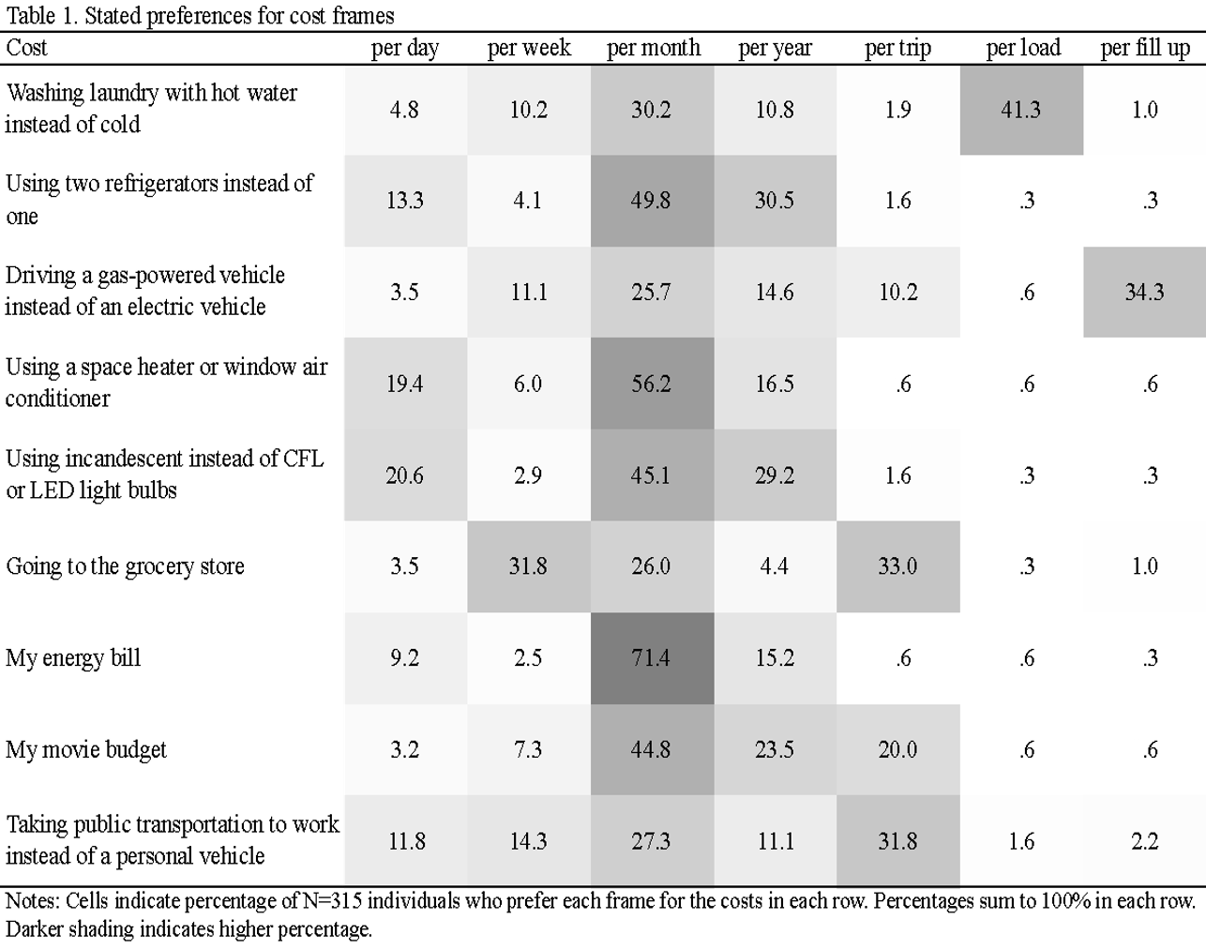

Figure 1.
Energy efficient behavior intentions by status quo condition and cost frame

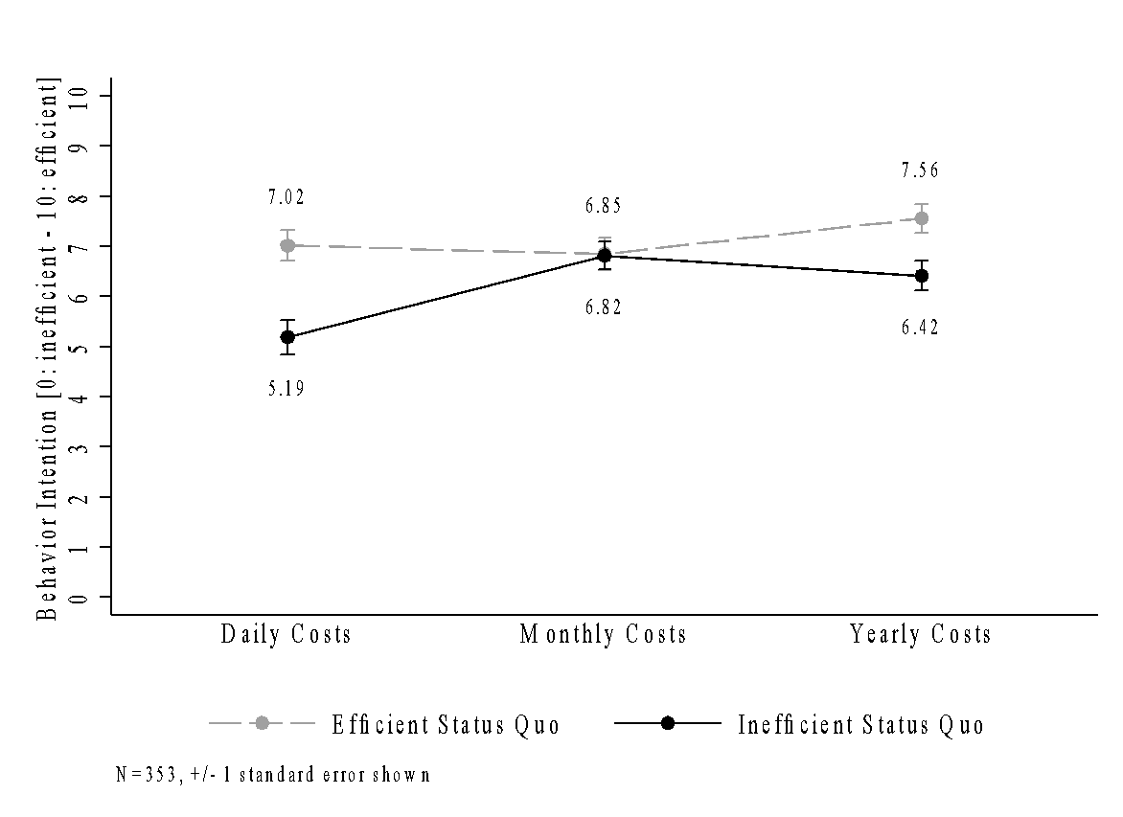
Notes. Figure illustrates intention to engage in energy efficient behavior as a function of status quo and assigned frame of costs or savings, averaged across scenarios in Study 1.

Figure 2.
Fluency by cost frame

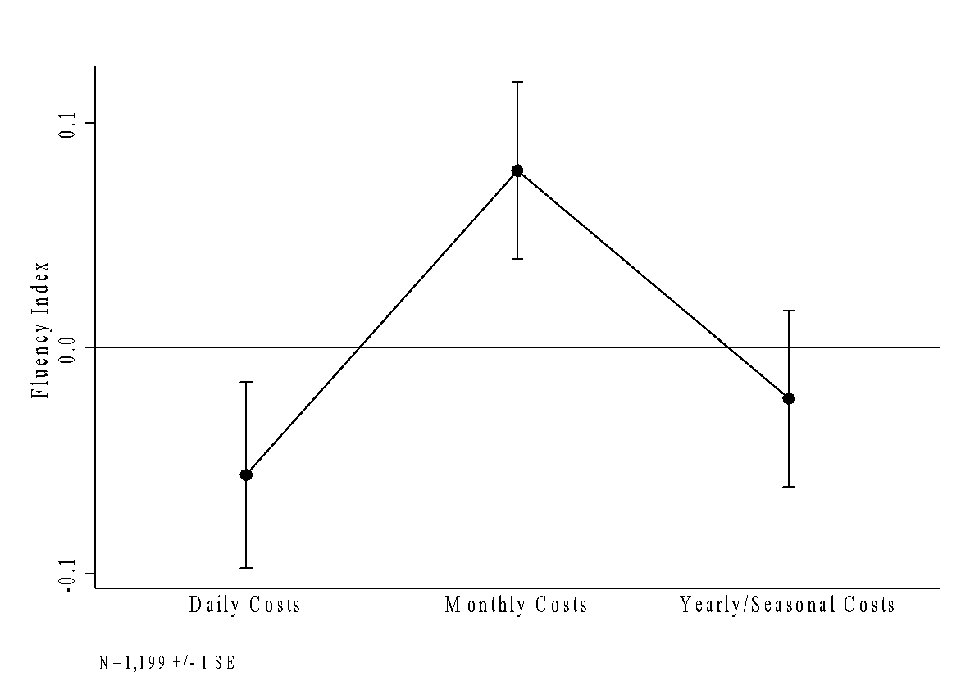
Notes: Figure illustrates Cronbach’s alpha of fluency measures by cost frame in Study 2.

Figure 3.
Stated preference for cost frame
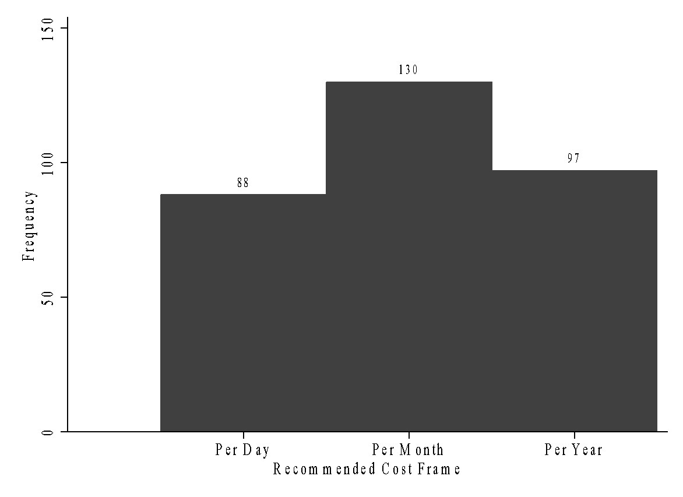
Notes: Figure shows number of individuals who recommended each cost frame. N=315

Figure 4.
Energy meter context and cost sticker

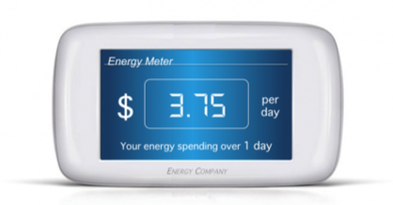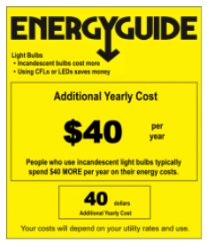
Notes: Participants saw the above images depicting typical energy spending (left) and costs of energy-inefficient choice alternatives (right). Energy meters showed daily and yearly frames ($3.75 per day, $1,370 per year). Cost labels showed daily and yearly frames ($0.11 per day, $40 per year).

Figure 5.
Energy efficient behavior intention cost frame and total expenditure context

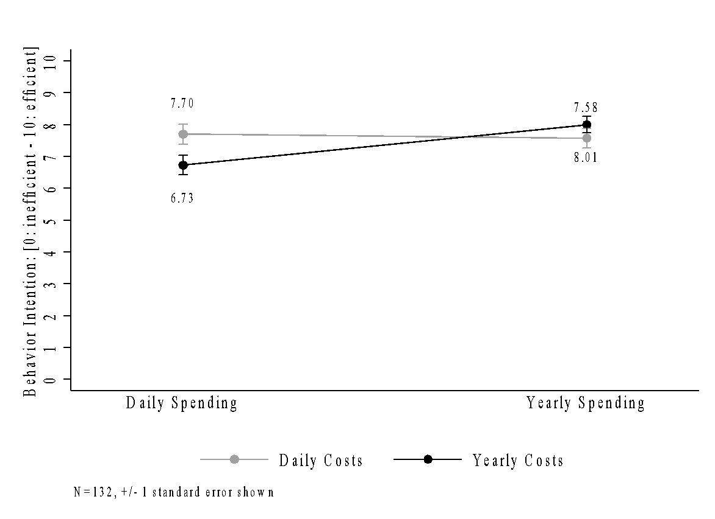
Notes: Figure shows intention to engage in the energy-efficient alternative by cost and context condition in Study 4. Measures of energy efficiency intentions were highest when an explicit context for typical energy spending was provided in a frame that matched the frame of cost of energy-inefficient choices.

Appendix A: Sample slider measuring energy-efficient behavior intention

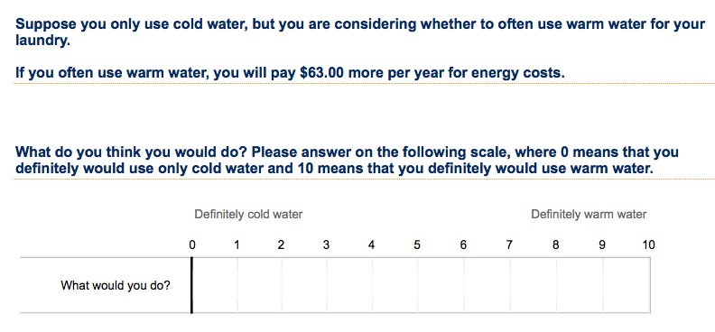

Note: Slider was anchored at 5. Responses were reverse coded (definitely energy efficient choice = 10, definitely energy inefficient choice = 0).

Appendix B: Full text of scenarios used in main analysis of Study 1
Scenario: Laundry
Scenario description
When doing the laundry, you can choose what water temperature your washing machine uses. Some people choose to use warm or hot water because they think warmer water is most effective for cleaning laundry. However, warm and hot water use more energy than cold water.

Status quo manipulation
For this scenario, suppose you often use [warm/cold] water.

Status quo condition check
This scenario asks you to assume that you currently use a certain type of water. What temperature is the water in this scenario?
- warm
- cold

Suppose you often use [warm/cold] water, but you are considering whether to use [cold/warm] water for your laundry.

Cost frame manipulation
If you always use cold water, you will save 17 cents per day on energy costs.
If you always use cold water, you will save $5.25 per month on energy costs.
If you always use cold water, you will save $63.00 per year on energy costs.
If you often use warm water, you will pay 17 cents more per day for energy costs.
If you often use warm water, you will pay $5.25 more per month for energy costs.
If you often use warm water, you will pay $63.00 more per year for energy costs.

What do you think you would do? Please answer on the following scale, where 0 means that you definitely would use only cold water and 10 means that you definitely would use warm water.

Scenario: Second refrigerator
Scenario description
Many homes have a second fridge or freezer. They are typically used for additional food storage or convenience, and are typically located in a garage, basement or another room in the house. Suppose you own a second fridge, and are deciding what to do with it. If it's plugged in, you can use it to keep things cold, but you must pay for its energy costs. If it's not plugged in, it you can store it in the house, give it away or sell it.

Status quo manipulation
For this scenario, suppose you own a second fridge and your second fridge is [plugged in/not plugged in].

Status quo condition check
This scenario asks you to assume something about your fridge. In the scenario, is it currently plugged in?
Yes, it is plugged in
No, it is not plugged in

Suppose you are considering whether to disconnect [connect] a second fridge in your home.

Cost frame manipulation
If you disconnect the second fridge, you will save 33 cents per day on energy costs.
If you disconnect the second fridge, you will save $10.00 per month on energy costs.
If you disconnect the second fridge, you will save $120.00 per year on energy costs.
If you connect the second fridge, you will pay 33 cents more per day on energy costs.
If you connect the second fridge, you will pay $10.00 more per month on energy costs.
If you connect the second fridge, you will pay $120.00 more per year on energy costs.

What do you think you would do? Please answer on the following scale, where 0 means that you definitely would disconnect the fridge and 10 means that you definitely would connect the fridge.

Appendix C: Main analysis of Study 1 using all five scenarios
Figure 1A shows mean behavior intention averaged across all five scenarios. In an ANOVA, there were main effects of status quo (F(1, 347) = 6.67, p = .0102), temporal frame (F(2, 347) = 8.38, p = .0003), and the interaction (F(2, 347) = 18.34, p = .0607). In the daily condition, participants preferred efficient behaviors more strongly when that was already their status quo, (t(113) = 2.465, p = .015, d = .460). Likewise, participants in the yearly condition also showed statistically significant differences in their behavior intentions, in line with their assigned status quos, (t(117) = 2.337, p = .0211, d = .429). However, participants assigned to the monthly frame showed no difference in behavior intention as a function of status quo, (t(117) = .449, p = .654, d = .0824).
The results from this analysis are consistent with those presented in the main paper. Additional scenarios include decisions about whether to shower with warmer or cooler water, ride the bus to work or commute using a personal vehicle, and whether to use a space heater or window air conditioning unit (based on each individual’s response to a question about which is more applicable to them).

Figure 1A. Energy efficient behavior intention averaged across five scenarios by status quo condition and cost frame
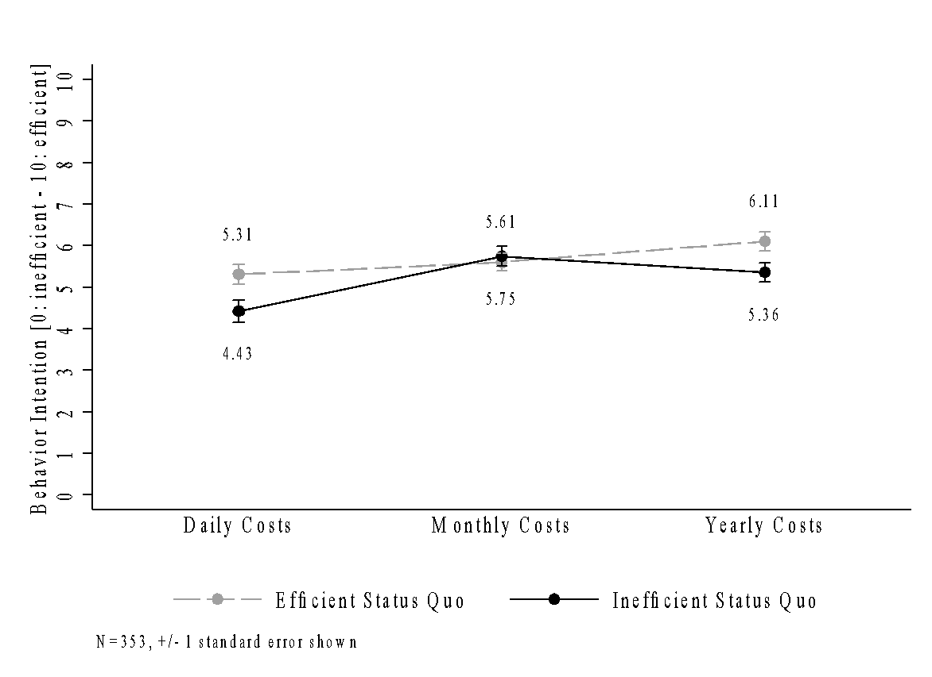
Appendix D: Independent measures and scale construction used in Study 1
Cognitive reflection and numerical ability items were taken from Atlas and Bartels (2017), based originally on Frederick (2005) and Lipkus, Samsa, and Rimer (2001). Scale was constructed as the proportion of correct responses (mean = .40, sd = .28, min = 0, max = 1). Similarly, we measured construal level using the four items in Atlas and Bartels (2017) originally from Vallacher and Wegner’s (1989) 24-item Behavioral Identification Form. Scale was constructed as the proportion of abstract descriptions (mean = .60, sd = .22, min = 0, max = 1). We constructed a scale about environmental concern using four measures. Together, these measures had a Cronbach’s $α$ of .866 and ranged from -2.4 to 1.6 (mean = 0, sd = .84).
Typical Energy Spending
Approximately how much did you spend on your energy bill last month?
- $0
- $1-50
- $51-100
- $101-200
- $201-300
- $301-400
- $401-500
- $501+
- I don’t remember

Actual status quo
Please identify how often you do the following behaviors:
[measured on a 5-point Likert scale from Always – Never]
- Wash my clothes using only cold water
- Use a second refrigerator in my home
- Shower using cooler water
- Take a bus to work
- Use a personal vehicle to commute to work
- Use a window AC unit in my home
- Use a space heater in my home

Perceived discomfort or inconvenience
How much discomfort, inconvenience, or effort would you experience following each of the following behaviors?
[measured on a 4-point Likert scale from Severe – Little to none]
- Always washing clothes in cold water (instead of using warm or hot water)
- Removing a second refrigerator from the home
- Always shower using cool or cold water (instead of warm or hot water)
- Using public transportation instead of a personal vehicle
- Removing a window AC unit from one room in my home
- Removing a space heater from your home

Environmental concern
Please select the option that best describes your opinion:
[measured on a 5-point Likert scale from Strongly agree – Strongly disagree]
- I care about the environmental impact of my energy choices
- I frequently think about the environmental impact of my energy choices
- I am an environmentally conscious person
- I value how environmentally conscious I appear to others

Cognitive reflection and numerical ability
Next we will ask you a few brain teasers. Please answer the following as best you can. [Correct answers in parentheses.)
- A bat and a ball cost $1.10 in total. The bat costs $1.00 more than the ball. How much does the ball cost? (5 or 0.05)
- In a lake, there is a patch of lilypads. Everyday, the patch doubles in size. If it takes 48 days for the patch to cover the lake, how long would it take for the patch to cover half the lake? (47)
- A 21 page album contains 480 photos. Each page displays either 18 large photos or 24 small photos. How many pages display small photos? (17)
- In the ACME PUBLISHING SWEEPSTAKES, the chance of winning a car is 1 in 1,000. What percent of tickets of ACME PUBLISHING SWEEPSTAKES win a car? (0.1)
- Suppose you have a close friend who has a lump in her breast and must have a mammogram. Of 100 women like her, 10 of them actually have a malignant tumor and 90 of them do not. Of the 10 women who actually have a tumor, the mammogram indicates correctly that 9 of them have a tumor and indicates incorrectly that 1 of them does not have a tumor. Of the 90 women who do not have a tumor, the mammogram indicates correctly that 81 of them do not have a tumor and indicates incorrectly that 9 of them do have a tumor. The table below [omitted here] summarizes all of this information. Imagine that your friend tests positive (as if she had a tumor), what is the likelihood that she actually has a tumor? (Please enter a percent.) (50)

Construal level
[Concrete (versus abstract) items are denoted with a *.]
Any behavior can be described in many ways. For example, one person might describe a behavior as “writing a paper,” while another person might describe the same behavior as “pushing keys on the keyboard.” Yet another person might describe it as “expressing thoughts.” This form focuses on your personal preferences for how a number of different behaviors should be described. Below you will find several behaviors listed. After each behavior will be two different ways in which the behavior might be identified. For example:
1. Attending class
a. sitting in a chair
b. looking at a teacher
Your task is to choose the option, a or b, that best describes the behavior for you. Simply select the option you prefer. Be sure to respond to every item. Please mark only one alternative for each pair. Remember, mark the description that you personally believe is more appropriate for each pair.
- Making a list
- a. Getting organized
- b. Writing things down*
- Voting
- a. Influencing the election
- b. Marking a ballot*
- Taking a test
- a. Answering questions*
- b. Showing one’s knowledge
- Eating
- a. Getting nutrition
- b. Chewing and swallowing*

Loss aversion
Consider a bet based on the toss of a (fair) coin. If the coin turns up heads then you win $20, and if the coin turns up tails you lose $2. Would you make this bet? For each of the following bets, please indicate if you would make the bet:
[individuals selected “yes” or “no”]
- HEADS: win $20 – TAILS: lose $2
- HEADS: win $20 – TAILS: lose $5
- HEADS: win $20 – TAILS: lose $10
- HEADS: win $20 – TAILS: lose $15
- HEADS: win $20 – TAILS: lose $20
- HEADS: win $20 – TAILS: lose $25

Appendix E: Full text of scenarios used in main analysis of Study 2
Individuals saw one of the following scenario descriptions
- Most people shower in temperatures ranging from 115 degrees (very hot) to around 65 degrees (cold). While many people find warmer showers to be more pleasant than cooler showers, warmer showers cost more than cooler showers.
- Suppose you live near a bus route that is convenient for your work commute and you also own a car. You must decide whether to drive or take the bus to work every day. If you take the bud your commute will take 20-30 minutes longer. Driving a personal vehicle to and from work is more convenient than the bus, but you must pay for the additional fuel cost.
- Most lamps and lighting fixtures are compatible with incandescent light bulbs, LEDs and CFL (compact fluorescent) light bulbs. Some people choose to use incandescent light bulbs because they prefer the color and tone of their light. However, incandescent light bulbs use more energy than LED and CFL light bulbs.
- Many homes have an air conditioner (AC) installed in a window to keep a room cool during the hot months. Suppose you own a window AC unit, and are deciding what to do with it. If you don’t use it you can store it in the house, give it away, or sell it. If you use it, the air conditioner will help you keep the room cool during the summer, but you must pay the energy costs.
- Many homes have a portable space heater to keep a room warm during the colder months. Suppose you own a portable space heater, and are deciding what to do with it. If you don’t use it you can leave it unused in the house, give it away, or sell it. You can use it to keep the room warm during the winter, but you must pay the energy costs.

Status quo manipulation and check
For this scenario, suppose you currently [do the energy efficient/inefficient alternative]. This scenario asks you to assume that you currently [do a certain type of behavior]. What is [the behavior]?
- Example: For this scenario, suppose you currently use cooler water to shower. This scenario asks you to assume that you currently use a certain type of water. What temperature is the water in this scenario?
  - warmer
  - cooler

Cost manipulation
Suppose you currently [do the energy efficient/inefficient alternative]. You are considering switching to [do the other alternative]. If you [do the alternative] you will [pay/save] $x per [day/month/year] on energy costs.
- Example: Suppose you currently shower using warmer water. You are considering switching to take showers using 15 degrees cooler water. This would be a noticeable, but not painful, difference in water temperature. If you use cooler water, you will save 12 cents per day on energy costs.

Dependent measure
What do you think you would do? Please answer on the following scale, where 0 means that you definitely would take cooler showers and 10 means that you definitely would take warmer showers. (note: reverse code)

Fluency measures [7-point Likert scale from Very Difficult – Very Easy]
- Estimating how the energy decision would financially impact me was…
- Understanding what the energy decision meant was…
- The description of the financial impact seemed…
- The description of the energy decision seemed…

Involvement [7-point Likert scale from Not at all involved – Very involved]
- How involved were you in the energy decision?

Concern about money [5-point Likert scale from Not at all – A lot]
- How much do you care about saving money?

Concern about environment [5-point Likert scale from Not at all – A lot]
- How much do you care about saving the environment?

Appendix F: Text used in main analysis of Study 3
Recommended cost frame
Now, suppose that in your neighborhood, most of your neighbors have energy meters in their houses. The meters have different settings for how to display energy costs. You know that all of your neighbors have left the meter on its default setting, which displays household energy expenses in the same way as the meter below.
[energy meter] Energy spending is [$3.75 per day/$114 per month/$1,370 per year]

Write a sentence or two describing the energy meter that your neighbors see, including how much they typically spend on their home energy.
[open-ended response]

Suppose a neighbor is designing a flyer to tell other households in your neighborhood about the costs of various energy-related choices at home, similar to the yellow label you saw in the previous scenario.

Your neighbor wants to ensure that the costs are easy to understand, and asks for your suggestions on the following ways to describe the costs. Please rate each description below.
[7-point Likert scale: Doesn’t make any sense at all – Makes complete sense]
- “… costs $0.10 per day”
- “… costs $3.10 per month”
- “… costs $36.50 per year”

Which description would you recommend that your neighbor use? [multiple choice selection]
- “… costs $0.10 per day”
- “… costs $3.10 per month”
- “… costs $36.50 per year”

Preferred frame
Suppose you were designing a label like the yellow label you saw before. You want to convey the costs of various household activities and alternatives so that your neighbors understand the costs easily. To do this, you want to describe costs in a way that seems the most natural.

For example, you might say that eating at a restaurant instead of buying groceries costs $50 more per week or $200 more per month. Or you might say that leaving the lights on at home all day instead of turning them off costs $1 more per day or $0.20 more per lamp.

Please select the description that you think makes the most sense for each activity below. There is no right or wrong answer – just select the choice that makes the most sense to you.
[multiple choice; frames include cost per day, cost per week, cost per month, cost per year, cost per trip, cost per load, cost per fill-up]
- My movie budget
- Using a space heater or window air conditioner
- Driving a gas-powered vehicle instead of an electric vehicle
- Using incandescent light bulbs instead of LED or CFL bulbs
- Going to the grocery store
- Taking public transportation to work instead of driving my own car
- My energy bill
- Washing laundry with hot water instead of cold water
- Using two refrigerators instead of one

Appendix G. Behavior Intentions in Study 2
Figure 2A presents behavior intentions by status quo condition and cost frame. There were main effects of status quo, (F(1, 1193) = 6.63, p = .010), temporal frame, (F(2, 1193) = 6.75, p = .001), but not the interaction, (F(2, 1193) = 0.24, p = 0.787). In the daily condition, participants preferred efficient behaviors more strongly when that was already their status quo, (t(400) = 2.064, p = .040, d = .206). Participants assigned to the monthly frame showed no difference in behavior intention as a function of status quo, (t(398) = 1.256, p = .210, d = .126). Participants in the yearly condition also showed statistically insignificant differences in their behavior intentions, (t(395) = 1.147, p = .252, d = .115).

Figure 2A. Behavior intentions by status quo condition and cost frame
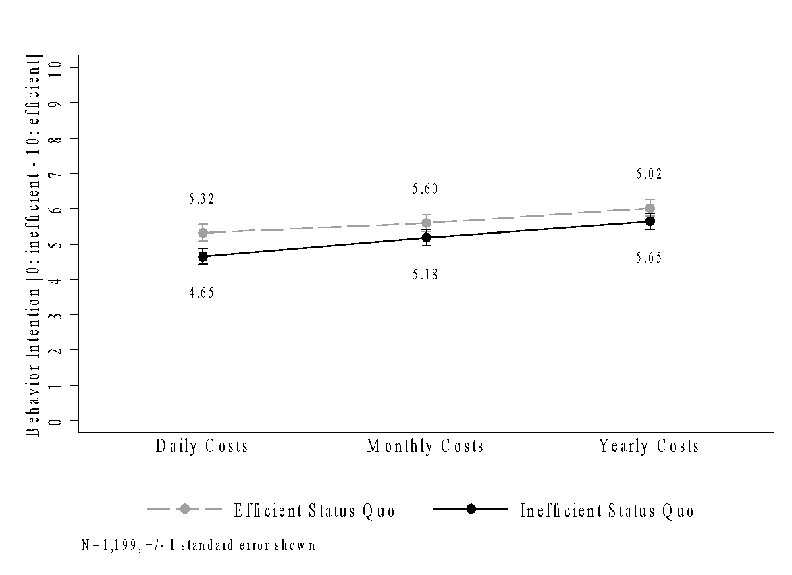

Appendix H. Behavior Intentions in Study 4
Figure 3A presents behavior intention across daily, monthly, and yearly cost and context (spending) conditions. We exclude monthly treatment conditions in the main analysis.

Figure 3A: Behavior intentions by cost and context condition
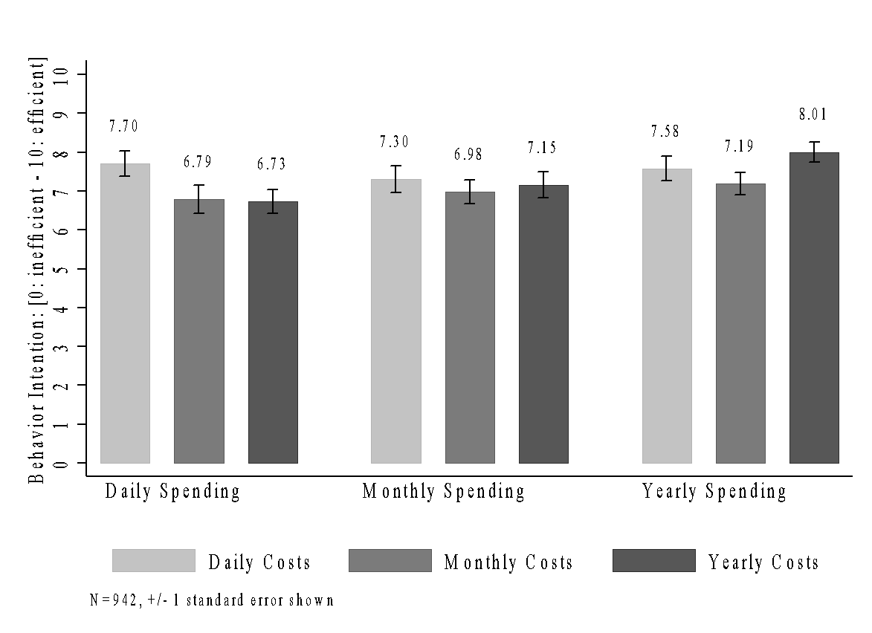

Though consumers may react differentially to the connection between pro-environmental preferences and fuel economy based on political ideology (Gromet et al., 2013).
Many detergents are formulated for use in cold water. If individuals have a strong preference for washing laundry with hot water, this preference should be equal in each experimental condition, and therefore this effect is orthogonal to our hypotheses.
Two individuals failed a survey-level attention check. Exclusion of these individuals from analysis does not substantially alter results.
The study included three additional scenarios whose results were discarded due to concerns about participant fatigue and quality of data. Full text of scenarios is included in the Appendix, as are similar results for analysis using all scenarios.
Measures of construal level, cognitive reflection and numeracy, loss aversion, and environmental concern are included in the Appendix, as are additional methodology details about scale construction.
Text of the scenarios and additional measures are provided in the Appendix.
We present results for behavior intention by status quo condition and cost frame in Appendix G.
Full text provided in the Appendix.
Some participants were instead assigned to monthly frames of typical spending context and costs of energy-inefficiency which was not presented here due to concerns about unintentionally prompting individuals. Behavior intention results from all conditions are presented in Appendix H.

