Good or bad, we want it now: Present bias for gains and losses explains magnitude asymmetries in intertemporal choice

David J. Hardisty, Kirstin C. Appelt, Elke U. Weber
Columbia University

Author Note: Please address correspondence to David Hardisty, Department of Psychology, 406 Schermerhorn Hall, 1190 Amsterdam Ave MC 5501, New York NY 10027, djh2117@columbia.edu, Tel: (212) 203-7520. Support for this research was provided by National Science Foundation Grants SES-0345840 and SES-0820496 to the Center for Research on Environmental Decisions. The authors would also like to thank Jake Lippman for assistance with the design and data collection for Study 1.
Abstract
Two studies investigated the joint effects of outcome sign (gains vs. losses) and outcome magnitude (small vs. large) on delay discount rates. Whereas rational-economic theory predicts that neither sign nor magnitude of outcomes should affect discounting, different psychological mechanisms predict different patterns of main effects and interactions. Study 1 replicates the well-established magnitude effect for gains, showing that large ($1,000) gains are discounted less than small ($10) gains, but also suggests that losses may show the opposite pattern, with small losses discounted less than large losses. Study 2 firmly establishes this pattern of results and provides process data implicating present bias in both the gain and loss decisions. Present bias is well established for gains and has traditionally described a prepotent preference for immediate rewards in order to satisfy the desire for obtainable gains (i.e., desire to have gains now). Our results establish present bias also for losses, where it describes a prepotent preference for immediate losses in order to preclude the need to attend to future losses (i.e., desire to have losses over with now). Present bias predicts increased discounting of future gains, but decreased (or even negative) discounting of future losses. Since present-bias feelings do not seem to scale with the magnitude of possible gains and losses, they play a larger role, relative to other motivations for discounting, for small magnitude intertemporal decisions than for than for large magnitude intertemporal decisions. This suggests that policy efforts to encourage future oriented choices should frame outcomes as large gains or small losses.
Good or bad, we want it now: Present bias for gains and losses explains magnitude asymmetries in intertemporal choice
Whether racking up credit card debt, eating unhealthy foods, or acting in environmentally destructive ways, people often discount future consequences, wanting to have gains immediately and to postpone losses until later. In general, the farther into the future that an outcome is delayed, the more it is discounted. There are a number of factors hypothesized to contribute to the discounting of future gains (for overviews, see Frederick, Loewenstein, & O'Donoghue, 2002; Hardisty, Orlove, Small, Krantz, & Milch, working paper). A reason often noted by economists is opportunity cost: one could take the immediate $100, invest it, and have more than $101 in a year's time (Franklin, 1748; Samuelson, 1937). A second reason to discount the future is uncertainty (Prelec & Loewenstein, 1991; B. J. Weber & Chapman, 2005). For example, if offered a choice between getting $100 now or $101 in a year, one may value the $100 more because it is a sure thing, whereas the future is inherently uncertain. A third reason is resource slack (Zauberman & Lynch, 2005): most people believe that, although money is tight right now, they will have more resources in the future, so it is more useful to have the money immediately rather than later. A fourth reason to discount the future is present bias (Laibson, 1997; O'Donoghue & Rabin, 1999): people are often impatient to have gains immediately, for no rational reason.
One well-established empirical observation about discounting is the so-called "magnitude effect", that people discount small gains at a higher rate than large gains (Baker, Johnson, & Bickel, 2003; Benhabib, Bisin, & Schotter, 2010; Chapman, 1996; Chapman & Elstein, 1995; Estle, Green, Myerson, & Holt, 2006; Giordano et al., 2002; Green, Myerson, & McFadden, 1997; Kirby & Marakovic, 1995; Kirby & Marakovic, 1996; Petry, 2001; Ranieri & Rachlin, 1993; Thaler, 1981). For example, someone might choose $10 today versus $11 in a month, yet prefer to wait for $11,000 in a month rather than take an immediate $10,000, even though in both cases the later amount is 110% of the sooner amount. Two explanations for this magnitude effect are mental accounting and fixed-cost present bias.
According to the mental accounting theory (Loewenstein & Thaler, 1989), people may discount small gains more steeply because small and large gains activate different mental accounts for which different discount rates may exist. When considering a small gain, people think of it as spending money, whereas when they consider a large gain, they think of it as a potential investment. Thus, small amounts are associated with immediate consumption accounts and their typically high discount rates, whereas large amounts are associated with long-term savings accounts and their typically lower discount rates.
According to the theory of fixed-cost present bias (Benhabib, et al., 2010), people's desire to have good things right away (i.e., their present bias) appears to be worth about $4 to them, regardless of the size of the outcome under consideration or the length of the delay. As a consequence, people's impatience weighs much more heavily (in relative terms) when outcomes are small than with outcomes are large; in the context of $10 now versus $11 in a month, $4 worth of impatience is a lot, but in the context of $10,000 now versus $11,000 in a month, $4 worth of impatience is not very important.
Unfortunately, although both these theories are plausible explanations for why people might show lower discount rates for larger gains, neither can easily explain people's time preferences for small and large losses. The vast majority of studies of intertemporal choice have focused exclusively on current versus future gains, but it turns out that losses may not show the magnitude effect (Baker, et al., 2003; Estle, et al., 2006). Participants in one study showed similar discount rates for $100 losses as for $100,000 losses (Estle, et al., 2006), and participants in another study showed almost no difference in discount rates between losses of $10, $100, and $1,000. These findings present a complication for the mental accounting theory. If small and large gains are considered in different accounts associated with different discount rates, why would not losses of different sizes go into different accounts with different discount rates as well? The theory of fixed-cost present bias also cannot explain this, as it predicts an equal magnitude effect for both gains and losses. Fixed-cost present bias theory predicts that people put a premium (of roughly $4) on having gains now, and a premium (again of roughly $4) on postponing losses. For example, when considering paying $10 immediately or $12 in one month, participants would be predicted to choose the future $12, because it is worth $4 to the participant to postpone bad things and only the payment of $2 additional dollars is incurred by waiting. In contrast, when choosing between $1,000 or $1,200 in one month, the same participant would be expected to choose the immediate $1,000, because the additional $200 lost from waiting is much greater than the $4 premium the participants puts on immediate welfare. In this way, Benhabib et al.'s theory predicts an equal magnitude effect for gains and losses. In both cases, it predicts lower discounting for larger amounts.
We propose an extension of present bias, in which people have a psychological desire to resolve both gains and losses immediately. In the case of gains, people want the gain immediately to satisfy their desire for positive outcomes. In the case of losses, people want to get the loss over with immediately to close their books on the loss and avoid having to allocate attention and emotional capacity (e.g., dread) to looming future losses. In both cases, we assume that this present bias is relatively insensitive to magnitude (as theorized and found by Benhabib et al., 2010, in the domain of gains). To explain further: as we consider when to receive or pay an amount, regardless of size, we have a desire to resolve the event immediately if possible. On a psychological level, we would like to have the gain now, and we would like to get the loss over with now. If the gain or loss is a small amount, such as $10, our desire to satisfy impatience or to avoid dread is a relatively important factor. If the gain or loss is a large amount, such as $10,000, we still have the desire to resolve the event as soon as possible, but our desire to satisfy impatience or to avoid dread is a relatively unimportant factor. Because $10,000 is a lot of money, other factors, such as uncertainty and resource slack, become more important considerations. See Table 1 for a summary of this idea. Thus, for gains we make identical predictions as Benhabib and colleagues (2010), however we make different predictions for losses.
Table 1
Summary of major factors hypothesized to determine intertemporal preferences for gains and losses of different sizes.
Motivational Factor | Description | Makes you prefer to have… | Causes discount rates to… | Scales with magnitude?
Uncertainty | Delayed gains and losses may never be realized | Gains now and losses later | Increase for gains and losses | Yes
Opportunity cost and investment | Resources can be invested and earn interest or otherwise grow over time | Gains now and losses later | Increase for gains and losses | Yes
Resource slack | Expecting to have more resources in the future means that immediate resources are more dear than future resources | Gains now and losses later | Increase for gains and losses | Yes
Present bias | Psychological desire to resolve events immediately | Both gains and losses now | Increase for gains, decrease for losses | No
Other factors, such as social norms and ideals | Variable, but often individuals are taught they ought to delay gratification | Variable, but often postponing gains and attending to losses immediately | Variable, but often a common goal is lower discount rates | Variable

Importantly, our theory predicts that negative discounting of losses should occur when amounts are small enough. Negative discounting implies that outcome values intensify (i.e., positives become more positive and negatives become more negative) the further they lie in the future; in the case of losses, negative discounting means a preference to have losses sooner rather than later. For example, some people might rather pay $10 immediately rather than $9 in a year, to satisfy their desire to get the loss over with. In this case, we should observe a full reversal of the magnitude effect when comparing small and large losses. Although this finding was not observed in existing studies on sign and magnitude (Baker, et al., 2003; Estle, et al., 2006), these studies did not in fact allow participants to express this preference. These studies always paired a smaller, sooner amount with a larger, later amount, so zero or negative discount rates were not possible.
In Study 1, therefore, we tested our prediction by presenting participants with choices between immediate and future gains and losses that were either small (around $10) or large (around $1,000). Importantly, we included choice options which allowed for negative discount rates, such as a choice between paying $10 immediately and $9 in the future. We predicted that whereas small gains would be discounted more than large gains, showing the usual magnitude effect, small losses would be discounted less than large losses, showing a reverse magnitude effect. We also expected losses to be discounted less than gains overall for the reasons mentioned above, as in previous studies on discount rates for gains and losses (Appelt, Hardisty, & Weber, working paper; Hardisty & Weber, 2009; Thaler, 1981).
Study 1
Method
A national sample of 58 participants (mean age=37, SD=13, 68% female) was recruited and run online through the virtual lab of the Center for Decision Sciences for a study on decision making. Participants were paid $7 for completing this and another study. In a 2x2 mixed design, each participant responded to two intertemporal choice scenarios, one gain and one loss, in counterbalanced order. Between subjects, participants were randomly assigned to scenarios with small or large magnitude outcomes, the same magnitude for both their gain and their loss choices.
In each scenario, participants made a series of eight hypothetical choices between a fixed immediate amount and a varying delayed amount available in six months (i.e., a choice titration was used). For example, in the small gain condition, participants were asked to choose between receiving $10 today and receiving $9 in six months, receiving $10 today and receiving $10 in six months, receiving $10 today and receiving $11 in six months, etc. The immediate amount was fixed at $10 in the small magnitude condition and $1,000 in the large magnitude condition. The delayed amounts varied from $9 to $500 and $900 to $50,000, respectively. For the complete list of choice options, see Appendix A. Hypothetical outcomes were used out of necessity, because it was not possible to execute real $50,000 losses with participants. Fortunately, several studies have shown that hypothetical intertemporal choice outcomes are consistent with and predict real outcomes (Bickel et al., 2010; Bickel, Pitcock, Yi, & Angtuaco, 2009; Chabris, Laibson, Morris, Schuldt, & Taubinsky, 2008; Shamosh et al., 2008).
Results
Data from 8 participants were excluded for careless responding, as determined by any of the following three criteria: switching back and forth on the intertemporal choice scale more than once (i.e., non-monotonic responding), perversely switching on the intertemporal choice scale (for example, choosing to receive $12 in six months rather than $10 today, and subsequently choosing $10 today rather than $14 in six months), or completing the study more than two standard deviations faster than the average natural log of completion time. This left data from 50 participants for further analysis (28 in the small magnitude condition, and 22 in the large magnitude condition).
Participants' responses were converted into intertemporal indifference pairs by taking the average of the values around the switch point. For example, if a participant chose to receive $10 today over $12 in six months, and chose $15 in six months over $10 today, then the participant was judged to be indifferent between receiving $10 today and $13.50 in six months. To easily compare discounting across magnitudes, indifference between choice options was converted into a discount rate, using the continuously compounded exponential formula V=Ae^{-kD} (Samuelson, 1937), where V is the immediately available amount (e.g., $10), A is the future amount (e.g.,, $13.50), e is the constant (2.718), D is the delay in years (e.g., 6 months = 0.5), and k is a fitted parameter, the discount rate.
As seen in Figure 1, discount rates varied considerably depending on whether participants were considering small or large gains or losses. Although small gains (mean discount rate=0.94, SD=1.03) were discounted significantly more than large gains (M=0.38, SD=.33), there was a non-significant trend for small losses (M=-.06, SD=.55) to be discounted less than large losses (M=.09, SD=.16). A 2x2 ANOVA with sign and magnitude predicting discount rates confirmed a main effect of sign as predicted, F(1,48)=37.0, p<.001, η²=.44; a sign by magnitude interaction as predicted, F(1,48)=11.5, p=.001, η²=.19; but no main effect of magnitude, F(1,48)=1.9, p>.1, η²=.04. Although a pairwise comparison of the small loss condition to the large loss condition did not find a significant difference, t(48)=1.3, p>.1, d=.44, sample sizes were somewhat small and the effect size was moderate, so results are inconclusive rather than indicating no difference at all. The paired comparison of large and small gains was significant, t(48)=2.5, p<.05, d=.82, demonstrating the classic magnitude effect.
Figure 1
Mean discount rates k for small and large gains and losses, in Study 1. Error bars indicate +/- one standard error.
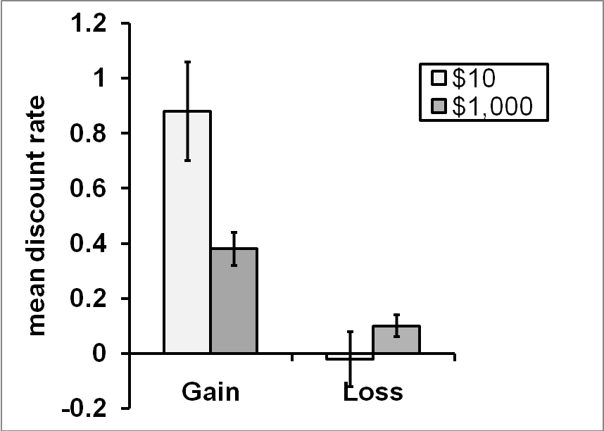
In concrete terms, participants considering small gains were indifferent on average between receiving $10 today and $16 in six months, whereas participants considering large gains were indifferent between receiving $1,000 today and $1,210 in six months. In contrast, participants considering small losses were indifferent between paying $10 today and $9.70 in six months, whereas those considering large losses were indifferent between paying $1,000 today and $1,070 in six months.
Notably, zero discounting and negative discounting were quite common in the small loss condition, but were fairly rare in the other conditions. Specifically, when faced with a choice between paying $10 immediately or $10 in six months, 50% of participants chose to pay immediately. In contrast, when considering large losses, only 22% expressed this preference, z=1.73, p<.10. When considering whether to receive $10 today or $10 in six months, only 11% chose the future option, and when considering $1,000 versus $1,000 in six months, 5% showed this preference.
Discussion
As predicted, there was an interaction between sign and magnitude in predicting discount rates; whereas small gains were discounted more than large gains, choices for losses eliminated or reversed this trend. As the evidence for the reversal with losses was weak, we decided to run a follow-up study with a larger sample size to see if this reversal would replicate.
Furthermore, we wanted to collect process data to test whether people's desire to resolve events immediately drives the reversal. To do this, we asked participants to list their thoughts about the intertemporal choice scenario, before they made any choices, using an established "type aloud" protocol (E. U. Weber et al., 2007). Subsequently, after making their choices, we presented participants' own thoughts back to them, and asked them to code the content of each thought. As summarized in Table 1 (above), we predicted that concerns about uncertainty and resource slack would grow more important for larger amounts, and therefore that mentions of wanting to have the gain or loss immediately for other, psychological reasons (i.e., present bias) would be proportionally less common with larger magnitudes. In other words, a fixed-cost present bias does not scale up with larger magnitudes, and so becomes proportionally less influential. We predicted that the relative frequency of these present-biased thoughts would mediate the effect of magnitude on discount rates, in opposite directions for gains and losses. In other words, we predicted that present bias would make participants desire to resolve gains immediately and losses immediately, which results in greater discount rates for gains and lower discount rates for losses. With increased magnitude, the influence of present bias is reduced, which changes discount rates accordingly (see Figure 6 for a summary).
Study 2
Method
A sample of 224 US residents (mean age=37, SD=12, 76% female) was recruited and run online in the same manner as Study 1. Participants were compensated $8 for completing this study and two unrelated studies. In a 2x2 between-subjects design, participants were randomly assigned to one of four conditions: small gain, large gain, small loss, or large loss. We ran this as a between-subjects design for two reasons. One was to maximize the asymmetries in discounting observed in Study 1 between small and large gains and losses, to see if the reversal of the magnitude effect could be replicated. The second reason was because the quality and quantity of thought listings often go down sharply after the first scenario participants complete.
Participants first received training with the computerized "type aloud" interface, in which participants entered one thought at a time. Participants in the small [large] gain conditions then read the following passage:
Imagine there was a legitimate error on your back taxes in your favor, and you will immediately receive $10 [$10,000] from the government. However, they are also giving you the option of receiving a different amount one year from now, instead. How much would the future amount need to be for you to choose it? The amount you would receive today is $10 [$10,000]. The amount you would receive in the future ranges from $9 [$9,000] to $35 [$35,000]. We will ask you several questions about whether you would prefer to get $10 [$10,000] today or another amount one year from today.
Participants in the small [large] loss conditions read:
Imagine there was a legitimate error on your back taxes against you, and you must pay the government $10 [$10,000] immediately. However, they are also giving you the option of paying a different amount one year from now, instead. How much would the future amount need to be for you to choose it? The amount you would pay today is $10 [$10,000]. The amount you would pay in the future ranges from $9 [$9,000] to $35 [$35,000]. We will ask you several questions about whether you would prefer to pay $10 [$10,000] today or another amount one year from today.
All participants then listed their thoughts about the scenario, following the instruction:
Before you indicate your preference for these choices, please tell us everything you are thinking of as you consider this decision between receiving [paying] $10 [$10,000] today or receiving [paying] a larger amount in one year.
We would like you to list any thoughts, both positive and negative, that you might have about this decision. We will ask you to enter your thoughts one at a time.
Subsequently, participants made a series of ten choices between a fixed immediate amount and a varying later amount, similar to Study 1. The immediate amount was always $10 [$10,000], and the future amount ranged from $9 [$9,000] to $35 [$35,000]. The future amount was always one year in the future. For the complete list of choices, please see Appendix B.
After that, participants were presented with the thoughts they had listed earlier, one at a time, and asked to code each thought as to whether the primary topic of the thought was "Earning interest on investments" (i.e. opportunity cost), "Future uncertainty" (i.e. uncertainty), "Expecting the money will be more useful now than in the future" (i.e. resource slack), "Other: what you want (for example, 'I want it now to get it over with')" (i.e. present bias), "Other: what you ought to do (for example, 'I should wait')" (i.e., social norms) or "None of the above." These categories correspond to the factors presented in Table 1 (above). Participants also coded whether the thought favored choosing the immediate option or the future option. Finally, participants answered demographics.
Results
The data from 25 participants were excluded because of careless responding, using the same criteria as in Study 1 and leaving data from 199 participants for analysis. We converted choices to indifference points and discount rates, again using the same procedure as for Study 1.
As summarized in Figure 2, participants' discount rates depended both on the sign and magnitude of the outcome, replicating the results of Study 1. Although participants discounted small gains (mean k =.51, SD=.45) more than large gains (M=.29, SD=.31), they discounted small losses (M=-.06, SD=.14) less than large losses (M=.07, SD=.17). This was confirmed with a 2x2 ANOVA using sign and magnitude to predict discount rates, which revealed a main effect of sign, F(1,195)=86.4, p<.001, η²=.31; and a sign by magnitude interaction, F(1,195)=17.5, p<.001, η²=.08; but did not find evidence for a main effect of magnitude, F(1,195)=1.1, p>.10, η²=.01. Pairwise comparisons within each sign between small and large outcomes confirmed the magnitude effect for gains, t(101)=2.9, p<.01, d=.58, and the reverse magnitude effect for losses, t(94)=4.2, p<.001, d=.87.
- In dollar terms, participants were on average indifferent between receiving $10 immediately and $16.60 in one year (i.e., when considering small gains), but $10,000 immediately and $13,310 (i.e., when considering large gains). In contrasts, participants were indifferent between losing $10 immediately and $9.42 in one year (i.e., when considering small losses), but $10,000 immediately and $10,740 in one year (i.e., when considering large losses). As in Study 1, zero and negative discount rates were extremely common when considering small losses, with 78% of participants expressing this preference. In contrast, only 23% of those considering large losses, 2% of those considering small gains, and 2% of those considering large gains showed zero or negative discount rates.
Figure 2
Mean discount rates k for small versus large gains and losses, in Study 2. Error bars show +/- one standard error.
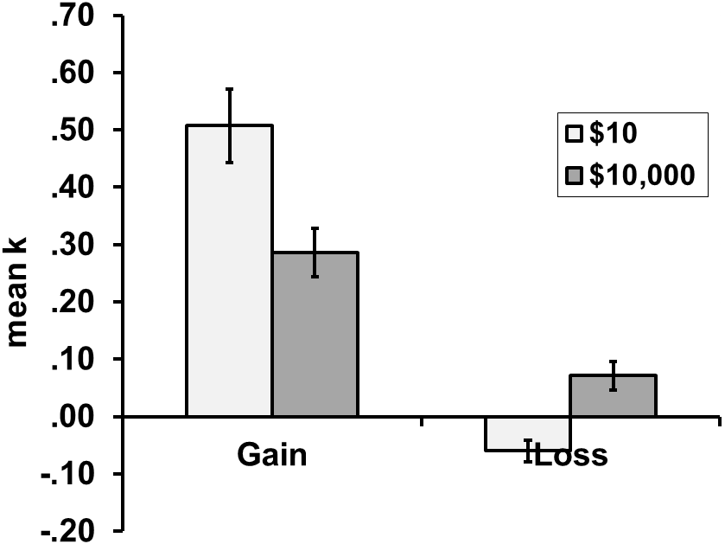
Prior to making their choices, participants listed an average of 3.4 thoughts (SD=2). Participants considering large magnitude outcomes listed 0.6 more thoughts than participants considering the small outcome, t(197)=2.1, p<.05, d=.15. This is consistent with the theory that most intertemporal motivations grow more pressing with larger magnitudes. The number of thoughts listed did not vary between gains and losses, nor was there an interaction. The number of thoughts coded as falling into the different types of thought categories described above differed depending on whether the intertemporal choice considered was between small or large gains or losses. We used the proportion of thoughts a decision maker classified as both "Other: what you want (for example, 'I want it now to get it over with')" and as favoring the immediate option as a measure of the relative prevalence of present-biased thoughts. An example of a present-biased thought provided by a participant was, "I like to manage situations that arise in my life as quickly as I can, regardless of the conditions/content."
As seen in Figure 3, the relative frequency of present-biased thoughts was significantly lower for large magnitude outcomes. A 2x2 ANOVA with sign and magnitude predicting proportion of present bias thoughts found significant main effects of magnitude, F(1,195)=8.3, p<.01, η²=.04; and sign, F(1,195)=14.9, p<.001, η²=.07; but not an interaction, F(1,195)=.88, p>.10, η²=.01.
Figure 3
Mean proportion of present bias thoughts, depending on the sign and magnitude of the outcomes, in Study 2. Error bars show +/- one standard error.
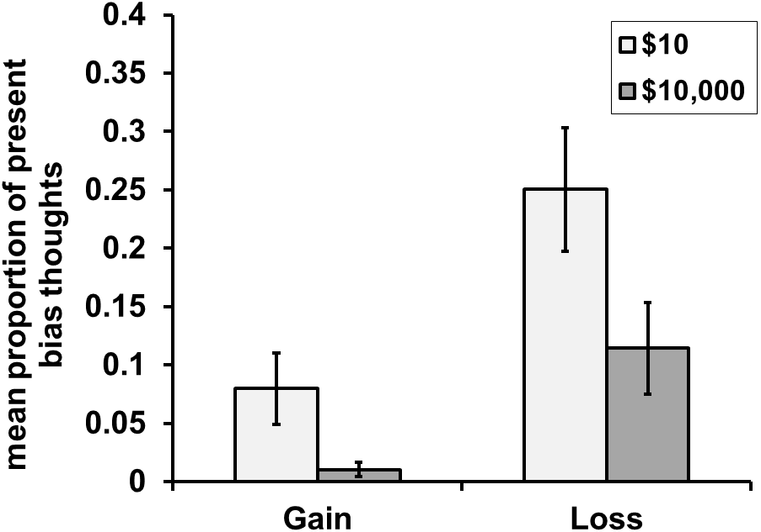
- In contrast, the relative frequency of other concerns such as future uncertainty and resource slack grew larger with larger magnitude outcomes, as seen in Figure 4 and Figure 5. A 2x2 ANOVA with sign and magnitude predicting proportion of thoughts about future uncertainty found a main effect of magnitude, F(1,195)=7.8, p<.01, η²=.04, but no evidence for a main effect of sign or an interaction. Similarly, an ANOVA predicting thoughts about resource slack found a marginally significant effect of magnitude, F(1,195)=3.7, p<.10, η²=.02, but no evidence for a main effect of sign or an interaction. Refer back to our new figure to make the point that only present-biased thoughts can possibly mediate the choice pattern we observed.
Figure 4
Mean proportion of thoughts about uncertainty, depending on the sign and magnitude of the outcomes, in Study 2. Error bars show +/- one standard error.
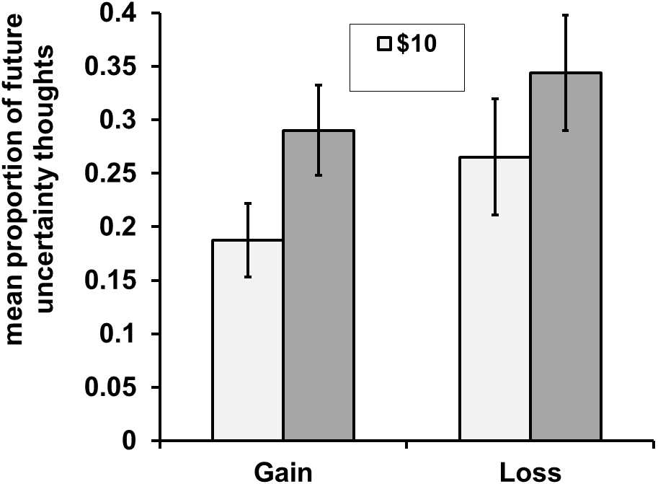
Figure 5
Mean proportion of thoughts about resource slack, depending on the sign and magnitude of the outcomes, in Study 2. Error bars show +/- one standard error.
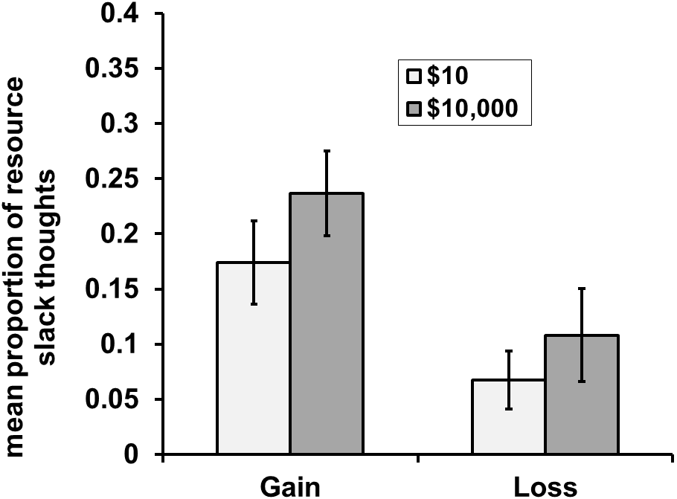
Finally, through mediation models, we tested whether the proportion of "want now" thoughts explain how sign and magnitude interact to predict discount rates, as summarized in Figure 6. We ran two separate mediation models, one for gains and one for losses. For both gain and loss choices, larger magnitude outcomes lead to a lower proportion of "want now" thoughts, and in both cases, the proportion of "want now" thoughts predicted discounting while controlling for magnitude (thus following the standard mediation model). However, as predicted and described above, the direction of the relationship between "want now" thoughts and discounting is opposite for gains and losses: more want now thoughts were associated with greater discounting of gains, but lower discounting of losses. Both mediation models were significant at p<.05, using a bootstrapping test with 10,000 replications, following the guidelines of Shrout & Bolger (2002). However, effect sizes were generally small (standardized betas in the range of .2 to .25), and the mediation was clearly only partial in both cases.
Figure 6
Mediation diagrams showing magnitude having an effect on discount rates through "want now" thoughts, separately for gains and losses, in Study 2. βs show standardized betas. Note, that the relationship between "want now" thoughts and discounting is positive for gains, but negative for losses.
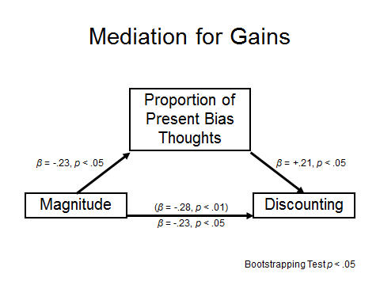
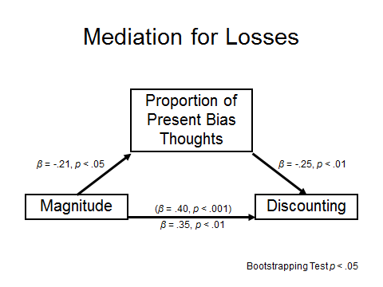
General Discussion
As observed in Study 1 and replicated in Study 2, losses can show a reverse magnitude effect in intertemporal choice. In other words, whereas people are more patient for large gains than small gains, they have a greater tendency to postpone large losses than small losses. Our studies are the first to demonstrate this reversal, which is most likely due to the fact that most studies of intertemporal choice do not allow participants to express zero or negative discount rates, because they take the rational-economic model of discounting as their point of departure.
We explain this reversal with a reconceptualization and generalization of present bias. We contend that in addition to people's desire to resolve intertemporal gains immediately, they also often have a psychological desire to resolve losses immediately. This present bias translates into higher discount rates for gains, and lower discount rates for losses. Furthermore, we agree with Benhabib and colleagues (2010) that this present bias does not scale with magnitude, representing a sort of "fixed cost" which becomes relatively unimportant with large magnitude outcomes. In other words, people are impatient to have gains immediatly, and people want to get losses over with as soon as possible, but this psychological concern is relatively unimportant in the face of large magnitude outcomes. For example, someone may prefer to deal with a small problem right away, but put off large problems until later. Our process data in Study 2 support this theory, showing that present bias thoughts mediate the effect of magnitude on discounting, for both gains and losses.
Our studies manipulated magnitude between subjects; it would be interesting in future studies to see if this reversal would hold in a within-subjects design. Furthermore, it would be interesting to parametrically manipulate outcome magnitude, to see at what point the reversal is strongest and at what point it is eliminated. It would also be interesting to run a study and analysis identical to Benhabib and colleagues (2010) but with losses instead of gains, to determine if the size of the present bias for losses (the desire to get them over with immediately) is also $4, or if it is a different amount. Our intuition is that it would be smaller, based on the data in this paper showing that while negative discounting of losses does occur, most people would not choose to lose $10 today rather than $6 in the future.
Our findings may offer some guidance to policy-makers hoping to encourage responsible intertemporal decision making. Whereas patience for gains can be encouraged by focusing on a large magnitude future goal, the same strategy should not be applied to losses; people are motivated to take care of small losses immediately, but large losses may swamp this tendency and result in postponing the loss until later. This might be one reason why efforts to portray global warming as a huge future problem have been unsuccessful for motivating action. Breaking the problem down into smaller pieces might be more effective.
References
Appelt, K., Hardisty, D. J., & Weber, E. U. (working paper). Asymmetric discounting of gains and losses: A query theory account.
Baker, F., Johnson, M. W., & Bickel, W. K. (2003). Delay discount in current and never-before cigarette smokers: Similarities and differences across commodity, sign, and magnitude. Journal of Abnormal Psychology, 112, 382-392.
Benhabib, J., Bisin, A., & Schotter, A. (2010). Present-bias, quasi-hyperbolic discounting, and fixed costs. Games and economic behavior, 69(2), 205-223.
Bickel, W. K., Jones, B. A., Landes, R. D., Christensen, D. R., Jackson, L., & Mancino, M. (2010). Hypothetical intertemporal choice adn real economic behavior: Delay discounting predicts voucher redemptions during contingency-management procedures. Experimental and Clinical Psychopharmacology, 18(6), 546-552.
Bickel, W. K., Pitcock, J. A., Yi, R., & Angtuaco, E. J. C. (2009). Congruence of bold response across intertemporal choice conditions: Fictive and real money gains and losses. The Journal of Neuroscience, 29(27), 8839-8846.
Chabris, C. F., Laibson, D., Morris, C. L., Schuldt, J. P., & Taubinsky, D. (2008). Individual laboratory-measured discount rates predict field behavior. Journal of Risk and Uncertainty, 37.
Chapman, G. B. (1996). Temporal discounting and utility for health and money. Journal of Experimental Psychology: Learning, Memory, and Cognition, 22, 771-791.
Chapman, G. B., & Elstein, A. S. (1995). Valuing the future: Discounting health and money. Medical Decision Making, 15, 373-386.
Estle, S. J., Green, L., Myerson, J., & Holt, D. D. (2006). Differential effects of amount on temporal and probability discounting of gains and losses. Memory & Cognition, 34, 914-928.
Franklin, B. (Producer). (1748). Advice to a young tradesman.
Frederick, S., Loewenstein, G., & O'Donoghue, T. (2002). Time discounting and time preference: A critical review. Journal of Economic Literature, 40, 351–401.
Giordano, L. A., Bickel, W. K., Loewenstein, G., Jacobs, E. A., Marsch, L., & Badger, G. J. (2002). Mild opioid deprivation increases the degree that opioid-dependent outpatients discount delayed herion and money. Psychopharmacology, 163, 174-182.
Green, L., Myerson, J., & McFadden, E. (1997). Rate of temporal discounting decreases with amount of reward. Memory & Cognition, 25, 715-723.
Hardisty, D. J., Orlove, B., Small, A., Krantz, D. H., & Milch, K. F. (working paper). About time: An integrative approach to effective policy.
Hardisty, D. J., & Weber, E. U. (2009). Discounting future green: Money versus the environment. Journal of Experimental Psychology: General, 138(3), 329-340.
Kirby, K. N. (1997). Bidding on the future: Evidence against normative discounting of delayed rewards. Journal of Experimental Psychology: General, 126, 54-70.
Kirby, K. N., & Marakovic, N. N. (1995). Modeling myopic decisions: Evidence for hyperbolic delay-discounting with subjects and amounts. Organizational Behavior and Human Decision Processes, 64, 22-30.
Kirby, K. N., & Marakovic, N. N. (1996). Delay-discounting probabilistic rewards: Rates decrease as amounts increase. Psychonomic Bulletin & Review, 3, 100-104.
Laibson, D. (1997). Golden eggs and hyperbolic discounting. Quarterly Journal of Economics, 112(2), 443-477.
Loewenstein, G., & Thaler, R. H. (1989). Anomalies: Intertemporal choice. Journal of Economic Perspectives, 3, 181-193.
Mazur, J. E. (1987). An adjusting procedure for studying delayed reinforcement. In M. L. Commons, J. E. Mazure, J. A. Nevin & H. Rachlin (Eds.), Quantitative analyses of behavior: Vol. 5. The effect of delay and intervening events on reinforcement value (pp. 55-73). Hillsdale, NJ: Erlbaum.
O'Donoghue, T., & Rabin, M. (1999). Doing it now or later. American Economic Review, 89, 103-124.
Petry, N. M. (2001). Delay discounting of money and alcohol in actively using alcoholics, currently abstinent alcoholics, and controls. Psychopharmacology, 154, 243-250.
Prelec, D., & Loewenstein, G. (1991). Decision-making over time and under uncertainty - a common approach. Management Science, 37(7), 770-786.
Ranieri, A., & Rachlin, H. (1993). The effect of temporal constraints on the value of money and other commodities. Journal of Behavioral Decision Making, 6, 77-94.
Samuelson, P. (1937). A note on measurement of utility. Review of Economic Studies, 4, 155-161.
Shamosh, N. A., DeYoung, C. G., Green, A. E., Reis, D. L., Johnson, M. R., Conway, A. R.-A., . . . Gray, J. R. (2008). Individual differences in delay discounting: Relation to intelligence, working memory, and anterior prefrontal cortex. Psychological Science, 19(9), 904-911.
Shrout, P. E., & Bolger, N. (2002). Mediation in experimental and nonexperimental studies: New procedures and recommendations. Psychological Methods, 7, 422-445.
Thaler, R. (1981). Some empirical evidence on dynamic inconsistency. Economics Letters, 8, 201-207.
Weber, B. J., & Chapman, G. B. (2005). The combined effects of risk and time on choice: Does uncertainty eliminate the immediacy effect? Does delay eliminate the certainty effect? Organizational Behavior & Human Decision Processes, 96(2), 104-118.
Weber, E. U., Johnson, E. J., Milch, K. F., Chang, H., Brodscholl, J. C., & Goldstein, D. G. (2007). Asymmetric discounting in intertemporal choice. Psychological Science, 18(6), 516-523.
Zauberman, G., & Lynch, J. J. G. (2005). Resource slack and propensity to discount delayed investments of time versus money. Journal of Experimental Psychology: General, 134(1), 23-37.

Appendix A
List of options presented to participants in Study 1.
Receive $10 immediately | Receive $9 in six months
Receive $10 immediately | Receive $10 in six months
Receive $10 immediately | Receive $11 in six months
Receive $10 immediately | Receive $15 in six months
Receive $10 immediately | Receive $20 in six months
Receive $10 immediately | Receive $30 in six months
Receive $10 immediately | Receive $50 in six months
Receive $10 immediately | Receive $100 in six months
Receive $10 immediately | Receive $500 in six months

Pay $10 immediately | Pay $9 in six months
Pay $10 immediately | Pay $10 in six months
Pay $10 immediately | Pay $11 in six months
Pay $10 immediately | Pay $15 in six months
Pay $10 immediately | Pay $20 in six months
Pay $10 immediately | Pay $30 in six months
Pay $10 immediately | Pay $50 in six months
Pay $10 immediately | Pay $100 in six months
Pay $10 immediately | Pay $500 in six months

Receive $1,000 immediately | Receive $900 in six months
Receive $1,000 immediately | Receive $1,000 in six months
Receive $1,000 immediately | Receive $1,100 in six months
Receive $1,000 immediately | Receive $1,500 in six months
Receive $1,000 immediately | Receive $2,000 in six months
Receive $1,000 immediately | Receive $3,000 in six months
Receive $1,000 immediately | Receive $5,000 in six months
Receive $1,000 immediately | Receive $10,000 in six months
Receive $1,000 immediately | Receive $50,000 in six months

Pay $1,000 immediately | Pay $900 in six months
Pay $1,000 immediately | Pay $1,000 in six months
Pay $1,000 immediately | Pay $1,100 in six months
Pay $1,000 immediately | Pay $1,500 in six months
Pay $1,000 immediately | Pay $2,000 in six months
Pay $1,000 immediately | Pay $3,000 in six months
Pay $1,000 immediately | Pay $5,000 in six months
Pay $1,000 immediately | Pay $10,000 in six months
Pay $1,000 immediately | Pay $50,000 in six months

Appendix B
List of options presented to participants in Study 2.
Receive $10 immediately | Receive $9 in six months
Receive $10 immediately | Receive $10 in six months
Receive $10 immediately | Receive $10.50 in six months
Receive $10 immediately | Receive $11 in six months
Receive $10 immediately | Receive $12 in six months
Receive $10 immediately | Receive $14 in six months
Receive $10 immediately | Receive $17 in six months
Receive $10 immediately | Receive $20 in six months
Receive $10 immediately | Receive $25 in six months
Receive $10 immediately | Receive $35 in six months

Pay $10 immediately | Pay $9 in six months
Pay $10 immediately | Pay $10 in six months
Pay $10 immediately | Pay $10.50 in six months
Pay $10 immediately | Pay $11 in six months
Pay $10 immediately | Pay $12 in six months
Pay $10 immediately | Pay $14 in six months
Pay $10 immediately | Pay $17 in six months
Pay $10 immediately | Pay $20 in six months
Pay $10 immediately | Pay $25 in six months
Pay $10 immediately | Pay $35 in six months

Receive $10,000 immediately | Receive $9,000 in six months
Receive $10,000 immediately | Receive $10,000 in six months
Receive $10,000 immediately | Receive $10,500 in six months
Receive $10,000 immediately | Receive $11,000 in six months
Receive $10,000 immediately | Receive $12,000 in six months
Receive $10,000 immediately | Receive $14,000 in six months
Receive $10,000 immediately | Receive $17,000 in six months
Receive $10,000 immediately | Receive $20,000 in six months
Receive $10,000 immediately | Receive $25,000 in six months
Receive $10,000 immediately | Receive $35,000 in six months

Pay $10,000 immediately | Pay $9,000 in six months
Pay $10,000 immediately | Pay $10,000 in six months
Pay $10,000 immediately | Pay $10,500 in six months
Pay $10,000 immediately | Pay $11,000 in six months
Pay $10,000 immediately | Pay $12,000 in six months
Pay $10,000 immediately | Pay $14,000 in six months
Pay $10,000 immediately | Pay $17,000 in six months
Pay $10,000 immediately | Pay $20,000 in six months
Pay $10,000 immediately | Pay $25,000 in six months
Pay $10,000 immediately | Pay $35,000 in six months

We chose this equation (rather than the hyperbolic model or the area-under-the-curve method) because it is easily interpretable. For example, a k of .6 is the equivalent of a continuous discount rate of 60%, in the standard economic sense. Higher numbers indicate greater discounting, a k of zero means no discounting, and negative k values indicate negative discounting. As choices in this study all involved the same two time points (immediate outcomes vs. outcomes in six months), exponential and hyperbolic modeling would fit the data equally well, so there was no advantage to using the hyperbolic model, which (which is known to generally model data better than the exponential model, Kirby, 1997; Kirby & Marakovic, 1995; Mazur, 1987).

