When "More" Seems Like Less: Differential Price Framing Increases the Choice Share of Higher-Priced Options

THOMAS ALLARD
DAVID J. HARDISTY
DALE GRIFFIN

Thomas Allard (tallard@ntu.edu.sg) is Assistant Professor of Marketing, Nanyang Technological University, Singapore. David J. Hardisty (david.hardisty@sauder.ubc.ca) is Assistant Professor, and Dale Griffin (dale.griffin@sauder.ubc.ca) is Professor of Marketing and Behavioural Science, University of British Columbia, Vancouver, Canada. The authors gratefully acknowledge financial support from a Singapore Ministry of Education (MOE) research grant awarded to Allard and from Social Sciences and Humanities Research Council of Canada (SSHRC) research grants awarded to Hardisty and Griffin. We thank Ajay T. Abraham and Dan Shley for helpful comments on this manuscript. In addition, the authors are grateful to the JMR review team for their insightful guidance and suggestions.

ABSTRACT
In four experiments supported by six supplemental studies, we show that premium but higher-priced products such as direct flights and larger capacity data storage devices are more popular when the differential cost is made explicit using Differential Price Framing (DPF) (e.g., "for $20 more") rather than being left implicit as in standard Inclusive Price Framing (IPF) (e.g., "for $60 total"). We show that the DPF effect is partly driven by pricing focalism: DPF—relative to IPF—creates a focus on the price difference which, because it is smaller than the total price, leads to lower perceived expensiveness and hence greater choice share for the premium option. This price framing effect is robust to displaying the total cost of the purchase, to bad deals, and to easy-to-compute price differences, and appears to be uniquely effective in pricing contexts. However, DPF effects are reduced among consumers who adopt a slow and effortful decision process. We discuss the implications of the DPF effect for research on price partitioning, the design of effective pricing strategy, the sources of expensiveness perceptions in the marketplace, and consumer welfare.

Keywords: Pricing Strategy, Price Partitioning, Attribute Framing, Heuristic Processing, Expensiveness
Imagine shopping for a new computer monitor from a well-known brand. Deliberating between the standard 23-inch model and the more expensive 27-inch model, you notice that Retailer A quotes $199.99 for the 23-inch model and $259.99 for the 27-inch model. In contrast, retailer B quotes the prices as $199.99 for the 23-inch model and “$60.00 more” for the 27-inch model. How might these two pricing strategies influence your choices? Although simple arithmetic quickly reveals that both pricing formats lead to equivalent payments at the cash register, we predict that because of a representational bias caused by consumers focusing on the explicitly presented price format (“pricing focalism”), consumers will be more likely to purchase the 27-inch version at retailer B, where it is offered for “$60 more.”
We test the notion that when selecting between a pair of products, with one being higher in quality and higher in price (henceforth the “premium” option), consumers are more likely to select the premium option when retailers quote the price difference from the standard option, rather than the total price of the premium option. Specifically, we define Differential Price Framing (DPF), a price framing strategy that presents consumers with the upward price difference between vertically differentiated products (e.g., “$199.99” and “$60 more”). We contrast this approach with a more traditional pricing strategy—Inclusive Price Framing (IPF)—that presents the total or aggregated price of each option (e.g., “$199.99” and “$259.99”).
We show that DPF leads to stronger preferences for the premium product than IPF because focusing on the price difference, compared to focusing on the two total prices, leads consumers to perceive the premium option as less expensive. For instance, when selecting between a standard version of a product for $X₁ and a premium quality version for $X₂, framing the price of the premium option as a Δ$X = ($X₂ - $X₁) increase will lead consumers to focus on the smaller Δ$X amount (rather than $X₂) as they make their subjective value assessment of the relative cost of the two products. Because Δ$X << $X₂ , and because most consumers use the information as presented to make expensiveness assessments (e.g., Raghubir and Srivastava 2002; Wertenbroch, Soman, and Chattopadhyay 2007), the display of the smaller focal amount Δ$X in the DPF condition leads to the perception of the premium product as less expensive (than in the IPF condition), thereby increasing the choice share of the premium option under DPF relative to IPF.
We provide support for the proposed focalism mechanism by demonstrating that the DPF effect is mediated through perceived expensiveness judgments and moderated by decision-making speed. Specifically, heuristic decision makers (i.e., those assigned to faster decision processes) show a marked difference in preference for the premium product between the DPF and IPF conditions because those in the DPF condition immediately form a judgment of expensiveness based on the focal price difference, whereas those in the IPF condition are likely to use the upgrade’s total price as a basis for their expensiveness judgments. Put another way, the DPF condition—but not the IPF condition—makes the information about price difference easily accessible and, thus, influential in heuristic thinkers’ expensiveness assessments and product choices. In contrast, systematic decision makers (i.e., those assigned to slower decision processes) show little or no difference between DPF and IPF because they take the time to compute the price difference Δ$X when evaluating the cost of the premium option in both conditions.
By defining and analyzing DPF, a pricing technique that makes the price difference associated with premium products more salient, this research makes four main contributions to the literature. First, this research adds a new branch to the rich literature on price presentation formats [e.g., Price Partitioning (Abraham and Hamilton 2019; Greenleaf et al. 2016), Add-On Pricing (Ellison and Ellison 2009)]. Second, the research highlights the benefit of going beyond the standard mental accounting explanation of the benefits of product bundling (e.g., Thaler 1985; Thaler and Johnson 1990), which relies on the curvature of the utility function to explain the value of bundled prices, and instead highlights the importance of understanding a consumer’s perception and representation of price information. Third, the research illuminates the targeted nature of DPF by showing how its effects on consumer preferences are primarily found when choice processes are heuristically based. Finally, this research offers straightforward and easy-to-implement managerial recommendations for optimal pricing strategy, particularly important given the complex nature of price inferences in consumption. We next turn to our theoretical framework.

THEORETICAL DEVELOPMENT
From fuel surcharges to resort fees, retailers have used various approaches that separate the total cost of products into multiple components, with the goals of reducing consumer price sensitivity and increasing demand. An extensive literature on the partitioning of price information (e.g., “$10.80 including tax” vs. “$10.00 plus $0.80 sales tax”) has demonstrated how price partitioning often shifts attentional focus away from the total price of operation and increases focus on, and hence memory for, the base price of the core product (Morwitz, Greenleaf, and Johnson 1998). For example, Hamilton and Srivastava (2008) have shown that price partitioning increases product evaluation when the mandatory partitioned surcharge (e.g., the tax) offers low consumption benefits. In the extreme case, the cost of the partitioned elements is ignored completely by some consumers when determining bundle value (Gabaix and Laibson 2006; Morwitz et al. 1998). A related literature on Add-On Pricing (AOP; and its Drip Pricing extension) shows that consumers’ purchase decisions are often driven by low base prices, even when high prices for add-ons such as mandatory printer ink make the purchase uneconomical (Ellison and Ellison 2009). Essentially, AOP takes advantage of consumers’ “myopic” focus on upfront payments rather than downstream costs.
Another important variant on price partitioning was described by Bertini and Wathieu (2005, 2008) who distinguished between aggregate or all-inclusive pricing (a single total price that includes the focal good plus a variety of mandatory infrastructural elements such as shipping, handling, etc.) and disaggregate or partitioned pricing (separating the price for each of the infrastructure elements). Based on the assumption that consumers minimize cognitive effort, they argued that an aggregate price leads to a focus on the base product only whereas the disaggregated price leads to a disproportionate focus on the infrastructural elements.
Pricing Focalism and Selective Information Processing.
In the current research, we examine the choice between (low-priced) basic and (higher-priced) premium models and introduce the concept of Differential Price Framing (DPF). DPF occurs when the price of the premium product in a vertically differentiated set is described in relative or incremental terms (e.g., "$20 more"). The conceptual model guiding this research is presented in Figure 1, which also illustrates the central theme of each study. According to our pricing focalism account, DPF makes the price difference between the available choice options more salient. Because this price difference is always lower than the total price, a focus on the price information as given (i.e., the price difference) increases consumer evaluations of the price-quality value (see Bertini and Wathieu 2008 for a similar account on product attributes). Thus, unlike price partitioning or add-on pricing techniques, which work by reducing consumers’ focus on additional charges relative to the focal price, DPF functions by increasing the focus on specific additional charges, which, by virtue of always being smaller than the total price, effectively increases perceptions of the value of the premium option.
Insert Figure 1 here

People often selectively base their judgments on the most salient information cues presented to them (e.g., Bettman, Luce, and Payne 1998; Hutchinson and Alba 1991; Kahneman and Tversky 1979; Wilson et al. 2000), and rarely transform the presented information into an inclusive “canonical” representation (Tversky and Kahneman 1986). This information processing tendency was originally defined as the “concreteness” principle (Slovic 1972): decision-makers tend to use only the information that is explicitly displayed to them and will use it only in the form in which it is displayed. For example, the same total price is perceived to be cheaper when it is divided into multiple temporal partitions (e.g., the “just pennies a day” phenomenon, also known as temporal reframing; Gourville 1998) because small units of money appear inexpensive and hence influence the overall price judgment through an association with “petty cash” (Gourville 1999).
In the case of a premium product with a higher price, the price difference will always be smaller than the total price of the premium option, and thus we expect DPF (relative to IPF) to reduce the perceived expensiveness of premium quality options and hence increase the proportion of consumers selecting such options. In other words, we expect consumers facing the price/quality trade-off in the DPF condition to think to themselves “the better model is only $20 more [than $40 for the standard model]—that doesn’t seem so expensive,” leading to greater preference for the premium product compared to the IPF condition. Put another way, DPF reduces the perceived cost of the premium option (e.g., Erickson and Johansson 1985; Völckner, Rühle, and Spann 2012), without affecting the perceived quality (e.g., Cronley et al. 2005; Kardes, Posavac, and Cronley 2004).
DPF works in the opposite direction to a classic mental accounting model of price bundling (Thaler 1985), which rests on the assumption that a single inclusive price creates less negative utility than the sum of the negative utilities obtained from two or more separate prices (see also Greenleaf et al. 2016). According to the mental accounting model, inclusive prices should be judged as less expensive than the sum of the standard and differential prices. However, according to our focal pricing account, by highlighting the differential cost of the premium option (vs. total cost), the DPF makes premium options appear relatively less expensive. Whether this price difference also drives expensiveness judgments in the IPF condition depends on the processing effort consumers spend to evaluate the expensiveness of the (implicit) difference between the two total prices.
Processing Effort.
Information processing is often conceived as falling along a continuum between more heuristic versus more systematic types of processing (e.g., Chaiken 1980; Petty and Cacioppo 1984), where heuristic processing is a less effortful and less capacity-limited type of decision-making (e.g., Chaiken and Maheswaran 1994). Decision-makers relying on heuristic processing are more likely to make inferences using only the information directly available to them (e.g., Bodenhausen and Wyer 1985; Schwarz 1998), often leading to less accurate judgments (e.g., Payne, Bettman, and Johnson 1988). The type of processing adopted by a decision-maker has been shown to vary based on motivational (e.g., involvement; MacInnis and Park 1991), situational (e.g., time constraints; Suri and Monroe 2003), and individual factors (e.g., Need for Cognition; Cacioppo et al. 1996).
In the context of consumer choice, we expect that participants relying on heuristic processing will be more likely to base their perceived value judgments on the price frame presented to them (i.e., the standard price and total premium price in the IPF condition, and the standard price and differential price in the DPF condition). Specifically, we expect that rapid decision-makers—manipulated by a belief that faster decision-making results in better decisions (Inbar, Botti, and Hanko 2011)—will choose the premium product more often when price information is presented using DPF because they will focus on the prices as shown. In contrast, we expect that slower (and presumably more careful and effortful) decision-makers naturally compare the standard and premium prices to assess the cost of the premium option. We posit that because of this ability to shift the focus towards the price difference even in the total price (IPF) condition, systematic decision-makers will show a similar degree of preference for the premium option regardless of whether they are exposed to DPF or IPF.
Note that these moderation predictions for DPF are the opposite of those that would be expected in the price partitioning context, where separating the base and add-on prices has a greater effect for consumers with a high motivation to deliberate about price information (i.e., high-effort) compared to those with low motivation. For instance, Burman and Biswas (2007) show an attenuated effect of price partitioning under low effort conditions (measured as lower Need for Cognition scores). They propose that this occurs because investing cognitive effort in a purchase decision is necessary for participants to draw inferences about the desirable versus undesirable nature of surcharges. In contrast, because that our effect relies on relatively quick perceptual processes to assess perceived expensiveness, we instead predict that more cognitive effort will reduce the effect of DPF on judgments of expensiveness and resulting preferences.
More formally, we predict:
H1: Differential Price Framing will increase the choice of premium (higher-priced, higher-quality) products compared to Inclusive Price Framing.
H2: Judgments of perceived expensiveness will mediate the relationship between price framing and the choice share of the premium option, such that premium options will be judged as relatively less expensive when presented using Differential Price Framing compared to Inclusive Price Framing.
H3: Cognitive effort will moderate the effect of a Differential Price Framing on consumer preferences. In particular, more effortful processing (i.e., slow decision times) will be associated with a weaker relative preference for the premium product under Differential Price Framing than under Inclusive Price Framing.
We test these three hypotheses in a series of four studies. In Study 1, we show the basic DPF effect and demonstrate that it occurs even when the total cost of the premium product is made salient (thus ruling out the possibility that the effect is driven by confusion or deception). Study 2 uses a Differential Quality Frame to rule out other alternative explanations (such as DPF activating a general trade-off mindset) and provides mediational support for the proposed mechanism, showing that DPF influences consumer choice by reducing the perceived expensiveness of the premium option. Study 3 provides further evidence for the perceived expensiveness model of DPF on premium product choice by showing that the pattern of results is reversed when goods are sold (rather than bought). In Study 4, we demonstrate the heuristic nature of the proposed process, showing that the DPF effects are mitigated for those who make a slower—and more deliberative—decision. Supplementary studies in Web Appendix B, C, D, E, F, and G (introduced below) further extend these results and rule out several alternative explanations. See Table 1 for a summary of all results.

STUDY 1
Study 1 provides support for our primary DPF hypothesis by showing that DPF increases the choice of premium options, and that this is true even when the total price of the purchase is presented along with the differential price frame. Our price focalism account predicts that when the prices are presented together, the differential price is more salient than the total price (because it is more relevant to assessing the upgrade decision). This focus on the differential price leads consumers to evaluate the premium option as less expensive in both the DPF and DPF + total price conditions. From a theoretical perspective, showing that the DPF is robust to displaying the total price of the purchase helps clarify the mechanism underlying the effect by providing evidence against a confusion or misinformation explanation (i.e., consumers confused the price difference with the total price for the premium option) for the observed shift in preferences.
Method
Participants and Design. Five hundred and forty-six undergraduate students took part in a laboratory experiment (58% female). The experimental design was a one-factor three-level (framing: inclusive-price vs. differential-price vs. differential-price+total-price) between-participants design. The dependent variable of interest was the proportion of participants selecting the premium choice option.
Procedure. Participants were instructed to imagine themselves shopping for a new computer monitor and shown two different monitor options on one web page (as seen in Web Appendix A). Both monitors were identical in every feature (i.e., brand, resolution, display type, aspect ratio, refresh rate) except for screen size—where larger is generally considered to be more desirable. The first monitor was the basic or standard 23-inch version and retailed for $199.99. The second monitor was a larger (premium) 27-inch version and thus, had a higher retail price. In the IPF conditions, the 27-inch monitor was available for “$259.99,” whereas the same premium product in the DPF condition was offered for “$60.00 more.” In the DPF + total price condition, the monitor was offered for “$60.00 more ($259.99 total).” Participants were instructed to select the monitor they would normally choose.
Results
Results from a logistic regression with two dummy coded variables revealed a significant effect of the framing condition in predicting the proportion of participants selecting the premium choice option (χ²(2) = 10.14, p < .01). Supporting H1, the proportion of participants selecting the premium option in the DPF condition (P = 58%) was significantly higher than in the IPF condition (P = 42%; b = .67, SE = .21, Wald χ²(1) = 9.81, p < .01; Cohen’s d = .37). Notably, the choice of the premium product in the DPF + total price condition was also higher than in the IPF condition (P = 53%; b = .44, SE = .21, Wald χ²(1) = 4.19, p < .05). Finally, there was no significant difference in the proportion of premium choice options selected between the DPF and the DPF + total price conditions (b = .23, SE = .21, Wald χ²(1) = 1.23, p > .75).
Discussion
Study 1 provides an initial demonstration showing that DPF (compared to IPF) increases consumers’ preferences for premium options over standard options. It supports our focalism account—that consumers naturally focus on the price difference when it is presented to them—by showing that the DPF effect is robust to displaying the total cost information along with the cost of the premium product, illustrating that the differential pricing effect is not simply a result of consumer confusion or lack of numeracy skills. This result showing that the DPF shifts preferences even when all the price information is prominently displayed carries important implications for managers and public-policy makers: the DPF effect on consumers’ product decisions is robust and does not arise from consumer confusion.

STUDY 2
Just as the differential price of a premium newspaper subscription can be represented as “+$7.00/month,” so too can the differential features be represented as “+print, podcast, and crosswords,” isolating (and highlighting) the marginal improvement in product features rather than the marginal increase in price. In Study 2, we add such a new framing condition, Differential Quality Framing (DQF), to test pricing focalism against two alternative mechanisms that may contribute to the DPF effect—compensatory decision-making and general attribute salience—as we explain below.
First, according to our pricing focalism model, consumers are particularly sensitive to prices and price differences. The DPF frame brings focus to a smaller value on the undesirable price scale (i.e., lowering the perception of expensiveness) and, as a result, leads to an increase in the choice of the premium option. If a strict version of the price focalism mechanism is correct, DQF, by making incremental product features rather than price salient, should not affect expensiveness judgments or the choice of the premium option.
Second, according to the compensatory decision-making hypothesis (e.g., Payne et al. 1988), many (heuristic) consumers seeing the total prices in the IP frame may instead simply choose the cheapest option (a non-compensatory process), whereas consumers seeing the DP frame may be more likely to adopt a trade-off mindset (e.g., “Is the upgrade worth the price?”) and thus increase their preference for the premium option. Following this logic, using DQF to focus consumers on the marginal quality difference should also induce a trade-off mindset, increasing compensatory decision making, and so increase the choice of the premium option. Therefore, if the compensatory/trade-off salience model is driving the effects in Study 1, DQF should influence the choice of the premium option just as DPF does, as both frames make the price/quality trade-off more salient and thus both should increase premium choices.
Third and finally, according to the generic attribute salience hypothesis (e.g., Hardisty, Johnson, and Weber 2010; Schkade and Kahneman 1998), consumers base judgments on the most salient information presented, without much regard for meaning or context. This account suggests that just as the lower price number in DPF leads to lower judgments of expensiveness (“+$7.00/month” is smaller than “$16.99/month”), so too may the fewer features presented in DQF lead to lower judgments of quality (the number of individual features appears smaller in the DQF frame compared to the IPF frame), and so decrease preference for the premium option. Therefore, if the effect relies on a generic salience (or counting) heuristic, smaller quantities associated with either the differential price number or the differential quality attributes should lead to lower judgments on the relevant dimension (price or quality). That is, whereas DPF should increase premium product choices (because the price difference is smaller than the total, and decreased expensiveness is desirable), DQF may decrease premium product choices (because the quality difference is smaller than the total, and decreased quality is undesirable; see also Kyung, Thomas, and Krishna 2017 for a discussion on numeric ranking orders and quality inferences).
In summary, while all three theories make the same prediction for the effect of DPF on upgrade choices, they all make different predictions for the effect of DQF. The pricing focalism hypothesis predicts no effect of DQF on upgrades, the compensatory decision-making hypothesis predicts a positive effect of DQF on premium product choices, and the generic salience theory predicts a negative effect of DQF on premium product choices.
Furthermore, in Study 2 we test two alternative mediators of the DPF effect. First, it could be perceptions of value rather than the price that are driving the effect in the previous study. If the extra quality gained by paying a higher price makes the offer a “good deal” (Bertini and Wathieu 2008), the offer may be perceived as “less expensive” because it is a good value. Therefore, we tested whether DPF influences the perceived value of the products and whether value ratings, in turn, predict choices. Second, it could be that DP framing makes the pricing or value easier (or harder) to evaluate, which could influence preferences through fluency (Novemsky et al. 2007). Therefore, we also test whether DPF influences the evaluability of the product attributes and whether evaluability predicts choices.
Method
Participants and Design. Two hundred and fifty-three undergraduate students took part in a laboratory experiment (59% female, M_{age} = 20.2). The experimental design was a one-factor three-level (framing: inclusive-price vs. differential-price vs. differential-quality) between-participants design. The dependent variable of interest was the proportion of participants selecting the premium option.
Procedure. Participants were first informed that we would randomly select 1 out of every 100 participants to execute their purchase for real; we endowed them with $20 and used a portion of that to purchase the option they selected, and let them keep the leftover endowment. Therefore, participants' choices were incentive compatible.
Next, participants chose whether to buy a cheaper versus more expensive one-month New York Times subscription. The cheaper Option A was the same in all conditions: "$9.99/month New York Times web and app." In the inclusive-price frame, the premium Option B was described as "$16.99/month New York Times web, app, print, podcast, and crossword", in the differential price frame it was "+$7.00/month New York Times web, app, print, podcast, and crossword", and in the differential-quality frame it was "$16.99/month +print, podcast, and crossword" (see Web Appendix A for stimuli).
Finally, participants answered on a series of 7-point scales (1: not at all, 7: very much) questions about how expensive each option was, how valuable the services offered in each option were, and how easy it was to evaluate the price and services of each option.
Results
Choices. Results from a logistic regression with two dummy coded variables (using IPF as the reference category) revealed a significant effect of the framing condition in predicting premium option choices (Wald χ²(2) = 14.72, p = .001). Supporting H1, the proportion of participants selecting the premium option in the DPF condition (P = 47%) was significantly higher than in the IPF condition (P = 23%; b = 1.09, SE = .34, Wald χ²(1) = 10.29, p = .001, d = .62). In contrast, there was no difference between the DQF condition (P = 22%) and the IPF condition (b = -0.04, SE = .36, Wald χ²(1) = 0.01, p = .96). Thus, consistent with our pricing focalism account, DPF influenced choice but DQF did not.
Perceived Expensiveness. Next, we turn to our proposed mediator, perceptions of expensiveness. Notably, DPF both decreased the perceived expensiveness of the premium option, the framing of which was manipulated (pairwise comparison between IPF and DPF, t(166) = 2.54, p = .01) and increased the perceived expensiveness of the standard option, which was not manipulated (pairwise comparison between IPF and DPF, t(166) = 2.26, p = .03), consistent with perceptions of expensiveness being relative judgments, depending on context. Because of this dual effect, the largest impact of DPF on expensiveness judgments is found when looking at the difference scores: DPF framing decreases the difference in perceived expensiveness between the premium and standard option substantially (t(166) = 4.76, p < .001), supporting H2. In contrast, DQF did not influence judgments of perceived expensiveness relative to IPF (all ns). See Web Appendix A for detailed results.
Mediation. Using an indirect effect analysis with 5000 bootstrap samples with two dummy coded variables for the framing conditions and continuous expensiveness judgments (difference scores) predicting choice, we tested whether perceived relative expensiveness mediated the effect of DPF (dummy coded as 1 vs. the two non-DPF conditions coded as 0) on choices. Consistent with H2, the mediation pathway between DPF (vs. no DPF) and premium product choice through expensiveness judgments was significant (b = .70, SE = .20, CI₉₅ [.38, 1.18]; note that a pairwise model with just DPF vs. IPF yields the same results). In contrast, the mediation between DQF (vs non-DQF) and choice through perceived expensiveness was not significant (b = -.19, SE = .15, CI₉₅ [-.51, .07]).
Perceived Value and Evaluability. Next, we examined two possible alternative mediators for the DPF effect: perceived product value judgments and evaluability. These did not vary significantly by condition, nor did they mediate the results (see Web Appendix A).
Discussion
Study 2 replicated the effect of DPF, cast doubt on the ability of the compensatory trade-off and generic salience models to explain the effect, and showed significant mediation by perceived relative expensiveness, supporting the pricing focalism model: DPF increases the focus on the price difference and hence lowers the perceived expensiveness of the premium option (because the displayed price difference under DPF is always numerically smaller than the displayed total price under IPF). Note that because the completely null effect of DQF in Study 2 was somewhat surprising, and because null results can be hard to interpret (e.g., perhaps consumers found the verbally described product features hard to understand, and so quality difference framing had no impact), we ran two replication studies comparing IPF, DPF, and DQF, using different stimuli and testing purely numerical descriptions of quality (see Web Appendix D: storage space in TB for hard drives, and Web Appendix E: travel times for flights). The results were the same: DPF influences choices, but DQF does not, even when all attributes are presented numerically. We further discuss in the General Discussion section reasons why price appears more sensitive to our DPF effect. Finally, Study 2 rules out self-reported differences in perceived value or evaluability as mediators.
The next study further supports the role of perceived expensiveness in price framing by testing a theoretically predicted reversal that should occur when sellers (rather than buyers) receive an offer using DP framing or IP framing. For a seller motivated by high earnings, an apparently inexpensive selling price is unattractive, and therefore sellers should be more likely to reject a given price under DP framing than under IP framing.

STUDY 3
In Study 3, we provide another test of the expensiveness mechanism underlying the DPF effect by examining the moderating role of buyer versus seller perspective. So far, we have shown that using DPF framing increases the attractiveness of the premium option because consumers focus on the price difference and consequently perceive the price of the premium object as relatively less expensive. By the same logic, we should observe the opposite effect—lower preference for the premium option—when the participant acts as a seller and receives an offer using the DP frame. This reversal of the DPF effect is predicted because the offered price (a gain) will appear smaller in the DPF condition (because of the focus on the price difference), leading the seller to be more willing to sell the premium product (for the same price) in the IPF condition, where total prices are displayed. In addition, this study eliminates a possible confound present in previous studies, the differential effect of round (e.g., $40) versus exact numbers (e.g., $41; Manning and Sprott 2009; Wadhwa and Zhang 2014; Yan and Pena-Marin 2017).
Method
Participants and Design. Two hundred and twenty-one undergraduate students took part in this laboratory experiment (44% female, M_{age} = 19.6). This experiment uses a 2 (framing: inclusive-price vs. differential-price) x 2 (transaction role: buyer vs. seller) between-participants design. The dependent variable of interest was the choice to sell (or buy) the premium option.
Procedure. Participants read a scenario about a buyer-seller interaction for a used bicycle sold through classified ads. Participants were randomly assigned to the role of a buyer or seller. In the buyer scenario, participants learned, they were interested in purchasing one of two second-hand bicycles a seller had put up for sale. In the seller condition, a buyer had shown interest in purchasing one of two second-hand bicycles the seller had put up for sale. One bicycle, the premium product, was superior because of better gear options (21-speed model vs. 3-speed model) and better parts (brand-name parts vs. generic parts). In the IPF condition, the standard bicycle was offered for $150 and the premium bicycle for $210. In the DPF condition, the price of the premium bicycle was described as “for $60 more” (see Web Appendix A for stimuli). Participants were instructed to select which of the two bicycles they would buy [sell] given the two offers. Participants also rated the relative expensiveness of the premium option by answering the question: “Compared to the 3-speed model, how much more money is the seller asking (buyer offering) for the 21-speed model?” 1: Very little more money, 7: A lot more money (e.g., Thomas and Morwitz 2009).
Results
Insert Figure 2 here

Product Choice. There was a significant two-way interaction between the price-framing condition and the buyer-seller role condition in determining the choice of the premium option (b = 1.69, SE = .57, Z = 2.98, p < .01; see Figure 3), consistent with the predicted reversal between the buyer and seller roles. As in previous studies, buyers in the DPF condition were significantly more likely to purchase the premium bicycle (P = 70%) than those in the IPF condition (P = 50%; b = .84, SE = .41, Z = 2.05, p < .05; Cohen’s d = .30), supporting H1. However, sellers in the DPF condition were significantly less likely to sell the premium bicycle (P = 26%) than those in the IPF condition (P = 46%; b = -.86, SE = .40, Z = 2.15, p < .05). In addition, there was a significant main effect of the role condition (b = 1.02, SE = .29, Z = 3.56, p < .001) such that the premium option was chosen more often for buyers than sellers, but no significant main effect of price framing (b = -.05, SE = .29, Z = .19, p > .85).
Perceived Expensiveness. As expected, there was no significant two-way interaction on the perceived expensiveness of the premium bicycle (b = .20, SE = .38, t < 1) and no main effect of the buyer-seller role (b = -.04, SE = .19, t < 1). There was, however, a main effect of the price framing condition (b = -.69, SE = .19, t(217) = 3.67, p < .001) suggesting that, across both buyers and sellers, the incremental price asked (or offered) for the premium bicycle appeared smaller in the DPF condition (M = 2.36, SD = 1.41) than in the IPF condition (M = 3.05, SD = 1.37), consistent with H2.
Mediation. Next, we conducted an indirect effect analysis to test whether the difference in perceived expensiveness between the price-framing conditions could explain the observed reversal between the selling and buying condition. Consistent with our prediction H2, perceived expensiveness mediated the effect; results suggested two equal and opposite significant indirect effects of perceived expensiveness depending on the participant’s role (buyer: b = .33, SE = .17, CI₉₅ [.07, .75]; seller: b = -.29, SE = .14, CI₉₅ [-.68, -.09]; index of moderated mediation: b = .62, SE = .26 CI₉₅ [.21, 1.23]), supporting H2. Specifically, while the premium option always appeared less expensive in DPF than in IPF (a-path: b = -.69, SE = .19, t(219) = 3.69, p < .001, CI₉₅ [-1.06, -.32]), we observed a significant two-way interaction between the perceived expensiveness of the premium option and transaction role in predicting product choice (b-path interaction term: b = -.90, SE = .22, Z = 4.07, p < .001, CI₉₅ [-1.34, -.47]).
Discussion
Study 3 provided evidence that because DPF makes premium options appear cheaper for both consumers and sellers, it simultaneously leads to an increased preference for premium products for buyers and a decreased preference for premium products for sellers, further supporting our explanation based on perceived expensiveness. Study 4 focuses on illustrating the heuristic nature of the processes underlying the effects of DPF versus IPF by manipulating participants’ effort invested in the decision-making as a moderator of the effect of DPF on consumer choices for upgrades.

STUDY 4
In Study 4, we examine how high-effort decision-making moderates the effect of the DP framing. We expect that participants assigned to spend more time and effort on their choice will be more likely to spontaneously compute and focus on the price difference in the IPF conditions than those in a standard effort (control) condition. As a result, high-effort participants will see the premium product as equally (in)expensive across the two framing conditions and hence will be equally likely to choose the premium product across the two conditions. However, we expect that those assigned to spend less time and effort (heuristic decision makers) will, like those in the control condition, be unlikely to compute the price difference in the IPF condition, leading to higher perceived expensiveness of the premium option and a lower choice of the premium option in this condition, relative to the DPF condition. That is, we expect that the control conditions will mirror the pattern found in the low-effort conditions. In this study, we experimentally manipulate decision speed, rather than measuring it, to avoid potential confounding variables such as numerical competence (perhaps people who naturally tend to decide slowly are also naturally better at math; e.g., Peters et al. 2006).
This study also provides additional evidence for our shift in expensiveness account by collecting separate assessments of the perceived expensiveness of each of the two choice options. Furthermore, this study rules out an additional alternative explanation: trust in the retailer (e.g., Cheema 2008).
Method
Participants and Design. Five hundred and seventy-one online panel participants recruited through Prolific Academic took part in this experiment (52% female, M_{age} = 37.3) in exchange for payment. This experiment used a 2 (framing: inclusive-price vs. differential-price) x 3 (speed of processing: slow vs. fast vs. control) between-participants design. The dependent variable of interest was the proportion of participants choosing the premium choice option.
Procedure. Participants were instructed to imagine themselves shopping for new wine glasses. They were told that they had settled on a specific model (e.g., classic shape, made in Italy, shatter and dishwater resistant) and told that it was available in two different set sizes. Before they made their choice, participants received a speed of processing manipulation adapted from Inbar et al. (2011). In the slow-is-accurate belief condition, participants were told that recent psychological research has shown “that making better choices often takes more time and effort. Taking your time often leads to making the best choice possible,” the summary concluded with the instruction to “fully consider the available options before making your selection.” Alternately, in the fast-is-accurate condition, participants read “that people often make better choices when they decide quickly and effortlessly. A quick response often leads to making the best choice possible,” the summary instructed them to “quickly consider the options and immediately make your selection.” (see Web Appendix A for details). In the control condition, participants did not receive such manipulation. They instead proceeded directly to making their choice between the two wine-glass set options.
The standard option was a set of four wine glasses for $29.00. The premium option was a set of eight wine glasses of the same model. Depending on the experimental condition, participants were offered the premium (i.e., larger) set for either “$41.00” (IPF condition) or “$12.00 more” (DPF condition). Participants selected the wine glasses set they normally would have chosen and proceeded to the next screen when done with the selection task. As a manipulation check, we measured the time spent on that web page. Decision-making duration values were log transformed for the inferential tests reported in the result section to correct for non-normality in response times (skewness = 9.29). For ease of interpretation, we present descriptive statistics in standard time units (based on geometric means).
As a mediating variable, participants then rated from memory the expensiveness of the two wine glasses set options they reviewed using a 5-point scale (1 = strongly disagree, 5 = strongly agree): “The set of 4’s [8’s] price is high” (Thomas and Morwitz 2005). These two ratings were used to create a difference score between the perceived expensiveness of the premium and the standard options (M_{Premium}-M_{Standard}). We also asked participants to assess their trust in the website using a 5-item scale (1 = strongly disagree, 7 = strongly agree) from Bart et al. (2005; e.g., "This site appears to be more trustworthy than other sites I have visited," α =.92). Finally, to rule out memory bias, we asked participants to recall the total (inclusive) price of each option. We categorized participants’ responses as a successful recall when both reported prices came within +/-$1 of the actual prices.
Manipulation Check
Decision-Making Duration. There was no significant price framing by processing speed interaction in predicting decision-making duration (F < 1). Importantly, there was a main effect of the processing speed manipulation (F(1,565) = 131.37, p < .001. Contrast analysis revealed that participants overall took longer to reach a decision when given the slow accuracy belief instructions (M = 34.26, SD = 48.22) compared to the control instructions (M = 20.71, SD = 35.61; t(565) = 6.99, p < .001) and the fast accuracy belief instructions (M = 8.87, SD = 7.09; t(565) = 16.17, p < .001). The latter two conditions were also significantly different from one another (t(565) = 9.03, p < .001). These results support the validity of our processing speed manipulation. There was also a main effect of the price framing manipulation (F(1,565) = 19.10, p < .01), such that participants in the DPF condition (M = 22.13, SD = 22.81) took longer than those in the IPF condition (M = 20.38, SD = 46.15) to make a decision, suggesting that the DPF format may be less familiar to participants and requires greater processing.
Results
Product Choice. Using logistic regression with two dummy coded variables (dummy 1 = fast; dummy 2 = slow), we found no significant dummy1*priceframing interaction (Z < 1) and a significant dummy2*priceframing interaction (b = -1.00, SE = .42, Z = 2.37, p < .05) suggesting no difference in the price-framing effect between the control and fast conditions, but a difference between the control and slow condition (see Web Appendix A for detailed results). Specifically, we replicated the usual pattern where a significantly higher proportion of people selected the premium choice option in the DPF condition compared to the IPF condition in both the control (b = .65, SE = .30, Z = 2.15, p < .05; Cohen’s d = .32) and fast processing conditions (b = .75, SE = .30, Z = 2.55, p = .01). However, this effect was much smaller and largely disappeared in the slow processing condition (b = .35, SE = .29, Z = 1.19, p > .20). These results support H3.
Perceived Expensiveness. Consistent with our previous findings, DPF both decreased the perceived expensiveness of the premium option (i.e., 8 glasses; main effect: F(1,565) = 9.72, p < .01) and increased the perceived expensiveness of the standard option (i.e., 4 glasses; main effect: F(1,565) = 8.09, p < .01). When we combined the expensiveness ratings in the form of a difference score and included it as a dependent variable in a regression analysis , we again found no significant dummy1*priceframing interaction (t < 1), but a significant dummy2*priceframing interaction (b = .80, SE = .32, t(565) = 2.51, p = .01). That is, we found no difference in the magnitude of the price framing effect on perceived expensiveness between the control and fast processing conditions, but a significant difference between the control and the slow processing conditions. Importantly, the DPF condition (compared to the IPF condition) increased choice of the premium option just where expensiveness differences between the premium and the standard options appeared smaller in the DPF compared to the IPF condition: in the control (b = -.90, SE = .23, t(565) = 4.00, p < .001) and fast processing conditions (b = -.69, SE = .22, t(565) = 3.11, p < .01). The effects on choice—as well as on expensiveness—almost fully disappeared in the slow processing condition (b = -.10, SE = .22, t < 1), consistent with H3.
Mediation. Next, we conducted an indirect effect analysis with multicategorical predictors (see Hayes and Preacher 2013) to test whether the difference between the price-framing conditions on the perceived expensiveness difference score could explain the selection of the premium over standard choice option at each level of processing speed. Consistent with our prediction, we first observed a significant index of moderated mediation when comparing the effect of the slow processing and control conditions, using the dummy for the fast condition as a covariate (b = -.56, SE = .23, CI₉₅ [-1.07, -.15]). That is, whereas the difference in perceived expensiveness difference score did not mediate the choice of premium choice option in the slow processing condition (b = .09, SE = .17, CI₉₅ [-.21, .47]), it did mediate the effect in the control condition (b = .65, SE = .16, CI₉₅ [.37, 1.04]). However, when comparing the effect of the fast processing to the control condition, using the dummy for the slow condition as a covariate, we did not observe a significant index of moderated mediation (b = .16, SE = .23, CI₉₅ [-.31, .59]) because the difference in perceived expensiveness mediated the choice of premium choice options in both the fast processing (b = .56, SE = .20, CI₉₅ [.19, .99]) and control conditions (b = .41, SE = .14, CI₉₅ [.15, .70]).
Additional Analyses
Retailer Trust. There was no significant price framing by speed of processing interaction in predicting trust in the retailer (F < 1), and, importantly, there was also no significant main effect of price framing (F < 1) or processing speed (F < 1) in predicting the retailer trust. These results suggest that DPF does not work through a shift in consumers' level of trust for the retailer.
Recall Accuracy. Using logistic regression with two dummy coded variables (dummy 1 = fast; dummy 2 = control), we found no significant interactions between the price framing and the processing speed conditions (Z’s < 1). However, we found a significant effect of dummy 1 (b = -.91, SE = .33, Z = 2.79, p < .01) consistent with an overall lower recall in the fast processing speed (P = .62) compared to the slow processing speed condition (P = .80). The main effect of dummy 2 comparing the overall recall between the slow processing and control conditions (P = .73) condition was only marginally significant (b = -.53, SE = .34, Z = 1.55, p > .10). Notably, there was also no significant main effect of the price framing condition (Z < 1), suggesting that DPF does not affect price-recall accuracy. When coded differently, the difference between the control and fast processing condition was not significant (b = -.38, SE = .32, Z = 1.24, p > .20).
Discussion
Study 4 provides additional support for our pricing focalism model of DPF. Consistent with our model, the relative preference for the premium options between the price framing conditions found in the fast processing and control conditions was mitigated when slow (systematic type) decision-making processes were used. Furthermore, slow and careful processing showed no difference in expensiveness rating across price framing conditions, suggesting that slow decision makers were able to represent, and focus on, the price difference in both the price framing conditions. Importantly, this study provides additional evidence for DPF as a focal perceptual account over an inattention account by demonstrating similar levels of recall of the price of each option across both DPF and IPF.

GENERAL DISCUSSION
The results of four studies provide converging evidence that representing premium product prices using Differential Price Framing (DPF) leads to a higher proportion of consumers choosing premium over standard products, and that this preference for premium products is driven by a focus on the price difference, which leads the premium product to be perceived as relatively less expensive than under Inclusive Price Framing (IPF). We demonstrate how the basic effect occurs because of the focus on the price-difference amount (Studies 1 to 4), which induces a reduction in the perceived expensiveness of the premium option (Studies 2 to 4), even when the total price is also represented (Study 1). Finally, we demonstrate that the process relies on heuristic processing (Study 4), and disappears under systematic processing because systematic thinkers go beyond the available information to compute the differential cost of upgrades.
This paper contributes a new branch of inquiry to a substantial literature examining the effect of various price formats on consumer judgments and choices (e.g., Guha et al. 2018; Kan et al. 2013; Krishna et al. 2002; Srivastava and Chakravarti 2011; Suk, Lee, and Lichtenstein 2012). Specifically, the current research offers several important theoretical contributions. First, although previous work on price partitioning has, for the most part, focused on contexts where the cost of mandatory surcharges is subtracted from the total to increase demand (see Greenleaf et al. 2016), we examine Differential Price Framing, a distinct framing technique which highlights the increased price of voluntary upgrades.
Second, we highlight a unique mechanism for this DPF effect. That is, although research on the partitioning of price has reported numerous instances where the partitioning leads to an anchoring on the base price (e.g., Morwitz et al. 1998) and is magnified for those using systematic processing (e.g., Burman and Biswas 2007), we find evidence that DPF instead leads to a focus on the partitioned component (i.e., the price difference) and is mitigated by systematic processing. Specifically, we demonstrate how DPF makes premium options appear relatively less expensive by making the price difference between options more salient. Furthermore, we show that perceived expensiveness mediates both the increase in premium choices by buyers and the decrease in premium choices by sellers (Study 3) under DPF.
Third, our results converge to support the pricing focalism account of the DPF effect in shaping expensiveness judgments and provide evidence against several alternative accounts. For instance, we demonstrate that the effect of DPF on consumer preferences does not occur because of poor memory (Study 4; e.g., Morwitz et al. 1998). Furthermore, when participants were shown both DPF and the total price simultaneously, preferences for the premium product were similar to the isolated DPF condition and higher than the IPF condition (Study 1). Even when the price difference is larger than the base price (e.g., €30.00 vs. €90.00 total compared to €30.00 vs. €60.00 more; see the supplementary Difference-Bigger-Than-Base-Study in Web Appendix F) or when computing the price difference between the choice options is relatively effortless (e.g., $150.00 vs. $200.00; see the supplementary Price-Computation-Difficulty study in Web Appendix G), making this price difference explicit still increases the choice of the premium option. In addition, because our effect is robust across numerical and non-numerical premium quality attributes (see Study 2: a fully featured digital good and Study 3: better bicycle parts) it also appears to be different from pricing effects that arise from consumers’ difficulty in processing such information (e.g., Estelami 1999; Herrmann and Wricke 1998; Homburg, Totzek, and Krämer 2014). Overall, our results suggest that DPF does not prevent consumers from knowing the total price of their purchase, but rather that consumers narrowly focus on the presented price when evaluating the relative expensiveness of the premium option. Notably, by showing this effect across a wide range of price types, we also rule out explanations relying on the difficulty of encoding specific prices (e.g., prices that end in .99; Manning and Sprott 2009; Schindler and Kirby 1997).
Practical Implications and Future Research
From a practical perspective, this research offers a number of important and straightforward implications for best pricing practices: When presenting consumers with vertically differentiated choices options (e.g., hotel booking: standard room for $259 or deluxe room for $339), presenting the premium option using an DP framing (e.g., deluxe room for $80 more) will generally increase the likelihood that consumers select the premium option. The implementation of such a price-framing approach is extremely straightforward when using online-shopping interfaces.
This framework may also be used by managers as well as policymakers for promoting more welfare-enhancing consumer purchases. For instance, while our results are limited to premium products offering self-benefits, we could extrapolate that more socially responsible—but also often more expensive—products and services (e.g., conflict-free gems, plane tickets with carbon offsets, fair trade goods) could also gain from communicating their prices using a comparative pricing strategy that would make them appear more inexpensive compared to their inclusive-price versions.
These results are nevertheless limited to the context in which we performed our inquiry, which opens the door to a number of opportunities for future research. For instance, the current research focused exclusively on measuring instances where participants were asked to make a selection between available options. Future inquiries should focus on measuring the effect of DPF on consumer demand at an earlier stage, when they are still deciding whether or not to purchase anything, providing them with a no-choice option (e.g., Dhar 1997) or allowing them to create their own consideration set. Furthermore, although we have focused on choices between two products, the same framing principles could be extended to the context of multi-option choice (i.e., three or more) and to product customization (e.g., Levav et al. 2010; Park, Jun, and MacInnis 2000). Finally, our results may also help explain the psychological impacts of Drip Pricing (e.g., Robbert and Roth 2014), although there are some structural differences between the two price framing approaches (e.g., the temporal component).
In addition, while we have focused on vertically differentiated choice options (i.e., the premium option is demonstrably and objectively better) with a higher price for the premium option and positive price elasticity, it would be easy to imagine contexts where this assumption is violated, where too much of a good thing would become undesirable. For instance, although most consumers would welcome a larger screen size TV, there is a point where a bigger TV would create negative utility (i.e., become cumbersome), especially for those with smaller apartments. In such cases, because there is no benefit associated with the premium option, the benefits associated with DPF become unclear. As such, future research would do well by better understanding the factors underlying such assumptions about the vertical differentiation between choice options for consumers.
Also, while all our predictions are based in an upselling context where X2 is a referent price against which we substitute ∆X, future research should also measure the effect of DPF in a downselling context (i.e., where X1 becomes the referent price). That is, what happens when the differential price refers to the standard product, available "for $20 less" than the premium product? In such cases, conflicting predictions can be made about the influence of DPF on consumer choice. First, it is possible that DPF—compared to IPF—will make salient the opportunity for savings offered by the standard version of the product, leading to lower sales of the premium version. That is, as the price difference is attached to the more basic option, it is possible that DPF will make the cheaper option appear even less expensive, due to pricing focalism decreasing expensiveness judgments for that option (i.e., the effect of substituting ∆X for X1 in price evaluation and decision-making), ultimately decreasing choice share for the premium option. Alternatively, it is possible that when the standard price is represented as the (negative) difference from the total price of the premium option, DPF will increase the choice of the premium option because it will make the savings difference appear relatively smaller compared to when the total price of each option is displayed. This important context of application remains to be explored.
Given our price focalism explanation, future research should also assess the effectiveness of DPF across contexts where participants have a natural tendency to focus on unit cost, rather than total cost or price difference. For example, it is possible that the DPF could be weakened among frequently-purchased commoditized goods (e.g., laundry detergent), where the decision is heavily influenced by an evaluation of the cost of the marginal unit (e.g., selecting between a small and a large format based on the cost per load). That is, in a context where consumers are already “doing the math,” and the larger item already looks less expensive in per-unit cost, the benefits of DPF in shaping consumer perception of expensiveness are uncertain.
Importantly, we did not observe any boundary conditions where the DPF strategy caused a boomerang effect on consumer choice, leading to a reduced preference for upgrades. While we did not find any effect of DPF on participants’ level of trust in the retailer (Study 4), it would be important for practitioners that future research investigates if and when such an effect could arise. It could be that for some consumers (e.g., those skeptical about persuasion intents; Friestad and Wright 1994), in certain contexts (e.g., when selecting within a clear budget constraint), any strategy aimed at making the total price of the purchase less salient could reduce consumers’ intentions to purchase. Similarly, multiple findings in both marketing and decision-making would suggest that other price variables such as the ratio between the price difference and the total premium option price could affect consumer receptivity to DPF. For example, Kim et al. (2011) studying trade-in transactions have found that consumers are more receptive when the buy-back and new-product price are both high—despite keeping constant the out-of-pocket amount of money or price difference. Similarly, Grewal and Marmorstein (1994) demonstrated that consumers’ willingness to spend time shopping to save a fixed amount of money was driven by the relative amount saved (the ratio of the amount saved to the product price; see also Tversky and Kahneman 1981). It would also be productive for future research to test whether the presentation order between price and non-price attributes (see Bagchi and Davis 2012) could affect consumer receptivity to DPF.
While this research brings attention to a novel phenomenon where objectively equivalent prices are perceived differently by consumers, future research would also gain from further improving our understanding of expensiveness judgments. For instance, Studies 2 and 4 revealed a main effect of the price framing condition on perceived expensiveness for both the standard and premium option—not only for the premium option. This result is consistent with a context-dependent explanation about how consumers make expensiveness judgments (e.g., Adaval and Monroe 2002; Allard and Griffin 2017; Hsee 1998; Janiszewski and Lichtenstein 1999). In other words, our price-framing effect appears to operate through complementary mechanisms. That is—in relative terms—the standard option appear more expensive, and the premium option appears cheaper when using DPF. While the current study did not aim a disentangling the two effects, further research should seek to understand better how each effect operate in isolation to shape consumer judgments.
In addition, while we found price focalism to be the most parsimonious explanation for the basic DPF effect, there is still substantial work ahead to better understand the ramifications of this theory. We report in this paper three studies where differential framing of non-price dimensions had no effect (Study 2 and Web Appendix D: quality differences; Web Appendix E: time differences). There are at least two possible explanations for this result. First, consumers may be more sensitive to differential framing of costs than of benefits. If this is true, differential framing should be effective with other forms of payment such as frequent flyer miles or paying with time (such as waiting “15 minutes more” for a better restaurant), but not when considering time as a quality attribute. Second, consumers may also be more fluent at processing dollars and DPF than other attributes and other differential frames. Thus, consumers may process dollars and DPF similarly to the “fast” condition in Study 4, while consumers may process other attributes and other differential frames (such as the time and DTF frames in Web Appendix E) similarly to the “slow” condition in Study 4 and therefore show no effect of framing. Given the often multiply-determined nature of most behavioral effects, these possibilities remain to be tested in future research.
Overall, although the present research points to multiple directions for future research, it provides an important first step by demonstrating that DPF and pricing focalism can influence consumers’ expensiveness perception during decision-making and thus increase the choice share of premium options.
TABLE 1
SUMMARY OF RESULTS BY STUDY CONDITION
Study 1: (Basic effect; Computer monitors; N = 546, 56% female, M_{age} = 20.5, students)
 | IPF |  |  |  |  |  | DPF |  |  |  |  |  |  |  | DPF + total
% Premium Option | 42% |  |  |  |  |  | 58% |  |  |  |  |  |  |  | 53%
Main finding: DPF increases the choice share of premium options. This effect is robust to the total cost of the premium option, ruling out the possibility that the effect is driven by confusion or deception.
Study 2: (Moderated-mediation by perceived expensiveness; Newspaper subscription; N = 253, 59% female, M_{age} = 20.9, students)
 | IPF |  |  |  |  |  | DPF |  |  |  |  |  |  |  | DQF (Quality framing)
% premium options | 23% |  |  |  |  |  | 47% |  |  |  |  |  |  |  | 22%
Expensiveness (Premium - Standard) | 1.23  (1.41) |  |  |  |  |  | 1.51  (1.08) |  |  |  |  |  |  |  | 0.20  (1.40)
Main finding: DPF increases the choice share of premium options by lowering their perceived expensiveness. This framing effect appears uniquely sensitive to price contexts.
Study 3: (Moderated-mediation by perceived expensiveness; Bicycles; N = 221, 44% female, M_{age} = 19.6, students)
Role | Buyer |  |  |  |  |  |  |  |  |  |  | Seller
 | IPF |  |  |  | DPF |  |  |  |  |  |  | IPF |  |  |  |  |  | DPF
% Premium Options | 50% |  |  |  | 70% |  |  |  |  |  |  | 46% |  |  |  |  |  | 26%
Expensiveness  (Relative) | 2.98  (1.31) |  |  |  | 2.40  (1.26) |  |  |  |  |  |  | 3.12  (1.43) |  |  |  |  |  | 2.33  (1.55)
Main finding: DPF works by increasing the focus on the price difference, which leads to a larger choice share of the premium option in a buying context, but a lower choice share in a selling context.
Study 4: (Moderated-mediation by perceived expensiveness; Wine glasses set; N = 571, 52% female, M_{age} = 37.3; Prolific Academic)
Speed of Processing | Control |  |  |  |  |  |  | Fast |  |  |  |  |  |  |  | Slow
 | IPF |  |  | DPF |  |  |  | IPF |  |  | DPF |  |  |  |  | IPF |  |  |  |  | DPF
% Premium Options | 52% |  |  | 68% |  |  |  | 47% |  |  | 65% |  |  |  |  | 63% |  |  |  |  | 55%
Expensiveness (Premium - Standard) | -.19  (1.63) |  |  | -1.09  (1.42) |  |  |  | -.20  (1.59) |  |  | -.89  (1.60) |  |  |  |  | -.68  (1.41) |  |  |  |  | -.79  (1.59)
% of successful price recall | 69% |  |  | 76% |  |  |  | 60% |  |  | 64% |  |  |  |  | 79% |  |  |  |  | 81%
Main finding: DPF is mitigated for systematic (slow) decision-making, supporting our focalism process model of the price difference effect, suggesting that slow decision makers were able to represent, and focus on, the price difference in both the price framing conditions. The recall result also rules out consumer confusion as an alternative causal explanation.
Web Appendix B: (Robust to bad deals; Train route; N = 517, 67% female, M_{age} = 36.7, Prolific Academic)
Deal attractiveness  (Price constant; ∆ Quality) | 8-hour journey  (bad deal) |  |  |  |  |  | 7-hour journey |  |  |  |  |  |  |  | 6-hour journey  (good deal)
 | IPF | DPF |  |  |  |  | IPF |  |  |  |  | DPF |  |  | IPF |  |  |  |  | DPF
% Premium Options | 19% | 27% |  |  |  |  | 27% |  |  |  |  | 43% |  |  | 50% |  |  |  |  | 60%
Main finding: DPF effect is distinct from a price partitioning effect. Whereas price partitioning leads to a reversal effect in the presence of bad deals, the DPF effect is robust to bad deals.
Web Appendix C: (Robust to bad deals; computer monitor; N = 404, 47% female, M_{age} = 35.7, MTurk)
Deal attractiveness  (∆ Price; Quality constant) | $379.99/$180.00 more  (bad deal) |  |  |  |  |  |  |  | $319.99/ $120.00 more |  |  |  |  |  |  |  | $259.99/$60.00 more  (good deal)
 | IPF | DPF |  |  |  |  | IPF |  |  |  |  | DPF |  |  | IPF |  |  |  |  | DPF
% Premium Options | 9% | 30% |  |  |  |  | 16% |  |  |  |  | 23% |  |  | 42% |  |  |  |  | 60%
Expensiveness  (Relative) | 5.91 (0.85) | 5.43  (1.70) |  |  |  |  | 5.73  (0.88) |  |  |  |  | 5.51 (1.46) |  |  | 4.45  (1.23) |  |  |  |  | 3.79  (1.23)
Main finding: Conceptual replication of Web Appendix B—DPF is robust across good and bad deals—keeping quality constant and varying price-- differentiating this from a price partitioning effect where a bad-deal reversal effect would have been expected.
Web Appendix D: (Non-price context replication 1; Hard drives; N = 235, 62% female, M_{age} = 19.5, students)
 | IPF |  |  |  |  |  | DPF |  |  |  |  |  |  |  | DQF (Quality framing)
% Premium Options | 33% |  |  |  |  |  | 48% |  |  |  |  |  |  |  | 29%
Main finding: Conceptual replication of Study 2—the DPF effect appears uniquely sensitive to price contexts.
Web Appendix E: (Non-price context replication 2; Flights; N = 400, 39% female, M_{age} = 19.5, Prolific)
 | Price Framing |  |  |  |  |  |  |  |  |  |  | Time Framing
 | Inclusive |  |  |  | Differential |  |  |  |  |  |  | Inclusive |  |  |  |  |  | Differential
% premium options | 32% |  |  |  | 46% |  |  |  |  |  |  | 63% |  |  |  |  |  | 57%
Expensiveness (Premium - Standard) | 1.76  (1.36) |  |  |  | 1.16  (1.72) |  |  |  |  |  |  | 1.41  (1.36) |  |  |  |  |  | 1.32  (1.28)
Main finding: Conceptual replication of Study 2—the DPF effect appears uniquely sensitive to price contexts.
Web Appendix F: (Robust to Δ$X > $X₁; Train routes; N = 621, 67% female, M_{age} = 35.5, students)
Price level (vs. €30) | €60 total /  €30 more |  |  |  |  | €70 total /  €40 more |  |  |  |  |  |  | €80 total /  €50 more |  |  |  |  |  | €90 total /  €60 more
 | IPF |  | DPF |  |  | IPF |  |  |  | DPF |  |  | IPF | DPF |  |  |  |  | IPF |  |  | DPF
% Premium Options | 68% |  | 75% |  |  | 57% |  |  |  | 71% |  |  | 48% | 65% |  |  |  |  | 38% |  |  | 58%
Main finding: DPF is robust to contexts where the price difference amount is larger than the cost of the standard option, differentiating this from a standard price partitioning effect where the beneficial effect of price partitioning diminishes and eventually reverses as the value of the quality gain decreases.
Web Appendix G: (Robust to easy-to-compute prices; Flights; N = 611, 57% female, M_{age} = 37.7, Prolific Academic)
Computation Difficulty | Easy-Low ($150.00-$200.00) |  |  |  |  | Hard-Low ($169.00-$219.00) |  |  |  |  |  |  | Hard-High ($189.00-$239.00) |  |  |  |  |  | Easy-High ($200.00-$250.00)
 | IPF |  | DPF |  |  | IPF |  |  |  | DPF |  |  | IPF | DPF |  |  |  |  | IPF |  |  | DPF
% Premium Options | 55% |  | 71% |  |  | 49% |  |  |  | 62% |  |  | 52% | 59% |  |  |  |  | 59% |  |  | 68%
Expensiveness (Relative) | -1.00 (1.39) |  | -.33 (1.37) |  |  | -.86 (1.40) |  |  |  | -.63  (1.38) |  |  | -.89 (1.37) | -.59 (1.37) |  |  |  |  | -.53 (1.25) |  |  | -.22  (1.21)
Main finding: DPF is robust to conditions where computing the price difference between the options is relatively effortless (e.g., $150.00 vs. $200.00), ruling out an alternative explanation relying on an underestimation of the price difference or consumer confusion.
Note: Standard deviations in parentheses.

FIGURE 1
CONCEPTUAL MODEL

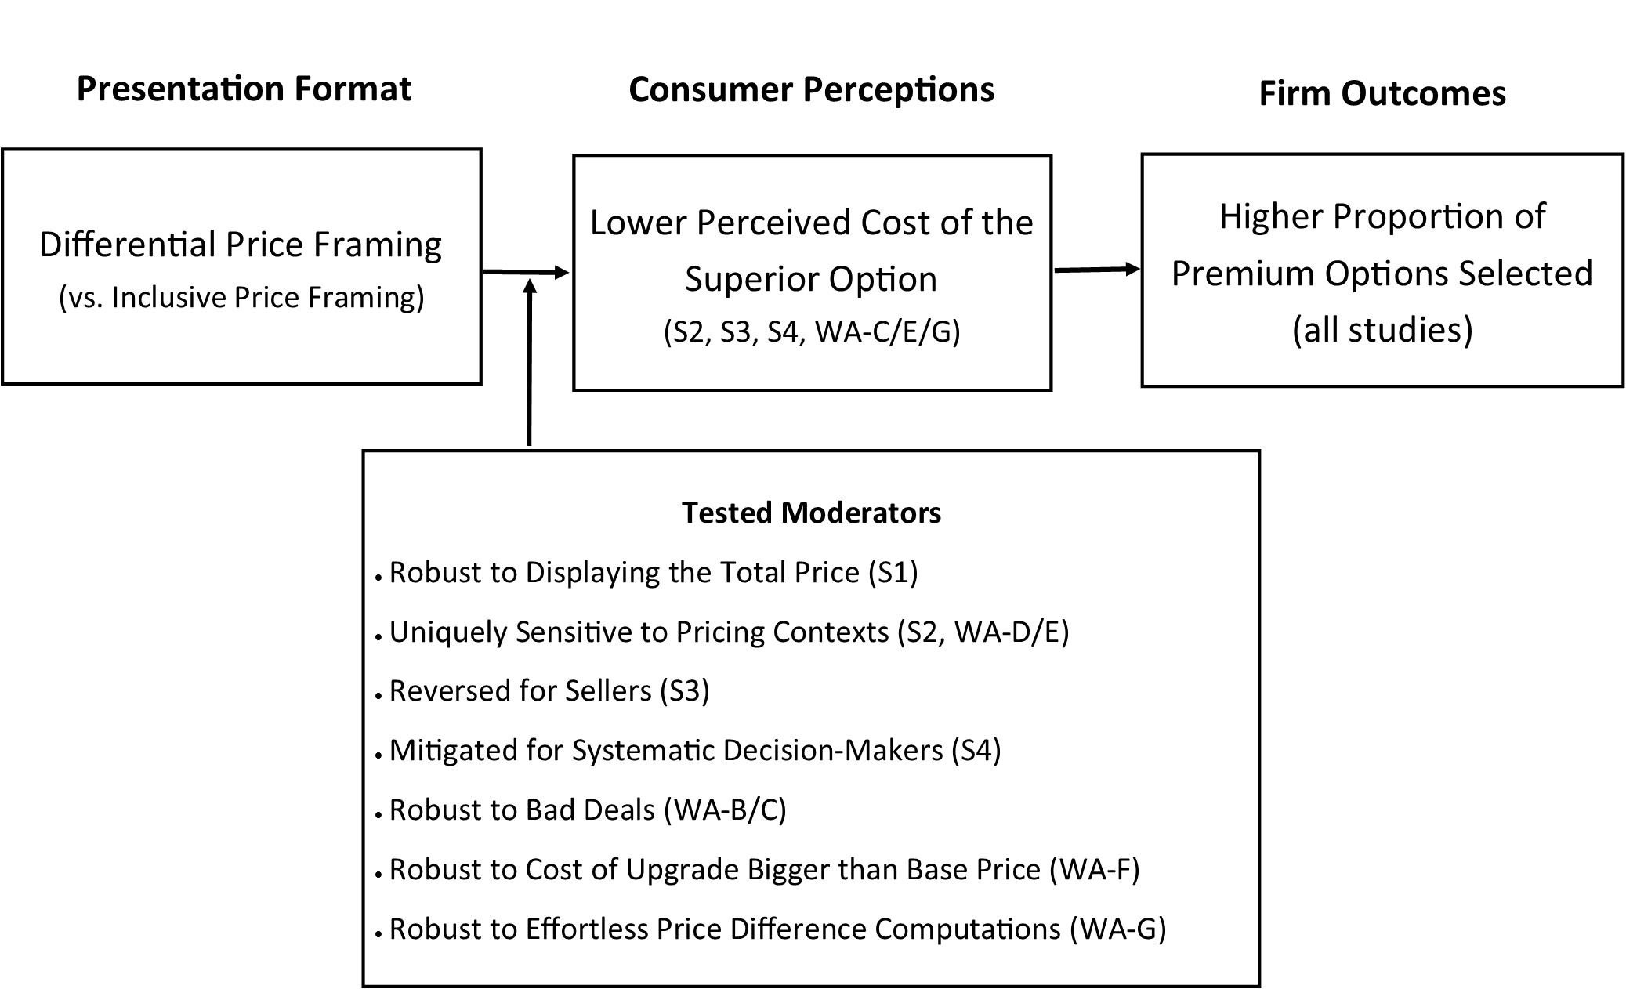

FIGURE 2
STUDY 3: PROPORTION OF PREMIUM OPTIONS SELECTED BY PRICE-FRAMING CONDITION AND TRANSACTION DOMAIN CONDITIONS

REFERENCES
Abraham, Ajay T. and Rebecca Hamilton (2019), "When Do Partitioned Prices Increase Demand? Meta-Analytic and Experimental Evidence," Journal of Marketing Research, 55 (5), 686-703.
Adaval, Rashmi and Kent B. Monroe (2002), "Automatic Construction and Use of Contextual Information for Product and Price Evaluations," Journal of Consumer Research, 28 (4), 572-88.
Allard, Thomas and Dale Griffin (2017), "Comparative Price and the Design of Effective Product Communications," Journal of Marketing, 81 (5), 16-29.
Bagchi, Rajesh and Derick F. Davis (2012), "$29 for 70 Items or 70 Items for $29? How Presentation Order Affects Package Perceptions," Journal of Consumer Research, 39 (1), 62-73.
Bart, Yakov, Venkatesh Shankar, Fareena Sultan, and Glen L Urban (2005), "Are the Drivers and Role of Online Trust the Same for All Web Sites and Consumers? A Large-Scale Exploratory Empirical Study," Journal of Marketing, 69 (4), 133-52.
Bertini, Marco and Luc Wathieu (2005), "Price Format and the Evaluation of Multicomponent Goods," Working paper.
--- (2008), "Attention Arousal through Price Partitioning," Marketing Science, 27 (2), 236-46.
Bettman, James R., Mary Frances Luce, and John W. Payne (1998), "Constructive Consumer Choice Processes," Journal of Consumer Research, 25 (3), 187-217.
Bodenhausen, Galen V. and Robert S. Wyer (1985), "Effects of Stereotypes in Decision Making and Information-Processing Strategies," Journal of Personality and Social Psychology, 48 (2), 267-82.
Burman, Bidisha and Abhijit Biswas (2007), "Partitioned Pricing: Can We Always Divide and Prosper?," Journal of Retailing, 83 (4), 423-36.
Cacioppo, John T., Richard E. Petty, Jeffrey A. Feinstein, and W. Blair G. Jarvis (1996), "Dispositional Differences in Cognitive Motivation: The Life and Times of Individuals Varying in Need for Cognition," Psychological Bulletin, 119 (2), 197-253.
Chaiken, Shelly (1980), "Heuristic Versus Systematic Information Processing and the Use of Source Versus Message Cues in Persuasion," Journal of Personality and Social Psychology, 39 (5), 752-66.
Chaiken, Shelly and Durairaj Maheswaran (1994), "Heuristic Processing Can Bias Systematic Processing: Effects of Source Credibility, Argument Ambiguity, and Task Importance on Attitude Judgment," Journal of Personality and Social Psychology, 66 (3), 460-73.
Cheema, Amar (2008), "Surcharges and Seller Reputation," Journal of Consumer Research, 35 (1), 167-77.
Cronley, Maria L., Steven S. Posavac, Tracy Meyer, Frank R. Kardes, and James J. Kellaris (2005), "A Selective Hypothesis Testing Perspective on Price-Quality Inference and Inference-Based Choice," Journal of Consumer Psychology, 15 (2), 159-69.
Dhar, Ravi (1997), "Consumer Preference for a No-Choice Option," Journal of Consumer Research, 24 (2), 215-31.
Ellison, Glen and Sara Fisher Ellison (2009), "Search, Obfucation, and Price Elasticity on the Internet," Econometrica: Journal of the Econometric Society, 77 (2), 427-52.
Erickson, Gary M. and Johny K. Johansson (1985), "The Role of Price in Multi-Attribute Product Evaluations," Journal of Consumer Research, 12 (2), 195-99.
Estelami, Hooman (1999), "The Computational Effect of Price Endings in Multi-Dimensional Price Advertising," Journal of Product & Brand Management, 8 (3), 244-56.
Friestad, Marian and Peter Wright (1994), "The Persuasion Knowledge Model: How People Cope with Persuasion Attempts," Journal of Consumer Research, 21 (1), 1-31.
Gabaix, Xavier and David Laibson (2006), "Shrouded Attributes, Consumer Myopia, and Information Suppression in Competitive Markets," Quarterly Journal of Economics, 121 (2), 505-40.
Gourville, John T. (1998), "Pennies-a-Day: The Effect of Temporal Reframing on Transaction Evaluation," Journal of Consumer Research, 24 (4), 395-408.
--- (1999), "The Effect of Implicit Versus Explicit Comparisons on Temporal Pricing Claims," Marketing Letters, 10 (2), 113-24.
Greenleaf, Eric A., Eric J. Johnson, Vicki G. Morwitz, and Edith Shalev (2016), "The Price Does Not Include Additional Taxes, Fees, and Surcharges: A Review of Research on Partitioned Pricing," Journal of Consumer Psychology, 26 (1), 105-24.
Grewal, Dhruv and Howard Marmorstein (1994), "Market Price Variation, Perceived Price Variation, and Consumers' Price Search Decisions for Durable Goods," Journal of Consumer Research, 21 (3), 453-60.
Guha, Abhijit, Abhijit Biswas, Dhruv Grewal, Swati Verma, Somak Banerjee, and Jens Nordfält (2018), "Reframing the Discount with a Comparison to the Sale Price: Does It Make the Discount More Attractive?," Journal of Marketing Research, 55 (3), 339-51.
Hamilton, Rebecca W. and Joydeep Srivastava (2008), "When 2 + 2 Is Not the Same as 1 + 3: Variations in Price Sensitivity across Components of Partitioned Prices," Journal of Marketing Research, 45 (4), 450-61.
Hardisty, David J., Eric J. Johnson, and Elke U. Weber (2010), "A Dirty Word or a Dirty World? Attribute Framing, Political Affiliation, and Query Theory," Psychological Science, 21 (1), 86-92.
Hayes, Andrew F. (2013), Introduction to Mediation, Moderation, and Conditional Process Analysis: A Regression-Based Approach: Guilford Press.
Hayes, Andrew F. and Kristopher J. Preacher (2013), "Statistical Mediation Analysis with a Multicategorical Independent Variable Doi: 10.1111/Bmsp.12028," British Journal of Mathematical and Statistical Psychology.
Herrmann, Andreas and Martin Wricke (1998), "Evaluating Multidimensional Prices," Journal of Product & Brand Management, 7 (2), 161-69.
Homburg, Christian, Dirk Totzek, and Melanie Krämer (2014), "How Price Complexity Takes Its Toll: The Neglected Role of a Simplicity Bias and Fairness in Price Evaluations," Journal of Business Research, 67 (6), 1114-22.
Hsee, Christopher K. (1998), "Less Is Better: When Low-Value Options Are Valued More Highly Than High-Value Options," Journal of Behavioral Decision Making, 11 (2), 107-21.
Hutchinson, J. Wesley and Joseph W. Alba (1991), "Ignoring Irrelevant Information: Situational Determinants of Consumer Learning," Journal of Consumer Research, 18 (3), 325-45.
Inbar, Yoel, Simona Botti, and Karlene Hanko (2011), "Decision Speed and Choice Regret: When Haste Feels Like Waste," Journal of Experimental Social Psychology, 47 (3), 533-40.
Janiszewski, Chris and Donald R. Lichtenstein (1999), "A Range Theory Account of Price Perception," Journal of Consumer Research, 25 (4), 353-68.
Kahneman, Daniel and Amos Tversky (1979), "Prospect Theory: An Analysis of Decision under Risk," Econometrica, 47, 263-91.
Kan, Christina, Donald R. Lichtenstein, Susan Jung Grant, and Chris Janiszewski (2013), "Strengthening the Influence of Advertised Reference Prices through Information Priming," Journal of Consumer Research, 40 (6), 1078-96.
Kardes, Frank R., Steven S. Posavac, and Maria L. Cronley (2004), "Consumer Inference: A Review of Processes, Bases, and Judgment Contexts," Journal of Consumer Psychology, 14 (3), 230-56.
Kim, Jungkeun, Raghunath Singh Rao, Kyeongheui Kim, and Akshay R. Rao (2011), "More or Less: A Model and Empirical Evidence on Preferences for under-and Overpayment in Trade-in Transactions," Journal of Marketing Research, 48 (1), 157-71.
Krishna, Aradhna, Richard Briesch, Donald R. Lehmann, and Hong Yuan (2002), "A Meta-Analysis of the Impact of Price Presentation on Perceived Savings," Journal of Retailing, 78 (2), 101-18.
Kyung, Ellie J., Manoj Thomas, and Aradhna Krishna (2017), "When Bigger Is Better (and When It Is Not): Implicit Bias in Numeric Judgments," Journal of Consumer Research, 44 (1), 62-79.
Levav, Jonathan, Mark Heitmann, Andreas Herrmann, and Sheena S. Iyengar (2010), "Order in Product Customization Decisions: Evidence from Field Experiments," Journal of Political Economy, 118 (2), 274-99.
MacInnis, Deborah J. and C Whan. Park (1991), "The Differential Role of Characteristics of Music on High-and Low-Involvement Consumers' Processing of Ads," Journal of Consumer Research, 18 (2), 161-73.
Manning, Kenneth C. and David E. Sprott (2009), "Price Endings, Left-Digit Effects, and Choice," Journal of Consumer Research, 36 (2), 328-35.
Morwitz, Vicki, Eric Greenleaf, and Eric J. Johnson (1998), "Divide and Prosper: Consumers' Reaction to Partitioned Prices," Journal of Marketing Research, 35 (4), 453-63.
Novemsky, Nathan, Ravi Dhar, Norbert Schwarz, and Itamar Simonson (2007), "Preference Fluency in Choice," Journal of Marketing Research, 44 (3), 347-56.
Park, C. Whan, Sung Youl Jun, and Deborah J. MacInnis (2000), "Choosing What I Want Versus Rejecting What I Do Not Want: An Application of Decision Framing to Product Option Choice Decisions," Journal of Marketing Research, 37 (2), 187-202.
Payne, John W., James R. Bettman, and Eric J. Johnson (1988), "Adaptive Strategy Selection in Decision Making," Journal of Experimental Psychology: Learning, Memory, and Cognition, 14 (3), 534-52.
Peters, Ellen, Daniel Västfjäll, Paul Slovic, CK Mertz, Ketti Mazzocco, and Stephan Dickert (2006), "Numeracy and Decision Making," Psychological Science, 17 (5), 407-13.
Petty, Richard E. and John T. Cacioppo (1984), "The Effects of Involvement on Responses to Argument Quantity and Quality: Central and Peripheral Routes to Persuasion," Journal of Personality and Social Psychology, 46 (1), 69-81.
Raghubir, Priya and Joydeep Srivastava (2002), "Effect of Face Value on Product Valuation in Foreign Currencies," Journal of Consumer Research, 29 (3), 335-47.
Robbert, Thomas and Stefan Roth (2014), "The Flip Side of Drip Pricing," Journal of Product & Brand Management, 23 (6), 413-19.
Schindler, Robert M. and Patrick N. Kirby (1997), "Patterns of Rightmost Digits Used in Advertised Prices: Implications for Nine-Ending Effects," Journal of Consumer Research, 24 (2), 192-201.
Schkade, David A. and Daniel Kahneman (1998), "Does Living in California Make People Happy? A Focusing Illusion in Judgments of Life Satisfaction," Psychological Science, 9 (5), 340-46.
Schwarz, Norbert (1998), "Accessible Content and Accessibility Experiences: The Interplay of Declarative and Experiential Information in Judgment," Personality and Social Psychology Review, 2 (2), 87-99.
Slovic, Paul (1972), "From Shakespeare to Simon: Speculations—and Some Evidence—About Man's Ability to Process Information," Oregon Research Institute Bulletin, 12 (12), 1-19.
Srivastava, Joydeep and Dipankar Chakravarti (2011), "Price Presentation Effects in Purchases Involving Trade-Ins," Journal of Marketing Research, 48 (5), 910-19.
Suk, Kwanho, Jiheon Lee, and Donald R. Lichtenstein (2012), "The Influence of Price Presentation Order on Consumer Choice," Journal of Marketing Research, 49 (5), 708-17.
Suri, Rajneesh and Kent B. Monroe (2003), "The Effects of Time Constraints on Consumers' Judgments of Prices and Products," Journal of Consumer Research, 30 (1), 92-104.
Thaler, Richard H. (1985), "Mental Accounting and Consumer Choice," Marketing Science, 4 (3), 199-214.
Thaler, Richard H. and Eric J. Johnson (1990), "Gambling with the House Money and Trying to Break Even: The Effects of Prior Outcomes on Risky Choice," Management Science, 36 (6), 643-60.
Thomas, Manoj and Vicki Morwitz (2005), "Penny Wise and Pound Foolish: The Left-Digit Effect in Price Cognition," Journal of Consumer Research, 32 (1), 54-64.
Thomas, Manoj and Vicki G. Morwitz (2009), "The Ease-of-Computation Effect: The Interplay of Metacognitive Experiences and Naive Theories in Judgments of Price Differences," Journal of Marketing Research, 46 (1), 81-91.
Tversky, Amos and Daniel Kahneman (1974), "Judgment under Uncertainty: Heuristics and Biases," Science, 185 (4157), 1124-31.
--- (1981), "The Framing of Decisions and the Psychology of Choice," Science, 211 (4481), 453-58.
--- (1986), "Rational Choice and the Framing of Decisions," Journal of Business, 59 (4), S251-S78.
Völckner, Franziska, Alexander Rühle, and Martin Spann (2012), "To Divide or Not to Divide? The Impact of Partitioned Pricing on the Informational and Sacrifice Effects of Price," Marketing Letters, 23 (3), 719-30.
Wadhwa, Monica and Kuangjie Zhang (2014), "This Number Just Feels Right: The Impact of Roundedness of Price Numbers on Product Evaluations," Journal of Consumer Research, 41 (5), 1172-85.
Wertenbroch, Klaus, Dilip Soman, and Amitava Chattopadhyay (2007), "On the Perceived Value of Money: The Reference Dependence of Currency Numerosity Effects," Journal of Consumer Research, 34 (1), 1-10.
Wilson, Timothy D., Thalia Wheatley, Jonathan M. Meyers, Daniel T. Gilbert, and Danny Axsom (2000), "Focalism: A Source of Durability Bias in Affective Forecasting," Journal of Personality and Social Psychology, 78 (5), 821.
Yan, Dengfeng and Jorge Pena-Marin (2017), "Round Off the Bargaining: The Effects of Offer Roundness on Willingness to Accept," Journal of Consumer Research, 44 (2), 381-95.

WEB APPENDIX A
EXPERIMENTAL STIMULI AND DETAILED RESULTS
Study 1: Stimuli
Inclusive Price Framing Condition
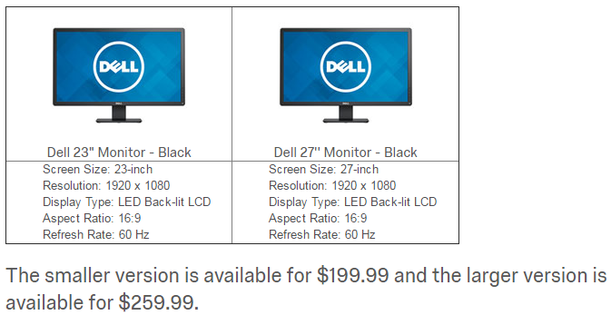

Differential Price Framing condition
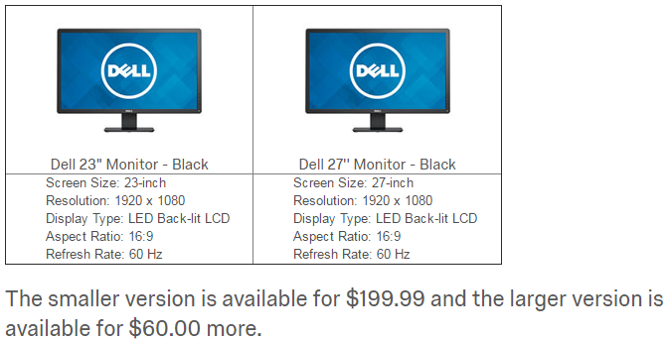

Differential Price Framing + total price condition (Study 1 only)
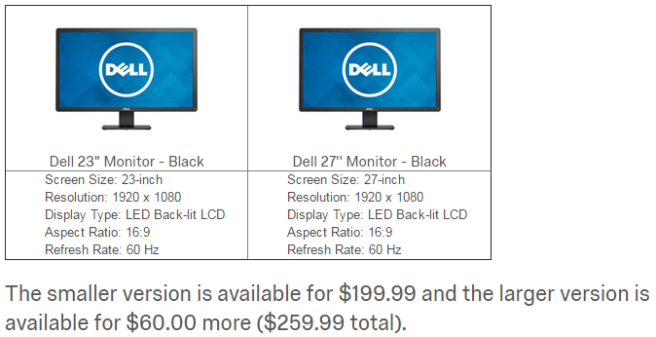
Study 2: Stimuli
- Inclusive Price Framing

Which will you choose to buy?
- $9.99/month New York Times web and app
- $16.99/month New York Times web, app, print, podcast, and crossword

- Differential Price Framing

Which will you choose to buy?
- $9.99/month New York Times web and app
- +$7.00/month New York Times web, app, print, podcast, and crossword

- Differential Quality Framing
Which will you choose to buy?
- $9.99/month New York Times web and app
- B. $16.99/month +print, podcast, and crossword

STUDY 2: EXPENSIVENESS, VALUE, AND EVALUABILITY RATINGS BY PRICE FRAMING CONDITION
Price Framing | Standard Option A | Premium Option B | Difference Score (B - A)
Perceived expensiveness (1-7; higher scores indicate more expensive)
IPF | 4.08 (1.42) | 5.31 (1.42) | 1.23 (1.41)
DQF | 3.92 (1.30) | 5.42 (1.06) | 1.51 (1.08)
DPF | 4.56 (1.30) | 4.75 (1.42) | 0.20 (1.40)
ANOVA | F(2,250) = 5.03,  p = .01, η_{p}² = .04 | F(2,250) = 10.63,  p < .01, η_{p}² = .05 | F(2,250) = 23.06,  p < .001, η_{p}² = .16
Perceived value of services (1-7; higher scores indicate more value)
IPF | 4.41 (1.46) | 4.52 (1.35) | .10 (1.53)
DQF | 4.42 (1.34) | 4.16 (1.37) | -.26 (1.42)
DPF | 4.54 (1.21) | 4.63 (1.54) | .09 (1.98)
ANOVA | F(2,250) = 0.24,  p = .79, η_{p}² = .00 | F(2,250) = 2.50,  p = .09, η_{p}² = .02 | F(2,250) = 1.29,  p = .28, η_{p}² = .01
Evaluability of price (1-7; higher scores indicate more difficult to evaluate)
IPF | 3.44 (1.28) | 3.70 (1.42) | 0.26 (1.62)
DQF | 3.07 (1.20) | 3.89 (1.41) | 0.81 (1.48)
DPF | 3.06 (1.32) | 3.69 (1.46) | 0.63 (1.57)
ANOVA | F(2,250) = 2.44,  p = .09, η_{p}² = .02 | F(2,250) = 0.48,  p = .62, η_{p}² = .00 | F(2,250) = 2.75,  p = .07, η_{p}² = .02
Evaluability of services (1-7; higher scores indicate more difficult to evaluate)
IPF | 3.18 (1.41) | 3.69 (1.46) | 0.51 (1.68)
DQF | 2.99 (1.29) | 3.74 (1.39) | 0.75 (1.41)
DPF | 3.12 (1.37) | 3.77 (1.50) | 0.64 (1.58)
ANOVA | F(2,250) = 0.47,  p = .63, η_{p}² = .00 | F(2,250) = 0.06,  p = .94, η_{p}² = .00 | F(2,250) = 0.54,  p = .58, η_{p}² = .00

The perceived value of Option A, Option B, and the difference score did not vary significantly by framing condition Bootstrapped mediations by perceived value difference scores were not significant, either for DQF (b = -.34, SE = .23, CI₉₅ [-.82, .09]) or DPF (b = -.02, SE = .27, CI₉₅ [-.56, .52]). Furthermore, ratings of the evaluability of the prices, services, and difference scores did not vary by framing condition and bootstrapped mediation of DPF or DQF by evaluability judgments (of price, quality, or difference scores) were all non-significant.
Study 3: Stimuli

Buyer Inclusive Price Framing (Differential Price Framing) condition:

Imagine you need a commuter bicycle and are looking to purchase a lightly-used second-hand one on Craigslist.
You have found an ad for two bicycles and have contacted the seller about your interest in purchasing one of them.

The two bicycles are both made by Schwinn, have the same frame and tires, but differ in that one has regular “generic” parts and one has premium “brand-name” parts.
- The first bicycle is a 3-speed bicycle with generic brand parts.
- The second bicycle is a 21-speed bicycle with Shimano parts.
The seller is offering to sell you the 3-speed bicycle for $150 or the 21-speed bicycle for $210 ($60 more).

Seller Inclusive Price Framing (Differential Price Framing) condition:

Imagine you own two lightly-used second-hand commuter bicycles and are looking to sell one on Craigslist.
You have posted an ad for your two bicycles and have been contacted by a buyer interested in purchasing one of them.

The two bicycles are both made by Schwinn, have the same frame and tires, but differ in that one has regular “generic” parts and one has premium “brand-name” parts.

- The first bicycle is a 3-speed bicycle with generic brand parts.
- The second bicycle is a 21-speed bicycle with Shimano parts.​
The buyer is offering to purchase from you the 3-speed bicycle for $150 or the 21-speed bicycle for $210 ($60 more).

Study 4: stimuli

Introduction prompt (constant across conditions)

Study 4: stimuli (Cont’d)

Slow-is-Accurate condition

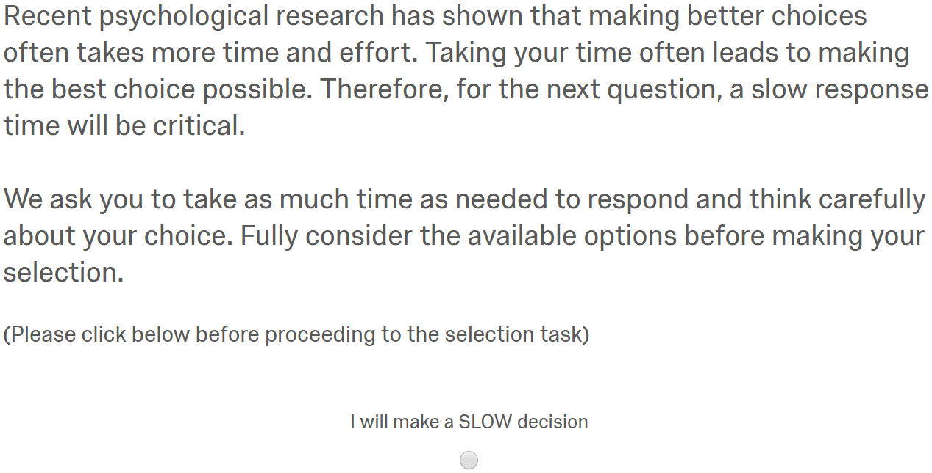

Fast-is-Accurate condition

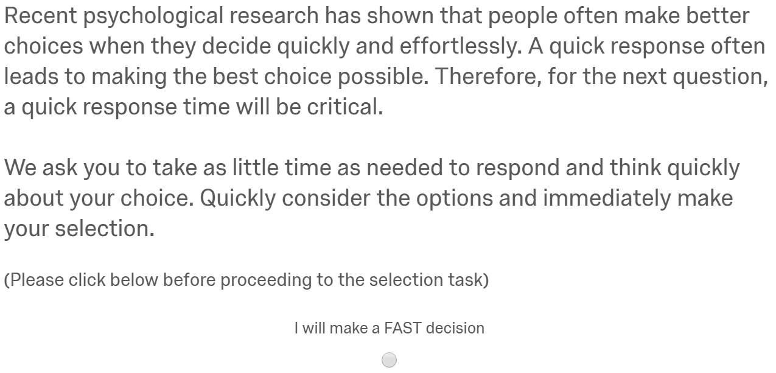

Study 4: stimuli (Cont’d)

Integrated Price Framing condition

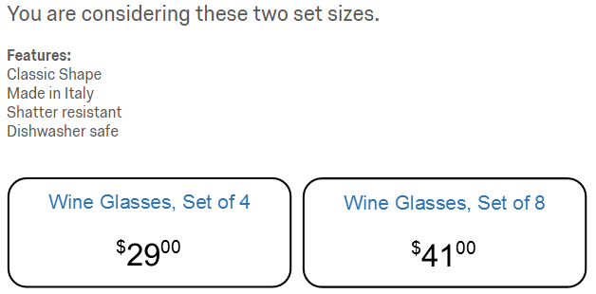

Differential Price Framing condition
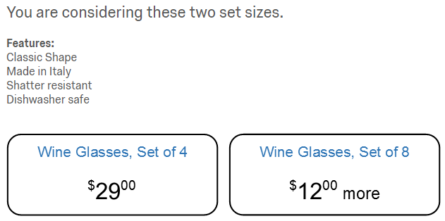

STUDY 4: DEPENDENT VARIABLES BY PRICE FRAMING
AND SPEED OF PROCESSING CONDITION
 | Speed of Processing
Price Framing | Control | Fast | Slow
Proportion selecting the premium option
IPF | 52% | 47% | 63%
DPF | 68% | 65% | 55%
Decision-making duration (in seconds)
IPF | 21.48 (49.27) | 7.62 (4.74) | 32.50 (61.22)
DPF | 19.98 (13.89) | 10.15 (8.73) | 35.98 (30.81)
Standard Option Expensiveness (4 wine glasses)
(1-5; higher scores mean more expensive)
IPF | 3.07 (1.13) | 3.26 (1.03) | 3.28 (1.05)
DPF | 3.46 (1.15) | 3.53 (1.06) | 3.40 (1.13)
Premium Option Expensiveness (8 wine glasses)
(1-5; higher scores mean more expensive)
IPF | 2.84 (1.17) | 3.05 (1.16) | 2.60 (1.14)
DPF | 2.53 (1.20) | 2.63 (1.27) | 2.61 (1.26)
Expensiveness Difference Score (Premium - Standard)
(smaller scores mean smaller perceived price differences between options)
IPF | -.19 (1.63) | -.20 (1.59) | -.68 (1.41)
DPF | -1.09 (1.42) | -.89 (1.60) | -.79 (1.59)
Retailer Trust
(1-7; higher scores mean more trustworthy)
IPF | 4.61 (1.04) | 4.52 (.83) | 4.58 (1.05)
DPF | 4.59 (1.05) | 4.58 (1.10) | 4.52 (.96)
Proportion successfully recalling the prices of each option (+/-$1)
IPF | 69% | 60% | 79%
DPF | 76% | 64% | 81%

WEB APPENDIX B
Robustness-to-Bad-Deals Study
This study tests whether DPF is moderated by whether the premium option is a "good deal" or a "bad deal," to test whether the DPF effect is different from previously established price framing methods. Specifically, Price Partitioning has been shown to make products more attractive under “good deal” conditions, but less attractive under “bad deal” conditions, when manipulating the offer value using variations in quality (Bertini and Wathieu 2008). Using a similar experimental approach keeping the prices constant and varying the quality of the premium option, this study shows that the DPF effect is robust to bad deals. We predict the DPF effect to be robust to quality-induced value variation because the driving mechanism for DPF framing is the increased salience of the price difference (versus the total price of the premium option), which is unaffected by the quality of the deal, irrespective of the source of the value variation. In other words, this study highlights the different mental processes and behavioral effects arising from DPF and PP under bad-deal conditions.
Method
Participants and Design. Five hundred and seventeen UK participants recruited through Prolific Academic took part in the main experiment (67% female, M_{age} = 36.7). This experiment uses a 2 (framing: inclusive-price vs. differential-price) x 3 (premium option quality levels: 8 hours vs. 7 hours vs. 6 hours for a train journey) between-participants design. The dependent variable of interest was the proportion of premium options selected.
Procedure. Participants were instructed to imagine themselves buying a train ticket and shown two different train-route options on one web page. Train A takes 10 hours to reach its destination and tickets retail for €79.00. The other option, Train B, offered a shorter journey for €109.00 in the IPF condition (for €30.00 more in the DPF condition). The premium train journey option took either 8 hours, 7 hours, or 6 hours to reach the destination. The instruction specified that the view along the way was not scenic and that both trains offered a similar level of comfort. Participants were instructed to choose their preferred train journey.
Pre-test
We pre-tested the extent to which the premium option prices used in this study (a shorter €109.00 train journey of either 8 hours, 7 hours, or 6 hours; compared to a longer €79.00 train journey of 10 hours) were perceived as good or bad deals (1 = a very bad deal; 9 = a very good deal; Bertini and Wathieu 2005) on a separate sample taken from the same UK Prolific population as the main study (n = 191). Using a between-participants design, the chosen prices led to significantly different ratings on deal attractiveness (F(2,188) = 9.80, p < .001). Planned contrasts revealed that the 8-hour journey (M = 4.31, SD = 1.62) was rated as significantly worse than the 7-hour journey (M = 5.02, SD = 1.70; t(188) = 2.50, p = .01) and the 6-hour journey (M = 5.57, SD = 1.50; t(188) = 4.41, p < .001), and that the two latter condition. Were also significantly different from each other (t(188) = 1.95, p = .05). More importantly, when comparing these values to the mid-point on the scale (x = 5), the 8-hours journey was rated as significantly worse than the mid-point (t(190) = 5.66, p < .001; suggesting a bad deal), the 7-hour journey offer did not significantly differ from the mid-point (t < 1), and the 6-hour journey was significantly above the mid-point (t(190) = 4.68, p < .001; suggesting a good deal), validating our bad deal manipulation.
Results
Using logistic regression with two dummy coded variables (using the intermediate option as the reference category), we found no significant two-way interaction between the quality-level and price-framing conditions (Z’s < 1) suggesting no difference in the price-framing effect between the different quality levels (i.e., duration of the train routes). Importantly, we observed a significant main effect of the price-framing condition (b = .74, SE = .32, Z = 2.29, p < .05). That is, across good and bad deals, a significantly higher proportion of people selected the premium, but more expensive choice option in the DPF conditions overall (P = 43%) compared to the IPF condition (P = 32%; Cohen’s d = .27); further supporting H1). We also observed a significant main effect of the 6-hour journey dummy (b = 1.01, SE = .33, Z = 3.10, p < .01) consistent with a larger proportion of participants selecting the premium option as commuting time decreases.
PROPORTION OF PREMIUM OPTIONS SELECTED BY PRICE-FRAMING AND QUALITY-LEVEL CONDITIONS

Discussion
This study provides additional evidence that the DPF effect is distinct from a standard price partitioning effect by showing how the effect is robust across “good” and “bad” deals. Whereas price partitioning leads to a reversal effect in the presence of bad deals because of its attentional mechanism (Bertini and Wathieu 2008), the DPF effect is robust to bad deals. We conducted a replication of this robustness study where quality was kept constant and prices varied (See Web Appendix C). The results again supported the robustness of the DPF effect across bad deals. Thus, we have not found any total-price limit or threshold for the effect. We explain this result by the consumers’ focus on the smaller cost difference (vs. the total price of the premium option) as they make their subjective value assessment of the cost of upgrade from the standard option across the range of available deals.

Stimuli

Imagine that you are planning a trip.
You are looking to purchase a train ticket that will bring you to your next destination. Two train routes are available on the date you wish to travel.
Train A takes longer to reach your destination but is cheaper. Train B is faster but more expensive.
The view along the way is not scenic and the trains offer a similar level of comfort.

- IPF/8-hour condition
Train A  Takes 10 hours  for £79.00 | Train B  Takes 8 hours  for £109.00

- DPF/6-hour condition
Train A  Takes 10 hours  for £79.00 | Train B  Takes 6 hours  for £30.00 more

WEB APPENDIX C
Deal-Attractiveness Robustness Study
This study provides further evidence that the DPF effect is robust across price levels, given a constant level of quality. That is, while other forms of price framing (specifically, Price Partitioning) have been shown to make products more attractive under “good deal” conditions, but less attractive under “bad deal” conditions because of the increased focus on the partitioned attribute (Bertini and Wathieu 2008), we expect the price-focalism-driven effect of DPF on consumer choice to be robust to variations in deal attractiveness. We make this prediction because the driving mechanism for DPF framing is the salience of the cost difference (versus the total price), which is unaffected by the quality of the deal (i.e., the focal price under DPF is always smaller than IPF).
Pre-test
Using a between-participants design, we pre-tested the extent to which the premium option prices used in this study (27-inch computer monitors priced at $259.99, $319.99, and $379.99) were perceived as good or bad deals (1 = a very bad deal; 9 = a very good deal; Bertini and Wathieu 2005), on a separate sample taken from the same MTurk population as the main study (n = 91). (The actual market prices for these 23-inch and 27-inch monitors were $199.99 and $259.99 respectively.) As expected, the chosen prices led to significantly different ratings on deal attractiveness (F(2,88) = 14.68, p < .001). Using planned contrasts, the $379.99 price (M = 3.19, SD = 1.40) was rated as significantly worse than the $319.99 price (M = 4.70, SD = 2.05; t(88) = 2.21, p < .05) and the $259.99 price (M = 5.82, SD = 2.26; t(88) = 5.41, p < .001). The $319.99 and $259.99 prices were also significantly different from each other (t(88) = 2.96, p < .01). Furthermore, when comparing these values to the mid-point on the scale (x = 5), the $379.99 offer was rated as significantly worse than the mid-point (t(90) = 7.79, p < .001; suggesting a bad deal), the $319.99 offer did not significantly differ from the mid-point (t(90) = 1.29, p = .20), and the $259,99 offer was significantly above the mid-point (t(90) = 3.53, p < .001; suggesting a good deal) validating our bad deal manipulation.
Method
Participants and Design. Four hundred and four participants recruited through Amazon MTurk took part in the main experiment (47% female, M_{age} = 35.7). This experiment uses a 2 (framing: inclusive-price vs. differential-price) x 3 (premium option price levels: $259.99 vs. $319.99 vs. $379.99) between-participants design. The dependent variable of interest was the proportion of premium options selected.
Procedure. As in Study 1, participants were instructed to imagine themselves shopping for a new computer monitor and shown two different monitor options (23-inch vs. 27-inch) on one web page, where the 23-inch version retailed at $199.99. In the IPF conditions, the premium 27-inch monitor was available for either “$259.99,” “$319.99,” or “$379.99” depending on the price condition, whereas the same size upgrades in the DPF conditions were offered for “$60.00 more,” “$120.00 more,” or “$180.00 more” respectively. Participants were instructed to select the monitor they would normally choose. After selecting the monitor of their choice, participants rated the extent to which the premium choice option appeared expensive compared to the standard option using one 7-point item: “Compared to the 23-inch version, how much more expensive is the 27-inch version?”; 1: No more expensive; 7: Very much more expensive.
Results

Product Choice. Results from a logistic regression with two dummy coded variables to account for multicategorical price levels suggested no significant dummy1*priceframing interaction (Z < 1) and a significant dummy2*priceframing interaction (b = .74, SE = .61, Z = 1.20, p > .20) suggesting no difference in the price-framing effect between the price levels. Following a traditional demand function, we observed two significant effects of the price-level condition (dummy1: b = -1.30, SE = .41, Z = 3.14, p < .01; dummy2: b = -1.99, SE = .49, Z = 4.02, p < .001), consistent with a smaller proportion of participants selecting the premium option as its price increases. More importantly, we observed a significant main effect of DP versus IP price framing (b = .72, SE = .35, Z = 2.06, p < .05) further supporting H1. Overall, across price-level conditions, a significantly higher proportion of people selected the premium, but more expensive choice option in the DPF conditions overall (P = 37%) compared to the IPF condition (P = 22%; b = .73, SE = .22, Wald χ² = 10.72, p = .001; Cohen’s d = .40).
PROPORTION OF PREMIUM OPTIONS SELECTED AND PERCEIVED EXPENSIVENESS BY PRICE-FRAMING AND PRICE-LEVEL CONDITIONS
 | Price Level
Price Framing | $259.99/  $60.00 more | $319.99/  $120.00 more | $379.99/  $180.00 more
Proportion selecting the premium option
IPF | 42% | 16% | 9%
DPF | 60% | 23% | 30%
Perceived Expensiveness (relative difference)
(1-7; higher scores mean more expensive)
IPF | 4.45 (1.23) | 5.73 (0.88) | 5.91 (0.85)
DPF | 3.79 (1.23) | 5.51 (1.46) | 5.43 (1.70)

Perceived Expensiveness. Mirroring the choice data, there was no interaction between price framing and price level in predicting the perception of expensiveness (b = .09, SE = .15, t < 1). However, consistent with H2, there was a significant main effect of price framing on judgments of expensiveness (b = -.45, SE = .13, t(400) = 3.43, p < .001) providing support for our proposed mechanism. The premium option was perceived to be less expensive overall in the DPF condition (M = 4.92, SD = 1.67) compared to the IPF condition (M = 5.36, SD = 1.19). There was also a significant main effect of the price level (b =.73, SE = .11, t(400) = 6.47, p < .001) consistent with participants perceiving the premium option as more expensive as its price increased.
Mediation. We conducted a mediation analysis to test whether perceived expensiveness could explain the difference in the proportion of premium options selected between the price-framing conditions, controlling for the price-level condition. Using a 5,000 bootstrap resampling method (Hayes 2013), there was a significant indirect effect (b = .35, SE = .12, CI₉₅ [.14, .62]) of price framing on the proportion of premium options selected, mediated by perceived expensiveness, supporting H2. As noted, the premium choice option was perceived to be less expensive in the DPF condition than in the IPF condition (b = -.45, SE = .13, t(401) = 3.44, p < .001, CI₉₅ [-.70, -.19]). In turn, the more expensive the premium product was perceived, the less likely people were to select it (b = -.79, SE = .11, Z = 7.21, p = .001, CI₉₅ [-1.01, -.58]).
Discussion
This study offers a conceptual replication of Web Appendix B, providing further evidence that the effect of DPF is robust across “good” and “bad” deals, further differentiating this from a standard price partitioning effect where a bad-deal reversal effect would have been expected (Bertini and Wathieu 2008): This demonstration extends the results of Web Appendix B by offering a replication in a context where price vary, keeping quality constant, as opposed to keeping price constant and varying quality. This study also shows that the increase in the proportion of participants selecting the premium choice option in the DPF over the IPF condition is consistent with a shift in the perceived expensiveness of the product. This result can be explained by the fact that the perceived expensiveness of the premium option is always lower in DPF than in IPF, no matter how large the price difference between products is.
WEB APPENDIX D
Differential Quality Frame Effect Replication Study
Given the somewhat surprising finding in Study 2 that a differential quality framing (DQF) does not affect choices, we conducted a conceptual replication of this effect using a different product category.
Method
Participants and Design. Two hundred and thirty-five undergraduate students took part in this laboratory experiment (62% female, M_{age} = 19.5). The experiment used a one-factor three-level (framing: inclusive-price vs. differential-price vs. differential-quality) between-participants design. The dependent variable was the proportion of participants selecting the premium option.
Procedure. Participants were instructed to imagine themselves shopping for a new external hard drive and shown two different hard drive options on one web page. Both hard drives were identical on every feature (i.e., brand, size, compatibility, data transfer rate, color) except for storage capacity and price. The smaller hard drive, which was the standard option, was presented as “2 TB storage capacity for $119.99 total.” The other hard drive, the premium option, was the larger version and thus, retailed for more. The premium hard drive was offered under three different framings. In the IPF condition, it was presented as “3 TB storage capacity for $169.99 total.” (Note that while we label it IPF, this condition also employs Inclusive Quality Framing, and so provides a control baseline against which to judge both experimental conditions.) In the DPF condition, it was presented as “3 TB storage capacity for $50.00 more.” Finally, in the DQF condition, it was presented as “1 TB additional storage capacity for $169.99 total.” Participants were instructed to select the hard drive they would normally choose.
Results
Results from a logistic regression with two dummy coded variables revealed a significant effect of the framing condition on the proportion of participants selecting the premium choice option (χ²(2) = 6.45, p < .05). Most importantly, the proportion of participants selecting the premium option in the DPF condition (P = 48%) was significantly higher than in the IPF condition (P = 33%; b = .65, SE = .33, Wald χ²(1) = 3.76, p = .05; Cohen’s d = .36), supporting again H1. Furthermore, the proportion of premium choices in the DPF condition was also significantly higher than that in the DQF condition (P = 29%; b = .80, SE = .34, Wald χ²(1) = 5.63, p < .05). Finally, there was no significant difference in the proportion of premium choice options selected between the IPF and the DQF conditions (b = .15, SE = .34, Wald χ²(1) = .20, p > .85).
Discussion
This study replicates the benefit of DPF and casts doubt on the ability of the more general compensatory trade-off or anchoring and adjustment models to explain the effect. Thus, the results further support the pricing focalism model: DPF increases the focus on the price difference when assessing the cost of the upgrade and hence lowers the perceived expensiveness of the premium option (because DPF is always numerically smaller than IPF). Because the null effect of DQF was somewhat surprising, and because null results can be hard to interpret (e.g., perhaps terabytes are hard for consumers to understand and so have no impact in any frame), we ran a third study dedicated to comparing IPF, DPF, and DQF, with different and more familiar stimuli (flight prices and travel times). The results, summarized in Web Appendix E, are the same: DPF influences choices, but DQF does not. The next study further tests these results with incentive compatible outcomes and directly tests the role of perceived expensiveness as a mediator of the DPF effect.
Stimuli
Inclusive Price Framing condition
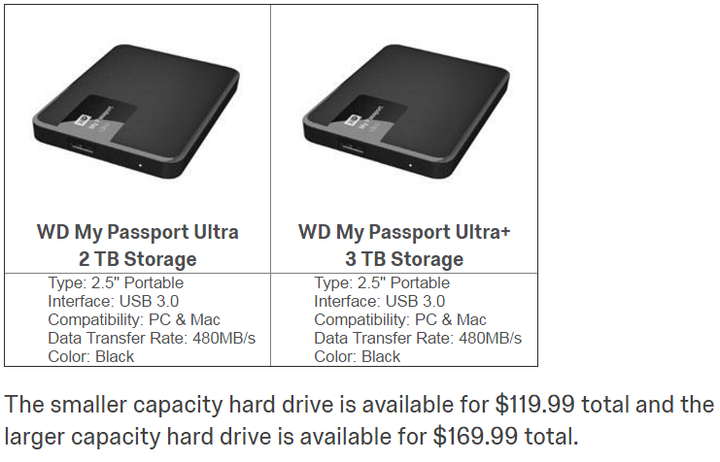
Differential Price Framing condition
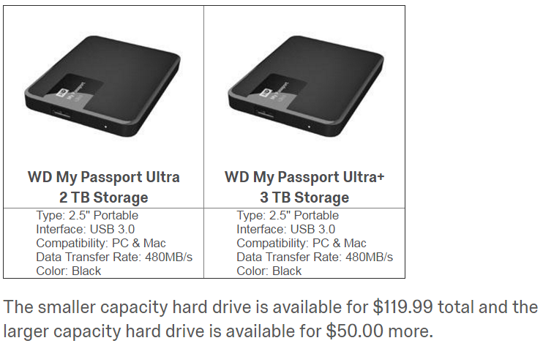
Differential Quality Framing condition
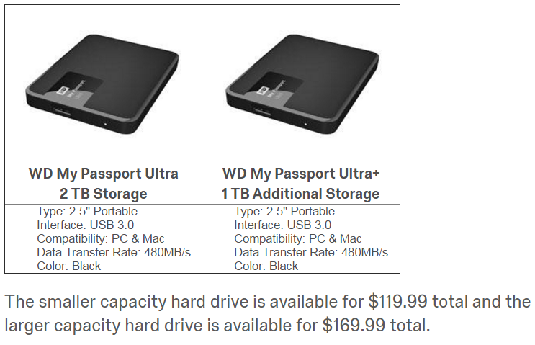
WEB APPENDIX E
Differential Time Framing Study
This study further tested whether the effectiveness of differential framing was unique to price framing and expensiveness judgments, or whether other focal attributes (such as the flight time) could be similarly influenced by differential framing.
Method
Participants and Design. Four hundred US participants (39% female, M_{age} = 32) were recruited through Prolific Academic. The experiment used a 2 (attribute focus: price vs. time) x 2 (attribute framing: inclusive vs. differential) between participants design. The dependent variable of interest was the choice proportion of "Flight B," the "differential" flight (i.e., the flight with differential price in the price condition, or the flight with differential time in the time condition).
Procedure. Participants were asked to choose between two flights from Chicago (ORD) to Los Angeles (LAX), where one flight was cheaper but took longer to reach the destination because of a connection. In the price condition, participants chose between "flight A, a 9-hour flight that costs $250 or flight B, a 5-hour flight that costs $399 [$149 more]", whereas in the time condition, participants chose between "flight A, a $399 flight that takes 5 hours or flight B, a $250 flight that takes 9 hours [4 hours more]". Thus, although the flights were the same in each condition, the order was reversed, such that in the price condition, flight B was more expensive (and shorter), and in the time condition, flight B was longer (and cheaper). Furthermore, the position and font size of the attributes (price and time) in the stimuli was reversed such that in the price condition, price was the focal attribute (more prominent position, bigger font), and in the time condition, flight time was the focal attribute.
Then, on a subsequent page, participants rated the expensiveness of each option using the same items as in Study 4. These items were used to compute a difference score representing the relative difference in expensiveness between the options. Similarly, participants rated the perceived length of each of the flights, and we calculated a difference score from these items as well.
Results
DIFFERENTIAL TIME FRAMING STUDY: DEPENDENT VARIABLES BY ATTRIBUTE FOCUS AND ATTRIBUTE FRAMING CONDITIONS
 | Attribute Focus Condition
Attribute Framing | Price | Time
Proportion selecting Flight B
Inclusive | 32% | 63%
Differential | 46% | 57%
Perceived Expensiveness of Flight A
(1-5; higher scores mean more expensive)
Inclusive | 2.33 (1.01) | 3.93 (0.98)
Differential | 2.74 (1.19) | 3.94 (0.93)
Perceived Expensiveness of Flight B
(1-5; higher scores mean more expensive)
Inclusive | 4.09 (0.88) | 2.52 (0.95)
Differential | 3.90 (1.01) | 2.62 (0.94)
Perceived Length of Flight A
(1-5; higher scores mean longer)
Inclusive | 4.33 (0.83) | 2.44 (0.91)
Differential | 4.32 (0.92) | 2.58 (0.93)
Perceived Length of Flight B
(1-5; higher scores mean longer)
Inclusive | 2.60 (0.96) | 4.45 (0.86)
Differential | 2.68 (1.04) | 4.41 (0.76)

Product Choice. Results from a 2 x 2 logistic regression suggested no main effect of attribute framing (b = -0.25, SE = 0.29, Wald χ²(1) = 0.75, p > .35), indicating no overall effect of differential framing, but this was qualified by a two-way interaction between attribute focus and attribute framing (b = 0.88, SE = 0.41, Wald χ²(1) = 6.60, p < .05). Follow-up pairwise comparisons revealed that in the price condition, people chose the more expensive option more often in the differential frame (P = 46%) than in the inclusive frame (P = 32%; b = .63, SE = .29, Wald χ²(1) = 4.55, p < .05; Cohen’s d = .30), in support of H1. Conversely, in the time condition, there was no significant difference in the selection of the longer option between the differential (P = 57%) and the inclusive frame (P = 63%; b = -0.25, SE = 0.29, Wald χ²(1) = 0.75, p > .35, Cohen’s d = 0.10).
Perceived Expensiveness. Results from a 2 x 2 ANOVA predicting judgements of relative expensiveness (i.e., the difference in perceived expensiveness of the two flights) found a main effect of attribute framing (F(1,396) = 5.78, p = .01), and a marginal interaction (F(1,396) = 6.52, p = .08). Pairwise comparisons confirmed that the differential frame reduced the difference in perceived expensiveness in the differential frame (M = 1.16, SD = 1.72) as compared to the inclusive frame (M = 1.76, SD = 1.36; t(198) = 2.75, p = .01), but that there was no difference in the time condition between the differential frame (M = 1.32, SD = 1.28) and the inclusive frame (M = 1.41, SD = 1.36; t < 1). Furthermore, as in previous studies, perceptions of expensiveness mediated the effect of framing on choices. Specifically, when looking at the price condition, there was a significant indirect effect (b = .06, SE = .03, CI₉₅ [.01, .11]) of differential framing on the proportion of premium options selected through the difference in perceived expensiveness, supporting H2.
Perceived Length. Neither the main effect of differential pricing on perceived flight length (F(1,396) = 1.04, p > .30) nor the interaction of differential pricing and attribute condition (F < 1) were significant. Likewise, pairwise comparisons of perceived length were not significantly different in the time condition (t(198) = 1.02, p > .30), nor the price condition (t < 1). Likewise, there was no significant effect of time framing on choices via perceptions of flight length.
Discussion
The results of this study replicate our previous findings: differential price framing (DPF) reduces judgments of the relative expensiveness of the premium option, increasing its choice share. Simultaneously, this study demonstrates that differential framing does not operate uniformly across domains: differential time framing did not affect judgments of flight length, nor on flight choice. This result replicates the DPF vs. DQF results from Study 2 and Web Appendix D, using a design where price and quality were equally featured in their respective conditions, balancing order, font-size, and position. It seems that when consumers are making cost-benefit judgments, differential framing influences judgments of costs but not judgments of benefits (i.e., the perceived lower cost of the premium option does not seem to affect price-quality inferences). We discuss this finding further in the General Discussion section.

Stimuli

Price condition
Flight A, Both conditions
Flight B, Inclusive price condition
Flight B, Differential price condition
Time condition
Flight A, Both conditions
Flight B, Inclusive time condition
Flight B, Differential time condition

WEB APPENDIX F
Price-Difference-Bigger-Than-Base Study
We designed this study to test whether the effect of DPF on the selection of premium choice options is robust to contexts where the price difference equates or surpasses the price of the cheaper option to compare the effect of DPF against those of price partitioning. That is, previous literature on price partitioning has shown that as the value of the quality gain decreases, the beneficial effect of a price partitioning diminishes and eventually reverses (Bertini and Wathieu 2008). Instead, because we predict that consumer make choices relying on an assessment Δ$X in under DPF for their decision (versus $X₂ under IPF) and that Δ$X << $X₂ do not predict such a mitigation of DPF effect when the cost difference increases relative to the standard price (e.g., becomes greater).
Method
Participants and Design. Six hundred and twenty-one panel UK participants from recruited through Prolific Academic took part in this experiment (67% female, M_{age} = 35.5) in exchange for payment. This experiment used a 2 (framing: inclusive-price vs. differential-price) x 4 (price level: €30/€60 vs. €30/€70 vs. €30/€80 vs. €30/€90) between participants design. The dependent variable of interest was the proportion of premium options selected.
Procedure. Participants were instructed to imagine themselves visiting France, shopping for a train ticket from Paris to Marseille. They considered two different travel options on one web page. Both trains were leaving Paris at the same time. One train cost €30 total and took seven hours to reach the destination because of stops along the way. The other was direct, taking only three hours to reach Marseille, but more expensive. Depending on the experimental condition, participants could select this premium flight for either “€60 total”/ “€70 total”/ “€80 total”/ “€90 total” (IPF conditions) or “€30 more”/ “€40 more”/ “€50 more”/ “€60 more” (DPF condition). Participants were instructed to select the train journey they would normally choose.
Results
Results from a logistic regression with four dummy coded variables to account for multicategorical price levels and using the €30/€90 condition used as reference category revealed no two-way interaction between the price-framing and the price-level conditions in predicting the choice of premium options (Z’s < 1). We instead observed a main effect of the price-framing condition (b = .80, SE = .33, Z = 2.46, p < .05), again supporting H1. Results also revealed two significant price-level dummies; we do not focus on these effects. Overall, across price-level conditions, we observed a larger proportion of participants selecting the premium option in the DPF (P = 67%) compared to the IPF (P = 53%) condition (see figure below; Cohen’s d = .34).
PROPORTION OF PREMIUM OPTIONS SELECTED BY PRICE-FRAMING AND PRICE-LEVEL CONDITIONS

Discussion
The results from this study suggest that the usual benefit of DPF in increasing the selection of premium choice options is robust to the context where the cost difference increases relative to the price of the standard option (e.g., is equal or increasingly larger). These results further support the distinction between DPF and price-partitioning.
Stimuli

Imagine that you are visiting France.
After visiting Paris for a few days, you have decided to spend the next portion of your trip in the South, near Marseille. You show up at the train station one morning, two train routes are leaving shortly.
One train is cheaper but gets you to your destination later because it makes stops along the way. The other one is a direct train. It is faster but more expensive.

(IPF and €30/€90 condition)
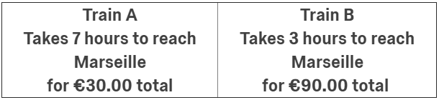

(DPF and €30/€90 condition)
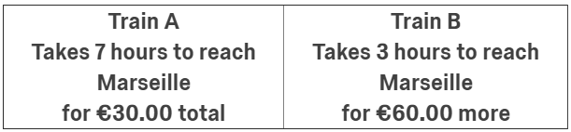

WEB APPENDIX G
Price-Computation-Difficulty Study
We designed this study to test whether the effect of DPF on the selection of premium choice options is robust to various levels of price computational difficulty. That is, we wished to test if our effect was robust to conditions where computing the price difference between the options what relatively effortless (e.g., $150.00 vs. $200.00) compared to relatively difficult (e.g., $169.00 vs. $219.00; see Thomas and Morwitz 2009), such that the DPF would not bring more focus to the price difference between the options (e.g., $50) beyond what participants could compute themselves when the price difference is easy to compute.
Method
Participants and Design. Six hundred and eleven online panel participants from recruited through Amazon Mechanical Turk took part in this experiment (57% female, M_{age} = 37.7) in exchange for payment. This experiment used a 2 (framing: inclusive-price vs. differential-price) x 4 (price level: easy-low vs. difficult-low vs. difficult-high vs. easy-high) between participants design. The dependent variable of interest was the proportion of premium options selected.
Procedure. Using a design similar to the one used un Web Appendix E, participants were asked to choose between two flights from New York (JFK) to Los Angeles (LAX), where one flight was cheaper but took longer to reach the destination because of a connection. Depending on the experimental condition, the price of the standard (i.e., slower and cheaper) and premium flight (i.e., faster and more expensive) ware available respectively for either: $150.00 vs. $200.00 (easy-low condition), $169.00 vs. $219.00 (hard-low condition), $189.00 vs. $239.00 (hard-high condition), or $200.00 vs. $250.00 (easy-high condition) in the IPF conditions. In comparison, the premium flight was constantly priced as “$50.00 more” in the DPF conditions. We used this low-high price approach to control for the varying ratio of the $50 price difference on the total price of each option when manipulating the computing difficulty (adapted from Thomas and Morwitz 2009). Participants were instructed to select the flight they would normally choose. On a subsequent page, participants rated the expensiveness of each option using the same items as in Study 6. These items were used to compute a difference score representing the relative difference in expenses between the options (M_{Premium}-M_{Standard}).
Manipulation Check
The extent to which the four prices differences used in this study ($150.00 vs. $200.00, $169.00 vs. $219.00, $189.00 vs. $219.00, $200.00 vs. $250.00) were perceived easy or hard to compute was pretested on a separate sample taken from the same population as the main study (n = 54), using a within-sample design ("the average person would find the price difference between the two prices:" 1 = very easy to compute; 7 = very hard to compute). Results suggest that the chosen price differences differ significantly in ease of computation ratings (F(3,51) = 53.39, p < .001). Using post-hoc comparisons, the $150.00-$200.00 price difference (M = 1.43, SD = .88) was rated as significantly easier to compute than the $169.00-$219.00 price difference (M = 3.59, SD = 1.31; t(53) = 12.12, p < .001) and the $189.00-$239.00 price difference (M = 3.70, SD = 1.38; t(53) = 11.79, p < .001), but not different from the $200.00-$250.00 price difference ( M = 1.31, SD = .75; t(53) = 1.18, p > .20). The $200.00-$250.00 price difference was also rated as significantly easier to compute than the $169.00-$219.00 (t(53) = 11.47, p < .001) and $189.00-$239.00 price difference (t(53) = 11.35, p < .001). Furthermore, the $169.00-$219.00 and $189.00-$239.00 price differences were not significantly different from each other (t < 1). These results validate our easy-to-compute vs. hard-to-compute price-difference manipulations.
Results
Product Choice. Results from a logistic regression with three dummy coded variables to account for multicategorical price levels suggested no main effect of the price-level condition and no two-way interaction between the price-framing and the price-level conditions in predicting the choice of premium options (χ²(1)’s < 1). We instead observed a main effect of the price-framing condition (b = .71, SE = .34, χ²(1) = 4.29, p < .05; Cohen’s d = .39) consistent with an overall larger proportion of participants selecting the premium option in the DPF (P = 65%) compared to the IPF condition (P = 54%), these results again support H1.
Expensiveness. Results from an ANOVA suggested no significant two-way interaction between the price-framing and the price-level condition in predicting the difference score for the expensiveness rating between the standard and the premium options (F’s < 1). Consistent with our general prediction, there was a main effect of the price-framing condition (F(1,603) = 11.99, p = .001) such that the perceived expensiveness difference between the options was smaller in the DPF (M = .44, SD = 1.34) compared to the IPF condition (M = .81, SD = 1.36). There was also a main effect of the price-level condition (F(3,603) = 2.61, p = .05); we do not focus on this effect.
Mediation. Next, we conducted an indirect effect analysis to test whether the expensiveness difference score observed between the standard and premium options could explain the selection of the premium choice option across price-level conditions. Consistent with our prediction, there was a significant indirect effect (b = .26, SE = .08, CI₉₅ [.13, .42]) of price framing on the proportion of premium options selected through the difference in perceived expensiveness when controlling from the price-level conditions, supporting H2. This effect relied on a significant effect of the perceived expensiveness difference in predicting the selection of the premium option (b-path: b = -.70, SE = .09, Z = 8.16, p = .001, CI₉₅ [-.86, -.53]).

COMPUTATION-DIFFICULTY STUDY: DEPENDENT VARIABLES BY PRICE-FRAMING AND PRICE-LEVEL CONDITIONS
 | Price-Level Conditions
Price Framing | Easy-Low  ($150.00-$200.00) | Hard-Low ($169.00-$219.00) | Hard-High ($189.00-$239.00) | Easy-High ($200.00-$250.00)
Proportion selecting the premium option
IPF | 55% | 49% | 52% | 59%
DPF | 71% | 62% | 59% | 68%
Standard Option Expensiveness (indirect flight)
(1-5; higher scores mean more expensive)
IPF | 2.36 (1.22) | 2.37 (1.02) | 2.36 (1.01) | 2.40 (1.03)
DPF | 2.63 (1.23) | 2.64 (1.14) | 2.62 (.99) | 2.86 (1.06)
Premium Option Expensiveness (direct flight)
(1-5; higher scores mean more expensive)
IPF | 3.36 (1.23) | 3.22 (1.09) | 3.25 (1.22) | 2.93 (1.06)
DPF | 2.96 (1.26) | 3.28 (1.12) | 3.21 (1.11) | 3.08 (1.02)

Discussion
The results from this study suggest that the usual benefit of DPF in increasing the selection of premium choice options is robust to the computation difficulty of the price difference. That is, even when computing the price difference between the choice options is effortless, highlighting this price difference increases the choice of the premium option. This direct comparison between 0-ending prices (i.e., easy-to-compute) and 9-ending prices (i.e., hard-to-compute) also rules out an alternative explanation relying on an underestimation of the price difference for 9-ending prices (Schindler and Kirby 1997). We note that these results are conceptually consistent with our findings of Study 1, suggesting that the DPF effect is robust to also displaying the total price of the purchase—despite making the cost of the premium option accessible to consumers, we replicate the DPF effect. Taken together, these results provided further support for our explanation relying on the always smaller number reported in DPF compared to IPF, reducing the perceived cost of the premium option.

Stimuli

Inclusive Price Framing condition
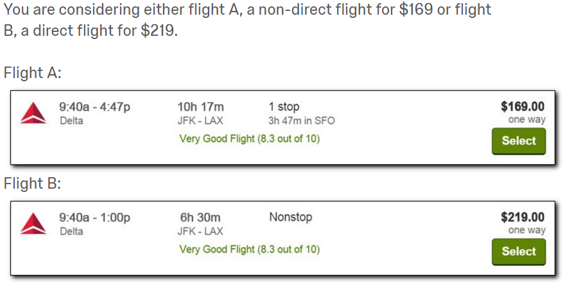

Differential Price Framing condition
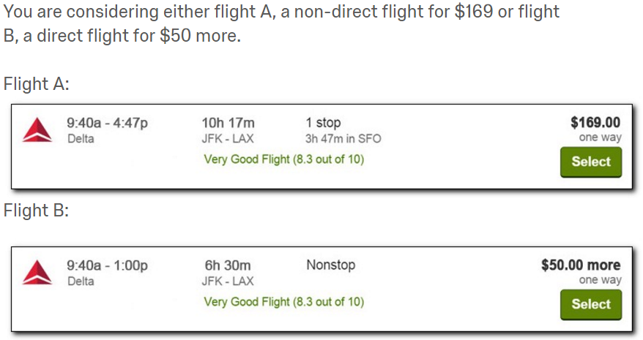

Note: we do not argue that consumers explicitly compare ∆X to X2, but rather that people base their decisions—and their underlying expensiveness perceptions—on the available information. As such, we contend that people decide by explicitly comparing X1 to X2 in the IPF condition and implicitly comparing X1 to ∆X in the DPF condition, but that because ∆X << X2, the premium product appears cheaper in the DPF condition.
Although this process superficially resembles an anchoring and adjustment heuristic (Tversky and Kahneman 1974), we rule out such a general adjustment-based process (e.g., Study 2). Indeed, using this framing method with differential quality does not appear to affect perceived quality or product choices (see also Web Appendix D and E for replications of this effect), further supporting our pricing focalism account.

