**Income Prediction Bias in the Gig Economy**

Ray Charles Howard (Corresponding Author)

Darden School of Business, University of Virginia

100 Darden Blvd, Charlottesville, VA 22903

[howardr@darden.virginia.edu](mailto:howardr@darden.virginia.edu)

David J. Hardisty

Sauder School of Business, University of British Columbia

2053 Main Mall, Vancouver, BC, V6T 1Z2, Canada

[david.hardisty@sauder.ubc.ca](mailto:david.hardisty@sauder.ubc.ca)

Dale W. Griffin

Sauder School of Business, University of British Columbia

2053 Main Mall, Vancouver, BC, V6T 1Z2, Canada

[dale.griffin@sauder.ubc.ca](mailto:dale.griffin@sauder.ubc.ca)

Chongbo Wang

Olin School of Business, Washington University in St. Louis

1 Snow Way Dr, St. Louis, MO 63130

[chongbo.wang@wustl.edu](mailto:chongbo.wang@wustl.edu)

**Income Prediction Bias in the Gig Economy**

**Abstract**

Sound financial decision-making requires accurately forecasting future earnings. However, the rise of the gig economy means an increasing number of people have volatile income, which may make predicting it more difficult. Across four longitudinal studies conducted with ride-hail and food delivery app workers, we find evidence of an *income prediction bias* in which people overpredict their future earnings. The bias emerges whether a person has ample or minimal gig experience, whether the gig is their primary or secondary income source, and whether they have high or low propensity to plan their finances. The bias is associated with a novel form of planning fallacy in which people overpredict how many hours they will work at their gig, but hourly wage predictions are fairly accurate. Finally, the bias is reduced by nudging people to consider relevant experience when predicting future income, but not by considering atypical outcomes.

*Keywords:* income prediction bias; budgeting; consumer financial decision making; forecasting; planning fallacy; gig economy

In recent years, income volatility has increased for millions of people around the world (Fulford et al. 2024, Dynan 2012, Hipp et al. 2015, Wang-Ly and Newell 2024). This instability is linked to negative outcomes for financial, psychological, and physical health (Habel, Alavi, and Linsenmayer 2021, PEW 2017, Salisbury et al. 2023, Zhang and Sussman 2024), raising urgent questions about how people will navigate an increasingly uncertain financial future. In this paper, we provide evidence that people facing income volatility are subject to an *income prediction bias* in which they systematically overpredict their income for the next week or month, as compared to the amount they subsequently earn. We also explore why this bias occurs, and we evaluate behavioral interventions to reduce it.

One reason income volatility is becoming more common is the rise of the gig economy, which involves temporary, freelance, or on-demand work (Hershfield, Shu, and Benartzi 2020, Ludwig et al. 2022). Paradigmatic gigs include driving for apps like Uber and delivering food for apps like DoorDash, but platforms like Fiverr, Upwork, and Task Rabbit make gig work possible in industries as diverse as accounting, computer science, home repair, and healthcare. Globally, more than 1.1 billion people work in the gig economy (Zgola 2021), and aggregate gig income in the United States alone exceeds $1.6 trillion annually (Ozimek 2021).

One defining characteristic of gig work is that both the output (income) and input (time commitment) can fluctuate from task-to-task, making them inherently uncertain and potentially difficult to predict. This makes gig work a natural setting for studying income predictions ‘in the wild,’ where people might mis-predict their income because they mis-predict their hours, wages, or both. Furthermore, gig workers tend to be financially vulnerable (Zipperer et al. 2022), and income overprediction can exacerbate this vulnerability. For example, when someone makes a budgeting or spending decision based on an income prediction that is higher than what they end up earning, they may spend more than they can afford, depleting their savings or incurring debt to make up the difference (Hershfield et al. 2015, Lukas and Howard 2023). Thus, given that gig workers already suffer from insufficient savings and high-interest debt (Commonwealth 2022), they stand to benefit from an intervention that improves their income prediction accuracy.

Data from four longitudinal field studies conducted with real gig workers reveal the following insights: First, the gig workers in our studies typically over-predict their gig income for the next week or month by more than 20%, as compared to the amount they end up earning. Moreover, income overprediction is surprisingly robust, occurring whether someone has ample or minimal gig experience, whether the gig is their primary or secondary income source, and whether they have high or low propensity to plan their finances. The fact that income overprediction is common across such heterogeneous groups suggests it may be a wide-spread phenomenon with broad implications for consumer financial budgeting and decision-making.

Second, we find that income prediction bias is associated with a novel form of planning fallacy in which people over-predict the number of *hours* they will work at their gig, even when they have relevant personal experience to draw on when making their prediction. In contrast, predicted hourly *wages* are fairly accurate, and if anything, lean toward under-prediction. This suggests that income prediction bias may not be driven by overconfidence or general optimism, as some ostensibly related judgments are (Sharot 2011, Ülkümen, Thomas, and Morwitz 2008)—if it was, then expected wages would be unrealistically high too. This also implies that legislation to increase gig economy wage transparency (e.g., Colorado SB24-075) will not necessarily make gig income easier to predict. Indeed, our studies indicate that even when gig workers know how much money they will earn per hour, they may still overpredict their total gig income for the next week or month because they overpredict how many hours they will work.

Finally, we show that income prediction bias is reduced by prompting people to base their predicted income on their average past income, but not by encouraging them to consider atypical outcomes. Importantly, the successful intervention works by significantly lowering predicted earnings but not actual earnings. This indicates that overprediction is not an adaptive, motivational response to uncertain income in which optimistically high predictions lead to greater earnings than lower, more realistic predictions. It also shows that a low-cost, easy-to-scale intervention can make income easier to predict, without imposing a significant burden on either individuals or firms. In the remainder of this article, we present our research in the way it was developed: by first considering a research question, then presenting a study designed to examine it.

**Is There an Income Prediction Bias?**

The question of whether gig workers display an income prediction bias is not a simple one to answer based on prior research and theory. To start, there are reasons to believe that income predictions may be quite *accurate*. For example, people may engage in “income targeting” and simply work for as long as it takes to hit their target (Camerer et al. 1997). Notably, this is encouraged by some gig companies who gamify their apps to keep people working for longer periods of time (Allon, Cohen, and Sinchaisri 2023). However, there are also reasons to believe that income predictions may be *pessimistic*, or too low*.* For example, gig workers can be prone to an “inertia” effect in which the longer they spend on shift the more likely they are to keep working (Allon et al. 2023). If people are unaware of this tendency when they predict their income, it could lead to income underprediction, given that longer shifts lead to higher earnings (Hall and Krueger 2018). Finally, there are reasons to believe that income predictions may be *optimistic*, by which we mean predicted income for the next week or month will be greater than the actual amount earned during that time. For example, people make optimistic financial predictions in domains that are ostensibly related to income, such as spending and savings (Koehler et al. 2011, Ülkümen et al. 2008). Similarly, individuals’ time predictions are subject to a “planning fallacy” in which they optimistically predict their task completion times (Buehler et al. 1994; Kahneman & Tversky, 1977). This is relevant to income prediction in the gig economy, which requires predicting how many hours one will work.

Given the competing hypotheses implied by extant research, we next present a preliminary study that examines whether there is an income prediction bias, and if so, in what direction.

**Study 1: The App Study**

**Method**

We conducted this preregistered study (<https://aspredicted.org/B7M_4DH>) in partnership with a boutique ride-hail app in a major North American city that operates as a local competitor to services like Uber and Lyft. The materials, data, syntax, and output files for all of our studies are available here: <https://osf.io/69xwq/?view_only=b10b86b610ad41c08bcc10b7caca0d16>. For brevity, we detail most exploratory measures and analyses in the Supplementary Information (SI).

We recruited participants for this study through the direct messenger system used by the app, offering their drivers $25 in exchange for completing two surveys. The first survey was completed immediately, at the start of February 2022, and the second survey was completed one month later, at the start of March. At the time of the study, the app had 88 active drivers, all of whom were sent our recruitment message. Forty-nine drivers participated in the first survey, and thirty-nine of those who participated in the first survey also participated in the second. The drivers who participated in at least one survey did not differ significantly from those who did not participate in either survey in terms of the variables we could observe for both groups, which were gender (95% of participants were male and 100% of non-participants were male; Ӽ(1) = 1.73, *p* = .19, *ϕ* = 0.15), age (Mparticipants = 42.57, SDparticipants = 11.04, Mnon-participants = 43.74, SDnon-participants = 7.90, *t*(75) = -0.52, *p* = .61, *d* = 0.12), and number of days since downloading the app (Mparticipants = 445.20, SDparticipants = 132.50, Mnon-participants = 446.60, SDnon-participants = 123.30, *t*(86) = -0.05, *p* = .96, *d* = .01).

In the first survey, we asked participants to predict their gig income for the next week, as follows:

Please take some time to estimate the total amount of money you will earn driving for [company name] in the next **week**.

How much money do you estimate you will earn (in total) driving for [company name] in the next **week**? [Free response text box.]

Participants then predicted their gig income for the next month, following the same instructions as above but with ‘month’ in place of ‘week’. We then asked:

In the following question, "total income" refers to the income you earned driving for [company name] **plus**the income you earned from all other jobs that you worked.

Over the **past eight weeks**, what percentage of your total income did you earn driving for [company name]? (0-10%, 11-20%, 21-30%, … , 91-100%)

We collected this measure to explore its relationship with income prediction bias, following the logic that when a gig is someone’s primary income source, they may be more motivated to imagine higher earnings and therefore overpredict, as compared to when a gig is their secondary income source. Finally, we measured gig experience by asking participants “How long have you been driving for [company name]?” (Less than one month; 1 to 3 months; 4 to 6 months; 7 to 9 months; 10 to 12 months; more than 12 months.) We collected this measure to explore its relationship with the bias, following the logic that experienced drivers may learn to anticipate income flows over time, and therefore be less likely to overpredict than inexperienced drivers.

The second survey was sent to participants one month after the first. It included the same weekly and monthly prediction measures as the first survey so we could determine whether prediction accuracy improves over time. One month after the second survey was fielded, the app provided us with each driver’s actual earnings over the course of the study so we could measure income prediction bias, which we define as predicted income minus actual income.[1]

**Results**

*Weekly income prediction bias.* As seen in Figure 1A, participants overpredicted their income for the first week of February (“Week 1”) by an average of $132.07 or 28.3%, as revealed by a paired-samples t-test (*M*predicted_income = $466.94, *SD* = 468.71; *M*actual_income = $334.87, *SD* = 403.56; *t*(48) = 4.01, *p* < .001, *d* = .57). Moreover, the bias was prevalent: 75.5% of participants overpredicted to at least some extent, and 53.1% of participants overpredicted by $100 or more. One month later, participants also overpredicted their income for the first week of March (“Week 2”), by an average of $118.36 or 22.2% (*M*predicted_income = $533.59, *SD* = 540.57; *M*actual_income = $415.23, *SD* = 480.54; *t*(38) = 2.25, *p* = .030, *d* = .36). This time, 69.2% of participants overpredicted to at least some extent, and 46.2% overpredicted by $100 or more. Among the participants who completed the weekly prediction measures in both surveys, prediction accuracy did not significantly improve over time (*t*(38) = 0.23, *p* = .82, *d* = .04).

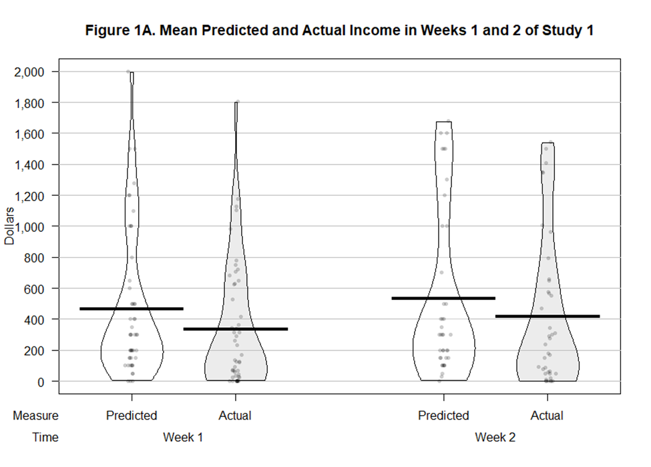

*Notes.*Bars show means, dots show individual datapoints, and beans represent the smoothed density of the data distribution. “Week 1” refers to the first week of February and “Week 2” to the first week of March.

*Monthly income prediction bias.* As seen in Figure 1B, participants overpredicted their income for February by an average of $347.43 or 20.1% (*M*predicted_income = $1724.52, *SD* = 1828.31; *M*actual_income = $1377.09, *SD* = 1722.71; *t*(47) = 2.96, *p* = .005, *d* = .43), and the bias was once again prevalent: 66.7% of participants overpredicted to at least some extent, and 54.2% of participants overpredicted by $300 or more. One month later, participants overpredicted their income for March by an average of $610.57 or 27.8% (*M*predicted_income = $2197.37, *SD* = 2139.27; *M*actual_income = $1586.80, *SD* = 1892.31; *t*(37) = 3.18, *p* = .003, *d* = .52). This time, 81.6% of participants overpredicted to at least some extent, and 60.5% overpredicted by more than $300. Among the participants who completed the monthly prediction measures in both surveys, prediction accuracy deteriorated somewhat over time (*t*(37) = -.2.03, *p* = .050, *d* = -.33).

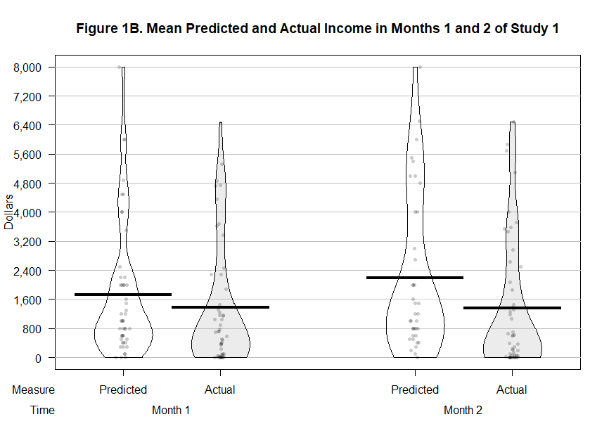

*Notes.*Bars show means, dots show individual datapoints, and beans represent the smoothed density of the data distribution. ‘Month 1’ is February, and ‘Month 2’ is March.

*Individual differences.* To explore if income prediction bias is associated with gig experience or the percentage of total income a person earns from their gig, we produced the correlation matrix seen in Table 1. First, experience is not significantly correlated with predicted income, actual income earned, or income prediction bias for any of the four time periods we collected these measures.[2] This latter result suggests that experienced gig workers fail to incorporate what they’ve learned about their gig income flows in the past when they predict their gig income for the future, which is consistent with the possibility that income prediction bias represents a novel form of planning fallacy. Second, percentage of total income earned from the app is correlated with both predicted income and actual income earned, and thus it is not significantly correlated with income prediction bias scores.[3] One interpretation of this result is that the bias is not driven by motivated reasoning, such that a stronger (vs weaker) motivation to earn leads to higher predicted income but not higher actual income (cf. Peetz and Buehler 2009).

**Table 1. Study 1 Correlation Matrix**



*Notes.* \**p* < 0.05. \*\**p* < 0.01. a Corresponds to approximately one year of experience.

b Corresponds to earning 30% to 40% of total income from the gig.

**Discussion**

Study 1 provides preliminary evidence that gig workers display an *income prediction bias* in which they overpredict their gig income. Moreover, we find that the magnitude of the bias in this sample is large enough to be economically meaningful for many people, and that the bias is both prevalent and persistent over time. Finally, we observe that the bias is not significantly correlated with gig experience or the percentage of total income a person earns from their gig. Supplemental study 1 (S1), which is detailed in the SI, conceptually replicates each of these findings with a sample of Uber drivers. Next, we discuss two factors that may contribute to income overprediction.

**Hours vs Hourly Wage**

Income prediction bias is almost certainly multiply determined, as are other related biases (Buehler, Griffin, and Peetz 2010). Here, we examine two possible sources of bias. The first is that people overpredict their income because they overpredict the number of hours they will work at their gig. When people make predictions, they often fail to consider all possible outcomes (Buehler et al. 2010, Howard et al. 2022). For instance, when predicting task completion times, people do not think of life events that might interfere with their ability to complete the task as planned. Rather, they focus solely on the plan itself, and what steps it will take to complete the task successfully (Buehler et al. 1994, Kahneman and Tversky 1977). In the context of income prediction, this suggests that people may fail to consider life events that could prevent them from working as much as planned. For example, when predicting future income, an Uber driver might not consider the possibility that their car will need repairs, which would prevent them from working as much as they anticipated.

A second potential cause of income prediction bias is that people overpredict their hourly wage. People tend to be overconfident in their abilities (West and Stanovich 1997), and overconfidence is one driver of optimistic financial predictions (Piehlmaier 2022, Ülkümen et al. 2008). If predicted hourly wage is at least partly a function of perceived ability, it stands to reason that people might overpredict their total income because they overpredict their hourly wage. Continuing the Uber driver example above, it is possible that this person overpredicts their gig income in part because they are overconfident in their ability to earn a higher-than-average hourly wage, perhaps by completing more trips than usual, or by earning higher tips than usual. A second possibility that could lead to hourly wage overprediction is a generalized optimism bias in which people over-optimistically forecast almost everything (Sharot 2011). Therefore, if income prediction bias is driven primarily by overconfidence or general optimism, we would expect people to overpredict their hourly wages. However, we believe this is likely *not* the case. Although people do tend to miss deadlines by failing to account for life events that interrupt their plans for success, they are more proficient at predicting “time on task” (Buehler et al. 2010), meaning they have an accurate sense of how much they can accomplish with each hour of work they do. Translated to the context of income prediction, this suggests that hourly wage estimates may not deviate much from actual outcomes. Study 2 tests these possibilities.

**Study 2: Income, Hours, and Hourly Wage**

**Method**

We recruited US and Canadian residents who deliver food for apps such as Door Dash by placing advertisements in reddit.com communities that app-based food delivery drivers use to communicate with each other (see SI for details). Our ads invited drivers to participate in a two-stage survey about working in the gig economy in exchange for a $10 Amazon.com gift certificate and a chance to win $250. Eighty-five participants completed the first survey (*M*age = 30.4, 24.7% female) and forty-seven (55.3%) completed the second survey (*M*age = 29.9, 23.4% female).

The first survey was completed immediately after participants responded to the recruitment ad. It asked participants to indicate which food delivery apps they currently work for, then predict their gig income, hours, and hourly wage for the next week. The second survey was sent to participants one week later, and it asked them to log into the relevant employment apps and report their gig income and hours for the past week. This two-stage design allows us to measure participants’ prediction accuracy for their gig income, hours, and hourly wage, where the latter is measured by comparing predicted hourly wage to reported income divided by reported hours. This study also included the same measures of gig experience and percentage of total income earned from the gig as studies 1 and S1, as well as a binary measure of whether food delivery is a person’s primary or secondary source of income (“Is delivering food currently your primary job (i.e., the job from which you earn most of your income) or secondary job (i.e., a job from which you earn "extra" income)?” Yes/No.) Because our focal hypothesis concerns prediction accuracy, all analyses were performed using data from participants who completed both surveys.

**Results**

*Bias scores.* As seen in Figure 2, participants overpredicted their gig income by 19.9% or $63.52 (Mpredicted_income = $382.13, 95% CI = [302.99, 461.26]; Mactual_income = $318.61, 95% CI = [246.13, 391.09]; *t*(46) = 2.56, *p* = .014, *d* = .37). This conceptually replicates the core finding of studies 1 and S1 with a sample drawn from a different gig population. Participants in this study also overpredicted their gig hours by 21.6% (Mpredicted_hours = 23.00, 95% CI = [19.29, 26.71]; Mactual_hours = 18.92, 95% CI = [14.80, 23.03]; *t*(46) = 3.43, *p* = .001, *d* = .50). However, predicted hourly wage did not differ significantly from actual hourly wage (Mpredicted_hourly_wage = $16.98, 95% CI = [15.41, 18.55]; Mactual_hourly_wage = $17.50, 95% CI = [15.53, 19.46]; *t*(45) = -.58, *p* = .56, *d* = -.09).

**Figure 2. Study 2 Results**

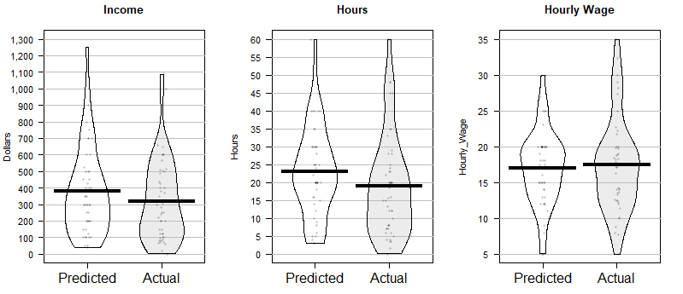

*Notes.*Bars show averages, dots show individual datapoints, and beans represent the smoothed density of the data distribution.

*Individual differences.* As in study 1, gig experience (M = 3.81, SD = 2.00) was not significantly correlated with predicted income (r(45) = .09, *p* = .57), reported income (r(45) = .-.06, *p* = .69), income prediction bias scores (r(45) = .22, *p* = .13), or percentage income prediction bias scores (r(45) = .23, *p* = .13.) Also echoing study 1, the percentage of total income participants generally earn from food delivery (M = 5.70, SD = 3.71) was positively correlated with predicted income (r(45) = .47, *p* < .001) and reported income (r(45) = .50, *p* < .001), but not with income prediction bias scores (r(45) = .02, *p* = .91) or percentage income prediction bias scores (r(45) = -.19, *p* = .20.) A repeated measures ANOVA with job category (primary vs secondary) as a between-subjects variable and income (predicted vs reported) as a within-subjects variable revealed a main effect of income (F(1, 45) = 5.88, *p* = .019, ηp2 = .116, Mpredicted_income = $391.38, CI95% = [312.60, 470.16], Mreported_income = $330.18, CI95% = [259.80, 400.57]), and a marginally significant effect of job category (F(1, 45) = 4.02, *p* = .051, ηp2 = .082, Mprimary = $430.70, CI95% = [324.21, 537.19], Msecondary = $290.87, CI95% = [199.22, 382.52]). However, the job category by income interaction was not significant (F(1, 45) = 0.38, *p* = .54, ηp2 = .008), indicating that both groups overpredicted their income.

**Discussion**

Study 2 shows further evidence of an income prediction bias and provides several additional insights regarding the nature of the bias. To begin, this study provides the first evidence that gig workers overpredict their gig hours but not their hourly wage. This suggests that income prediction bias may not be primarily driven by overconfidence or general optimism—if it was, then predicted wages should also be unrealistically high. Second, this study provides initial evidence that overpredicting income is associated with overpredicting hours, suggesting income prediction bias is the result of a novel type of planning fallacy. Third, this study offers additional evidence that income prediction bias is not meaningfully correlated with gig experience, which further suggests the bias is akin to a planning fallacy that is not reduced by learning about gig income flows over time. This study also shows that income prediction bias is not meaningfully correlated with the percentage of total income a person earns from their gig or whether it is their primary or secondary income source, which suggests the bias may not be principally driven by motivation. We next consider how income prediction bias might be reduced.

**Improving Prediction Accuracy**

When people make predictions, they tend to focus too narrowly on expected or typical outcomes (Buehler et al. 1994, Howard et al. 2022). Two solutions to this problem that have reduced prediction biases in related domains are: 1) prompting people to include their past experiences in their predictions, or 2) prompting people to consider atypical outcomes when formulating their predictions. One goal of the present research is to compare the effectiveness of these interventions in the context of income prediction.

**Taking an Outside View**

Our first intervention is derived from work on the classic planning fallacy in time prediction, which refers to the phenomenon that people underestimate their task completion times, even when they know similar tasks took longer than planned in the past (Kahneman and Tversky 1977). The original explanation for the planning fallacy is that when people make predictions, they tend to adopt an “inside view” in which they focus on plan-based scenarios that do not consider all the ways that such plans can go wrong. Accordingly, it has been shown that the planning fallacy can be reduced by prompting people to adopt an “outside view” in which their predictions are based on relevant experience (Buehler et al. 1994).

We propose that income prediction bias may also be reduced by taking an outside view. If, like time predictions, income predictions are biased due to plans that neglect possible obstacles to working as much and as successfully as expected, then prompting people to base their income predictions on past outcomes that reflect these obstacles should reduce the bias. We reasoned that one way to accomplish this is to have people consider their average past earnings while predicting their future earnings, because average earnings account for both good and bad weeks at work. Note that a nudge to consider average past earnings is a light-touch (low effort, low coercion) intervention, especially when compared to validated interventions used to reduce the planning fallacy in project completion, which typically involve enumerating past failures (e.g., Buehler et al, 1994) or mapping out the full distribution of comparable past projects (e.g., Flyvbjerg, 2006).

**Considering Atypical Outcomes**

Our second intervention is derived from work on expense misprediction. When consumers predict their future spending, their predictions are based on highly typical expenses such as groceries and rent, but not atypical expenses such as car repairs or home improvements (Sussman and Alter 2012). This leads people to underpredict their future spending, because in any given week or month most consumers will face at least some atypical expenses (Howard et al. 2022). Consistent with this analysis, expense prediction accuracy can be improved by prompting people to consider reasons why their expenses will be different than usual, because this helps people bring atypical expenses to mind and incorporate them into their predictions (Howard et al. 2022).

Here, we test the possibility that this type of “atypical” intervention can also reduce income prediction bias. Specifically, we test whether income prediction bias can be decreased by prompting people to consider reasons why their work schedule might be different from a typical week. The logic underlying this intervention is that, in the context of income overprediction, deviations from a typical work schedule are asymmetric: most “surprises” capture reasons why a person might work *less* than usual. For example, when a gig worker needs to stay home to care for a sick child or parent, they will work fewer hours and income will go down. In contrast, there are relatively few surprises that lead a gig worker to have more time to work than usual. Thus, accounting for atypical experiences may reduce the tendency to overpredict future income. Study 3 tests the effectiveness of our outside view and atypical interventions.

**Study 3: Improving Prediction Accuracy**

**Method**

This study was preregistered on aspredicted.org (<https://aspredicted.org/blind.php?x=nu8j4c>). We recruited food delivery app workers to a two-stage study via reddit.com advertisements (as in study 2) until six hundred people had completed both stages. Demographics are reported in the SI.

In the first survey, all participants were asked to indicate which food delivery apps they currently work for, as in study 2. They were then randomly assigned to predict their gig income for the next week in one of three conditions. Participants in the *control condition* predicted their income as in study 2. Participants in the *outside view condition* were asked to “Please take some time to estimate the total amount of money you have earned working for food delivery apps over the past four weeks. How much money do you estimate you have earned (in total) working for food delivery apps over the past four weeks? (Page break.) Over the past 4 weeks you estimate you have earned $XX per week working for food delivery apps. Based on that experience, how much money do you estimate you will earn working for food delivery apps in the next week?” The value of $XX was the participant’s answer to the preceding question divided by 4. We hypothesized that providing this anchor based on relevant experience would produce lower, more accurate predictions, because average past income accounts for both good and bad weeks at work.

Participants in the *atypical condition* were asked to “Please take some time to consider reasons why the number of hours you work for food delivery apps in the next week might be different than usual. Please list 2 reasons why the number of hours you work for food delivery apps in the next week might be differentthan usual. [Page break.] Keeping in mind your answer to the previous question, how much money do you estimate you will earn (in total) working for food delivery apps in the next week?” We hypothesized this ‘atypical’ intervention would improve income prediction accuracy based on the assumption that deviations from a typical work schedule will usually capture reasons why a person might work less than usual. If so, this should lead to lower income predictions (versus control) and therefore reduce the bias.

After predicting their gig income for the next week, all participants predicted their gig hours. In this study, we calculated predicted hourly wage as predicted income divided by predicted hours because our explicit measure of predicted hourly wage in study 2 did not differ significantly from simply dividing predicted income by predicted hours. Data from four participants whose predicted hourly wage was more than three standard deviations (SD = 9.54) above the sample mean (M = $15.70) were excluded from all analyses, because they represent highly implausible wages in this context that likely stem from typos (e.g., typing $1,500 for weekly income instead of $150). This exclusion criterion was not preregistered, so as a robustness test, we present a non-parametric analysis in the SI that confirms the difference between the median income prediction bias in each condition remains significant even with the inclusion of these outliers. The second survey, sent one week after the first, asked participants to check each relevant app and report the following information for the past week: (a) which food delivery apps they had worked for, (b) how much money they had earned (in total) working for food delivery apps, and (c) how many hours (in total) they had worked for food delivery apps. The surveys in this study also measured gig experience and percentage of total income earned from the gig (as in studies 1 and 2), as well as short term financial propensity to plan (Lynch et al. 2010). We collected these measures to explore (a) if they are correlated with bias scores in the control condition, and (b) examine treatment effect heterogeneity by determining if they moderate the effect of our interventions on bias scores.

**Results**

Figure 3 plots mean predicted income versus mean actual income in each condition of study 3. To test the effect of the interventions on income prediction accuracy, we conducted a preregistered 3 (condition: control vs. outside view vs. atypical) × 2 (income: predicted vs. actual) mixed-model ANOVA with condition as a between-subjects variable and income as a within-subject variable. The model revealed a significant main effect of predicted vs actual income (*F*(1, 593) = 71.10, *p* < .001, ηp2 = .107), a non-significant main effect of condition (*F*(2, 593) = 1.80, *p* = .17, ηp2 = .006), and a significant condition by income interaction (*F*(2, 593) = 4.07, *p* = .018, ηp2 = .014). Replicating our previous studies, participants in the control condition overpredicted their weekly income by $66.42 or 25.2% (*F*(1, 593) = 30.18, *p* < .001, ηp2 = .048).[4] However, income overprediction dropped to $30.83 or 12.5% among participants in the outside view condition (*F*(1, 593) = 7.65, *p* = .006, ηp2 = .013). Thus, the outside view intervention reduced the bias by $35.59 or 53.6% versus control (*t*(403) = 2.20, *p* = .029, *d* = .22). Contrary to expectations, the atypical intervention did not reduce the bias. Participants in the atypical condition overpredicted their income by $74.07 or 28.2% (*F*(1, 593) = 38.53, *p* < .001, ηp2 = .061), and the magnitude of the bias did not differ significantly between the control and atypical conditions (*t*(375) = 0.45, *p* = .65, *d* = .05).

Planned contrasts confirmed that predicted income was significantly lower in the outside view condition (*M* = $278.22, *SD* = 233.82) than in the control condition (*M* = $329.83, *SD* = 230.28, *t*(403) = 2.23, *p* = .026, *d* = .22) and atypical condition (*M* = $336.66, *SD* = 236.39, *t*(408) = 2.51, *p* = .012, *d* = .25), and that predicted income in the control and atypical conditions did not differ significantly (*t*(375) = 0.28, *p* = .77, *d* = .03). Planned contrasts also confirmed that actual income earned in the outside view condition (*M* = $247.39, *SD* = 252.01) did not differ significantly from actual income earned in the control condition (*M* = $263.41, *SD* = 225.63, *t*(403) = 0.67, *p* = .50, *d* = .07) or atypical condition (*M* = $262.60, *SD* = 227.78, *t*(408) = 0.64, *p* = .52, *d* = .06), nor did actual income earned in the control and atypical conditions differ significantly (*t*(375) = 0.04, *p*= .97, *d* = .00). Thus, importantly, the outside view intervention reduced income prediction bias by producing lower income predictions without significantly lowering actual income earned.

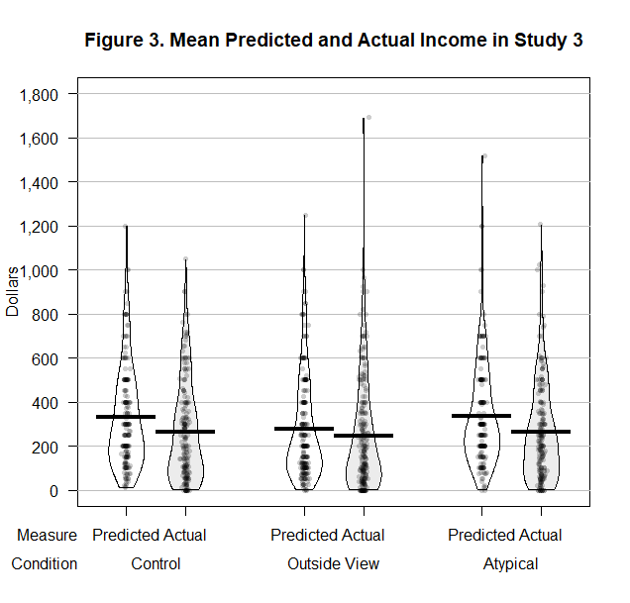

*Notes.*Bars show averages, dots show individual datapoints, and beans represent the smoothed density of the data distribution.

*Individual differences.* We created the correlation matrix seen in Table 2 using data from participants in the control condition so we could determine if the individual difference results in the preceding studies replicate in a larger sample. The only individual difference variable significantly correlated with income prediction bias is percentage of total income earned from the gig, but the size of the correlation is small (*r*(184) = .15, *p* = .044).[5] Echoing the results of studies 1 and 2, this suggests that if motivation to earn is higher for people who earn a relatively large proportion of their total income from their gig, then motivated reasoning is unlikely to be a major determinant of the bias. The low correlations overall suggest that prediction accuracy does not improve with gig experience (consistent with studies 1 and 2) or short-term financial propensity to plan. This latter finding may be because a focus on plans does not improve prediction accuracy if plans neglect potential barriers to success (Buehler, Griffin, and Ross 1994).

**Table 2. Study 2 Control Condition Correlation Matrix**



*Notes.* *Correlation is significant at the 0.05 level (2-tailed). **Correlation is significant at the 0.01 level (2-tailed).

*Treatment effect heterogeneity.* To determine if the individual differences we measured in this study moderate the effect of the outside view intervention on bias scores, we next performed a set of pre-registered regression analyses in which we regressed bias scores onto a condition dummy variable (control = 0, outside view = 1), an individual difference variable, and a condition × individual difference interaction term. So, in our first regression we regressed bias scores onto condition, propensity to plan, and a condition × propensity to plan interaction term, in our second regression we replaced propensity to plan with gig experience, and in our third regression we replaced gig experience with percentage of total income earned from the gig. (Individual difference variables were mean centered.) As seen in Table 3, these regressions revealed that none of the individual differences we measured moderated the effect of the outside view intervention on bias scores versus control (*p*’s > .46). This is a potentially important finding for consumers and practitioners because it suggests that the outside view intervention may work equally well for a broad cross-section of consumers, including those who have high propensity to plan and those who do not, those with lots of gig experience and those with very little, and those who work at their gig full-time as well as those who work part-time. The same set of regressions using atypical = 1 (instead of outside view = 1) also did not yield any significant interactions (*p*’s > .11). Thus, in summary, the effectiveness of the interventions did not vary significantly across the individual differences that we measured in this study.

**Table 3. Study 3 Regression Results**



*Notes.* *Coefficient is significant at the 0.05 level (2-tailed). The individual difference in each model is (1) short-term financial propensity to plan, (2) gig experience, and (3) percentage of total income earned from the gig. Standard errors in parentheses.

**General Discussion**

We document an income prediction bias in which gig economy workers overpredict their gig income. We also provide two pieces of convergent evidence that the source of this bias is a novel form of planning fallacy. First, we show that overpredicting gig income is associated with overpredicting how many hours one will be able to work. This implies a planning fallacy is at play because optimistic time predictions are the defining characteristic of such fallacies (Kahneman and Tversky 1977). Importantly, though, overpredicting work hours differs from the classic planning fallacy because it connects the misprediction of time and money, and optimistic time predictions are typically conceptualized as underprediction rather than overprediction (Buehler et al. 2010). Second, we show that the income prediction bias persists over time and is not strongly correlated with gig experience. This indicates that people do not learn to make more accurate predictions *even when they have relevant personal experience to draw on*, which is a hallmark of the planning fallacy (Kahneman and Tversky 1977). These findings are descriptive, so future research is required to confirm causality.

We also show that hourly wage predictions are fairly accurate, and if anything, tend to be somewhat pessimistic. This implies that income prediction bias may not be driven by general overconfidence or general optimism, as some other biases are (Ülkümen et al. 2008, Sharot 2011)—if it were, then people would overpredict their hourly wages too. Additionally, we find that the correlation between income prediction bias and the percentage of total income earned from a gig is consistently small. Assuming that motivation to earn is higher for people who earn a relatively large proportion of their total income from their gig, this implies that motivated reasoning is unlikely to be a major determinant of the bias. Future research should conduct high-powered, confirmatory tests of these possibilities.

Furthermore, we find that income prediction bias is reduced by considering average past earnings. The success of this outside view intervention is notable because it is an easy-to-scale nudge that is ‘light touch’ compared to other methods used to reduce the classic planning fallacy (e.g., Buehler et al, 1994; Flyvbjerg, 2006). Importantly, the outside view intervention works by significantly lowering predicted but not actual earnings. This shows that overprediction is not an adaptive response to uncertain income in which higher predictions lead to greater earnings than lower, more realistic predictions. Testing the efficacy of other potential interventions is a fruitful direction for future research.

The existence of an income prediction bias has broad implications for theories of financial decision-making. Budgeting is frequently conceptualized as a two-stage process in which people allocate their income to different budget categories, then track their spending in each category against their budget (Heath and Soll 1996, Lukas and Howard 2023; Thaler 1985). However, our work indicates that when income is volatile, a prior stage is required in which people must first predict their earnings. Moreover, income overprediction may help explain subsequent overspending, given that spending is often based on expected earnings (Gelman et al. 2014; Olafsson and Pagel 2018).

One benefit to working in the gig economy is that gig workers have more flexibility in their work schedule than those with more traditional jobs. However, our findings reveal this flexibility comes with a previously hidden cost: income that is difficult to predict accurately. Whether this cost outweighs the corresponding benefits remains to be seen, but if income overprediction leads to overspending, as seems likely, it may be the case that flexible work arrangements are financially disadvantageous for many people.

Finally, our work contributes to the debate regarding wage transparency in the gig economy. Some gig intermediaries have been accused of overstating how much money their (potential) workers can earn (Griswold 2014). Explicit deception is clearly unacceptable and should be prevented. However, our work indicates that even when people know exactly how much money they will earn on an hourly basis, they may still overpredict their total income because they overpredict how many hours they will work. This suggests that merely increasing wage transparency in the gig economy will not give people an accurate view of their potential earnings. Fortunately, behaviorally informed interventions such as taking an outside view can improve income prediction accuracy.

**References**

Allon G, Cohen MC, Sinchaisri WP (2023) The Impact of Behavioral and Economic Drivers on

Gig Economy Workers. *Manufacturing & Service Operations Management* 25(4):1376-

1393.

Buehler R, Griffin DW, Peetz J (2010) The Planning Fallacy: Cognitive, Motivational, and

Social Origins. *Advances in Experimental Social Psychology* 43:1-62.

Buehler R, Griffin DW, Ross M (1994) Exploring the "Planning Fallacy": Why

People Underestimate Their Task Completion Times. *Journal of Personality and Social*

*Psychology* 67(3):366.

Camerer C, Babcock L, Loewenstein G, Thaler R (1997) Labor Supply of New York City

Cabdrivers: One Day at a Time. *The Quarterly Journal of Economics* 112(2):407-441.

Fulford S, Kalish E, Wilson E, Kruse Z, LeBuhn S, Cotter I (2024). Making Ends Meet in

2024 Insights from the Making Ends Meet survey. CFPB Office of Research Publication

No. 2024-5, *Available at SSRN 5069485*.

Colorado SB24-075 (2024). Senate Bill 24-075. Colorado General Assembly, 74th General

Assembly, 2nd Reg. Sess.

Commonwealth (2022) *Evaluating the impact of income volatility benefits on gig workers:*

*Preliminary insights from the Financial Benefits Project*. Commonwealth.

<https://buildcommonwealth.org>

Dynan K, Elmendorf D, Sichel D (2012) The evolution of household income volatility. *The BE*

*Journal of Economic Analysis & Policy*, 12(2).

Flyvbjerg B (2006) From Nobel Prize to Project Management: Getting Risks Right. *Project*

*Management Journal*, *37*(3), 5-15. <https://doi.org/10.1177/875697280603700302>

Gelman M, Kariv S, Shapiro MD, Silverman D, Tadelis S (2014) Harnessing naturally occurring

data to measure the response of spending to income. *Science* 345(6193):212-215.

Griswold A (2014) In Search of Uber’s Unicorn. *Slate* (October 27)

<https://www.inc.com/slate/in-search-of-uber-s-unicorn.html>

Habel J, Alavi S, Linsenmayer K (2021) Variable compensation and salesperson health. *Journal*

*of Marketing* *85*(3):130-149.

Hall JV, Krueger AB (2018) An Analysis of the Labor Market for Uber’s Driver-Partners in the

United States. *ILR Review* 71(3):705-732.

Heath C, Soll J (1996) Mental Budgeting and Consumer Decisions. *Journal of*

*Consumer Research* 23(1):40-52.

Hershfield HE, Shu S, Benartzi S (2020) Temporal Reframing and Participation in a Savings

Program: A Field Experiment. *Marketing Science* 39(6):1039-1051.

Hipp L, Bernhardt J, Allmendinger J (2015) Institutions and the prevalence of

nonstandard employment. *Socio-Economic Review*, 13(2), 351-377.

Howard RC, Hardisty DJ, Sussman AB, Lukas MF (2022) Understanding and Neutralizing the

Expense Prediction Bias: The Role of Accessibility, Typicality, and Skewness. *Journal of*

*Marketing Research* 59(2):435-452.

Kahneman D, Tversky A (1977) *Intuitive Prediction: Biases and Corrective Procedures*.

Decision Research, Perceptronics.

Koehler DJ, White RJ, John LK (2011) Good Intentions, Optimistic Self-Predictions, and Missed

Opportunities. *Social Psychological and Personality Science* 2(1):90-96.

Ludwig S, Herhausen D, Grewal D, Bove L, Benoit S, De Ruyter K, Urwin P (2022)

Communication in the gig economy: Buying and selling in online freelance

marketplaces. *Journal of Marketing*, 86(4), 141-161.

Lukas MF, Howard RC (2023) The Influence of Budgets on Consumer Spending. *Journal of*

*Consumer Research* 49(5):697-720.

Lynch JG, Netemeyer RG, Spiller SA, Zammit A (2010) A Generalizable Scale of Propensity to

Plan: The Long and the Short of Planning for Time and for Money. *Journal of Consumer*

*Research* 37(1):108-128.

Olafsson A, Pagel M (2018) The liquid hand-to-mouth: Evidence from personal finance

management software. *The Review of Financial Studies* 31(11):4398-4446.

Ozimek A (2021) *Freelance forward: Economist report*. Upwork.

<https://www.upwork.com/research/freelance-forward-2021>

Peetz J, Buehler R (2009) Is there a budget fallacy? The role of savings goals in the prediction of

personal spending. *Personality and Social Psychology Bulletin*, 35(12), 1579-1591.

PEW (2017) How Income Volatility Interacts With American Families’ Financial Security.

Accessed June 3, 2022, https://www.pewtrusts.org/en/research-and-analysis/issue-

briefs/2017/03/how-income-volatility-interacts-with-american-families-financial-security

Piehlmaier DM (2022) The One-Man Show: The Effect of Joint Decision-Making on

Investor Overconfidence. *Journal of Consumer Research* 50(2):426-446*.*

Salisbury LC, Nenkov GY, Blanchard SJ, Hill RP, Brown AL, Martin KD (2023) Beyond

income: Dynamic consumer financial vulnerability. *Journal of Marketing* 87(5):657-678.

Sharot T (2011) The optimism Bias. *Current Biology* 21(23):R941-R945.

Sussman, AB, Alter AL (2012) The Exception is the Rule: Underestimating and Overspending

on Exceptional Expenses. *Journal of Consumer Research* 39(4):800-814.

Thaler R (1985) Mental accounting and consumer choice. *Marketing Science* 4(3):199-214.

Ülkümen G, Thomas M, Morwitz VG (2008) Will I Spend More in 12

Months or a Year? The Effect of Ease of Estimation and Confidence on Budget

Estimates. *Journal of Consumer Research* 35(2):245-256.

Wang-Ly N, Newell BR (2024) Income volatility and saving decisions: Experimental

evidence. *Journal of Behavioral and Experimental Finance*, 43, 100941.

West RF, Stanovich KE (1997) The Domain Specificity and Generality of

Overconfidence: Individual Differences in Performance Estimation Bias. *Psychonomic*

*Bulletin & Review* 4(3):387-392.

Zgola M (2021) Will the Gig Economy Become the New Working-Class Norm? *Forbes* (August

12), <https://www.forbes.com/sites/forbesbusinesscouncil/2021/08/12/will-the-gig-economy-become-the-new-working-class-norm/?sh=46e09497aee6>

Zhang CY, Sussman AB (2024) Income predictability and budgeting. *Journal of*

*Consumer Affairs* 58(1):304-341.

Zipperer B, McNicholas C, Poydock M, Schneider D, Harknett K (2022) *National survey of gig*

*workers paints a picture of poor working conditions, low pay*. Economic Policy Institute.

https://www.epi.org/publication/gig-worker-survey-2022/

1. As per our preregistration, we also intended to compare participants predicted hours to the number of hours they ended up working, as recorded by the app. However, at the conclusion of the study, the app was only able to provide us with drivers’ earnings, and not the amount of time they worked. Therefore, our analysis in this study focuses on income prediction bias, and we address the question of whether people can accurately predict their gig hours and hourly wage in subsequent studies.
2. To be consistent with our other income prediction bias analyses the correlations in this matrix were calculated using raw bias scores (i.e., predicted income – actual income earned). Using percentage bias scores (i.e., [predicted income – actual income earned]/actual income earned]) produces the following correlations between experience and bias scores: Week 1: *r*(32) = .11, *p* = .55; Month 1: *r*(34) = .09, *p* = .60; Week 2: *r*(28) = -.24, *p* = .20; Month 2: *r*(30) = .06, *p* = .75.
3. Using percentage bias scores produces the following correlations between % of total gig income and bias scores: Week 1: *r*(32) = .22, *p* = .22; Month 1: *r*(34) = 0.22, *p* = .20; Week 2: *r*(28) = -.12, *p* = .53; Month 2: *r*(30) = -.04, *p* = .81.
4. Further replicating study 2, participants in the control condition of study 3 also overpredicted the number of hours they would work at their gig by 42.2% (Mpredicted_hours = 22.14, SD = 14.37; Mactual_hours = 15.57, SD = 12.36; *t*(185) = 8.48, *p* < .001, *d* = .62), but their expected hourly wage was relatively accurate or even slightly pessimistic, as compared to the hourly wage they ended up earning (Mpredicted_hourly_wage = $15.77, SD = 7.06; Mactual_hourly_wage = $16.48, SD = 8.84; *t*(185) = -1.19, *p* = .24, *d* = -.09).
5. The correlation between each individual difference measure and percentage income prediction bias scores is: *r*(184) = .10, *p* = .19 for propensity to plan, *r*(184) = .03, *p* = .69 for gig experience, and *r*(184) = .11, *p* = .14 for % of total income from gig.